

MIRPUR UNIVERSITY OF SCIENCE
AND TECHNOLOGY (MUST)
Lab Task Report
Group Members:
NAME | ROLL NO
MUHAMMAD ZESHAN | FA23-BSE-050
WAQAR YOUNAS | FA23-BSE-066

SUBJECT: SQE
SUBMITTED TO: ENGR.ASIM JAVED
SESSION: 2023-27
DEPARTMENT: SOFTWARE ENGINEERING

GitHub Link: https://github.com/waqar-92/sqe-labs-waqar-92/tree/main/week2

QUALITY ASSESSMENT REPORT

1. Cover Information
- App 1 Name: Google Map
- Version: 11.72.0302
- Platform: Android
- Device: Infinix Hot 40i
- OS Version: Android 13
- App 2 Name: Apple Maps
- Version: 26.3.1 (a)
- Platform: iOS
- Device: iPhone 13 Pro
- OS Version: iOS 26.3.1
- Evaluator Name: Muhammad Zeshan, Waqar Younas
- Student ID: FA23-BSE-050, FA23-BSE-066
- Evaluation Date: 16 April 2026

2. App Overviews
Google Map is a navigation and location-based service application designed for Android users. Its primary purpose is to provide real-time navigation, route planning, traffic updates, and location discovery. It is widely used by travelers, commuters, and delivery services. Key features include GPS navigation, live traffic conditions, offline maps, and business listings.
Apple Maps is a similar navigation application designed specifically for iOS users. It provides route guidance, real-time traffic updates, and integration with Apple’s ecosystem. Its key features include voice navigation, 3D maps, and seamless integration with Siri.
Both apps serve the same purpose (navigation), but they differ in ecosystem integration. Google Map is more flexible across platforms, while Apple Maps is optimized for Apple devices.

3. Evaluation Methodology
The evaluation was conducted using a 5-point Likert scale (1 = Poor, 5 = Excellent).
Each of the 8 ISO 25010 quality characteristics was tested through practical usage, including:
- Searching locations
- Navigation accuracy
- Response time
- Error handling
Testing Conditions:
- Both apps were tested on separate devices but under similar conditions
- Same day evaluation
- Stable internet connection
Tools Used:
- Mobile device settings
- Stopwatch (for response time)
- Visual observation
Each characteristic included at least 3 observations to ensure accuracy.

4. Completed Checklists
(Your Excel already contains detailed checklists, so in report you summarize)
Both applications were evaluated across the following characteristics:
- Functional Suitability
- Performance Efficiency
- Compatibility
- Usability
- Reliability
- Security
- Maintainability
- Portability
Each characteristic was rated with:
- Score (1–5)
- Weight
- Observational evidence
Google Map showed strong performance in usability and functionality, while Apple Maps performed well in integration and interface design.

5. Quality Profile Chart
(A radar chart should be inserted here from your Python output)
The chart visually compares both applications across all 8 characteristics. Google Map shows higher scores in functionality and compatibility, while Apple Maps shows balanced performance but slightly lower overall scores.
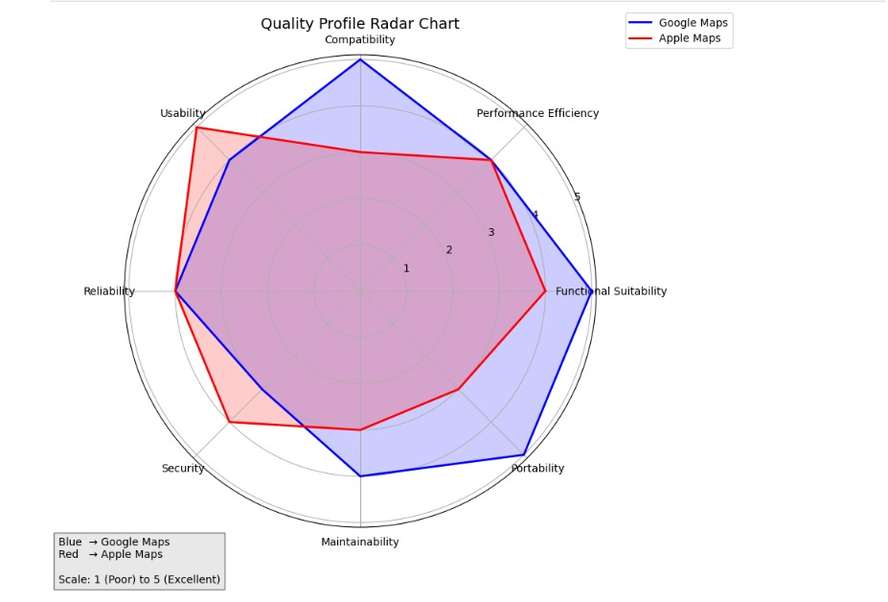

6. Comparative Analysis
Both Google Map and Apple Maps are powerful navigation tools, but their performance differs based on several quality attributes.
Firstly, in terms of overall score, Google Map performs better due to its extensive features and cross-platform compatibility. It provides more accurate location data and better route suggestions, especially in regions with complex road networks. Apple Maps, while efficient, lacks some detailed mapping features in certain areas.
Secondly, the top three quality gaps observed are:
- Functional Suitability: Google Map offers more features like offline maps and business reviews, giving it an advantage.
- Compatibility: Google Map works across multiple platforms, while Apple Maps is limited to Apple devices.
- Usability: Apple Maps has a cleaner interface, but Google Map provides more control and customization options.
A clear trade-off exists between simplicity and functionality. Apple Maps focuses on simplicity and smooth integration, making it easier for beginners. In contrast, Google Map offers advanced features but can feel slightly complex for new users.
In terms of performance, both apps respond quickly, but Google Map handles real-time updates more effectively. Apple Maps performs well in stable conditions but may lag in updating traffic data compared to Google Map.
Based on this evaluation, Google Map is recommended for users who need advanced features, better accuracy, and cross-platform support. However, Apple Maps is recommended for users within the Apple ecosystem who prefer a simple and clean interface.

7. Recommendations

For Google Map
- Improve User Interface Simplicity (Usability)
The app should reduce clutter by simplifying menus and navigation options. A cleaner interface will help new users interact more easily.
- Enhance Privacy Controls (Security)
Provide clearer options for location tracking permissions and data usage transparency to improve user trust.

For Apple Maps
- Expand Feature Set (Functional Suitability)
Add features such as offline maps and detailed business reviews to match competitors and improve usefulness.
- Improve Cross-Platform Availability (Compatibility)
Developing a version for Android or web access would increase accessibility and user base.

Conclusion
In conclusion, both applications are effective navigation tools, but Google Map stands out due to its rich functionality and wider compatibility. Apple Maps, on the other hand, excels in simplicity and integration within the Apple ecosystem. The final choice depends on user needs—advanced features versus ease of use.

The End

