HashMap

1. What is an HashMap?
A Hash Map (or Hash Table) is a data structure that stores data in key-value pairs. It is designed for ultra-fast data retrieval, insertion, and deletion. In Python, the built-in dictionary is a highly optimized implementation of a hash map.

Example in Python:
vehicles = ['car', 'truck', 'bus', 'motorbike']
print(vehicles[0]) # 'car' — O(1) lookup by index
print(vehicles[2]) # 'bus' — O(1) lookup by index

Memory Representation Diagram
The diagram below illustrates how the array is stored in contiguous memory blocks, the index-based access model, Big O complexity table, and the Static vs Dynamic comparison — as explained in the video:

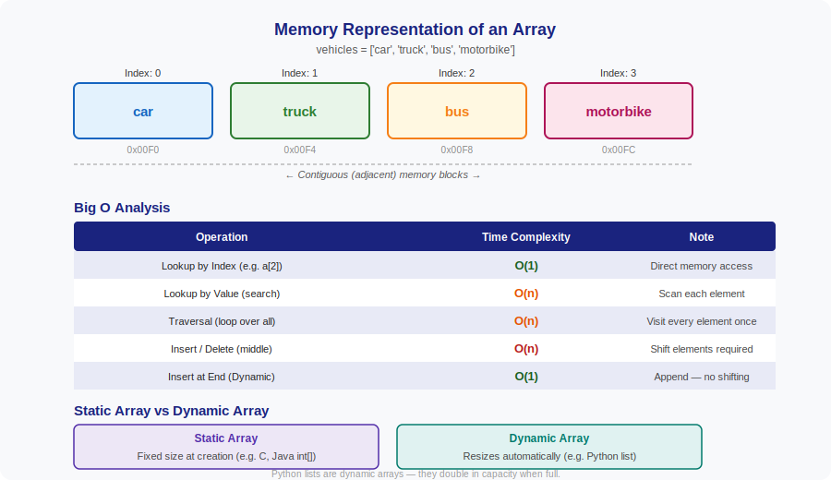

2. Static Array vs Dynamic Array
The video explains the important distinction between fixed-size and resizable arrays:

 | Static Array | Dynamic Array
Size | Fixed at the time of creation | Grows / shrinks automatically
Language | C, Java (int[]), C++ | Python list, JavaScript Array
Memory | Allocated once; cannot resize | Doubles capacity when full (O(1) amortised)
Flexibility | Low — size must be known upfront | High — append/remove at end easily

How Python lists resize:
When a Python list runs out of capacity, it allocates a new block roughly double the size, copies all existing elements, then continues appending. This makes the amortised cost of append O(1) even though individual resizing is O(n).

# Python list — dynamic array example
fruits = []
fruits.append('apple') # O(1) amortised
fruits.append('mango') # O(1) amortised
fruits.insert(1, 'grape') # O(n) — shifts 'mango' right

3. Python Code Examples

Creating an Array
vehicles = ['car', 'truck', 'bus', 'motorbike']

Index Lookup — O(1)
print(vehicles[0]) # car
print(vehicles[-1]) # motorbike (last element)

Value Search — O(n)
def search(arr, val):
for i, item in enumerate(arr):
if item == val:
return i
return -1

print(search(vehicles, 'bus')) # 2

Traversal — O(n)
for v in vehicles:
print(v)

Key Takeaways
- Arrays store elements in contiguous memory — this enables O(1) index access.
- Searching by value is O(n) — the computer must check element by element.
- Inserting or deleting in the middle is O(n) — elements must shift.
- Python lists are dynamic arrays — they resize automatically using a doubling strategy.
- Static arrays (fixed size) are more memory-efficient; dynamic arrays are more flexible.

