Arrays

1. What is an Array?
An array is a collection of elements stored at contiguous (adjacent) memory locations. Because each element occupies the same amount of memory, the CPU can calculate the exact address of any element in O(1) time using its index — this is the key advantage of arrays.

Example in Python:
vehicles = ['car', 'truck', 'bus', 'motorbike']
print(vehicles[0]) # 'car' — O(1) lookup by index
print(vehicles[2]) # 'bus' — O(1) lookup by index

Memory Representation Diagram
The diagram below illustrates how the array is stored in contiguous memory blocks, the index-based access model, Big O complexity table, and the Static vs Dynamic comparison — as explained in the video:

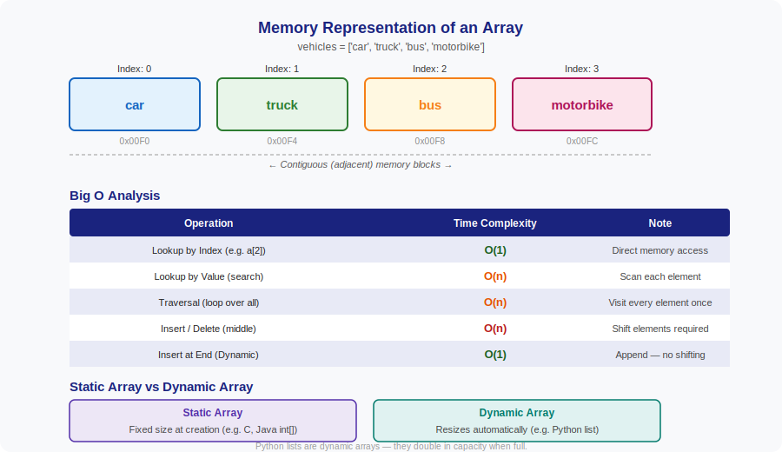

2. Static Array vs Dynamic Array
The video explains the important distinction between fixed-size and resizable arrays:

 | Static Array | Dynamic Array
Size | Fixed at the time of creation | Grows / shrinks automatically
Language | C, Java (int[]), C++ | Python list, JavaScript Array
Memory | Allocated once; cannot resize | Doubles capacity when full (O(1) amortised)
Flexibility | Low — size must be known upfront | High — append/remove at end easily

How Python lists resize:
When a Python list runs out of capacity, it allocates a new block roughly double the size, copies all existing elements, then continues appending. This makes the amortised cost of append O(1) even though individual resizing is O(n).

# Python list — dynamic array example
fruits = []
fruits.append('apple') # O(1) amortised
fruits.append('mango') # O(1) amortised
fruits.insert(1, 'grape') # O(n) — shifts 'mango' right

3. Python Code Examples

Creating an Array
vehicles = ['car', 'truck', 'bus', 'motorbike']

Index Lookup — O(1)
print(vehicles[0]) # car
print(vehicles[-1]) # motorbike (last element)

Value Search — O(n)
def search(arr, val):
for i, item in enumerate(arr):
if item == val:
return i
return -1

print(search(vehicles, 'bus')) # 2

Traversal — O(n)
for v in vehicles:
print(v)

Key Takeaways
- Arrays store elements in contiguous memory — this enables O(1) index access.
- Searching by value is O(n) — the computer must check element by element.
- Inserting or deleting in the middle is O(n) — elements must shift.
- Python lists are dynamic arrays — they resize automatically using a doubling strategy.
- Static arrays (fixed size) are more memory-efficient; dynamic arrays are more flexible.

