Lab 05: Synchronization Mechanisms
Introduction to Parallel & Distributed Computing (CS426L)
Name: Waqar Ali
Registration No:232457

Task 1: Mutex-Protected Bounded Buffer
Source code: buffer_mutex.c
/* buffer_mutex.c - Task 1: bounded buffer, one producer, one consumer, mutex only
usage: ./buffer_mutex [buffer_size] [items] default: 8 200000 */
#include <stdio.h>
#include <stdlib.h>
#include <pthread.h>
#include <sched.h>
#include <time.h>

#define MAX_BUFFER 64

int buffer[MAX_BUFFER];
int buffer_size = 8;
int items = 200000;

int in_pos = 0, out_pos = 0, count = 0; /* shared state */
pthread_mutex_t lock = PTHREAD_MUTEX_INITIALIZER;

long producer_retries = 0;
long consumer_retries = 0;
long consumed_sum = 0;
long order_errors = 0;

double now_ms()
{
struct timespec ts;
clock_gettime(CLOCK_MONOTONIC, &ts);
return ts.tv_sec * 1000.0 + ts.tv_nsec / 1e6;
}

void *producer(void *arg)
{
for (int i = 1; i <= items; i++) {
while (1) {
pthread_mutex_lock(&lock);
if (count < buffer_size) {
buffer[in_pos] = i;
in_pos = (in_pos + 1) % buffer_size;
count++;
pthread_mutex_unlock(&lock);
break;
}
pthread_mutex_unlock(&lock); /* buffer full, try again */
producer_retries++;
sched_yield();
}
}
return NULL;
}

void *consumer(void *arg)
{
for (int i = 1; i <= items; i++) {
int item = 0;
while (1) {
pthread_mutex_lock(&lock);
if (count > 0) {
item = buffer[out_pos];
out_pos = (out_pos + 1) % buffer_size;
count--;
pthread_mutex_unlock(&lock);
break;
}
pthread_mutex_unlock(&lock); /* buffer empty, try again */
consumer_retries++;
sched_yield();
}
if (item != i) order_errors++; /* items must come as 1, 2, 3, ... */
consumed_sum += item;
}
return NULL;
}

int main(int argc, char *argv[])
{
if (argc > 1) buffer_size = atoi(argv[1]);
if (argc > 2) items = atoi(argv[2]);

pthread_t prod, cons;
double start = now_ms();
pthread_create(&prod, NULL, producer, NULL);
pthread_create(&cons, NULL, consumer, NULL);
pthread_join(prod, NULL);
pthread_join(cons, NULL);
double elapsed = now_ms() - start;

long expected_sum = (long)items * (items + 1) / 2;
printf("[mutex + polling] items=%d buffer=%d\n", items, buffer_size);
printf("expected_sum=%ld actual_sum=%ld checksum_ok=%s order_errors=%ld\n",
expected_sum, consumed_sum,
expected_sum == consumed_sum ? "YES" : "NO", order_errors);
printf("producer_retries=%ld consumer_retries=%ld time=%.2f ms\n",
producer_retries, consumer_retries, elapsed);
return 0;
}

Screenshot: 5 runs (buffer size 8)
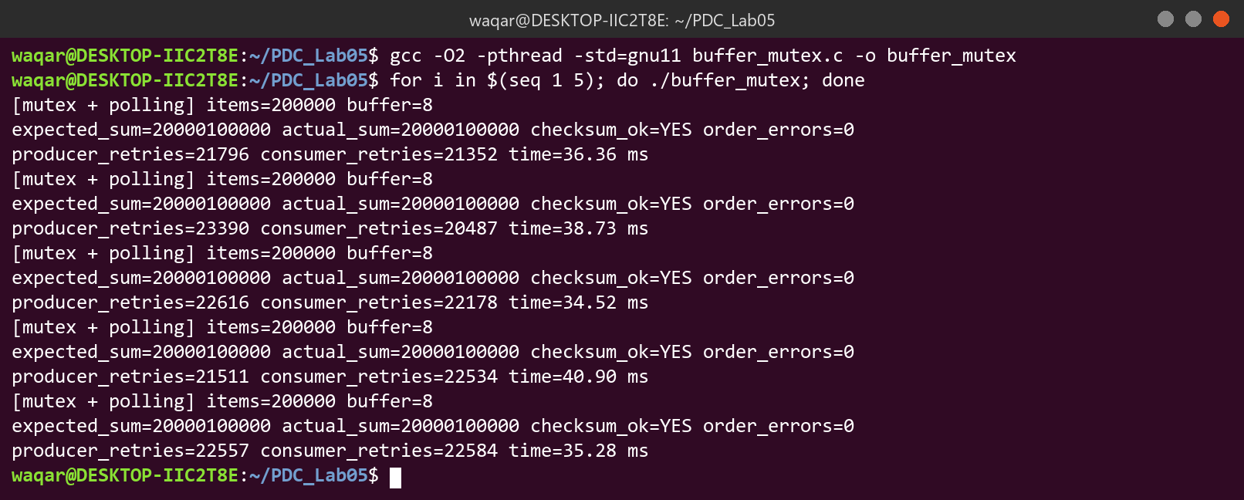

Run results (buffer size 8)
Run | Items | Checksum OK (Y/N) | Order errors | Producer retries | Consumer retries | Time (ms)
1 | 200000 | Y | 0 | 21796 | 21352 | 36.36
2 | 200000 | Y | 0 | 23390 | 20487 | 38.73
3 | 200000 | Y | 0 | 22616 | 22178 | 34.52
4 | 200000 | Y | 0 | 21511 | 22534 | 40.90
5 | 200000 | Y | 0 | 22557 | 22584 | 35.28
Average | 200000 | Y | 0 | 22374 | 21827 | 37.16

Buffer size and number of items used for the first table: Buffer size = 8, number of items = 200000
Screenshot: ThreadSanitizer build (20000 items)
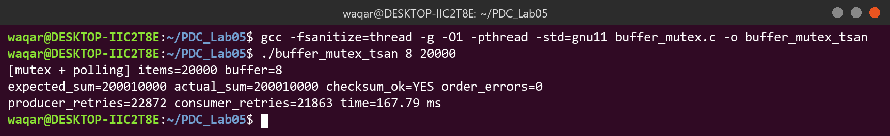

No ThreadSanitizer warning was printed.
Screenshot: buffer size 1, 8 and 64 (one run each)
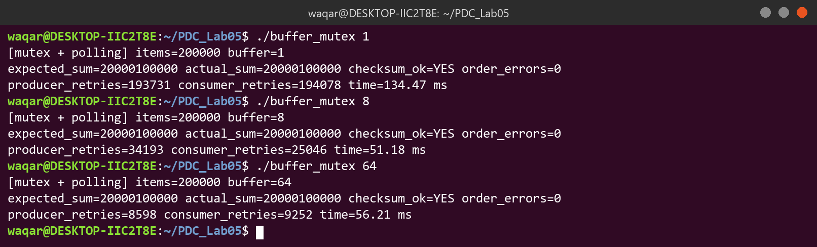

Effect of buffer size on retries (one run each)
Buffer size | Producer retries | Consumer retries | Time (ms)
1 | 193731 | 194078 | 134.47
8 | 34193 | 25046 | 51.18
64 | 8598 | 9252 | 56.21

Discussion Questions
Q1. Was every item received in order, and did the checksum always match? Explain why a single producer and a single consumer working on a circular buffer preserve FIFO order.
Yes, all 5 runs had a matching checksum and 0 order errors. With one producer and one consumer, both indices move forward around the same circle, so items come out in the same order they went in.
Q2. Why must the test of count and the insertion happen inside the same critical section?
The check and the insert must be one atomic step. If the lock is released in between, another thread can change count, so two producers could both fill the last free slot and overwrite an unread item.
Q3. Compare the retry counts for buffer sizes 1, 8 and 64. What do the retries represent in terms of CPU time, and why does sched_yield() reduce but not remove the waste?
Retries dropped from 193731/194078 (size 1) to 34193/25046 (size 8) and 8598/9252 (size 64). Each retry is wasted CPU time. sched_yield() only gives up the CPU for a moment; the thread stays runnable and checks again.
Q4. Suppose the producer, on finding the buffer full, simply slept while still holding the lock. What would happen to the consumer, and why?
The consumer would block on the mutex and could never empty the buffer, so neither thread can continue (deadlock).

Task 2: Multiple Producers and Consumers with Semaphores
Source code: buffer_sem.c
/* buffer_sem.c - Task 2: bounded buffer, many producers and consumers, semaphores
usage: ./buffer_sem [producers] [consumers] [buffer_size] [items_per_producer]
default: 4 4 8 50000 */
#include <stdio.h>
#include <stdlib.h>
#include <pthread.h>
#include <semaphore.h>
#include <time.h>

#define MAX_BUFFER 64
#define MAX_THREADS 8

int buffer[MAX_BUFFER];
int num_producers = 4, num_consumers = 4;
int buffer_size = 8;
int items_per_producer = 50000;
int total_items;

int in_pos = 0, out_pos = 0; /* shared state */
sem_t empty_slots; /* number of free slots */
sem_t full_slots; /* number of filled slots */
pthread_mutex_t buf_lock = PTHREAD_MUTEX_INITIALIZER;
int *seen; /* how many times each item was consumed */

double now_ms()
{
struct timespec ts;
clock_gettime(CLOCK_MONOTONIC, &ts);
return ts.tv_sec * 1000.0 + ts.tv_nsec / 1e6;
}

void *producer(void *arg)
{
long id = (long)arg;
for (int k = 0; k < items_per_producer; k++) {
int item = id * items_per_producer + k; /* unique item number */

sem_wait(&empty_slots);
pthread_mutex_lock(&buf_lock);
buffer[in_pos] = item;
in_pos = (in_pos + 1) % buffer_size;
pthread_mutex_unlock(&buf_lock);
sem_post(&full_slots);
}
return NULL;
}

void *consumer(void *arg)
{
for (int k = 0; k < total_items / num_consumers; k++) {
sem_wait(&full_slots);
pthread_mutex_lock(&buf_lock);
int item = buffer[out_pos];
out_pos = (out_pos + 1) % buffer_size;
pthread_mutex_unlock(&buf_lock);
sem_post(&empty_slots);

__atomic_fetch_add(&seen[item], 1, __ATOMIC_RELAXED);
}
return NULL;
}

int main(int argc, char *argv[])
{
if (argc > 1) num_producers = atoi(argv[1]);
if (argc > 2) num_consumers = atoi(argv[2]);
if (argc > 3) buffer_size = atoi(argv[3]);
if (argc > 4) items_per_producer = atoi(argv[4]);
total_items = num_producers * items_per_producer;
seen = calloc(total_items, sizeof(int));

pthread_t prod[MAX_THREADS], cons[MAX_THREADS];
sem_init(&empty_slots, 0, buffer_size);
sem_init(&full_slots, 0, 0);

double start = now_ms();
for (long i = 0; i < num_producers; i++)
pthread_create(&prod[i], NULL, producer, (void *)i);
for (long i = 0; i < num_consumers; i++)
pthread_create(&cons[i], NULL, consumer, NULL);
for (int i = 0; i < num_producers; i++) pthread_join(prod[i], NULL);
for (int i = 0; i < num_consumers; i++) pthread_join(cons[i], NULL);
double elapsed = now_ms() - start;

long lost = 0, duplicated = 0;
for (int i = 0; i < total_items; i++) {
if (seen[i] == 0) lost++;
else if (seen[i] > 1) duplicated += seen[i] - 1;
}
printf("[semaphores] producers=%d consumers=%d buffer=%d items=%d\n",
num_producers, num_consumers, buffer_size, total_items);
printf("lost=%ld duplicated=%ld correct=%s time=%.2f ms\n",
lost, duplicated, (lost == 0 && duplicated == 0) ? "YES" : "NO", elapsed);

sem_destroy(&empty_slots);
sem_destroy(&full_slots);
free(seen);
return 0;
}

Screenshot: all six configurations (three runs each)
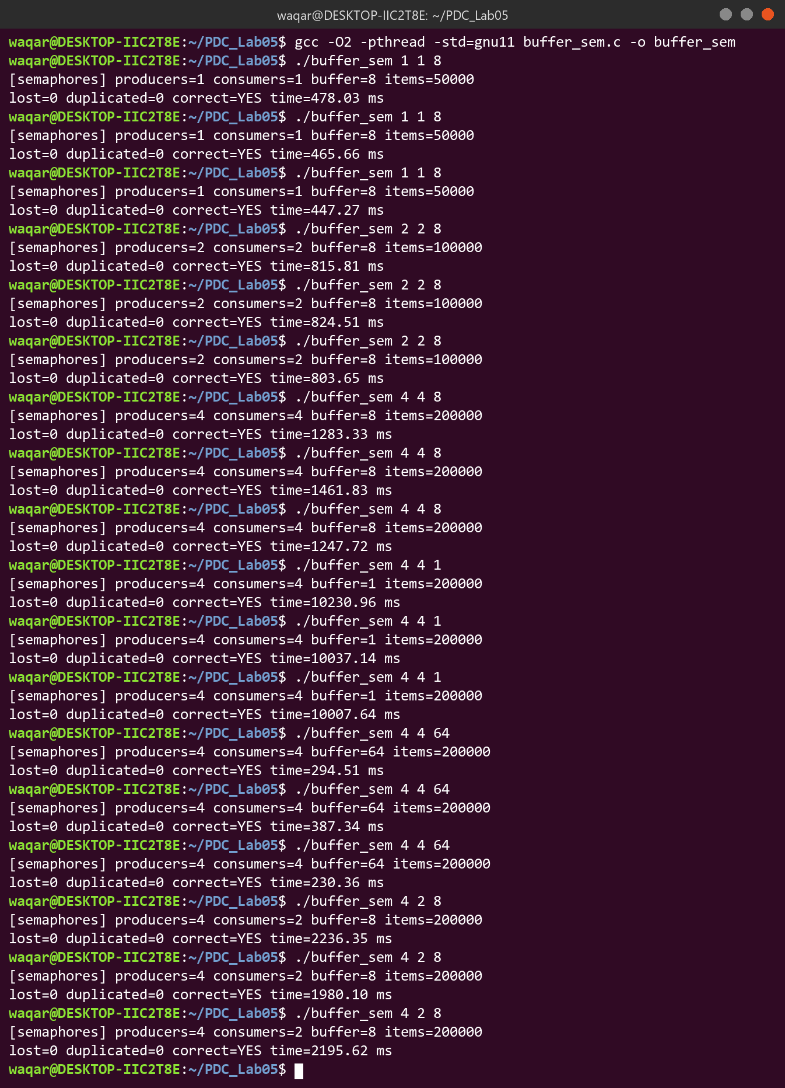

Configurations (three runs each, 50000 items per producer)
Producers / consumers / capacity | Lost | Duplicated | Run 1 (ms) | Run 2 (ms) | Run 3 (ms) | Average (ms)
1 / 1 / 8 | 0 | 0 | 478.03 | 465.66 | 447.27 | 463.65
2 / 2 / 8 | 0 | 0 | 815.81 | 824.51 | 803.65 | 814.66
4 / 4 / 8 | 0 | 0 | 1283.33 | 1461.83 | 1247.72 | 1330.96
4 / 4 / 1 | 0 | 0 | 10230.96 | 10037.14 | 10007.64 | 10091.91
4 / 4 / 64 | 0 | 0 | 294.51 | 387.34 | 230.36 | 304.07
4 / 2 / 8 | 0 | 0 | 2236.35 | 1980.10 | 2195.62 | 2137.36

Screenshot: ThreadSanitizer build, 4 producers / 4 consumers (5000 items per producer)
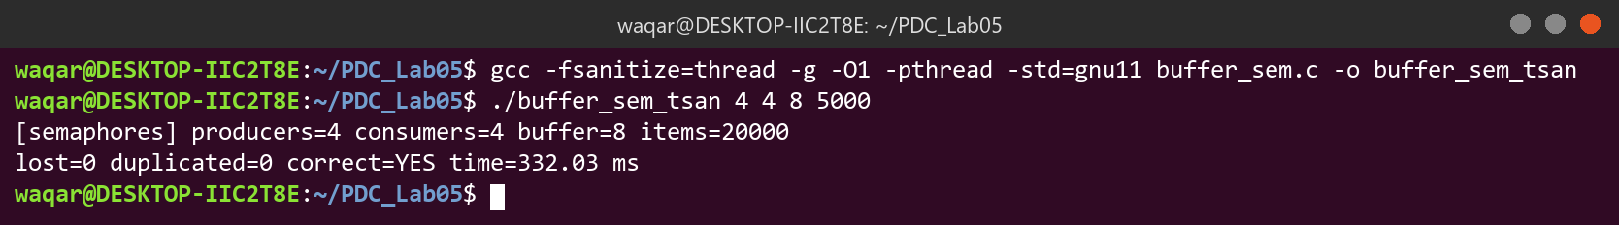

No data-race warning was printed.
Screenshot: deadlock experiment
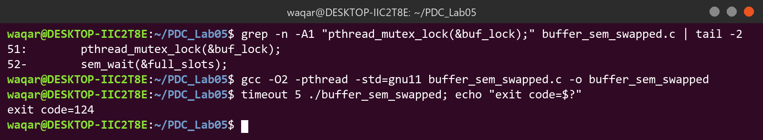

Observation: the program printed nothing and was killed by timeout after 5 seconds (exit code=124). It was stuck in a deadlock. The correct order was kept in buffer_sem.c.

Discussion Questions
Q1. Explain the roles of the two semaphores and why their initial values are the buffer capacity and 0.
empty_slots counts free slots and full_slots counts filled slots. The buffer starts empty, so all slots are free and 0 are full.
Q2. Why is a mutex still needed in addition to the semaphores? Would it be needed with exactly one producer and one consumer?
Semaphores only limit how many threads enter, not which slot they use, so two producers could write to the same in_pos. With one producer and one consumer each index has only one user, so the mutex is not strictly needed, but it is kept for safety.
Q3. In the deadlock experiment, describe step by step why the program stops making progress.
A consumer locks the mutex and then sleeps on full_slots (value 0). Producers need the same mutex to insert and post full_slots, so everyone waits forever. timeout killed it after 5 s.
Q4. How did the time change with the buffer capacity (1, 8, 64) and with the number of threads?
A bigger buffer was faster (1: 10092 ms, 8: 1331 ms, 64: 304 ms) because threads block less often. More threads were slower (464, 815, 1331 ms) because of more contention on the same mutex and semaphores.
Q5. Compare the 1 / 1 / 8 semaphore version with the Task 1 polling version. Why does blocking differ from polling?
Polling (Task 1) took about 37 ms and the 1/1/8 semaphore version took about 464 ms here, because every block and wakeup is a costly kernel call on WSL. But polling keeps the CPU busy while waiting, and blocked threads use no CPU.
Q6. Is FIFO order guaranteed as seen by multiple consumers? Why does the seen array check lost and duplicated items instead of order?
No. Items from different producers get mixed and a consumer can be paused after removing an item, so the order is not fixed. What must always hold is that each item is consumed exactly once.

Task 3: Condition-Variable Signaling
Source code: cond_signal.c
/* cond_signal.c - Task 3: condition-variable signaling of a "data ready" flag
usage: ./cond_signal [scenario] [delay_ms] default: A 1000
A = 1 worker waits, B = signal first, C = 3 workers, D = spin (polling) */
#include <stdio.h>
#include <stdlib.h>
#include <pthread.h>
#include <time.h>

#define MAX_WORKERS 3

pthread_mutex_t lock = PTHREAD_MUTEX_INITIALIZER;
pthread_cond_t data_cv = PTHREAD_COND_INITIALIZER;
int data_ready = 0; /* the flag, protected by lock */
int shared_data = 0;
int wait_calls[MAX_WORKERS];
int received[MAX_WORKERS];

int num_workers = 1;
int use_spin = 0;

double now_ms()
{
struct timespec ts;
clock_gettime(CLOCK_MONOTONIC, &ts);
return ts.tv_sec * 1000.0 + ts.tv_nsec / 1e6;
}

double cpu_ms()
{
struct timespec ts;
clock_gettime(CLOCK_PROCESS_CPUTIME_ID, &ts);
return ts.tv_sec * 1000.0 + ts.tv_nsec / 1e6;
}

void sleep_ms(int ms)
{
struct timespec ts = { ms / 1000, (ms % 1000) * 1000000L };
nanosleep(&ts, NULL);
}

void *worker(void *arg)
{
long id = (long)arg;

if (use_spin) {
/* polling: keep checking the flag, burns CPU */
while (1) {
pthread_mutex_lock(&lock);
int ready = data_ready;
pthread_mutex_unlock(&lock);
if (ready) break;
}
pthread_mutex_lock(&lock);
} else {
pthread_mutex_lock(&lock);
while (!data_ready) { /* check again after every wakeup */
wait_calls[id]++;
pthread_cond_wait(&data_cv, &lock);
}
}
received[id] = shared_data;
pthread_mutex_unlock(&lock);
return NULL;
}

void publish()
{
pthread_mutex_lock(&lock);
shared_data = 42;
data_ready = 1;
if (num_workers > 1)
pthread_cond_broadcast(&data_cv); /* wake all workers */
else
pthread_cond_signal(&data_cv); /* wake one worker */
pthread_mutex_unlock(&lock);
}

int main(int argc, char *argv[])
{
char scenario = 'A';
int delay = 1000;
if (argc > 1) scenario = argv[1][0];
if (argc > 2) delay = atoi(argv[2]);
if (scenario == 'C') num_workers = 3;
if (scenario == 'D') use_spin = 1;

pthread_t threads[MAX_WORKERS];
double wall0 = now_ms(), cpu0 = cpu_ms();

if (scenario == 'B')
publish(); /* publish before any worker waits */

for (long i = 0; i < num_workers; i++)
pthread_create(&threads[i], NULL, worker, (void *)i);

if (scenario != 'B') {
sleep_ms(delay); /* workers are waiting now */
publish();
}

for (int i = 0; i < num_workers; i++)
pthread_join(threads[i], NULL);

double wall = now_ms() - wall0, cpu = cpu_ms() - cpu0;
for (int i = 0; i < num_workers; i++)
printf("[worker %d] blocked in wait %d time(s), received %d\n",
i, wait_calls[i], received[i]);
printf("scenario=%c workers=%d delay=%d ms wall=%.2f ms cpu=%.2f ms\n",
scenario, num_workers, delay, wall, cpu);
return 0;
}

Screenshot: scenarios A, B, C and D
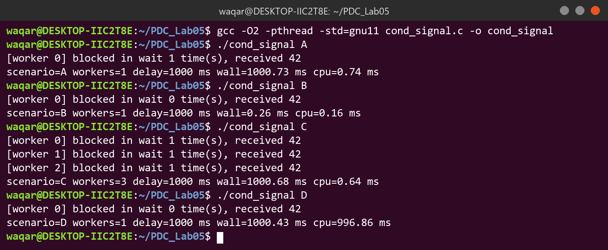

Scenario results
Scenario | Times blocked in wait | Value received | Wall time (ms) | CPU time (ms)
A: cond, 1 worker | 1 | 42 | 1000.73 | 0.74
B: signal-first | 0 | 42 | 0.26 | 0.16
C: cond, 3 workers | 1, 1, 1 | 42, 42, 42 | 1000.68 | 0.64
D: spin (polling) | 0 | 42 | 1000.43 | 996.86

Screenshot: ThreadSanitizer build, scenario A with 200 ms delay
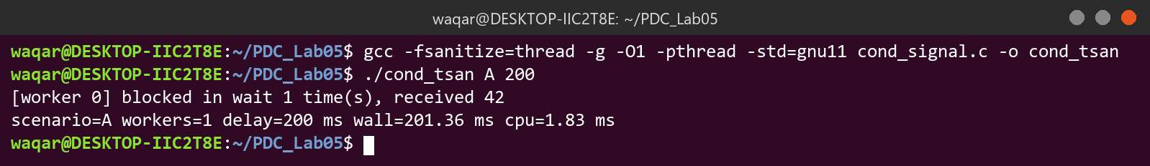

No ThreadSanitizer warning was printed.
Screenshot: lost-signal experiment
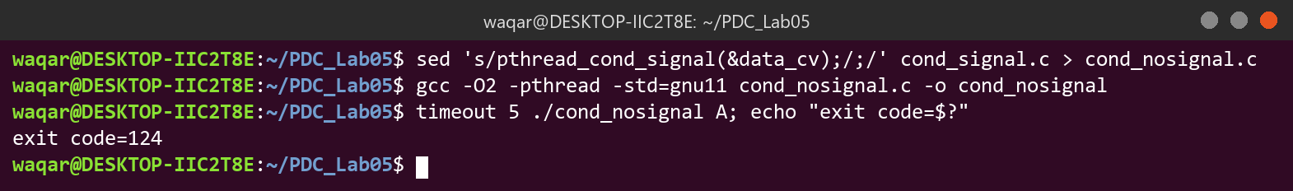

Observation: the worker never woke up. The program printed nothing and was killed by timeout after 5 seconds.

Discussion Questions
Q1. Why does the worker test the flag in a while loop instead of an if? Give two situations where it must check again.
Waking up does not guarantee the flag is set. The flag must be checked again after a spurious wakeup, and when another woken thread has already changed the data.
Q2. What does pthread_cond_wait() do with the mutex, and why must the mutex be held when it is called?
It releases the mutex and sleeps in one atomic step, and locks it again before returning. Holding the mutex makes sure the signal cannot slip in between checking the flag and starting to wait.
Q3. In scenario B the worker never blocks, and in the lost-signal experiment it never wakes up. Explain both.
In B the flag was already 1, so the worker skipped the loop. Without the signal, the waiting worker is never woken up to check the flag. The flag holds the state; the signal only wakes the waiters.
Q4. Compare the CPU time of scenario A with scenario D. Why is blocking so much cheaper than polling?
A used 0.74 ms of CPU and D used 996.86 ms for the same 1 s wait. A blocked thread sleeps in the kernel, while a spinning thread keeps one core busy the whole time.
Q5. In scenario C, why is pthread_cond_signal() not sufficient for three waiting workers, and what does pthread_cond_broadcast() change?
pthread_cond_signal() wakes only one waiter, so two workers would sleep forever. pthread_cond_broadcast() wakes all three.

Task 4: Phase Barrier for Worker Threads
Source code: phase_barrier.c
/* phase_barrier.c - Task 4: reusable phase barrier for worker threads
usage: ./phase_barrier [workers] [rounds] [use_barrier] default: 4 100000 1
use_barrier = 0 runs the experiment without the barrier */
#include <stdio.h>
#include <stdlib.h>
#include <stdint.h>
#include <pthread.h>
#include <time.h>

#define MAX_WORKERS 8

typedef struct {
pthread_mutex_t m;
pthread_cond_t cv;
int parties; /* threads that must arrive */
int waiting; /* threads that have arrived in this phase */
unsigned long generation; /* increases every time the barrier opens */
} barrier_t;

barrier_t bar;
uint64_t cells[MAX_WORKERS]; /* shared array */
int num_workers = 4;
int rounds = 100000;
int use_barrier = 1;

void barrier_init(barrier_t *b, int parties)
{
pthread_mutex_init(&b->m, NULL);
pthread_cond_init(&b->cv, NULL);
b->parties = parties;
b->waiting = 0;
b->generation = 0;
}

void barrier_wait(barrier_t *b)
{
pthread_mutex_lock(&b->m);
unsigned long my_gen = b->generation;
b->waiting++;
if (b->waiting == b->parties) {
/* last thread: open the barrier */
b->waiting = 0;
b->generation++;
pthread_cond_broadcast(&b->cv);
} else {
while (my_gen == b->generation)
pthread_cond_wait(&b->cv, &b->m);
}
pthread_mutex_unlock(&b->m);
}

double now_ms()
{
struct timespec ts;
clock_gettime(CLOCK_MONOTONIC, &ts);
return ts.tv_sec * 1000.0 + ts.tv_nsec / 1e6;
}

void *worker(void *arg)
{
long id = (long)arg;
for (int r = 0; r < rounds; r++) {
uint64_t next = cells[id] + cells[(id + 1) % num_workers]; /* read */
if (use_barrier) barrier_wait(&bar); /* all reads done */
cells[id] = next; /* write */
if (use_barrier) barrier_wait(&bar); /* all writes done */
}
return NULL;
}

int main(int argc, char *argv[])
{
if (argc > 1) num_workers = atoi(argv[1]);
if (argc > 2) rounds = atoi(argv[2]);
if (argc > 3) use_barrier = atoi(argv[3]);

pthread_t threads[MAX_WORKERS];
uint64_t expected[MAX_WORKERS], tmp[MAX_WORKERS];

for (int i = 0; i < num_workers; i++) {
cells[i] = i + 1;
expected[i] = i + 1;
}
barrier_init(&bar, num_workers);

double start = now_ms();
for (long i = 0; i < num_workers; i++)
pthread_create(&threads[i], NULL, worker, (void *)i);
for (int i = 0; i < num_workers; i++)
pthread_join(threads[i], NULL);
double elapsed = now_ms() - start;

/* same computation done sequentially, used as reference */
for (int r = 0; r < rounds; r++) {
for (int i = 0; i < num_workers; i++)
tmp[i] = expected[i] + expected[(i + 1) % num_workers];
for (int i = 0; i < num_workers; i++)
expected[i] = tmp[i];
}
int mismatches = 0;
for (int i = 0; i < num_workers; i++)
if (cells[i] != expected[i]) mismatches++;

printf("[%s] workers=%d rounds=%d matches_reference=%s mismatching_cells=%d time=%.2f ms\n",
use_barrier ? "barrier" : "no barrier", num_workers, rounds,
mismatches == 0 ? "YES" : "NO", mismatches, elapsed);
return 0;
}

Screenshot: with barrier and without barrier (5 runs each)
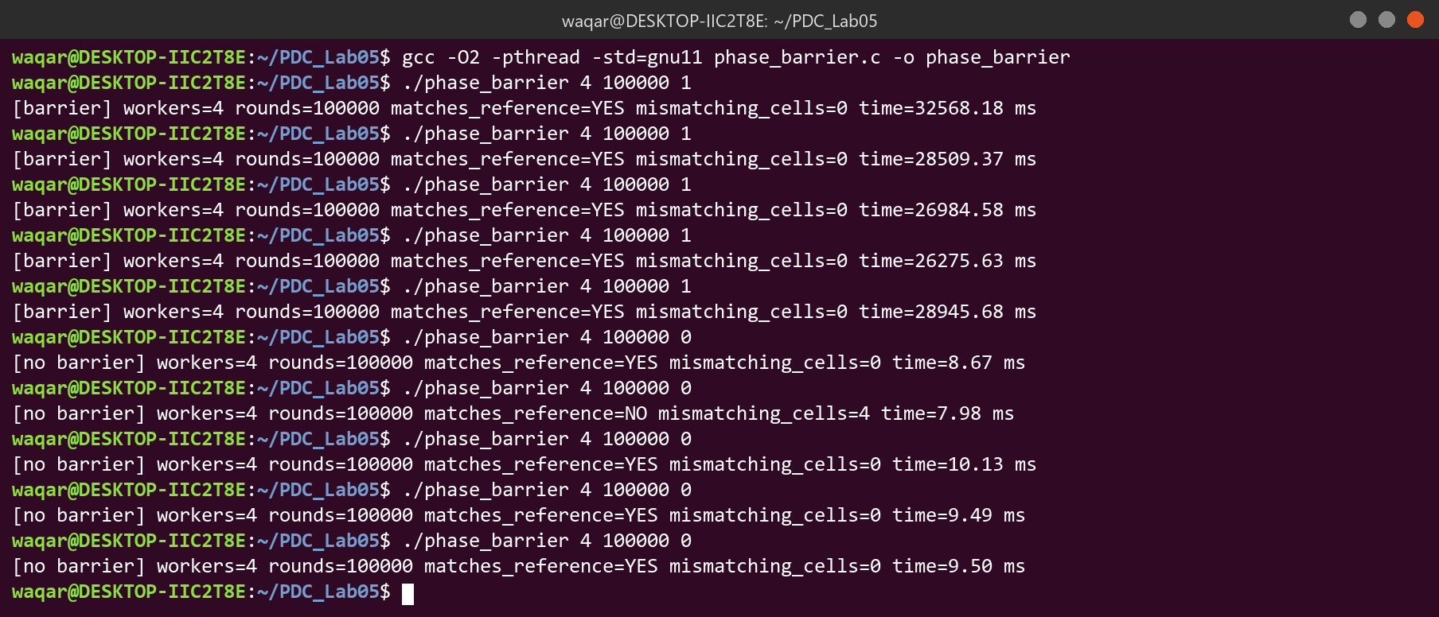

Run results (4 workers)
Run | With barrier: correct? (Y/N) | With barrier: time (ms) | No barrier: correct? (Y/N) | No barrier: mismatching cells
1 | Y | 32568.18 | Y | 0
2 | Y | 28509.37 | N | 4
3 | Y | 26984.58 | Y | 0
4 | Y | 26275.63 | Y | 0
5 | Y | 28945.68 | Y | 0

Average time with barrier (4 workers) = 28656.69 ms
Screenshot: ThreadSanitizer build (2000 rounds) and 8-worker run
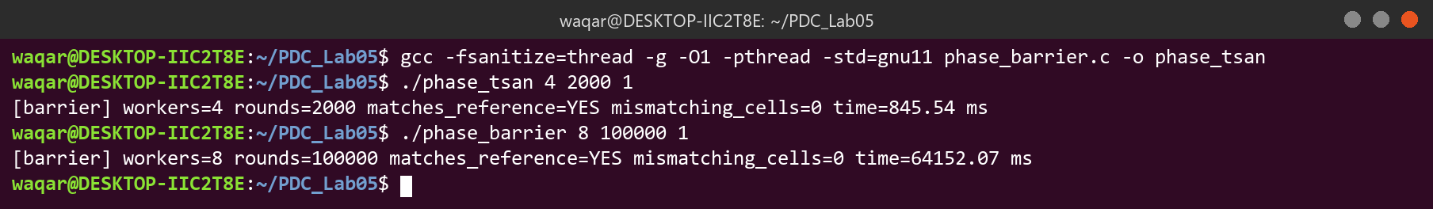

TSan warnings on the barrier build: None Time with 8 workers (ms): 64152.07 nproc: 8

Discussion Questions
Q1. Why are two barrier calls needed in every round? What could go wrong if the second one were removed?
The first barrier makes all reads finish before any write. The second makes all writes finish before the next round's reads; without it a fast thread could read a neighbour's old value.
Q2. Why does the barrier use a generation number instead of only an arrival count?
waiting is reset to 0 when the barrier opens, so a count alone cannot tell the old waiters that it opened, and a fast thread entering again would mix with the old phase. Waiting until the generation changes fixes this.
Q3. What did the no-barrier version produce? Was the wrong result the same in every run, and why is it a data race even if the output looks right?
It was wrong in 1 of 5 runs, so the result changed from run to run. It often still matched because with 4 workers all cells wrap around to 0 after about 200 rounds, so many wrong orders end at the same value. It is still a data race because threads read and write the same cells without synchronization, so a correct-looking output is just luck.
Q4. How did the time change with 8 workers compared with 4? Why is the duration of a round determined by the slowest thread?
8 workers took 64152 ms vs 28657 ms on average for 4, because the work per round is tiny and the barrier overhead grows with more threads. A round only ends when the last thread arrives.
Q5. Name two features that the built-in pthread_barrier_t offers or guarantees that the hand-built barrier does not.
pthread_barrier_wait() returns PTHREAD_BARRIER_SERIAL_THREAD to one thread for serial work, and it is a tested, optimized library version (it also supports process-shared barriers). A custom barrier is useful for extras like timeouts.

Task 5: Lock-Free Stack with Compare-and-Swap (Optional)
Source code: lockfree_stack.c
/* lockfree_stack.c - Task 5 (optional): lock-free stack using compare-and-swap
usage: ./lockfree_stack [threads] [nodes_per_thread] default: 4 50000 */
#include <stdio.h>
#include <stdlib.h>
#include <pthread.h>
#include <sched.h>
#include <stdatomic.h>
#include <time.h>

#define MAX_THREADS 8

typedef struct node {
int value;
struct node *next;
} node_t;

_Atomic(node_t *) head = NULL; /* top of the stack */
node_t *pool; /* all nodes, never freed during the test */
int *seen; /* how many times each value was popped */
int num_threads = 4;
int nodes_per_thread = 50000;

double now_ms()
{
struct timespec ts;
clock_gettime(CLOCK_MONOTONIC, &ts);
return ts.tv_sec * 1000.0 + ts.tv_nsec / 1e6;
}

void push(node_t *n)
{
node_t *old = atomic_load(&head);
do {
n->next = old;
} while (!atomic_compare_exchange_weak(&head, &old, n));
}

node_t *pop()
{
node_t *old = atomic_load(&head);
while (old != NULL && !atomic_compare_exchange_weak(&head, &old, old->next)) {
/* CAS failed, old now has the new head, try again */
}
return old;
}

void *worker(void *arg)
{
long id = (long)arg;
for (int i = 0; i < nodes_per_thread; i++) {
node_t *n = &pool[id * nodes_per_thread + i];
n->value = id * nodes_per_thread + i;
push(n);
}
for (int i = 0; i < nodes_per_thread; i++) {
node_t *n;
while ((n = pop()) == NULL)
sched_yield(); /* stack empty for now, wait a bit */
__atomic_fetch_add(&seen[n->value], 1, __ATOMIC_RELAXED);
}
return NULL;
}

int main(int argc, char *argv[])
{
if (argc > 1) num_threads = atoi(argv[1]);
if (argc > 2) nodes_per_thread = atoi(argv[2]);
int total = num_threads * nodes_per_thread;
pool = calloc(total, sizeof(node_t));
seen = calloc(total, sizeof(int));

pthread_t threads[MAX_THREADS];
double start = now_ms();
for (long i = 0; i < num_threads; i++)
pthread_create(&threads[i], NULL, worker, (void *)i);
for (int i = 0; i < num_threads; i++)
pthread_join(threads[i], NULL);
double elapsed = now_ms() - start;

long lost = 0, duplicated = 0;
for (int i = 0; i < total; i++) {
if (seen[i] == 0) lost++;
else if (seen[i] > 1) duplicated += seen[i] - 1;
}
int empty = (atomic_load(&head) == NULL);
printf("[lock-free stack] threads=%d nodes=%d\n", num_threads, total);
printf("lost=%ld duplicated=%ld stack_empty=%s correct=%s time=%.2f ms\n",
lost, duplicated, empty ? "YES" : "NO",
(lost == 0 && duplicated == 0 && empty) ? "YES" : "NO", elapsed);

free(pool);
free(seen);
return 0;
}

Screenshot: 5 runs with 4 threads
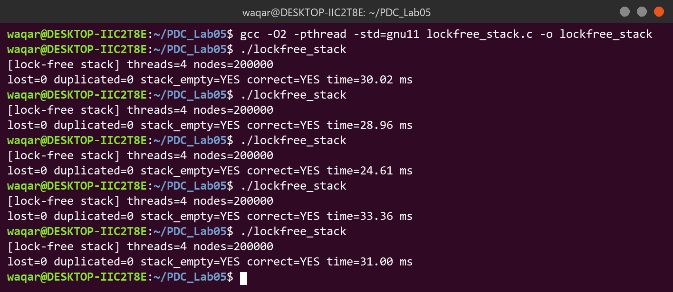

Run results (4 threads)
Run | Nodes (total) | Lost | Duplicated | Stack empty (Y/N) | Time (ms)
1 | 200000 | 0 | 0 | Y | 30.02
2 | 200000 | 0 | 0 | Y | 28.96
3 | 200000 | 0 | 0 | Y | 24.61
4 | 200000 | 0 | 0 | Y | 33.36
5 | 200000 | 0 | 0 | Y | 31.00

Screenshot: ThreadSanitizer build (5000 nodes per thread) and 8-thread run
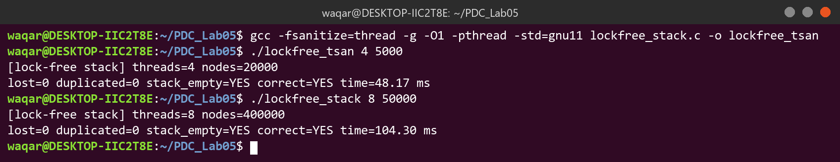

No ThreadSanitizer warning was printed.

Discussion Questions
Q1. Explain why the CAS retry loop never loses an element. Why is this stack lock-free but not wait-free?
CAS only succeeds if head is unchanged; otherwise it retries with the new head, so no update is overwritten. It is lock-free because some thread always succeeds, but not wait-free because one thread may keep retrying.
Q2. Describe the ABA problem. Why can it not occur in this test?
ABA: head changes A to B and back to A, so an old CAS succeeds with a wrong next pointer. Here nodes are never reused, so A cannot come back; reusing popped nodes would make it a risk.
Q3. Why are popped nodes never freed? Name one technique to reclaim memory safely.
Another thread may still be reading a popped node, so freeing it would cause use-after-free. Hazard pointers (or epoch-based reclamation) are used to free memory safely.
Q4. What does the "no lost, no duplicated, stack empty" check prove, and what does it not prove?
It proves every node was popped exactly once in these runs. It does not prove the stack is always correct, and it does not check LIFO order or ABA.
Q5. Compare the time with a mutex-protected stack. Does lock-free always mean faster?
Going from 4 threads (~30 ms for 200000 nodes) to 8 threads (104 ms for 400000 nodes) increased the time per node because of CAS contention on head. Lock-free is not always faster; its benefit is guaranteed progress.

Conclusion
In this lab the mutex, semaphores, condition variable, barrier and CAS stack all gave correct results. Blocking (semaphores and condition variables) saves CPU compared to polling, and the order of locking and signaling must be followed exactly.

