**User Manual**

**Services Elite**

V 1.0

**Table of Contents**

**Setup your** **Services Elite**

Requesting Free 7 Days Demo

Add your LinkedIn Account

Setting up Bids Templates

Manage Multiple Job Type Templates.

How to use Auto Pilot.

**Welcome!** Following pages explains to you about how to setup your Services Elite.

### Requesting Free 7 Days Demo

After installation Click “ServicesElite.exe” inside installation folder. These steps are:



1. Click Request Demo button.
2. Enter your Name.
3. Enter your Email. This doesn’t need to be your LinkedIn email.
4. Click Request Demo button.
5. You get your Demo Key free for 7 days to use.

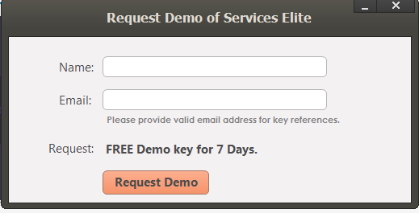

### Add your LinkedIn Account

When you have activated your key and have opened main screen. These steps are:

1. Click LinkedIn Account on Left Pane.
2. Enter your LinkedIn Email.
3. Enter your LinkedIn Password.
4. Click Save button.
5. Our process will auto fill text boxes so you must not click inside browser.
6. **If LinkedIn sends you Verification Code on your mobile number registered with LinkedIn then you enter it manually inside browser.**

#### 

### Setting up Proposals Template

1. Click Proposals Templates on Left Pane.
2. Enter your Template Message. **YOU MAY LEAVE THIS EMPTY IF YOU WANT TO SUBMIT PROPOSALS BASED ON SPECIFIC JOBS ONLY i.e. Resume Writing, Graphic Design etc.**
3. Click Save button.

### Manage Multiple Job Type Templates

This Feature allows you to have separate Message Templates according to Job Types.

1. Click Bids Templates on Left Pane.
2. Click Multiple Job Type Messages Button.
3. Enter Job Type.
4. Enter Template Message.
5. Select Match Type i.e. Partial Match or Full Match.
6. Click Save Button.
7. This helps to send Template Message according to Job Type like this

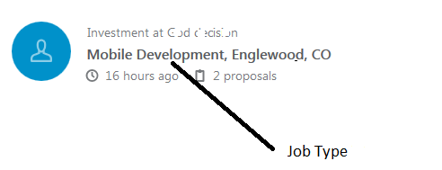

### How to use Auto Pilot.

Auto pilot helps you to auto process proposals on daily basis automatically. These steps are:

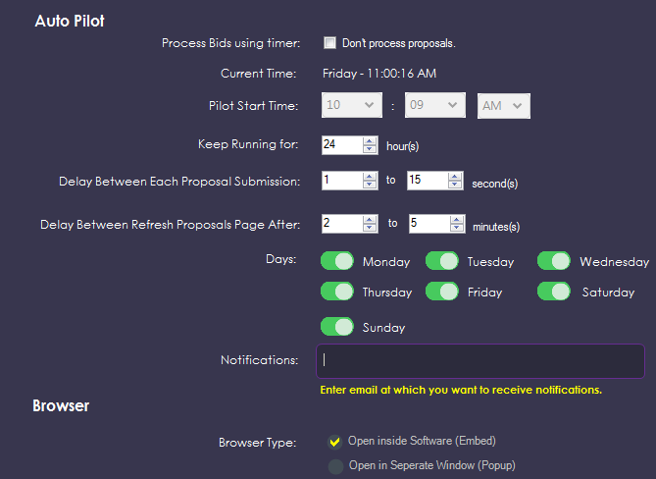

1. Click Auto Pilot on Left Pane.
2. Uncheck “Don’t process proposals” option.
3. Select “Pilot Start Time”. If your system time is 3.00 PM you should future time i.e. 3:05 PM so it starts processing after 5 minutes. You can view countdown timer on top right of Services Elite like below. 12 Hours 52 Minutes 45 Seconds



1. Select “Keep Running for” option. You can select from 1 hour to 24 hours.
2. Select “Delay between Each Proposal Submission” option. You can set this setting in Seconds.
3. Select “Delay between Refresh Proposals Page After” option. This settings reload proposals page to get new available proposals after X minutes.
4. Select “Days” option. You can run Pilot 7 days a week or only particular days.
5. Enter “Notification” option. If you fill this textbox then you will be notified at this email address when Pilot starts and finishes daily.
6. Browser Type should be “Open inside Software (Embed)” so you don’t have separate popup of processor.
7. Click Save Settings button