**User Manual**

**Upwork Elite**

V 1.0

**Table of Contents**

**Setup your** **Upwork Elite**

Requesting Free 7 Days Demo

Add your Upwork Account

Setting up Proposal Settings

Manage Additional Questions.

How to use Auto Pilot.

**Welcome!** Following pages explains to you about how to setup your Upwork Elite.

### Requesting Free 7 Days Demo

After installation Click “UpworkElite.exe” inside installation folder. These steps are:



1. Click Request Demo button.
2. Enter your Name.
3. Enter your Email. This doesn’t need to be your Upwork email.
4. Click Request Demo button.
5. You get your Demo Key free for 7 days to use.

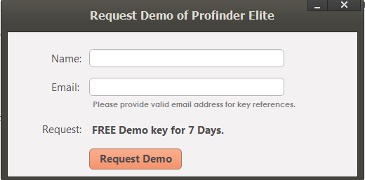

### Add your Upwork Account

When you have activated your key and have opened main screen. These steps are:

1. Click Upwork Account on Left Pane.
2. Enter your Upwork Email/Username.
3. Enter your Upwork Password.
4. Enter your Upwork Secret Answer.
5. Click Save button.
6. Our process will auto fill text boxes so you must not click inside browser.

### Setting up Proposals Settings

1. Click Proposals Settings on Left Pane.
2. Enter your Search Phrase i.e. Resume Writer.
3. Enter your Cover Letter.
4. Click Save button.

### Manage Additional Questions

This Feature allows you to have question.

1. Click Bids Template on Left Pane.
2. Click Additional Questions Button.
3. Enter Question.
4. Enter Answer.
5. Click Save Button.

### How to use Auto Pilot.

Auto pilot helps you to auto process proposals on daily basis automatically. These steps are:

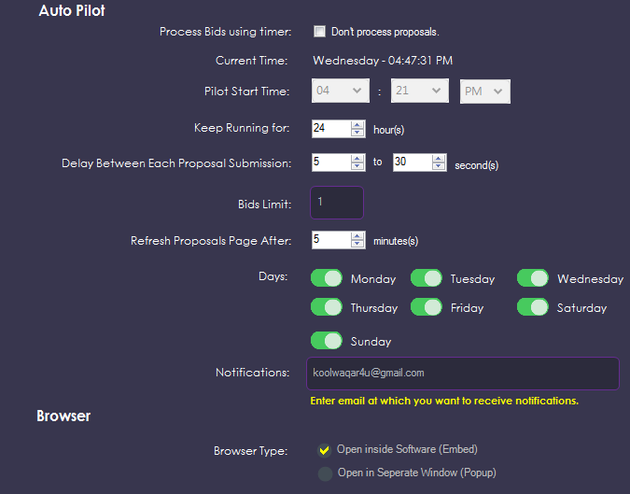

1. Click Auto Pilot on Left Pane.
2. Uncheck “Don’t process proposals” option.
3. Select “Pilot Start Time”. If your system time is 3.00 PM you should future time i.e. 3:05 PM so it starts processing after 5 minutes. You can view countdown timer on top right of Upwork Elite like below. 12 Hours 52 Minutes 45 Seconds



1. Select “Keep Running for” option. You can select from 1 hour to 24 hours.
2. Select “Delay between Each Proposal Submission” option. You can set this setting in Seconds.
3. Select “Refresh Proposals Page After” option. This settings reload proposals page to get new available proposals after X minutes.
4. Enter “Bids Limit”.
5. Select “Days” option. You can run Pilot 7 days a week or only particular days.
6. Enter “Notification” option. If you fill this textbox then you will be notified at this email address when Pilot starts and finishes daily.
7. Browser Type should be “Open inside Software (Embed)” so you don’t have separate popup of processor.
8. Click Save Settings button