

**Department of Economics**

**Assignment Title:** Build details area plan around Gulishtan to Sadarghat: Define problems, solutions and innovative idea.

**Submitted to**

Md. Rabiul Karim

Course Instructor

Transport Economics

**Submitted By**

Group Lotus

Total Word count: 1742

**Build details area plan around Gulishtan to Sadarghat: Define problems, solutions and innovative idea.**

**Introduction:**

Gulistan is a very busy street of Dhaka city in Bangladesh. Several important streets are connected to Gulistan which makes it busy and crowded. Thousands of people visit this place for their daily needs. The road is always occupied with traffic and passersby. One of the oldest transports of Dhaka City. There is one major bus stand situated in Gulistan. Most of the buses here are public and the number of buses is very few according to the number of passengers. The 11-km-long Gulistan Jatrabari Flyover was opened in October 2013 to ease traffic jams and reduce travel time from the usual one hour to just five minutes.Osmani Uddyan park, Dhaka City Corporation, Dhaka GPO, Bangabandhu National Stadium, Baitul Mukarram and many other important infrastructures are very close to this street.Sadarghat Launch Terminal is one of the largest river ports in this country. More than 200 large and small passenger launches depart and arrive at the terminal every day. the Dhaka port handled 53 million tonnes of cargo and 22 million passengers in 2013-14.

Gulistan to shadarghat is the most major transport system for the southern areas people.Shadarghat is the only transport system for the water route.And gulistan is the center place of many other place to go.But we faced lot of problem in this route. Because this is the very crowded route, traffic jam, road accident is the common phenomenon for this route.Footpaths and roadside are covered by the hawkers, there are no traffic signals in the road of gulistan to shadarghat. There are lots of vehicles like bus, rickshaw, truck, car, tom tom, van etc. by there's no specific lane for those vehicles, there’s no pickup hour for specific time. We have to focus on this type of problem to solve this.

**Problems of Gulistan to Sadarghat Route:**

1. There are so many buses on the same route. That creates traffic mismanagement and traffic congestion.

2. Court is the major reason of sadarghat area congestion problem.

3. There is acute lack of provision for pedestrians, and poor maintenance and management of footways.

4. Besides rickshaws are often blamed for this area perennial traffic chaos.

5. Inadequate logistics.

6. Tendency to break the traffic law.

7. Adequacy of bus services has encouraged proliferation of rickshaws which is the main problem.

8. Sadarghat is basically launch/ boat terminal used for going to southern districts of Bangladesh .For this reason the place is very busy, crowd. That creates high-traffic and congestion.

9. Defective system of construction.

10. Undisciplined traffic signal in the road.

11. Indiscipline among the road user.

12. No knowledge of traffic rules which encourage violating the rules.

13. Enforcement of rules by dishonest persons who are busy in collection of illegal money from traffic rules violators.

14. Illegal parking.

**Probable Solutions:**

1. Car parking on the main road should have to be prohibited.
2. Local Bus should be stopped at certain Bus Stoppage.
3. Government should have to make Flyover at every congested point of this area.
4. Proper arrangement for pedestrian access.
5. Traffic Police should have to be trained up
6. Policies should have to be strict on each traffic laws enforcement.
7. High Parking Charge.
8. Control over the number of vehicles allowable inside the city.
9. Control over the entry of vehicles from outside.
10. Giving license to the private car should be very limited. On the other side, of a franchising system of public buses should be increased.
11. Any kind of people’s congestion, meeting, symposium, or seminar should be prohibited in the middle of road. Hartal should legally be disallowed

12. Each road must have separate lanes. Different type of vehicles will run on the different lanes. Up and Down bus lines should be separate.

It’s often suggested that congestion may be solved with one big idea, such as:

1. Widen roads
2. Narrow roads
3. Add bus lanes
4. Build tunnels
5. Switch off traffic lights
6. Ban cycling.
7. Ban cars from city centres.
8. Close through-routes to private vehicles
9. Close car parks
10. Build more park-and-rides
11. Introduce a congestion charge/road pricing.

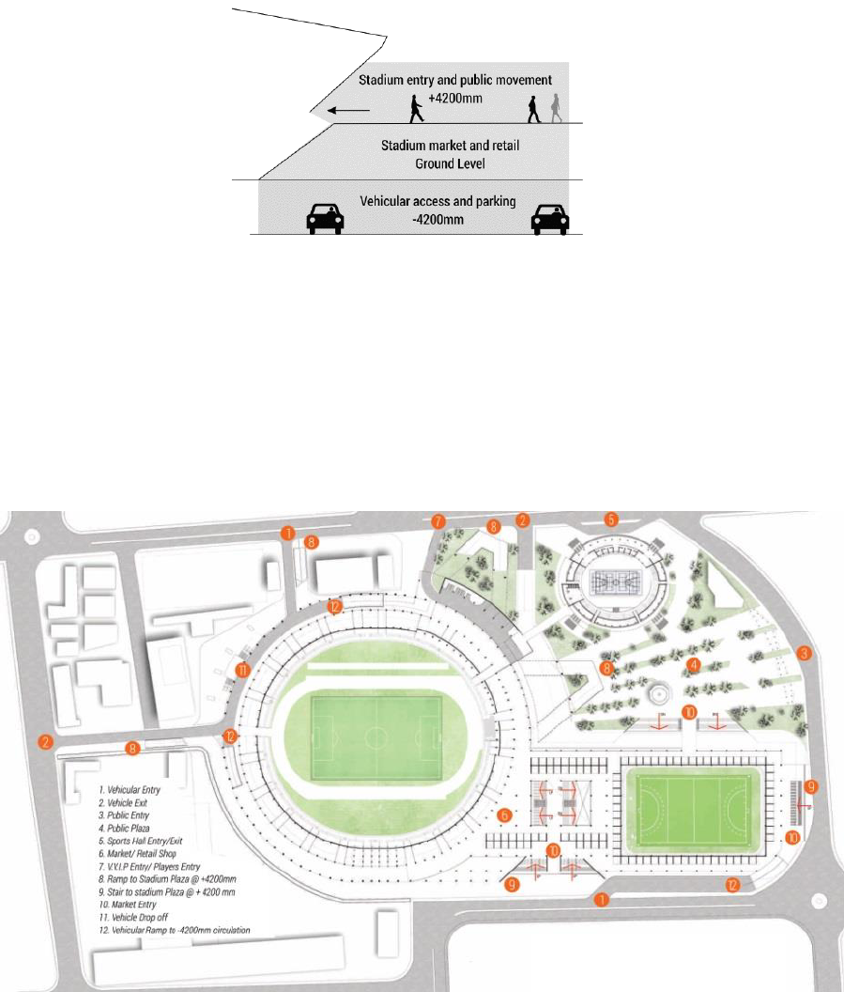

**Figure: Proposed Metro plan**

**Innovative idea to reduce traffic congestion with smart city technology:**

**1. Adaptive traffic signals:**

Traffic signals are getting smarter through V2I technology. By getting a better idea of traffic flow and how long a vehicle idles at stop lights, the city can better modify traffic signal timing with the changes in traffic throughout the day.

**2. Autonomous vehicle technology:**

While autonomous vehicles for the passenger car won’t necessarily decrease the number of cars on the road, with fewer accidents and driver-caused traffic, autonomous vehicles are likely to reduce congestion. For example, companies like Lyft and Uber are looking at how autonomous vehicles could make their services a more viable service in conjunction with public transit.

**3. Real-time traffic feedback:**

Real-time traffic feedback makes concepts like “congestion pricing” a little easier to sell to consumers who’re used to using roads for free. Instead of the typical toll for express lanes, this would change the pricing structure based on peak traffic times and for high-occupancy or exempt vehicles, with the goal of discouraging single-passenger drivers to be on the road at peak travel times.

**4. Car sharing and multi-modal solutions:**

Reports are not yet consistent on whether or not car sharing and ride hailing apps actually alleviate congestion. But either way, they provide alternative options. City planners and those in the public transit industry see it as an issue of connectivity making it easy to grab a car through a private company’s app to head to a public transit station.

**5. Tracking pedestrian traffic:**

Addressing traffic congestion is also about understanding pedestrian traffic. In Las Vegas, for example, the city is using V2I technology to not only track how many vehicles go through a given intersection at different times but how many pedestrians are crossing streets and even jay walking so the city can reroute vehicle traffic at times of high pedestrian traffic, and so on. The city can also get alerts when a pedestrian is in a roadway when the light is about to change so they can delay the light if needed, increasing the safety of the streets as well. So we can used or follow this idea to remove congestion from gulisthan to sadarghat route.

**6. 3D Zebra Crossing:**

From a distance, they look like solid obstacles on the road, but closer inspection reveals them to be mere optical illusions of three-dimensional paintings. The newly-painted 3D zebra crossings are the latest road safety initiative taken by Barisal City Corporation, the first of its kind in Bangladesh. So we can use 3D zebra crossing in Gulistan to Sadarghat route.

**Recommendations:**

Making Gulistan to Sadarghat route congestion free and reducing all the problems of this route. There are lots of solutions. We need to work on the basis of long term plan and at the same time take care of short term solution to remove current discomforts or problems. It needs a balance both of this solution. In the following we are showing some short term strategies that can be taken care of:i. Increasing pedestrian facilities,

ii. Controlling road side activities,

ii. Training of traffic polices.

iv. Modern signaling system,

v. Speed wise dedicated road for vehicles, vii. High Parking charge,

vii. Discourage private cars,

viii. Time rescheduling, ix. TIA (Traffic Impact Assessment) before plan pass of any construction,

x. Increase the number of public vehicle,

Similarly we can work on some midterm strategies, which can be taken care of within 5 to 10 years, are given below: i. BRT (Bus Rapid Transit), ii. Central authority to control traffic of Dhaka City, iii. Construction of roads through East-West, iv. Adequate parking facilities,v. Connecting the missing links of important roads.For long term solution we have to think of implementing -

1) Environment sustainable transport,

2) MRT (Mass Rapid Transit), and 3) Grade separated road network.

We hope that by implementing these plans through proper care, definitely we can ensure that will reducing the problems of Gulistan to Sadarghat route. We have endeavored to raise the issues related with this extremely complicated problem. We have endeavored to mention the vital and decisive points, without the consideration of which such a complicated problem can not be solved.And government should do more things to solve the problem of this route, first of all we should clear the shop from footpaths for street people, private car should be limited, widened road for the avoid traffic jam, traffic signals should be strictly follow by the all kind of drivers. Banned the vehicles which have no license. Traffic police should be placed most important point of this route etc.

**References**

1.https://www.nibusinessinfo.co.uk/content/advantages-innovation

2.Shuichi, M., & Hironao, K. (2003). A Study on the Traffic Impacts in City Traffic Consideration of the Value of Time about Streetcar.

3.Journal of Nippon Kikai Gakkai Kotsu, Butsuryu Bumon Taikai Koen Ronbunshu (Japan), 12, 403-406

4. Statistical Pocket Book. (2008). Bangladesh Bureau of Statistics. Ullah, A. H. J. (2001).

5.Dhaka’s hopeless traffic jams stop everything but the clock! The Dhaka Diary.YI, Z. (1991). Family dynamics in China: a life table analysis. Wisconsin: The University of Wisconsin Press.