ExxonMobil or Chevron When the War Premium Fades
Investor / Analyst Report · Energy: U.S. Integrated Oil
Data and analysis current through October 13, 2026
Abstract—Brent crude trades near $105 because of the Iran conflict and disruption around the Strait of Hormuz, and ExxonMobil (XOM) and Chevron (CVX) shares are both up roughly 30 to 40 percent in 2026. The U.S. Energy Information Administration (EIA) expects most of that premium to fade by late 2027. This report asks which major is the better holding for an investor who wants integrated oil exposure without betting on the war lasting. Using a normalized cash flow model built on 2025 results and each company's disclosed oil price sensitivity, the two stocks offer the same free cash flow (FCF) yield of about 4.9% at the EIA's late 2027 price of $74. Exxon loses less on the way down: its FCF falls 32% moving from the war case to the peace case versus 47% for Chevron, and it still covers its dividend at $60. We prefer XOM over CVX. The call flips if Chevron's third quarter results show its Tengiz and Hess cash flows pulling its breakeven down toward management's sub-$50 claim.
1 THE QUESTION AND THE RECOMMENDATION
Investment question. For an investor adding a position in a U.S. integrated oil major today, is ExxonMobil or Chevron the better risk-adjusted choice, given that current oil prices carry a war premium that most forecasters expect to shrink?
Recommendation: prefer ExxonMobil over Chevron. This is a relative call, not a claim that either stock is cheap. At peace-case oil prices, each company's FCF yield sits only about 1.5 to 2.5 points above its dividend yield, so neither leaves much room for the buybacks investors have come to expect. Three findings drive the preference. First, once cash flows are normalized, Chevron is not actually cheaper: both stocks yield about 4.9% at $74 Brent. Second, Chevron is more exposed to falling oil. Each $1 move in Brent changes about 0.14% of Chevron's market value in annual cash flow versus 0.10% for Exxon. Third, Exxon carries a built-in hedge against peace. Roughly 20% of its 2025 production came from Qatar and the UAE, and about 10% of its upstream output was offline in the second quarter [4][5]. If the conflict ends, oil falls but those barrels come back.
2 WHY THIS QUESTION, WHY NOW
Brent closed at $71.32 on February 27, 2026, the last trading day before the conflict began, and passed $100 by mid-March [20]. It averaged about $104 in the second quarter [14] and $114 in September, and traded near $105 on October 13 [13][21]. The EIA's October outlook forecasts Brent at $105 in the fourth quarter of 2026, $84 on average in 2027, and $74 by the fourth quarter of 2027. That path assumes about 4.5 million barrels per day of Middle East output stays shut in for now, with most of it returning by mid-2027 [13]. The EIA's own baseline, in other words, is that today's price is temporary.
Equity investors have priced the windfall aggressively. By late July, Chevron was up 29% for the year and Exxon about two points ahead of it [19]. With both companies reporting third quarter results at the end of October, the question for a new buyer is less about which company is better run and more about which one still earns its share price when $105 oil becomes $74 oil.
3 THE TWO COMPANIES
Table 1 sets out the inputs used throughout. Market values use the diluted share counts implied by each company's second quarter earnings per share. Exxon is the larger, more diversified business, with bigger refining and chemicals operations. Chevron completed its $53 billion acquisition of Hess on July 18, 2025, gaining a 30% stake in Guyana's Stabroek block [18]. Because Hess was only in Chevron's numbers for about five months of 2025, Chevron's 2025 cash flow understates its current scale; Section 4 adjusts for that.
The exposures differ sharply. Exxon's Qatar LNG and UAE assets were disrupted from March, and the company attributed about $1.3 billion of second quarter upstream earnings losses to Middle East volumes [4][5]. Chevron's direct regional exposure is the Saudi Arabia and Kuwait Partitioned Zone, about 1% of second quarter output, plus its Leviathan gas field off Israel, which was shut for 33 days and restarted on April 2 [8][17].
Table 1—Key inputs. Sources in brackets. Cash flow (CFO) is operating cash flow excluding working capital.
Item | XOM | CVX
Share price, Oct 13, 2026 [16] | $173.24 | $217.73
Diluted shares (from Q2 EPS) [1][6] | 4.17B | 1.98B
Market value | $722B | $431B
Annual dividend at current rate [1][8] | $17.2B | $14.1B
Dividend yield | 2.4% | 3.3%
2025 CFO [2][7] | $59.7B | $33.9B
2026 capex guidance [2][9] | $27–29B | $18–19B
Buyback plan / pace [2][11] | $20B | $10–20B / ~$11B
Mgmt. sensitivity per $1 Brent [3][9] | ~$0.70B | ~$0.60B
Middle East share of output [4][17] | ~20% | ~1%

4 METHOD: NORMALIZING CASH FLOW
4.1 Why not just annualize the latest quarter
The obvious shortcut is to multiply second quarter cash flow by four. That gives $102.6 billion for Exxon and $78.8 billion for Chevron. We tested whether oil prices alone explain those figures. Q2 Brent averaged about $103.50 versus $69.10 in 2025 [14][15]. Backing out that $34.40 difference with each company's own sensitivity still leaves $78.5 billion for Exxon and $58.2 billion for Chevron at 2025 oil prices, compared with actual 2025 cash flow of $59.7 billion and $33.9 billion. Roughly $19 billion (Exxon) and $24 billion (Chevron) of the run rate is unexplained by crude. Part of it is real growth, chiefly Hess for Chevron. Much of it is the war itself: Exxon reported record refining margins in the quarter [5], and those margins should normalize along with crude. Annualizing Q2 would treat a wartime quarter as the new normal, so we reject it as a base case.
4.2 The model
We start from 2025 operating cash flow, a year with no war premium (Brent $69.10), and move it to each scenario price using the company's disclosed sensitivity: about $0.70 billion per $1 for Exxon [3] and $0.60 billion for Chevron [9]. Cash flow at price P is the 2025 base plus sensitivity times (P minus $69.10). For Chevron we add the missing part of Hess. Hess reported $6.35 billion of 2024 cash flow before working capital at roughly $80 Brent [12]. Adjusting that to $69 with an assumed $0.10 billion per $1 (our assumption, not a sourced figure; zero or double would move the adjustment by about $0.6 billion and Chevron's breakevens by about $1) and taking the 55% of 2025 that preceded the deal gives +$2.9 billion, for a Chevron base of $36.8 billion. Free cash flow subtracts the capex guidance midpoint for Exxon ($28 billion) and $18.5 billion for Chevron, which guided to the low end of its range [9]. Exxon plans $20 billion of buybacks, 2.8% of its market value. To compare like with like, we test Chevron at the same 2.8%, about $12 billion, which sits inside its $10 to $20 billion range and slightly above its first half pace of $5.5 billion [11].
We run four Brent scenarios: a post-war glut at $60, the EIA's late 2027 price of $74, its 2027 average of $84, and the current $105 if the war persists. We treat $74 as one input, not a prediction. The EIA raised its fourth quarter 2026 forecast by $14 in a single month [13], so its forecasts are moving quickly, and the $60 and $84 cases bracket it on both sides. In the war case only, Exxon's cash flow is reduced by $5.2 billion a year (four times the Q2 loss) because its Middle East volumes stay offline. The 2025 base already includes those volumes, so the peace cases assume they return.
Assumptions to keep in view. Both companies' sensitivities are management estimates. Exxon's is an upstream figure, and we treat it as a cash flow figure. The model gives neither company credit for growth after 2025 other than Hess. That understates both, and it understates Chevron more, because its Tengiz expansion ramped up during 2025.
5 RESULTS
Table 2—Annual free cash flow and cash left after dividends, before buybacks. Author's model.
Scenario | XOM FCF | XOM after div. | CVX FCF | CVX after div.
Glut, $60 | $25.3B | $8.1B | $12.8B | $-1.3B
Peace, $74 | $35.1B | $17.9B | $21.2B | $7.1B
EIA 2027, $84 | $42.1B | $24.9B | $27.2B | $13.1B
War, $105 | $51.6B | $34.4B | $39.8B | $25.7B

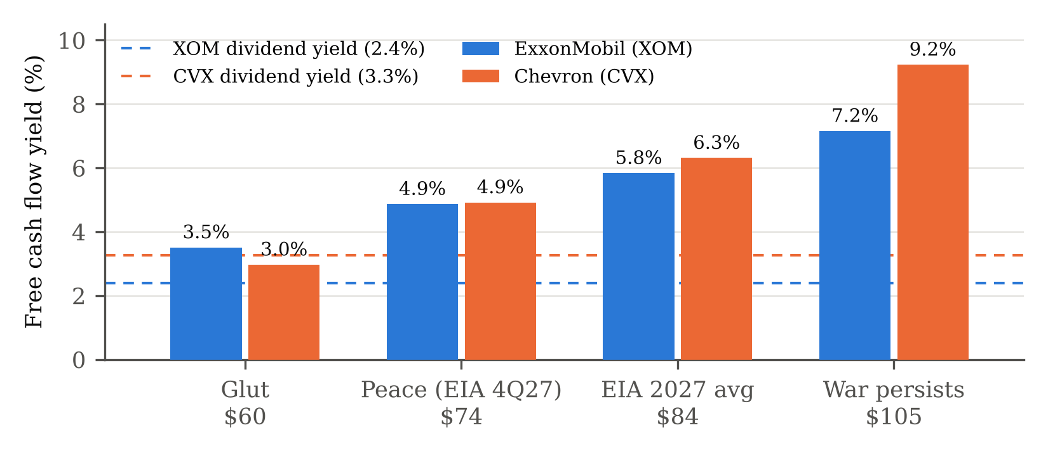
Figure 1—Free cash flow yield (FCF divided by market value) under four Brent scenarios, with each stock's dividend yield. Author's model; inputs from Table 1.
Figure 1 and Table 2 show the core trade-off. At $74 the two stocks are tied on FCF yield at about 4.9%, so Chevron's apparent cheapness on headline numbers disappears once cash flows are normalized. Moving from the war case to the peace case, Exxon's free cash flow falls from $51.6 billion to $35.1 billion (down 32%), while Chevron's falls from $39.8 billion to $21.2 billion (down 47%). In a $60 glut, Exxon's $25.3 billion of FCF still covers its $17.2 billion dividend, while Chevron's $12.8 billion falls $1.3 billion short of its $14.1 billion dividend. Chevron is clearly the better stock only if the war persists, where its yield reaches 9.2% against Exxon's 7.2%.
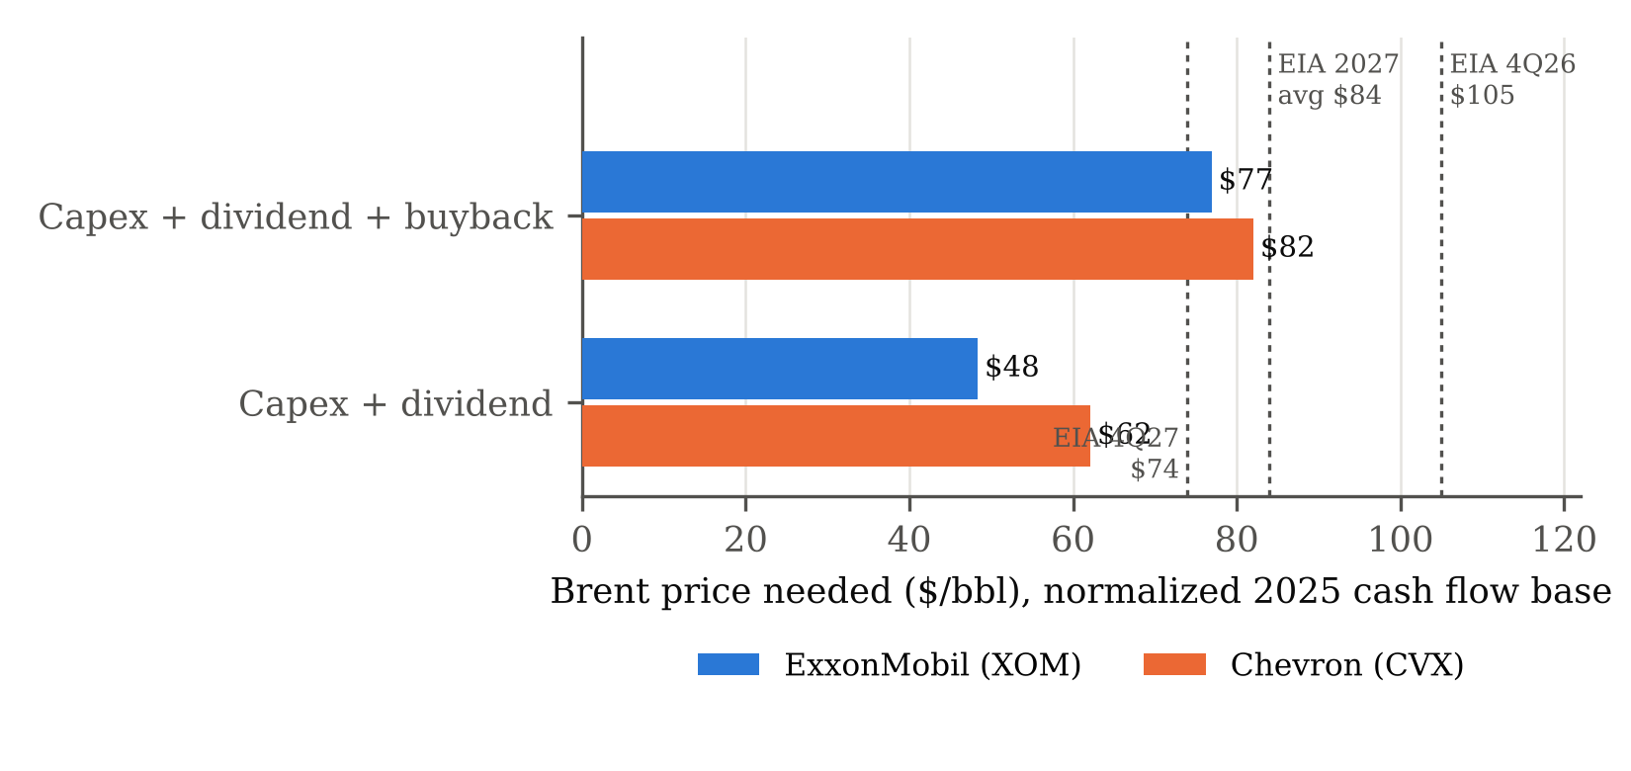
Figure 2—Brent price at which normalized cash flow covers capex and the dividend, and capex, dividend and buyback, against EIA forecast prices [13]. Author's model.
Figure 2 restates the same results as breakevens. Exxon covers capex and its dividend at about $48 Brent and its full $20 billion buyback at about $77. Chevron needs about $62 for capex and dividend, and $82 to add a buyback of the same 2.8% size. Both full payout programs need more than the EIA's $74 late 2027 price, so investors should expect buybacks to shrink or be funded from the balance sheet. Exxon has done the latter before: in 2025 it distributed $37.2 billion against $26.1 billion of free cash flow [2]. Chevron's management targets a capex-plus-dividend breakeven below $50 [10]. Our estimate is about $12 higher. Either our model misses real growth at Tengiz and in Guyana, or management's target is optimistic. That gap is the single biggest uncertainty in this report.
6 ALTERNATIVES CONSIDERED
The case for Chevron. Chevron offers a higher dividend yield (3.3% versus 2.4%), traded at a slightly lower forward earnings multiple in July (13.6 times versus 14.3 times [19]), has more upside if the conflict drags on, and has growth our model deliberately leaves out. An investor who expects $100 oil through 2027 should prefer Chevron. We do not, because the EIA forecast and Chevron's own planning range ($60 to $80 for Chevron's buyback guidance [10]) all point lower.
Owning neither. Both stocks have rallied on a windfall the EIA calls temporary, and a peace-case FCF yield near 5% is not a margin of safety. An investor with no mandate to hold energy could reasonably wait for a lower entry point. Our recommendation is aimed at the investor who wants the exposure and has to choose between the two.
The optimistic base. If Q2 2026 cash flow were the right base, both stocks would yield 8% to 10% even at $74, and both would look cheap. We rejected this in Section 4.1 because it treats wartime refining and gas margins as permanent.
7 RISKS AND WHAT WOULD CHANGE THE CALL
Exxon's hedge may not pay out. Two Qatar LNG trains were damaged and Exxon has not given a restart date [4]. If those volumes stay offline in the peace case, scaling the Q2 loss to $74 oil cuts about $3.7 billion from Exxon's FCF. Its yield at $74 then falls to roughly 4.4%, below Chevron's 4.9%, and most of the preference disappears.
Chevron's growth may be bigger than modeled. If Chevron's third quarter cash flow, adjusted for Brent, implies a normalized base well above our $36.8 billion, its breakeven moves toward management's target and Chevron becomes the better value. This is the first thing we would check after the late October reports.
Oil can overshoot downward. Once the 4.5 million barrels per day of shut-in output returns, a glut below $60 is plausible. That would favor Exxon on dividend coverage but would hurt both stocks in absolute terms. Chevron's Tengiz output also depends on the CPC pipeline through the Black Sea, which has been intermittently disrupted [17].
Model risk. The 2025 cash flow figures, the Hess adjustment and the sensitivities are the inputs the conclusion depends on most. A $1 billion error in a company's base moves its breakevens by about $1.4 (Exxon) to $1.7 (Chevron) a barrel.
8 CONCLUSION
At today's prices the market is valuing both majors partly on wartime cash flows. Once those cash flows are normalized, Chevron's apparent discount disappears, and Exxon has two advantages that matter if the EIA's forecast is right: less sensitivity to falling oil and production that comes back when the conflict ends. We prefer ExxonMobil, with a clear trigger to revisit: Chevron's third quarter results. We would not recommend either stock to an investor who does not need energy exposure until the price of entry reflects peace-case cash flows.

REFERENCES
[1] ExxonMobil Holdings Corp. (2026, July 31). ExxonMobil announces second-quarter 2026 results [Form 8-K, Ex. 99.1]. https://www.sec.gov/Archives/edgar/data/0002115436/000211543626000006/livef8k2q26991.htm
[2] ExxonMobil. (2026, January 30). ExxonMobil announces 2025 results. https://corporate.exxonmobil.com/news/news-releases/2026/0130-exxonmobil-announces-2025-results
[3] ExxonMobil. (2026). 2Q 2026 sensitivities and key assumptions. https://d1io3yog0oux5.cloudfront.net/_9c0226c1dc3efd2dbe7760ece1f33886/exxonmobil/db/2431/22314/file/Sensitivities+and+Key+Assumptions.pdf
[4] Exxon Mobil Corp. (2026, April 8). Form 8-K, first-quarter 2026 earnings considerations. https://www.sec.gov/Archives/edgar/data/34088/000003408826000056/f8k1q992040826.htm
[5] Investing.com. (2026, July 31). ExxonMobil Q2 2026 slides: record margins offset Middle East disruption. https://www.investing.com/news/company-news/exxonmobil-q2-2026-slides-record-margins-offset-middle-east-disruption-93CH-4828827
[6] Chevron Corp. (2026, July 31). Chevron reports second quarter 2026 results [Form 8-K, Ex. 99.1]. https://www.sec.gov/Archives/edgar/data/0000093410/000009341026000162/a06302026ex9918-k.htm
[7] Chevron Corp. (2026, January). Chevron reports fourth quarter 2025 results [Form 8-K, Ex. 99.1]. https://www.sec.gov/Archives/edgar/data/93410/000009341026000019/a12312025ex9918-k.htm
[8] Chevron Corp. (2026). Form 10-Q for the quarter ended June 30, 2026. https://www.sec.gov/Archives/edgar/data/0000093410/000009341026000167/cvx-20260630.htm
[9] Chevron Corp. (2026). Form 10-Q for the quarter ended March 31, 2026. https://www.sec.gov/Archives/edgar/data/0000093410/000009341026000113/cvx-20260331.htm
[10] Chevron Corp. (2025, November 12). 2025 Investor Day, edited transcript. https://chevroncorp.gcs-web.com/static-files/f8964224-9b9a-4be6-8644-9f96bd1e1fe4
[11] Chevron Corp. (2026, August 7). Chevron 2026 investor presentation. https://chevroncorp.gcs-web.com/static-files/6fe32bf1-951a-44c8-81ee-74cd626c0095
[12] Hess Corp. (2025). Form 10-K for fiscal year 2024. https://www.sec.gov/Archives/edgar/data/4447/000162828025008716/hes-20241231.htm
[13] U.S. Energy Information Administration. (2026, October 6). Short-Term Energy Outlook, October 2026. https://www.eia.gov/outlooks/steo/archives/oct26.pdf
[14] APA. (2026). World Bank releases average oil price data for Brent and WTI. https://en.apa.az/energy-and-industry/world-bank-releases-average-oil-price-data-for-brent-and-wti-519072
[15] Statista. (2026). Brent crude oil price annually 1976–2025. https://www.statista.com/statistics/262860/weekly-crude-oil-prices
[16] Morningstar. (2026, October 13). XOM and CVX stock quotes. https://www.morningstar.com/stocks/xnys/xom/quote ; https://www.morningstar.com/stocks/xnys/cvx/quote
[17] The Motley Fool. (2026, August 3). Chevron (CVX) Q2 2026 earnings call transcript. https://www.fool.com/earnings/call-transcripts/2026/08/03/chevron-cvx-q2-2026-earnings-call-transcript/
[18] World Oil. (2025, July 18). Chevron completes $53 billion Hess takeover following lengthy Exxon arbitration. https://worldoil.com/news/2025/7/18/chevron-completes-53-billion-hess-takeover-following-lengthy-exxon-arbitration/
[19] 24/7 Wall St. (2026, July 23). At $100 per barrel, which oil stock has dominated in 2026; The Motley Fool. (2026, July 30). These 3 oil stocks surged in the first half of 2026. https://247wallst.com/investing/2026/07/23/at-100-per-barrel-which-oil-stock-has-dominated-in-2026-exxonmobil-chevron-or-bp/
[20] Politis. (2026). Tracking oil prices since the beginning of the war 100 days ago. https://en.politis.com.cy/news/world/1011001/tracking-oil-prices-since-the-beginning-of-the-war-100-days-ago
[21] Trading Economics. (2026, October 13). Brent crude oil. https://tradingeconomics.com/commodity/brent-crude-oil

