Genomic Selection

Jinliang Yang

04-24-2025

## Path Normalization

# A real world example: Loblolly pine data

In this example, we will use the breeding values of crown width across the planting beds at age 6 (CWAC6).

# read phenotype and SNP files  
pheno_file <- "https://jyanglab.com/img/data/DATA_nassau_age6_CWAC.csv"  
geno_file <- "https://jyanglab.com/img/data/Snp_Data.csv"  
  
pheno <- read.csv(pheno_file, header=TRUE, stringsAsFactors = FALSE)  
hist(pheno$Derregressed_BV, main="Crown width at Age 6", xlab="width")

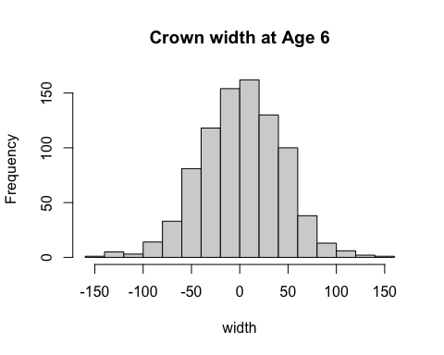

# geno[1:10, 1:10]

# Loblolly pine data

### Remove missing phenotypes

There are some accessions containing no phenotype. We need to remove these accessions first.

na.index <- which(is.na(pheno$Derregressed_BV))  
# length(na.index)  
pheno <- pheno[-na.index, ]  
  
# phenotypes   
y <- pheno$Derregressed_BV  
y <- matrix(y, ncol=1)

# Genotype data: SNP quality control

In the geno matrix, row indicates individual, column indicates SNPs.

### Missingness and MAF

geno <- read.csv(geno_file, header=TRUE, stringsAsFactors = FALSE)  
dim(geno)

## [1] 926 4854

# Keep genotypes for these remaining lines  
geno <- geno[geno$Genotype %in% pheno$Genotype, ]  
# markers   
geno <- geno[,-1] # 861 x 4853  
geno[geno == -9] <- NA  
  
# missing rate  
missing <- apply(geno, 2, function(x){sum(is.na(x))/length(x)})  
# minor allele frequency  
maf <- apply(geno, 2, function(x){  
 frq <- mean(x, na.rm=TRUE)/2 # 1 allele  
 return(ifelse(frq > 0.5, 1-frq, frq))  
})

# Genotype data: SNP quality control

In the geno matrix, row indicates individual, column indicates SNPs.

#### Plot the results

hist(missing, breaks=100, col="blue", xlab="SNP Missing rate")

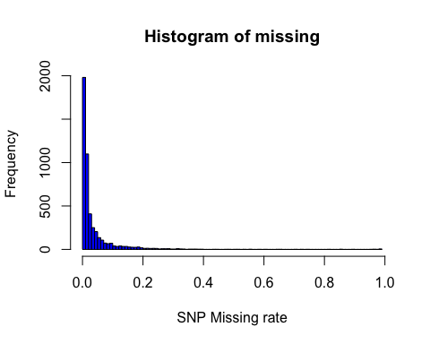

hist(maf, breaks=100, col="blue", xlab="Minor Allele Freq")

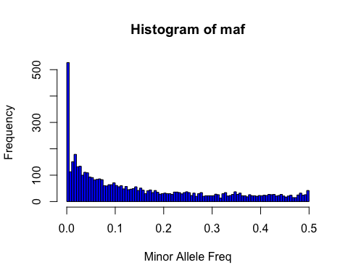

Removing SNPs with high missing rate (missingness > 0.2) and low MAF (MAF < 0.05)

* Question: How many markers are removed?

idx1 <- which(missing > 0.2) #154  
idx2 <- which(maf < 0.05) #1647  
idx <- unique(c(idx1, idx2)) #1784  
  
geno2 <- geno[, -idx]  
dim(geno2)

## [1] 861 3069

### Missing marker imputation

Replace missing marker genotypes with **mean values**. Then store the marker genotypes in a matrix object Z.

Z <- matrix(0, ncol=ncol(geno2), nrow=nrow(geno2))  
for (j in 1:ncol(geno2)){  
 #cat("j = ", j, '\n')  
 Z[,j] <- ifelse(is.na(geno2[,j]), mean(geno2[,j], na.rm=TRUE), geno2[,j])  
}  
# sum(is.na(Z))  
write.table(Z, "data/Z.txt", sep="\t", row.names = FALSE,   
 col.names=FALSE, quote=FALSE)

# Genomic relationship

### SNP Matrix standardization

Standardize the genotype matrix to have a mean of zero and variance of one. Save this matrix as Zs.

Zs <- scale(Z, center = TRUE, scale = TRUE)  
# dimensions   
n <- nrow(Zs)  
m <- ncol(Zs)

### Calcualte genomic relationship

* Compute the second genomic relationship matrix of [VanRaden (2008)](https://www.ncbi.nlm.nih.gov/pubmed/18946147) using the entire markers.
* Then add a very small positive constant (e.g., 0.001) to the diagonal elements so that G matrix is invertible. A singular matrix cannot be inverted, which poses computational challenges.

# Given matrices x and y as arguments, return a matrix cross-product.   
# This is formally equivalent to (but usually slightly faster than)   
# the call t(x) %*% y (crossprod) or x %*% t(y) (tcrossprod).  
G <- tcrossprod(Zs) / ncol(Zs)  
# G <- Zs %*% t(Zs) /ncol(Zs)  
G <- G + diag(n)*0.001

* tcrossprod(Zs) computes the matrix product of Zs and its transpose, yielding an n x n matrix where n is the number of individuals.
* Dividing by the number of markers (ncol(Zs)) standardizes the matrix.

# Solve MME for GBLUP

Set up mixed model equations (MME) by fitting the model:

$$y=1μ+Zu+e$$

* where $μ$ is the intercept,
* $Z$ is the incident matrix of individuals,
* $u$ is the breeding value of the individuals,
* and $e$ is the residual.

Directly take the inverse of LHS to obtain the solutions for GBLUP. Report the estimates of intercept and additive genetic values. Use $λ=1.35$.

lambda <- 1.35 # fit$Ve / fit$Vg  
Ginv <- solve(G)  
ones <- matrix(1, ncol=1, nrow=n)  
Z <- diag(n)  
# Given matrices x and y as arguments, return a matrix cross-product.   
#This is formally equivalent to (but usually slightly faster than)   
#the call t(x) %*% y (crossprod) or x %*% t(y) (tcrossprod).  
LHS1 <- cbind(crossprod(ones), crossprod(ones, Z))   
LHS2 <- cbind(crossprod(Z, ones), crossprod(Z) + Ginv*lambda)  
LHS <- rbind(LHS1, LHS2)  
RHS <- rbind( crossprod(ones, y), crossprod(Z,y) )  
sol <- solve(LHS, RHS)  
head(sol)

## [,1]  
## [1,] 2.275528  
## [2,] 12.915583  
## [3,] -15.949010  
## [4,] 18.411816  
## [5,] 4.649033  
## [6,] -23.828528

tail(sol)

## [,1]  
## [857,] -3.877303  
## [858,] 5.900186  
## [859,] 7.631312  
## [860,] -49.125424  
## [861,] -8.490103  
## [862,] -37.223103

# R package: rrBLUP

Fit GBLUP by using the mixed.solve function in the [rrBLUP](https://cran.r-project.org/web/packages/rrBLUP/index.html) R package.

* Report the estimates of intercept and additive genetic values.
* Do they agree with previous estimates?
* Also, report the estimated genomic heritability and the ratio of variance components $λ=\frac{V_{e}}{V_{A}}$.

#install.packages("rrBLUP")  
library(rrBLUP)  
fit <- mixed.solve(y = y, K=G)  
# additive genetic variance  
fit$Vu

## [1] 721.3393

# residual variance  
fit$Ve

## [1] 997.0729

# intercept   
fit$beta

## [1] 2.275528

# additive genetic values  
head(fit$u)

## [1] 12.872001 -16.009856 18.153310 4.307152 -23.873051 16.372003

tail(fit$u)

## [1] -3.964626 6.047412 7.634191 -48.812717 -8.437586 -36.961484

# genomic h2  
fit$Vu / (fit$Vu + fit$Ve)

## [1] 0.4197708

# ratio of variance components   
fit$Ve / fit$Vu

## [1] 1.382252

# plot(x=sol[-1], y=fit$u)

# RR-BLUP

Set up mixed model equations (MME) by fitting the model $y=1b+Zm+e$, where $b$ is the intercept, $Z$ is the standardized marker genotypes (Zs), $m$ is the additive marker genetic effects, and $e$ is the residual.

Directly take the inverse of LHS to obtain the solutions for marker-based GBLUP (RR-BLUP). Report the estimates of intercept and marker additive genetic effects. Use $λ=4326.212$.

–

lambda <- 4326.212 # fit$Ve / fit$Vu  
ones <- matrix(1, ncol=1, nrow=n)  
I <- diag(m)  
LHS1 <- cbind(crossprod(ones), crossprod(ones, Zs))   
LHS2 <- cbind(crossprod(Zs, ones), crossprod(Zs) + I*lambda)  
LHS <- rbind(LHS1, LHS2)  
RHS <- rbind( crossprod(ones, y), crossprod(Zs,y) )  
sol2 <- solve(LHS, RHS)  
head(sol2)

## [,1]  
## [1,] 2.27552828  
## [2,] 0.25984118  
## [3,] -0.03032116  
## [4,] -0.12452689  
## [5,] 0.15758584  
## [6,] -0.13104812

tail(sol2)

## [,1]  
## [3065,] 0.009042828  
## [3066,] 0.065547947  
## [3067,] -0.235825005  
## [3068,] 0.042984822  
## [3069,] 0.102930180  
## [3070,] 0.262549987

# Use rrBLUP package

Fit RR-BLUP by using the mixed.solve function in the [rrBLUP](https://cran.r-project.org/web/packages/rrBLUP/index.html) R package.

* Report the estimates of intercept and marker additive genetic effects.
* o they agree with the estimates with the manual calculation?
* Also, report the ratio of variance components $λ=\frac{V_{e}}{V_{A}}$.

library(rrBLUP)  
fit2 <- mixed.solve(y = y, Z=Zs)  
# marker additive genetic variance  
fit2$Vu

## [1] 0.2350402

# residual variance  
fit2$Ve

## [1] 997.7947

# intercept   
fit2$beta

## [1] 2.275528

# marker additive genetic effects  
head(fit2$u)

## [1] 0.26285584 -0.03075328 -0.12570117 0.16019719 -0.13267752 -0.06454280

tail(fit2$u)

## [1] 0.008232377 0.066259519 -0.237935580 0.042789624 0.103950959  
## [6] 0.264838013

# ratio of variance components   
fit2$Ve / fit2$Vu

## [1] 4245.208

# plot(x=sol2[-1], y=fit2$u)

# K-fold validation

Repeat GBLUP but treat the first 600 individuals as a training set and predict the additive genetic values of the remaining individuals in the testing set. - What is the predictive correlation in the testing set? Use $λ=1.348411$.

n.trn <- 600  
n.tst <- 261  
y.trn <- y[1:n.trn]  
y.tst <- y[n.trn+1:n.tst]  
Zs.trn <- Zs[1:n.trn,]  
Zs.tst <- Zs[n.trn+1:n.tst,]  
  
Gtrn <- tcrossprod(Zs.trn) / ncol(Zs.trn)  
Gtrn <- Gtrn + diag(n.trn)*0.001  
Gtst.trn <- tcrossprod(Zs.tst, Zs.trn) / ncol(Zs.tst)  
#Gtrn <- G[1:n.trn, 1:n.trn]  
#Gtst.trn <- G[n.trn+1:n.tst, 1:n.trn]  
  
lambda <- 1.348411 # fit$Ve / fit$Vu  
Ginv.trn <- solve(Gtrn)  
ones <- matrix(1, ncol=1, nrow=n.trn)  
Z <- diag(n.trn)  
LHS1 <- cbind(crossprod(ones), crossprod(ones, Z))   
LHS2 <- cbind(crossprod(Z, ones), crossprod(Z) + Ginv.trn*lambda)  
LHS <- rbind(LHS1, LHS2)  
RHS <- rbind( crossprod(ones, y.trn), crossprod(Z,y.trn) )  
sol.trn <- solve(LHS, RHS)  
  
# prediction  
y.hat <- Gtst.trn %*% Ginv.trn %*% matrix(sol.trn[c(2:(n.trn+1))])  
cor(y.hat, y[(n.trn+1):n])

## [,1]  
## [1,] 0.4635443

# plot(y.hat, y[(n.trn+1):n])

Repeat RR-BLUP but treat the first 600 individuals as a training set and predict the additive genetic values of the remaining individuals in the testing set. - What is the predictive correlation in the testing set? Use $λ=4326.212$. - Also, compare this predictive correlation to the one from GBLUP.

Zs.trn <- Zs[1:n.trn, ]  
Zs.tst <- Zs[n.trn+1:n.tst, ]  
lambda <- 4326.212 # fit$Ve / fit$Vu  
ones <- matrix(1, ncol=1, nrow=n.trn)  
I <- diag(m)  
LHS1 <- cbind(crossprod(ones), crossprod(ones, Zs.trn))   
LHS2 <- cbind(crossprod(Zs.trn, ones), crossprod(Zs.trn) + I*lambda)  
LHS <- rbind(LHS1, LHS2)  
RHS <- rbind( crossprod(ones, y.trn), crossprod(Zs.trn, y.trn) )  
sol.trn <- solve(LHS, RHS)  
  
# prediction  
y.hat2 <- Zs.tst %*% matrix(sol.trn[-1])  
cor(y.hat2, y[(n.trn+1):n])

## [,1]  
## [1,] 0.4635768

plot(y.hat2, y[(n.trn+1):n])

