Extreme House Hunters Inc  P.O. Box 210  Temple Hills MD 20757 | 1-866-745-2268 (Office)  1-866-745-2268 (Fax)

7505 Leona St District Heights, MD 20747

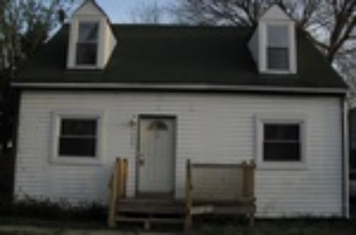
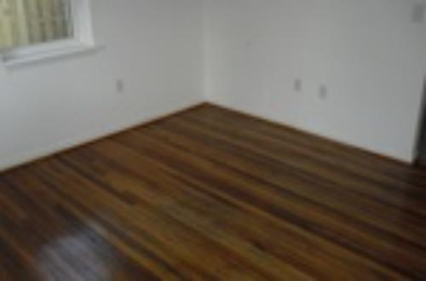

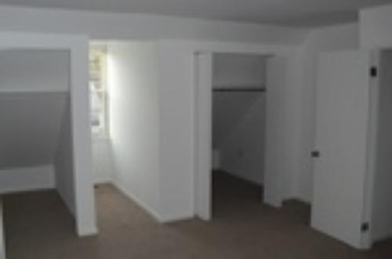
$102,000.00
Property Details
Year Built: | 1947
Square Feet: | 1378
# of Bedrooms: | 4
# of Bathrooms: | 2.0
Lot Dimensions: | 7907
Property Taxes: | $
Property Type: | Single Family
Basement: | No
Garage: | None
Pool: | None



