

L1S21BSSE0119 WAQAR ASGHAR

DRAW A USE CASE DIAGRAM

*Suppose you need to make a software, in which the user purchase products online to fulfill them*

*need or wish. User can confirm their order through email or mobile number. Oder confirmation*

*depends upon product in cart, product price including sales tax and payment methods. Payment*

*can be through cash on delivery, credit Card, Debit Card and PayPal.*

*In this case following are Functional Requirements;*

*1. User can add product to Cart, can update cart and user can checkout to complete the order.*

*2. Oder confirmation depends products in cart, product price, sales tax, and selection of*

*payment method.*

*3. Payment depends upon products price, quantity and sales tax.*

*4. The order confirmation must be followed by the Payment.*

*5. The payment can be done through cash on delivery, credit card, debit card and PayPal.*

*6. User confirm their order through Email or mobile number.*

*7. Explain all use cases associated with actors*

**Explanation:**

The user can add product to cart.

The user can update product in the cart cart. (delete or change the values like color, quantity)

The user can check out.

The user can select a payment option.

The user can pay.

The user can confirm the order.

The bank can view the payment method (not in case of cash on delivery).

The bank verifies the payment method selected by the user.

The system controls the products quantity.

The system provides a secured and reliable platform for online shopping.

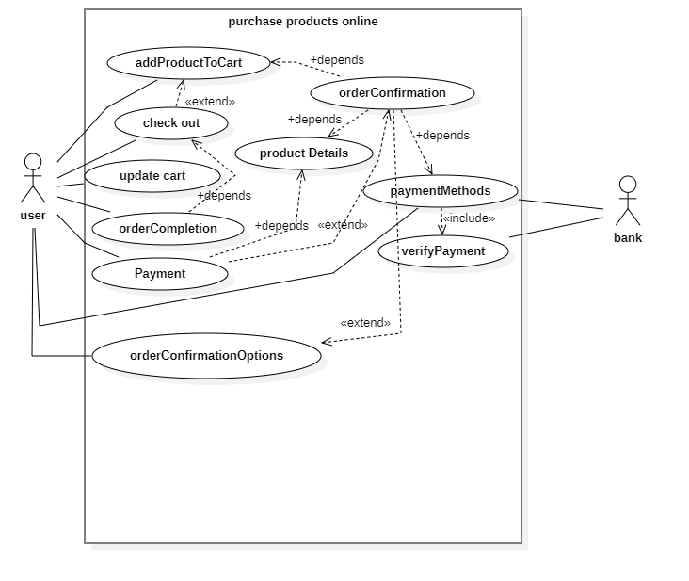

Payment methods includes all possible methods like *cash on delivery, credit card, debit card and PayPal.*

Product details use case includes, *product price, sales tax, quantity and related attributes.*

OrderConfirmation options includes all possible options phone, email e.t.c.