**Lab Manual for Software Construction and Development -SESD3241**

**Lab Manual-05**

**SCD LAB Booklet**



**Faculty of Information Technology**

**UCP Lahore Pakistan**

Contents

Backlogs 2

Representation of in process and To-Do tasks 3

Default Process 3

SPRINTS 4

Sprints Backlog 5

Sprint Member Capacity 6

BackLog Epics 6

Backlog Issues 7

Practice Tasks 7

# Backlogs

The product backlog is your project plan, which shows what your team intends to deliver. It contains user stories, backlog items, or requirements that you add to it. Backlog is a flat list of work items

Your backlog contains a list of features and requirements that you want to build, ordered by priority. By default, each project has a team and a set of backlogs for that team. You can add more backlogs if you need to support more teams. When you create a new team, you also create various team assets that a team admin can customize to suit the team’s workflow.

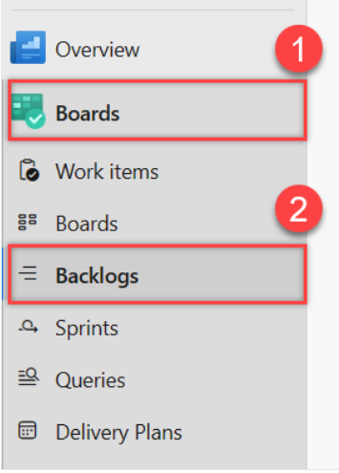

# Representation of in process and To-Do tasks

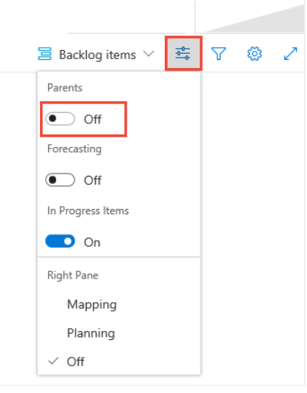

# Default Process

The backlogs defined for each default process are:

* [Agile](https://learn.microsoft.com/en-us/azure/devops/boards/work-items/guidance/agile-process?view=azure-devops): Stories, Features, and Epics
* [Basic](https://learn.microsoft.com/en-us/azure/devops/boards/get-started/plan-track-work?view=azure-devops): Issues and Epics
* [Scrum](https://learn.microsoft.com/en-us/azure/devops/boards/work-items/guidance/scrum-process?view=azure-devops): Backlog items, Features, and Epics
* [CMMI](https://learn.microsoft.com/en-us/azure/devops/boards/work-items/guidance/cmmi-process?view=azure-devops): Requirements, Features, and Epics

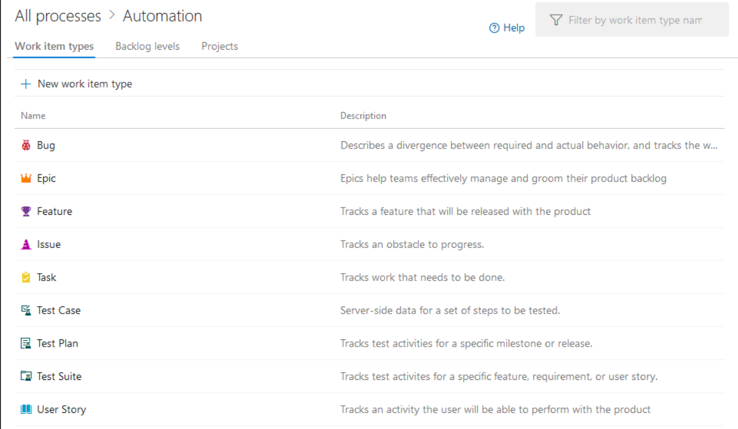

# SPRINTS

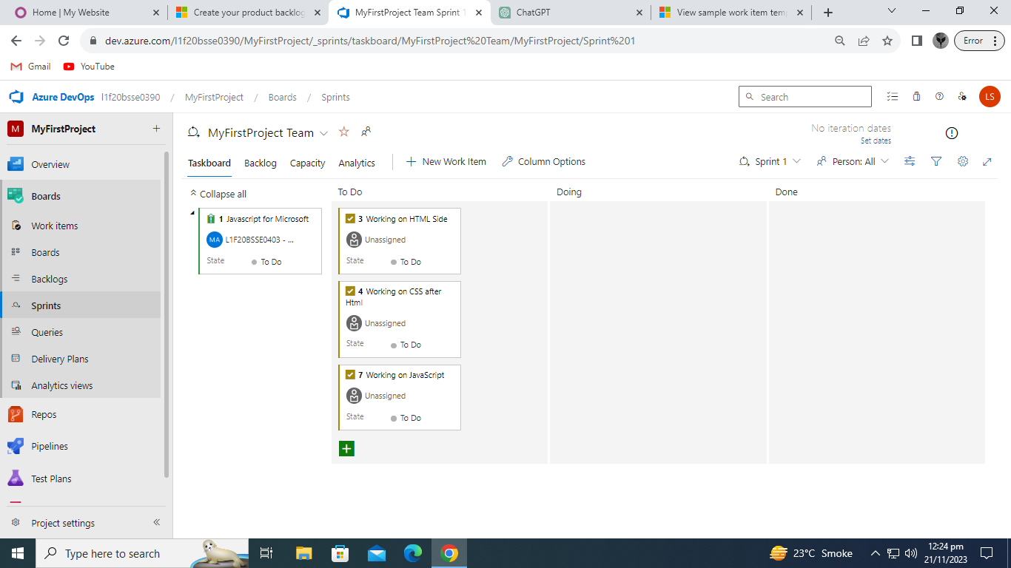

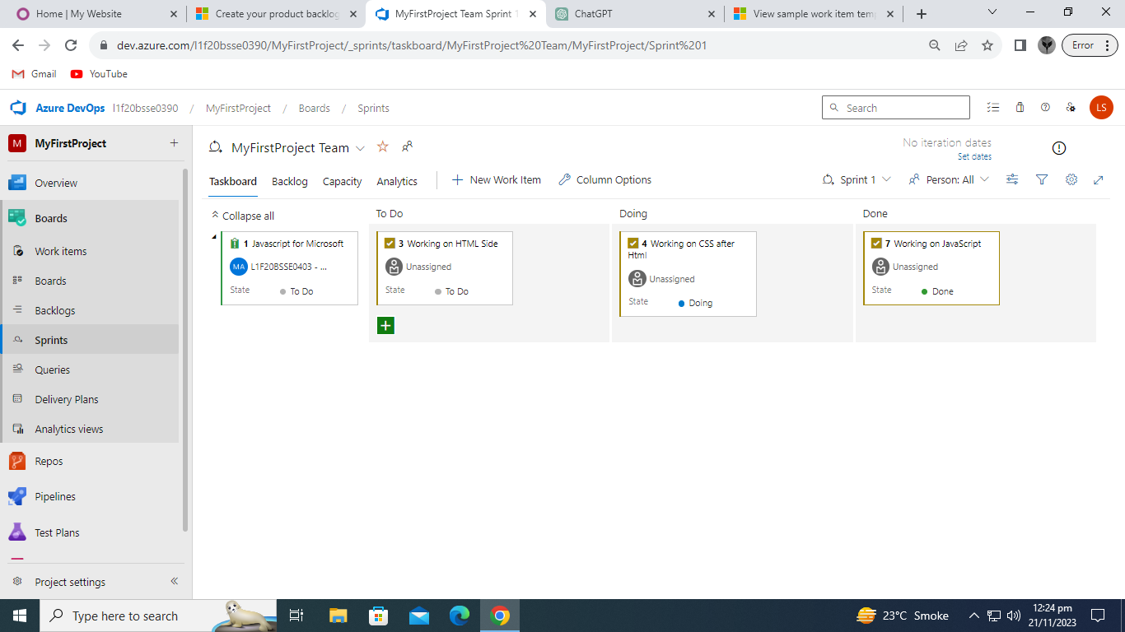

# Sprints Backlog

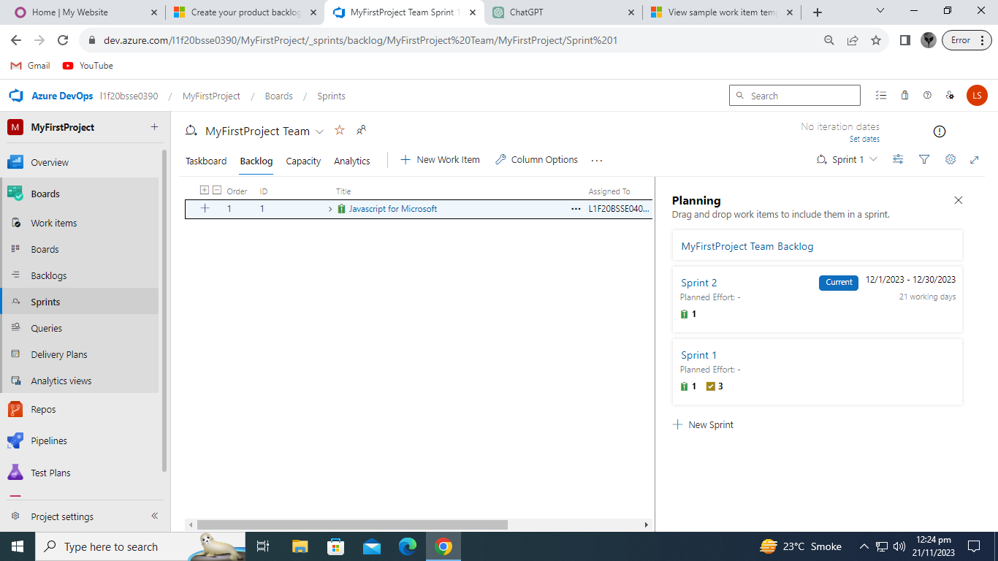

# Sprint Member Capacity

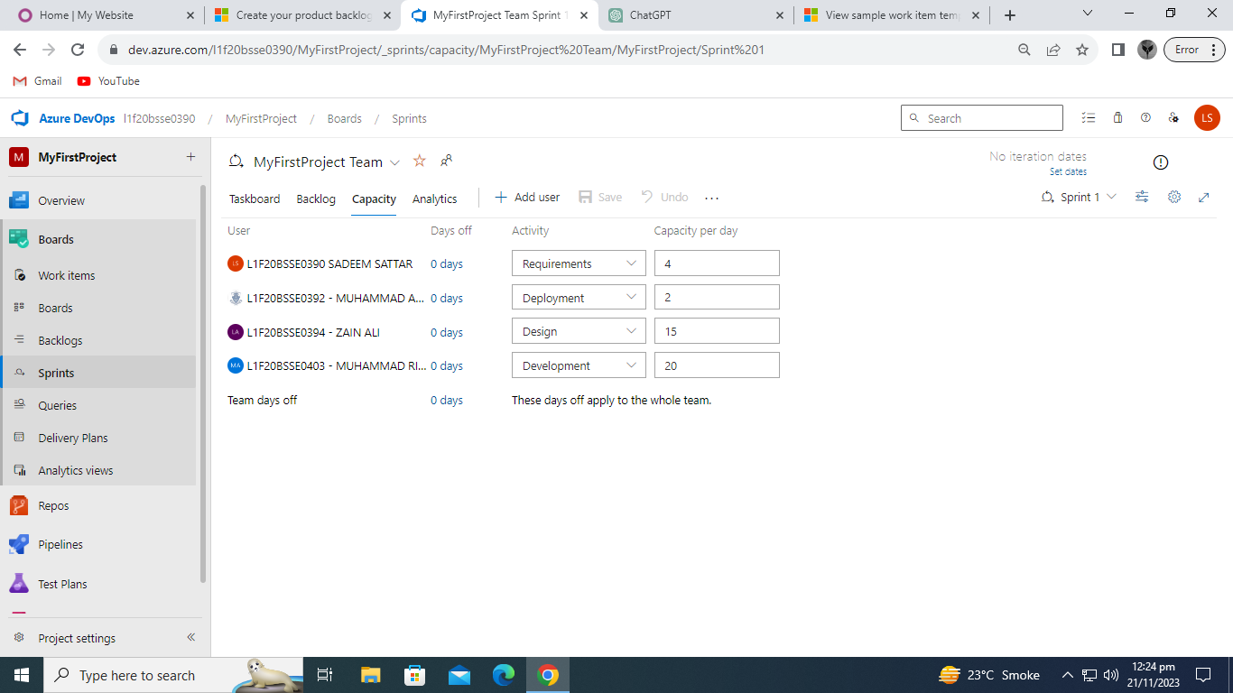

# BackLog Epics

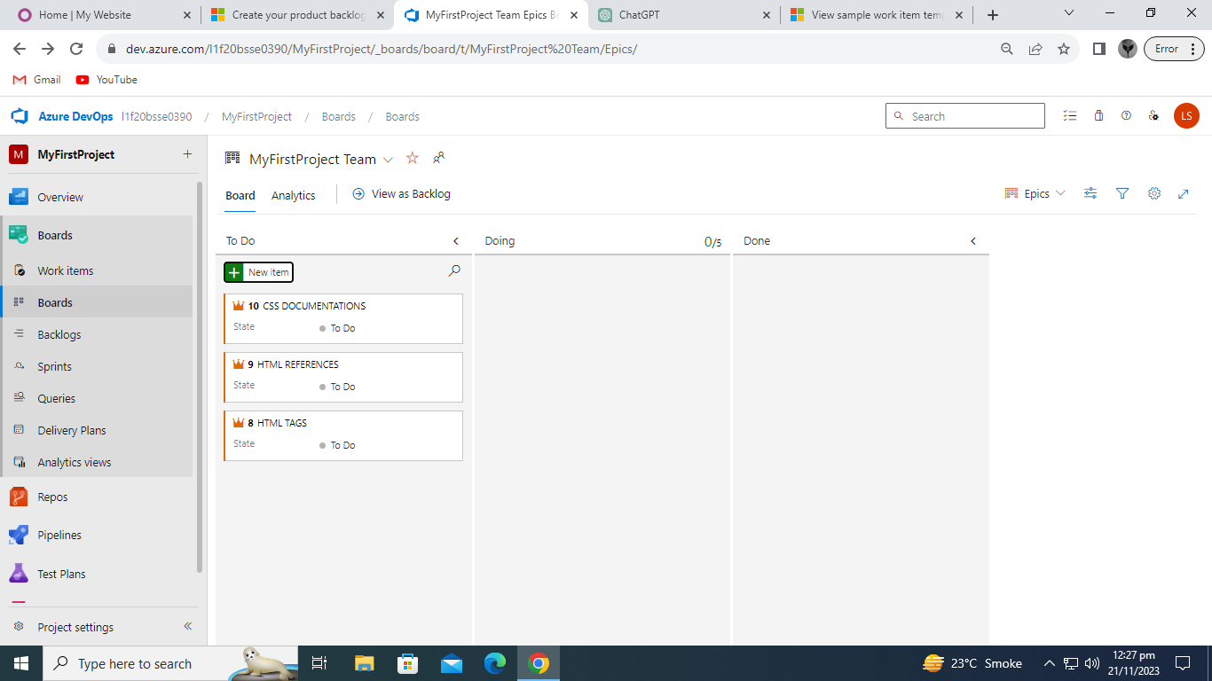

# Backlog Issues

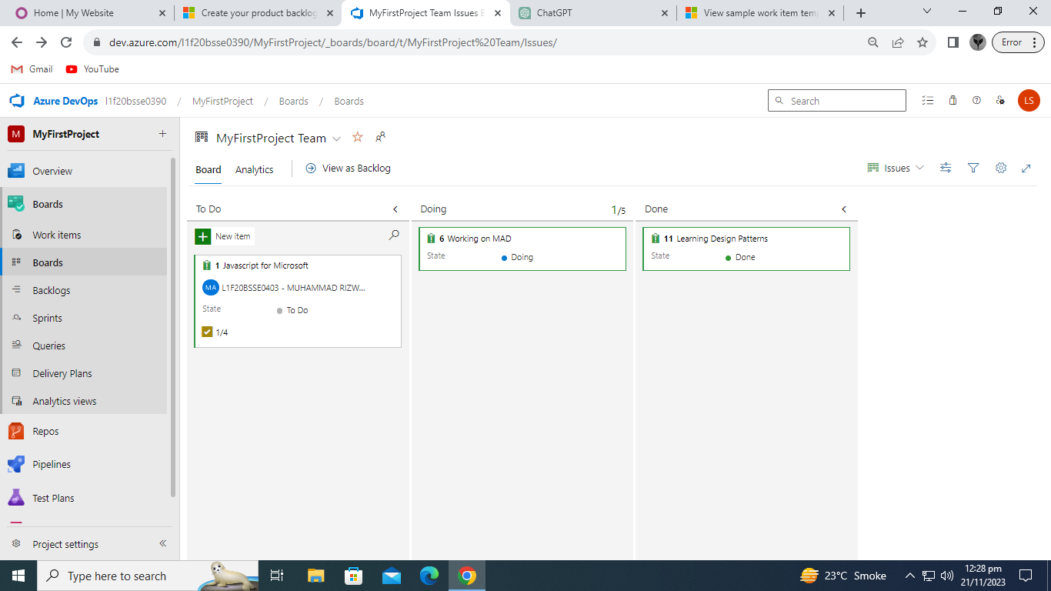

# Practice Tasks

1. You are required to create backlog files
2. You are required to create Epics
3. You are required to create Tasks
4. You are required to create Issues
5. You are required to create Sprints