Question 1:

http://localhost:5000/humor-news
(this will show the message for the required Query parameters)

I have added some default parameters too so this program will show result even on 1 parameter
due to already assigned default parameters

All query parameters:

http://localhost:5000/humor-news?country=in
http://localhost:5000/humor-news?category=general
http://localhost:5000/humor-news?country=general&category=general
http://localhost:5000/humor-news?q=a&country=in

country= #us, in, ar, de, en, es, fr, he, it, nl, no, pt, ru, sv, ud, zh
category= business, entertainment, general, health, science, sports, technology
q= any matching search

saved the result in "updated_news.json"
and also on browser because used jsonify

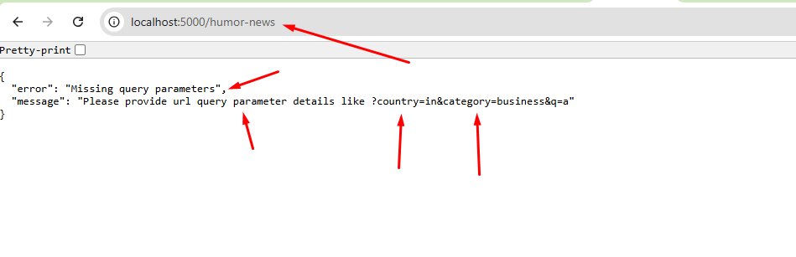

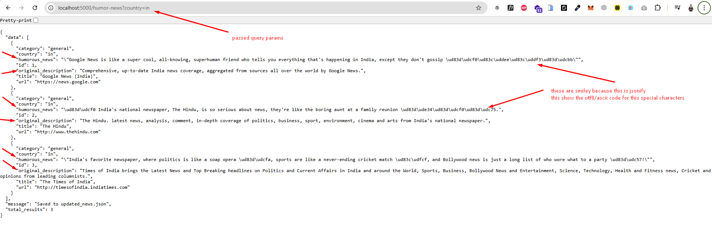

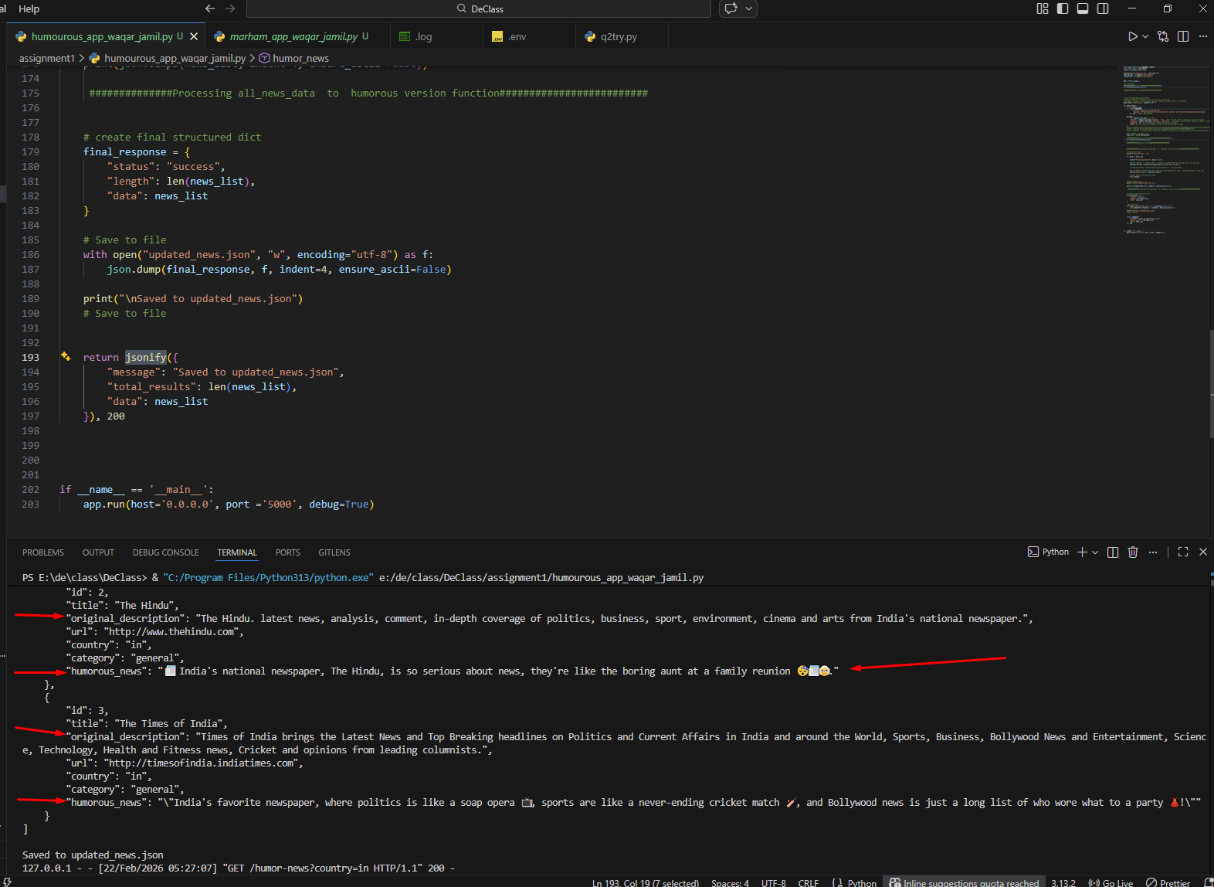

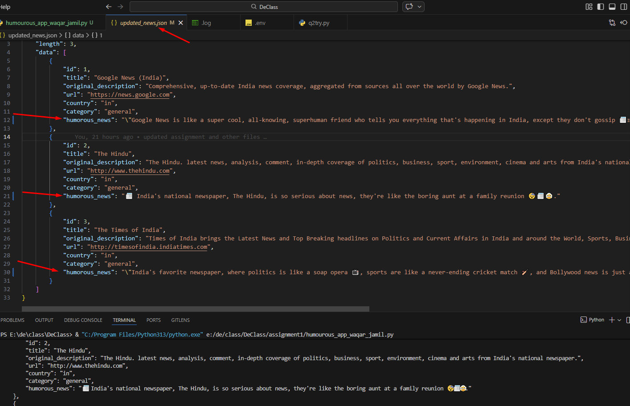

Question 2:
Marham’s web url is not showing any data on default html some js function is blocking the html content
through id="jsonify" go this info too by using BeautifulSoup
(soup = BeautifulSoup(response.text, 'html.parser'))
so this was not showing that html parent div and rows in python code

so tried network tab in chrome so go a file which was loading the data for a specific lab
https://www.marham.pk/api/lab/tests-optimized?lab_id=15

So I picked the data through this url and tried same approach on other 3 labs too
then I got all 4 lab results in json format and then used that as per our requirement of assignment
stored final required data in "marham_data.csv"

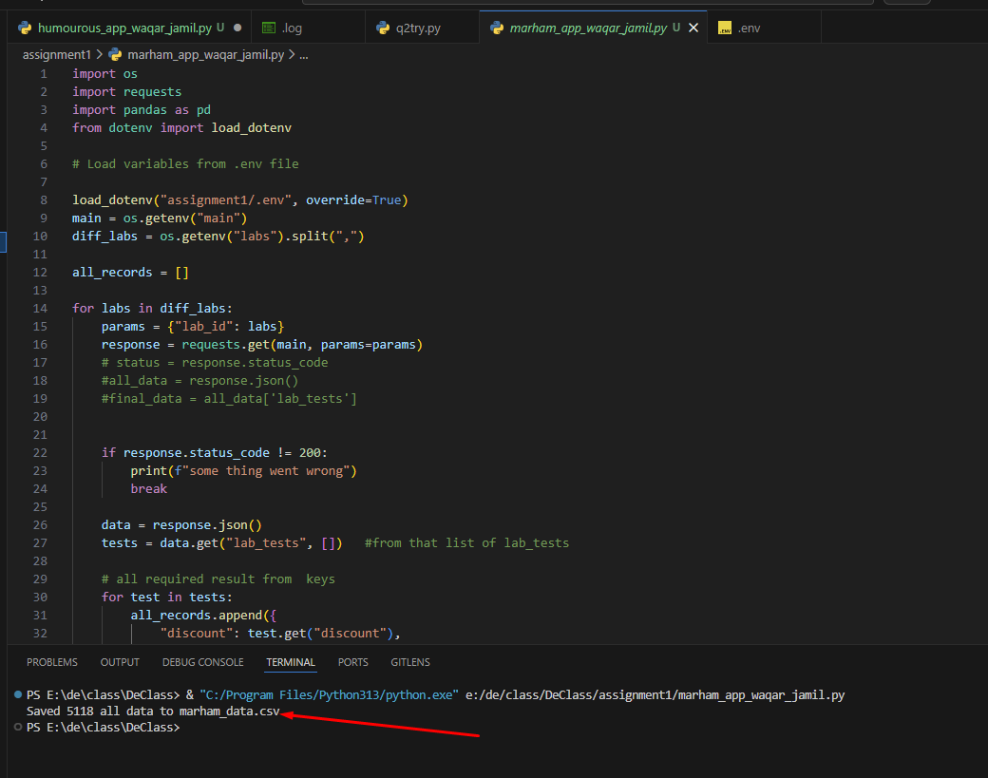
code run = directly in vs code python run

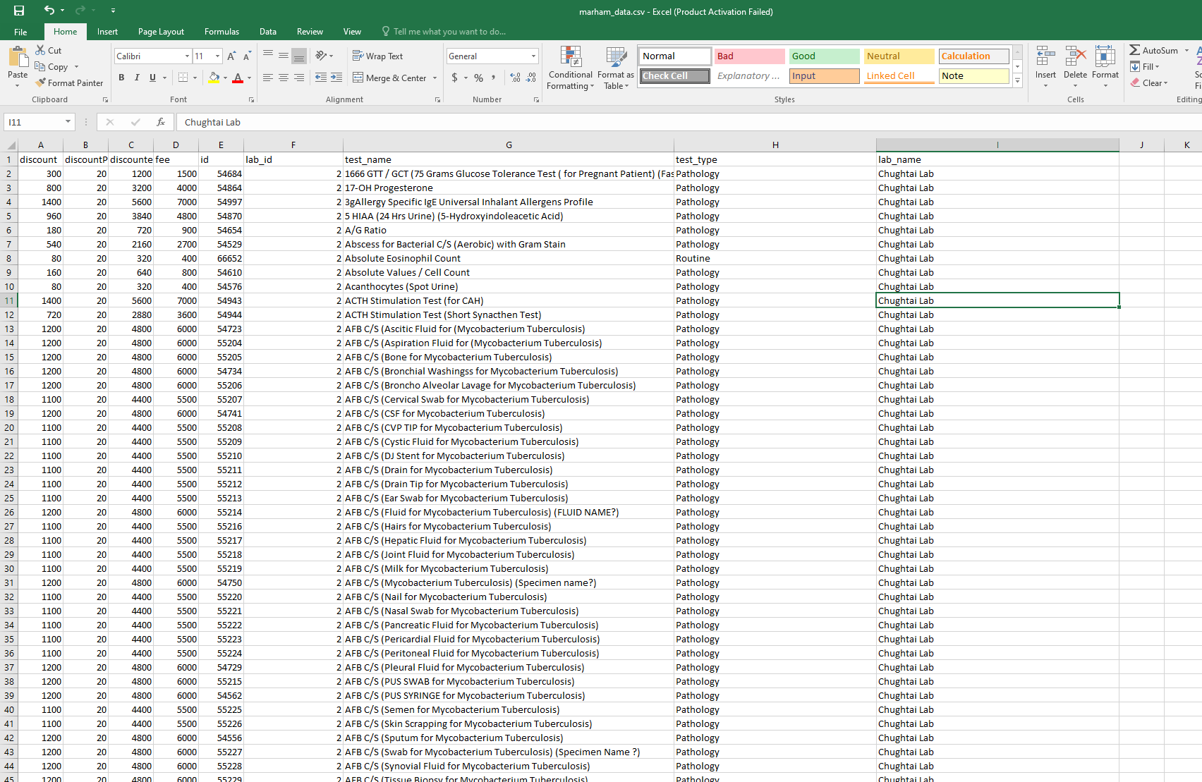

Got the data in through this from marham’s web`
