Companies House
Financial Data Pipeline
Business Logic & Architecture Brief

Prepared for: Data Engineering Team
April 2026

1. Purpose
This document describes the business logic, data sources, write strategies, and processing rules for the Companies House financial data pipeline. It is intended as a reference for the data engineer building and maintaining the system.
The pipeline ingests two separate data products published by Companies House, processes them into a PostgreSQL database, and supports monthly automated re-runs. The core goal of the financials table is to show financial metrics movement over time — building a full time series of how company finances evolve across filing periods.

2. Data Sources
There are two completely independent data sources from Companies House. Both must be loaded.

2.1 Accounts Data (iXBRL)
UK companies file annual accounts with Companies House in iXBRL format (HTML with embedded XBRL tags). These are published as monthly bulk ZIP files at:
https://download.companieshouse.gov.uk/en_monthlyaccountsdata.html
Each monthly ZIP contains approximately 300,000 individual company account filings as HTML files. Each filing is named in the format:
Prod224_YYMM_CCCCCCCC_DDDDDDDD.html
- YYMM — batch year+month (e.g. 2602 = February 2026)
- CCCCCCCC — company number (8 digits with leading zeros)
- DDDDDDDD — accounts date
From the YYMM batch code, we derive a human-readable ch_upload label (e.g. 2602 → Feb-26). This column appears on every row in all accounts-derived tables so we can trace which monthly batch a record came from.

Backfill scope
The pipeline must process all monthly accounts ZIPs from January 2021 to the present month. This is approximately 60+ monthly ZIPs. They must be processed in chronological order (oldest first) so that upsert tables end up with the most recent data. The financials table accumulates every month; the directors and reports tables only retain the latest data per company.

2.2 Free Company Data Product (CSV)
The basic company data snapshot is published at:
https://download.companieshouse.gov.uk/en_output.html
This is a monthly snapshot of all live companies on the register. It is provided as ZIP files containing CSV data. The data can be downloaded as a single large file (~468 MB) or as 7 smaller part-files (~70 MB each).
Update schedule: The snapshot is updated within 5 working days of the previous month end. Contents are compiled up to the end of the previous month.
The CSV contains: company name, registered address, SIC codes, company status, company type, incorporation date, country of origin, and other company metadata fields. A full list of data fields is available in a PDF linked from the download page.
Important: This data is NOT extracted by the iXBRL parser. It requires a separate CSV loader. The Free Company Data Product is the authoritative source for company metadata because the iXBRL accounts data is unreliable for this purpose — many filings (especially micro-entity accounts) don’t consistently tag address, SIC codes, or even company name. The CSV covers all live companies, not just those that filed in a given month.

3. Target Tables & Write Strategies
The pipeline writes to four PostgreSQL tables. Each has a different write strategy. Getting this right is essential.
Table | Source | Strategy | Reason
financials | Accounts (iXBRL) | APPEND | Full time series needed to show financial metrics movement over time. Never overwrite — we accumulate every filing from Jan 2021 onward. One row per metric per period per company.
directors | Accounts (iXBRL) | UPSERT | Only the latest director list per company matters. Newer filings overwrite older ones.
reports | Accounts (iXBRL) | UPSERT | Only the latest narrative text per company matters. Text can be 10,000+ characters — must use PostgreSQL TEXT type.
metadata | Company Data (CSV) | UPSERT | Full snapshot replacement. The CSV contains all live companies. Each load is a complete refresh of company identity data.

3.1 Hard Requirements (All Tables)
- company_number must be TEXT (preserves leading zeros like 01174621)
- Narrative text must use PostgreSQL TEXT type, not VARCHAR
- Index on company_number in all tables
- loaded_at TIMESTAMP DEFAULT NOW() on all tables

3.2 What the Parser Produces
The iXBRL parser (test_pipeline.py) is a first draft only! At this stage, we might have to review dozens of different account types to ensure that the parser picks up all the relevant and html tags. Paul and Stefan can assist with that.
The parser, takes an HTML file path and returns structured data for three categories:
- Financials: Numeric metrics (revenue, profit, assets, liabilities, cash, employees, cash flow, equity). One row per metric per period. The parser returns multiple rows for the same company across different periods (current year vs. prior year comparatives). This time series must be preserved — it is essential for showing movement over time.
- Directors: Director and secretary names. One row per named officer per company.
- Reports: Narrative text sections (strategic report, directors report, related party disclosures, ultimate controlling party). One row per section per company.
- Metadata: This is the fourth data category. It comes from the Free Company Data Product CSV, NOT from the iXBRL parser. One row per company. This is the master reference for company identity.

4. Pipeline Architecture
The diagram below shows the complete data flow, including both sources, all four target tables, and the backfill logic.
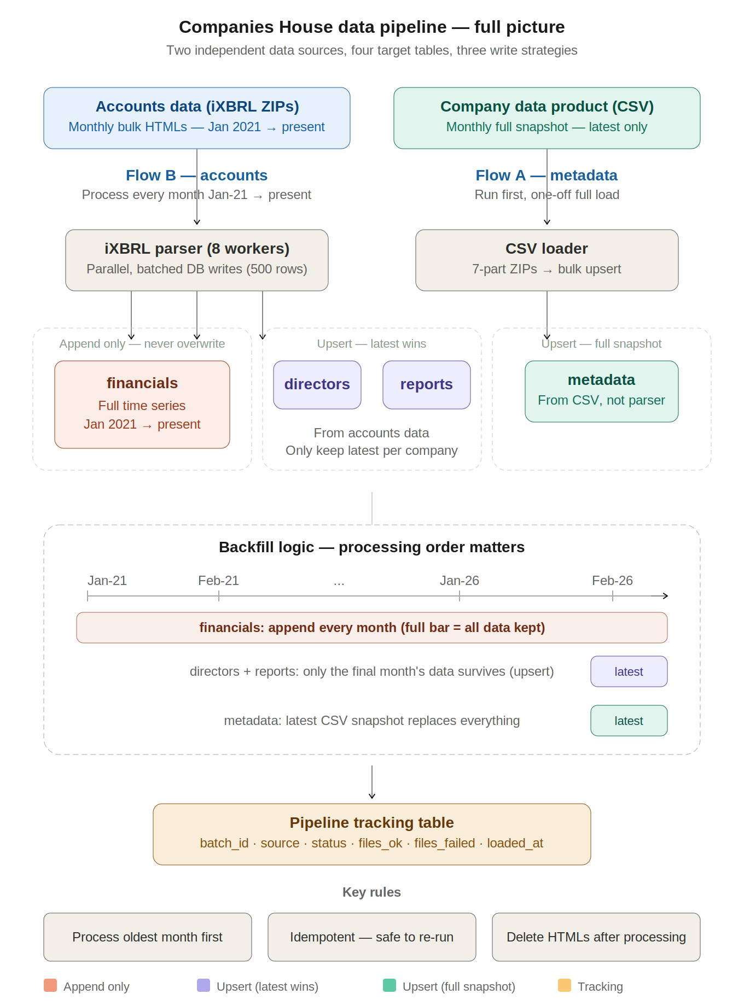
Figure 1: Pipeline overview — two data sources, four tables, three write strategies

4.1 Two Independent Data Flows
The pipeline has two flows that can run independently:
Flow A — Company Data (CSV): Download the 7-part CSV ZIPs from the Free Company Data Product page, extract, bulk upsert into the metadata table, update tracking. This should run first so company metadata is in place before accounts processing. The full snapshot replaces all existing metadata each time.
Flow B — Accounts Data (iXBRL): Download each monthly accounts ZIP (~300k files per month), extract, parse each file in parallel using the iXBRL parser (8 workers), batch database writes (500 rows at a time), clean up extracted HTML files, update tracking. Must process all months from January 2021 to present in chronological order.

4.2 Per-File Processing
For each individual iXBRL HTML file, the following happens:
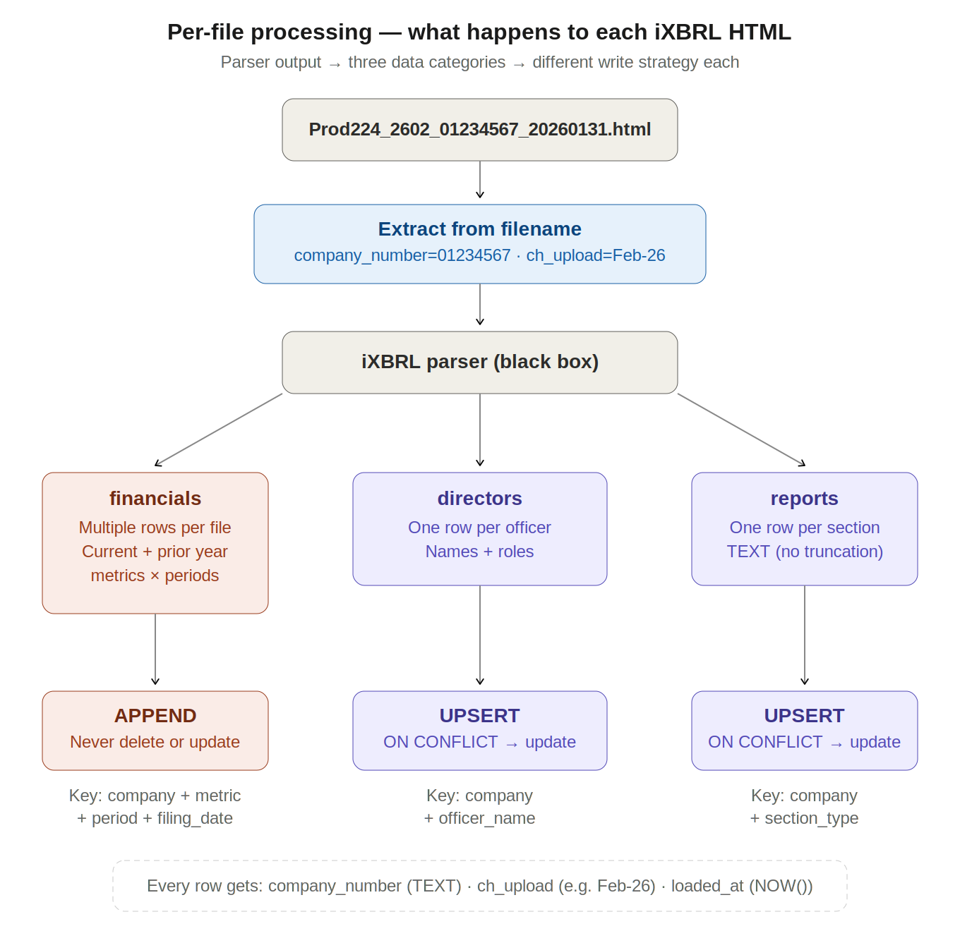
Figure 2: Per-file processing — parser output splits into three data categories with different write strategies

5. Backfill & Processing Order
The pipeline needs to backfill data from January 2021 to the present. This is approximately 60+ monthly accounts ZIPs. The processing order is critical:
- Run Flow A first — load the latest Company Data Product CSV into the metadata table.
- Process accounts ZIPs in chronological order (Jan-21, Feb-21, Mar-21, ... through to the latest available month).
- Processing order matters because of upsert tables. Since directors and reports use upsert (latest wins), processing must go oldest-to-newest so the most recent data naturally overwrites older entries. If you process Feb-26 first and Jan-21 after, you would overwrite current directors with five-year-old data.

5.1 What Each Table Gets From the Backfill
Table | Backfill result | Detail
financials | 60+ months of data | Every row from every month is kept. This builds the full time series: revenue, profit, assets, etc. across all filing periods from Jan 2021 onwards. Each filing also includes prior year comparatives, giving two data points per metric per filing.
directors | Latest month only | After processing all 60+ months chronologically, only the most recent filing per company survives. Earlier data is overwritten by later upserts.
reports | Latest month only | Same as directors — only the most recent narrative text per company is retained.
metadata | Latest snapshot | Loaded once from the most recent CSV (updated within 5 working days of month end). Full snapshot replacement — not cumulative.

6. Pipeline Tracking & Idempotency
A pipeline tracking table records every batch processed. At any point, we must be able to answer: “What is the latest accounts batch loaded? What is the latest company data snapshot loaded?”
The tracking table stores:
- batch_id — unique identifier for the run (e.g. “accounts_Feb-26” or “company_data_2026-03-02”)
- source — which data product (accounts or company_data)
- status — running, completed, failed
- files_processed / files_failed — counts for monitoring
- loaded_at — timestamp of completion

6.1 Idempotency
The pipeline must be safe to re-run. Re-processing the same batch must not create duplicate data. The tracking table prevents accidentally reprocessing a completed batch. For financials (append only), idempotency is ensured by checking the tracking table before processing; for upsert tables, re-running is naturally safe because duplicate inserts resolve via ON CONFLICT.

7. Error Handling & Cleanup
- Parser failures: Some iXBRL files will fail to parse (malformed HTML, missing data). The pipeline logs failures and continues processing. Failed file counts are tracked per batch.
- Cleanup: Delete unzipped HTML files after processing. Keep original ZIP files for potential reprocessing.
- Notifications: Email alerts on pipeline success or failure, with metrics on files processed vs. failed.

8. Monthly Operations (Future State)
Once the backfill is complete, the pipeline should support automated monthly re-runs via a cron job. The monthly process would:
- Detect which monthly batches are available on the Companies House website
- Compare against the tracking table to find unprocessed months
- Process unprocessed months in chronological order (oldest first)
- Update tracking so we always know which batch is current
- Refresh the company data CSV (full snapshot replacement — the CSV is updated within 5 working days of month end, compiled up to end of previous month)

9. Key Identifiers
Field | Format | Notes
company_number | TEXT (8-digit CRN) | Leading zeros must be preserved (e.g. 01174621). Maps to registration_number in our existing PostgreSQL database. This is the unique identifier for a company across all tables.
ch_upload | TEXT (e.g. Feb-26) | Derived from the YYMM batch code in the accounts filename. Must appear on every row in all accounts-derived tables (financials, directors, reports) so we can trace which monthly batch a record came from.

10. Quick Reference Summary
Aspect | Detail
Accounts ZIP size | ~1.8 GB per month, ~300k HTML files per ZIP
Backfill range | January 2021 → present (~60+ months)
CSV snapshot | ~468 MB (7 parts), updated within 5 working days of month end
Parallelism | multiprocessing.Pool, 8 workers (configurable), batch writes of 500 rows
Processing order | Oldest month first (chronological) — critical for upsert correctness
Financials purpose | Show financial metrics movement over time — full time series, never overwrite

