ViewController is the default controller used for fetching records from phonebook and it stores it into the local database.

For local database I have use the core data. I am pasting the ER-Diagram below:

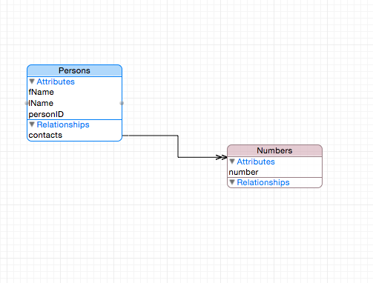

Currently I have written code to manage the above database using core data. We can use excellent library “Magical Records” for managing core data related functionalities.

Any changes made in the phonebook will be displayed in the UITextView. We can also use different things for displaying the results e.g. an overlay; which contains a table containing all the changes with different section on it or anything else that may be required by the user.

