**Q.No.01:**

**(a)** Consider the C++ code, you need to write how many times each statement execute in the blanks given against each statement.

intx = 0, y = 0; ______1__ times

for(inti=0;i<N;i++)____n____ times

{

for(int j=0;j<N;j++) ____n^2____ times

{

x = x + j; ___1_____times

}

}

for(int k = 0; k < N; k++)_____n____times

y = y + k; _____1____times

What will be the total time complexity of this code?

**Answer:**

T(n) = 1+ n+ n^2+ 1+n

T(n) = O(n^2)

**b)**  Consider the following given code, You need to write how many times each statement execute in the blanks given against each statement

for(int x =n/2; x <=n;i++) ____________ times

{

for(int y =1; y <=n; y = y*2) ____________ times

{

cout<<x<<y; ____________ times

}

}

What will be the total time complexity of this code?

**Answer:**

It is a bad syntax and it is also an infinite loop and there is no time complexity for infinite loops

Thus

Time complexity = NULL

**Q.No.02**

**Take your VU Student ID as a list of digits and sort it in Ascending Order using Merge Sort.**

**For Example:**

**Consider the following digits as a list of a student ID (i.e., BS217683249) having name "ABC”:**

**2, 1, 7, 6, 8, 3, 2, 4, 9**

**Solution:**

**Divide:**

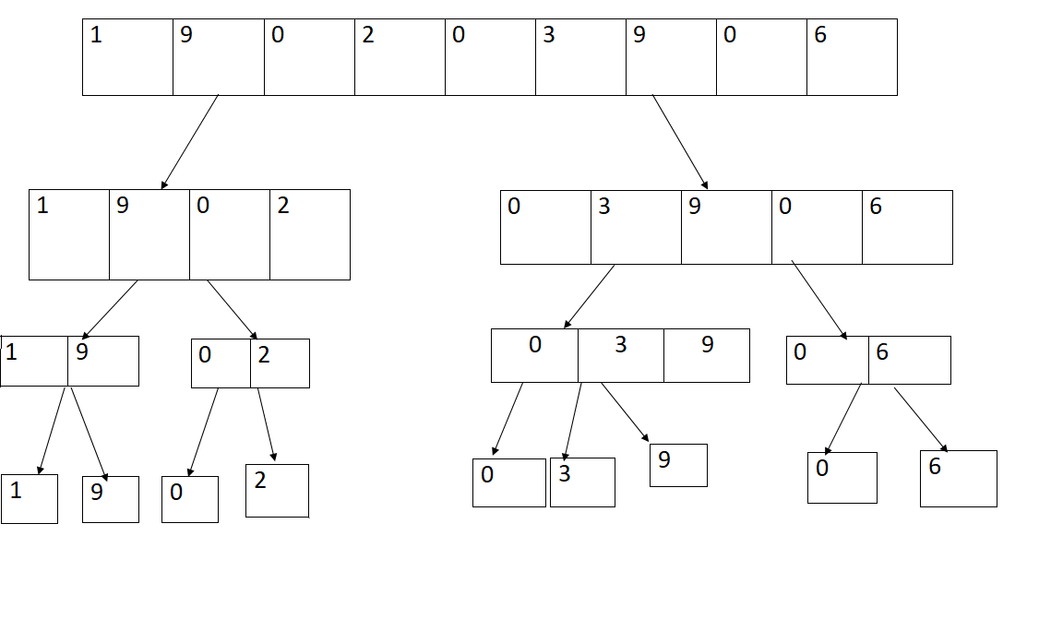

**Combine:**

