Information Technology University Of The
Punjab Lahore

Department Of Electrical Engineering

Power Electronics
Project Report

Single Phase ø To 3 Phase ø VFD(Variable
Frequency Drive) For 750W Motor

Course Instructure
Dr Tousef Touqeer
Teaching Assistant
Mr Umair Nazir

Group Members
Furqan Bari BSEE21005
Waqas AFZAL BSEE21079

Table of Contents
What is VFD 1
Construction or Block Diagram 1
1
External Diagram 2
Working 2
Project Scope 3
Components 3
How PWM works to attain variable frequency 4
Simulation of Matlab 5
Motor speed stabilizer 6
Simulation on Proteous 7
Potentiometer Change Frequency 7
3-phase output of Inverter 8
Arduino PWM output 8
Potentiometer change frequency 9
Hardware Implementation on Vero board 10
Simulation 10
Components Ratings 11
Components Calculation: 11
Input: 220V AC (single phase) 11
Full bridge Rectifier (15A GBJ3510 1000V) 11
Capacitor (400V 470uF) 11
Mosfet and driver ic selection 11
Deadtime 11
Booststrap 11
Optocoupler 11
Arduino PWM output three phase 12
Conduction Table 12
PCB Circuit 13
PCB Circuit Printing on Couper Plate 14
14
Code 15
Conclusion 1
References 1

What is VFD
A variable field drive (VFD) is the device which is used in industrial machinery to control the speed of the ac motors or ramp up their speed to give them a smooth startup. Its works by adjusting frequency of the motor to adjust the rpms. And for this purpose a VFD will actually convert the voltage twice. First it converts our ac phases to dc can be both single or three phase by using diode rectifier then it cleans the dc with a capacitor. Next it converts the DC to AC by using transistor acting as switches and in our case we use MosFets. One common used in the industry of VFD is water pumps in water treatment plants. Like if the water demand exiting the plant is lower than the supply entering the plant, so to low down the flow of water can be achieved by using a VFD on the AC motor. Another great thing about VFDs is the fact that they can be controlled with a PLC. PLC can monitor and control motor speeds using VFD. Which helps make a process like water treatment much easier and more efficient.
Construction or Block Diagram

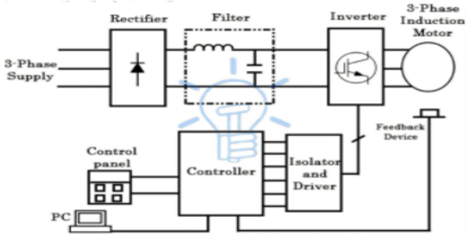
Fig 1.1 Block Diagram

Block Diagram
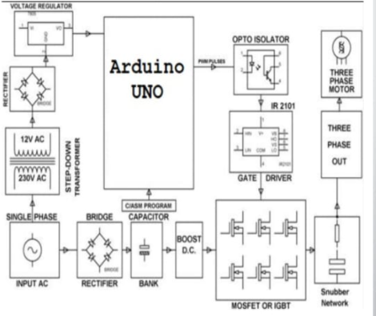
Fig 1.2 Block diagram of VFD

External Diagram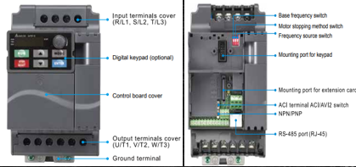
Fig 1.3 VFD Front and Back View

Working
In the diagram given in Fig:1.1 and Fig: 1.2 simple flow of VFD shown that at first we apply single phase ac voltage to the rectifier for the dc voltage. After that there is more filtration required for pure dc then for this purpose we are using here filter. After conversion into dc voltage we want to again convert dc voltage into controllable ac voltage and for this purpose we used inverter circuit using 6 MosFets. In the downward of inverter circuits there is our microcontroller and octocoupler is attached which given separation between mosfet and Arduino voltage otherwise Arduino will burns. Here by using Arduino we are doing PWM to adjust the frequency for further control the voltage output for the motor speed control. PWM refers to pulse width modulation where we can change the frequency of output signal. Due to its high efficiency, low power loss and its ability to precisely control the power this technique is used in many applications. For example dimming the LED lights, or controlling the fan speed of the cpu this PWM technique is preferred over the conventional methods. And in some laptops even the brightness of the screens is also controlled using this pulse width modulation technique. Apart from these application PWM is extensively used in the power electronics. In pulse width modulation we just controls the width of the voltage like if a signal will given of 9 v but only apply 25 % of 9 V then we are also changing the width of the voltage output. Duty cycle also plays important role in PWM. The duty cycle defines for what fraction of the time period, the pulse remains in the on conditions. Also it is the ratio of the on time to the total time period. PWM signal also cane be generate using microcontroller.
In the second Figure Fig: 1.3 shows the External looks of the established VFD which shows the input and output terminal with ports of others features like digital keypad, mounting port for keypad and mounting port for extension card etc.

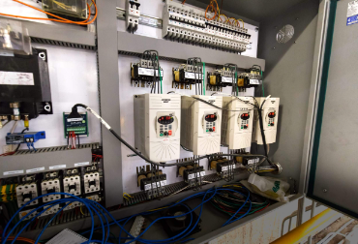

Project Scope
- Pumps
- Fans
- Compressors
- Conveyors
- Elevators
- Extruders
- As a Motor Starter
- Used in pumps to control Flow
- Electric Trains
- Roller Coasters
- VFD expands the process
ontrol options

Fig 1.4 VFD expands the process control

Components
Sr.no | Name | Quantity | Price
1 | Capacitor 400V  470uF | 1 | 500
2 | Full Bridge Rectifier (15A GBJ3510 1000V) | 1 | 45
3 | Irf 840 Mosfet | 6 | 6*100
4 | Ir2110 igbt driver IC | 3 | 3*220
5 | Diode 1n4148 &  capacitor 10uf | 6 +3 | 5*2 & 30
6 | Heatsink | 6 | 6*15
7 | 3 pin & 2 pin connector | 3 | 30 & 30
8 | pc817 Octocouplors | 7 | 7*10
9 | 2.2uf 50v capactor | 5 | 5*5
10 | UF4007 | 12 | 12*12
11 | 5*104 100nf | 5 | 5*3
12 | Rectifier bridge small db107 | 1 | 10
13 | 4 pin socket | 5 | 5*5
14 | Veroboard and female pin | 1 + 1 | 330
15 | 4th round Pcb board and solution, again vfd components | Includes pcb board and solution (240),  again components buy of vfd for pcb (150) | 390
 | Total |  | 3004/- Rs

How PWM works to attain variable frequency

PWM involves two factors
Duty cycle : the time for the positive pulses
-The duty cycle can adjust by the timer of the microcontroller to set the time on and off for
transistors.
Frequency : Distance between two cycles
- By changing the time period we can change the frequency of the output as T = 1/ f.
- Timer or counter register of microcontroller also can helps to change the duration of cycle.

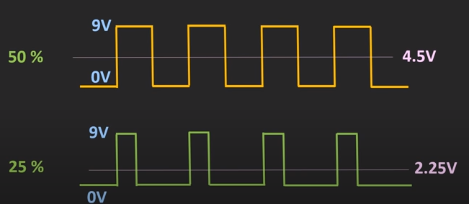
Fig 1.4.1 For Frequency Control
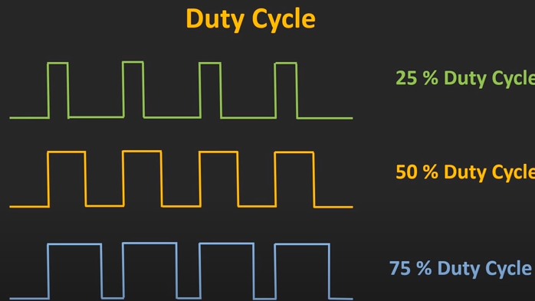
Fig 1.4.2 For Duty cycle control

Simulation of Matlab
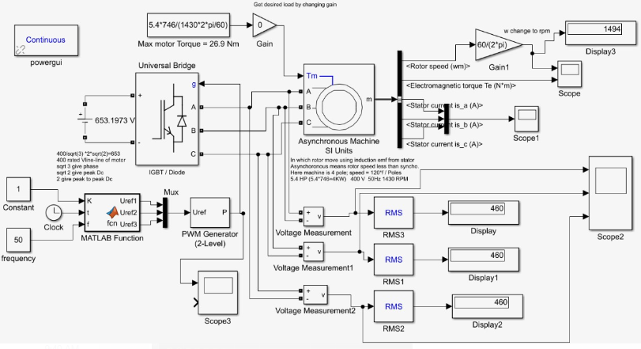
Fig 1.5 Simulink Matlab Circuit

Motor speed stabilizer
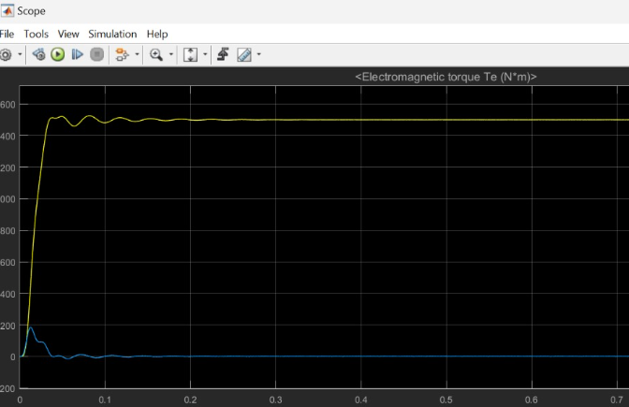
Fig 1.6 Matlab output of Dc motor speed stablizer
This is our circuit of matlab simulation where we use inverter module in the circuit of IGBT. We has not used MosFet here. After the inverter driver our output goes to microcontroller where it performs the PWM to change the frequency ultimately which also refers to the speed control of the ac motor. From controller we give our output to the motor for the testing. Checking all voltages and currents at outputs.
Motor speed stabilizer shown in pic Fig which show the motor speed with stability of system either stable or not and how much fault occurs or not.

Simulation on Proteous
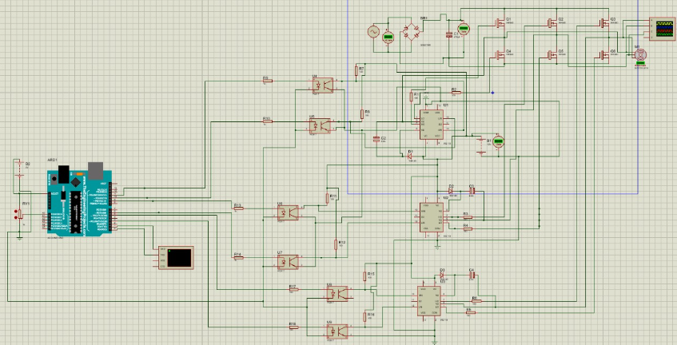

Potentiometer Change Frequency

3-phase output of Inverter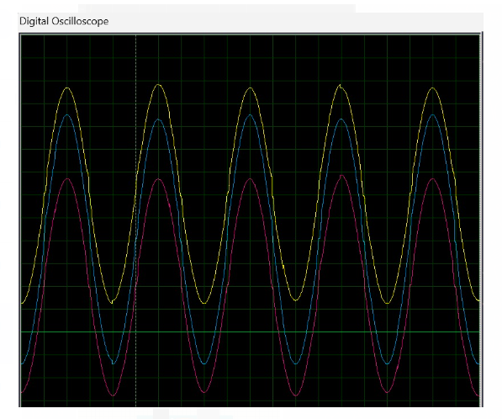

Arduino PWM output
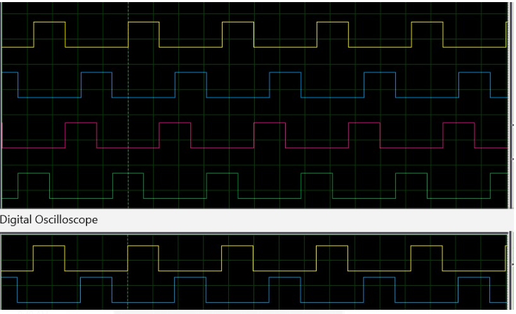

- Our Proteous circuit diagram shown In given picture with simulations. Circuit show PWM Arduino outputs with three different colors. And oscilloscope shows the overall output of the circuit whose phase shows the high and low phases.

Potentiometer change frequency

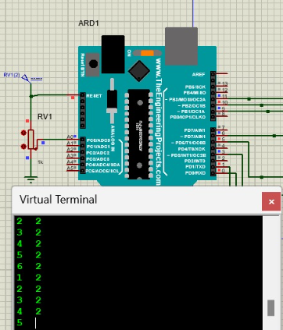
Fig 1.7 This is the output verses different readings for potentiometer
which shows us our circuit simulates with desired values.

Hardware Implementation on Vero board
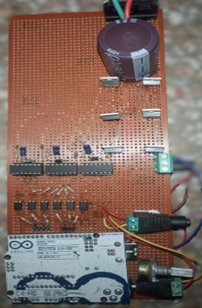
Fig 1.8 Hardware circuit on Vero board
After implementation on the breadboard multiple times here in the given circuit we are made it finally in the Vero board. Our controller, gate driver ic’s, octocouplers, rectifier circuit along with high capacitor soldered. And our output after testing shows the given output waveform using oscilloscope which also shows peak to peak , average and Vrms values of the voltages.

Simulation
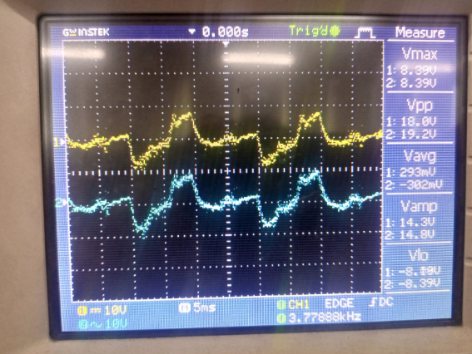

Components Ratings

Components Calculation:

Input: 220V AC (single phase)

Full bridge Rectifier (15A GBJ3510 1000V)
220V*$\sqrt{2}$ = 311 V rectified
Current max 3.41A = 750W/220V so, (Gbj 3510 is best of 1000v and 15v ratings)

Capacitor (400V 470uF)

1/50hz = 20ms
50hz for half AC cycle = 10ms
Voltage average = Vp*0.636 = 311*0.636 = 197.796V
Del V = Vp - Vavg = 311-192.8= 113V
Current = 3.41A
Capacity Farads = (I*t)/Del V = (3.41*10m) / 113 = 301uF

Mosfet and driver ic selection
Ir840 gives 500v 15A electrical ratings at standard use and for their driver circuit we use ir2110 which control the high and low side of half bridge.

Deadtime

for mosfets from datasheet is 20ns which is max time take to proper switch by mosfet.

Booststrap

Use a uf4007 diode which is fast recovery diode(75ns max) and high current capability (instead of 1n4148 which is low current support) and 2.2uf capacitor from datasheet and internet basic circuit.

Optocoupler

Used for Arduino next circuit for the isolation between Arduino low voltage and mosfet circuit high voltage with max transition time of 18us.

Arduino PWM output three phase

Six pins Digital(3,5,6,9,10,11) out the pwm signal such as
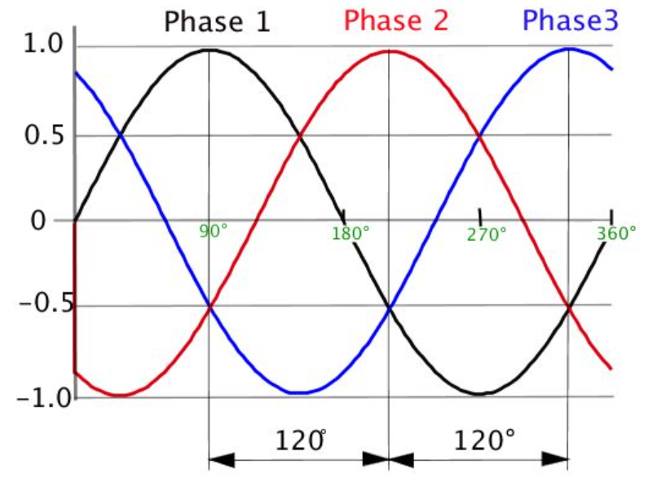
Fig 1.9 Conduction phases

Conduction Table
Time angle | 3rd Pin | 5th Pin | 6th Pin | 9th Pin | 10th Pin | 11th Pin
0 | ON | OFF | OFF | ON | ON | OFF
60 |  |  |  |  | OFF | ON
120 |  |  | ON | OFF
180 | OFF | ON
240 |  |  |  |  | ON | OFF
300 |  |  | OFF | ON
360 | ON | OFF

PCB Circuit
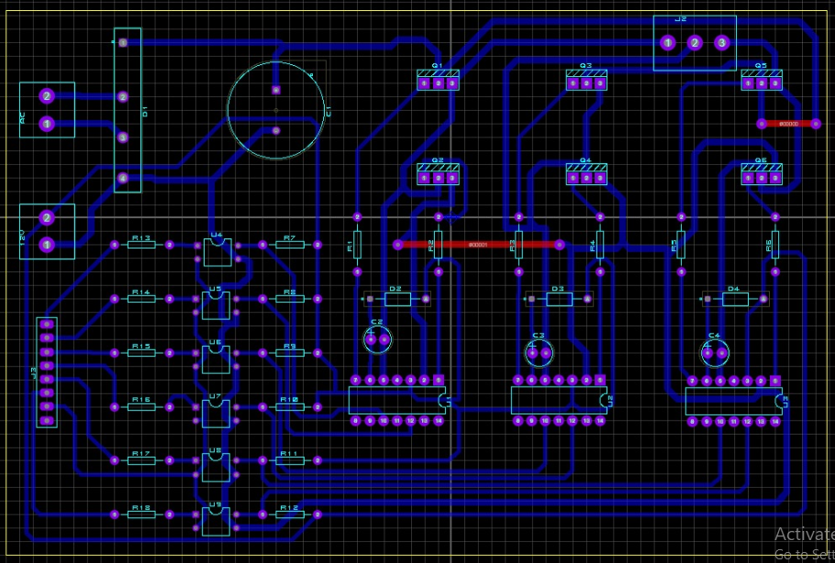
Fig 2.1 Hardware Pcb circuit

PCB Circuit Printing on Couper Plate
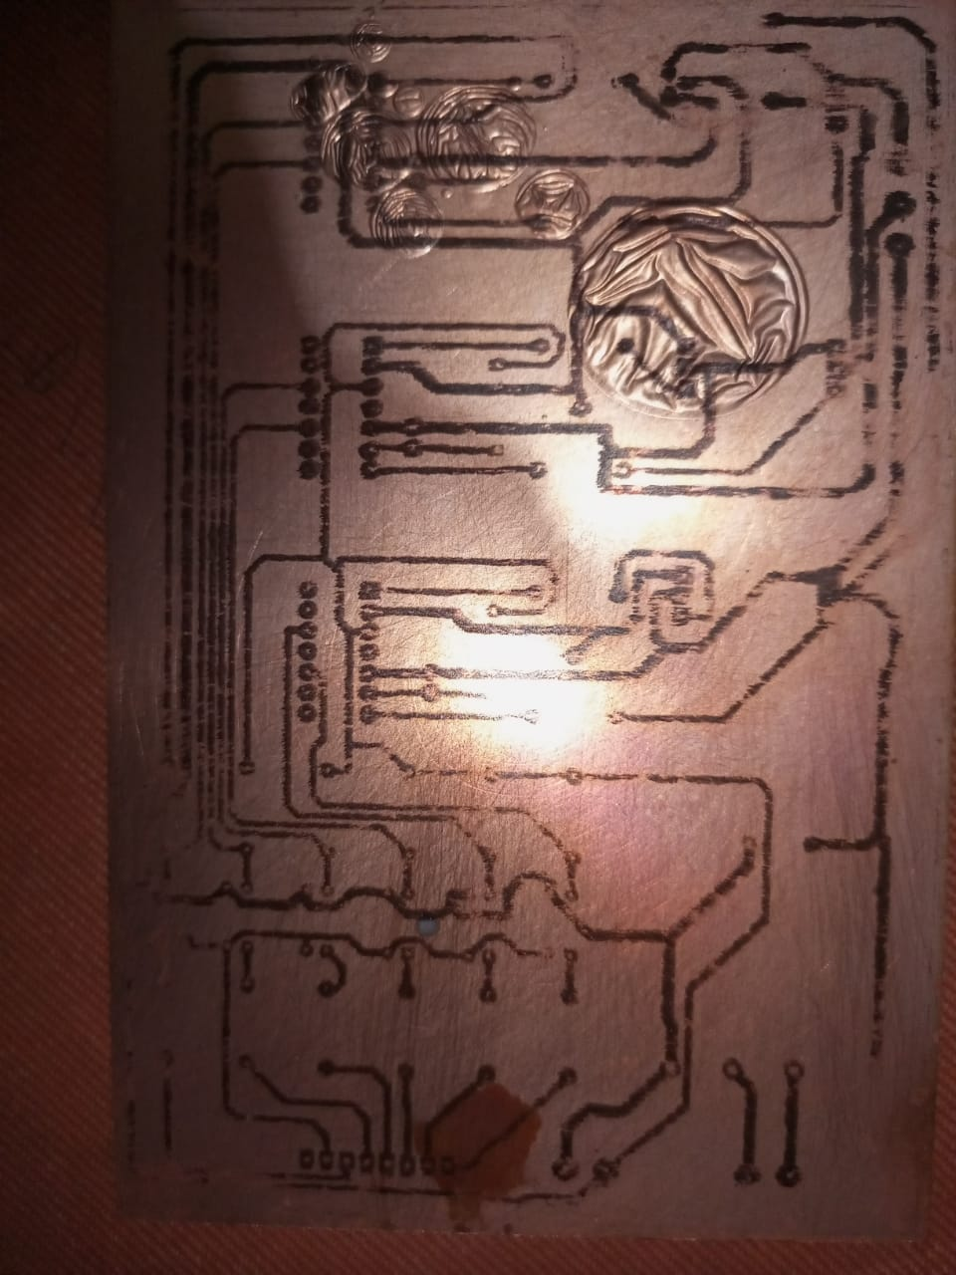
Fig : 2.2
PCB Printed Circuit
on Couper plate

Code

int AA1=3; //name pins as high low phase  int AA2=5;  int BB1=6;  int BB2=9;  int CC1=10;  int CC2=11;  int delayPd; //delay period  int deadtime; //delay for no short of mosfet or igbt  void setup() {  Serial.begin(9600);  pinMode(AA1,OUTPUT);  pinMode(AA2,OUTPUT);  pinMode(BB1,OUTPUT);  pinMode(BB2,OUTPUT);  pinMode(CC1,OUTPUT);  pinMode(CC2,OUTPUT);  digitalWrite(AA1,LOW);  digitalWrite(AA2,LOW);  digitalWrite(BB1,LOW);  digitalWrite(CC2,LOW);  digitalWrite(BB2,LOW);  digitalWrite(CC1,LOW);  delay(1000);  delayPd = 3333; //delay for 50hz in micros as ((1/50)*1000*1000)/6  //1000*1000 convert 0.02 in to millies then micros and 6 each phases  deadtime = 3; //according to igbt transition time in datasheet  } | void loop() {  digitalWrite(AA1,HIGH); //AH HIGH  digitalWrite(BB2,HIGH); //BL HIGH  digitalWrite(CC1,HIGH); //CH HIGH  delayMicroseconds(delayPd);  digitalWrite(CC1,LOW); //CH LOW  delayMicroseconds(deadtime); //for mosfet not short  digitalWrite(CC2,HIGH); //CL HIGH  delayMicroseconds(delayPd);  digitalWrite(BB2,LOW); //BL LOW  delayMicroseconds(deadtime); //for mosfet not short  digitalWrite(BB1,HIGH); //BH HIGH  delayMicroseconds(delayPd);  digitalWrite(AA1,LOW); //AH LOW  delayMicroseconds(deadtime); //for mosfet not short  digitalWrite(AA2,HIGH); //AL HIGH  delayMicroseconds(delayPd);  digitalWrite(CC2,LOW); //CL LOW  delayMicroseconds(deadtime); //for mosfet not short  digitalWrite(CC1,HIGH); //CH HIGH  delayMicroseconds(delayPd);  digitalWrite(BB1,LOW); //BH LOW  delayMicroseconds(deadtime); //for mosfet not short  digitalWrite(BB2,HIGH); //BL HIGH  delayMicroseconds(delayPd);  digitalWrite(AA2,LOW); //AL LOW  delayMicroseconds(deadtime); //for mosfet not short  }

Conclusion

This project controls the speed of 3-phase induction motor by controlling its frequency and also gives 0 starting torque. There basic flow also shown in adjacent block diagram. This is only for AC, where single phase do in and become Dc using rectifier and high power capacitor. Then it again converts to 3-phase Ac using IGBT/MOSFET with variable frequency which controlled by Arduino using concept of PWM modulation. Thus by this method speed of 3-phase 750W motor controlled

References
https://www.homemade-circuits.com/3-phase-vfd-circuit/
https://digitalcommons.calpoly.edu/cgi/viewcontent.cgi?article=1129&context=eesp
https://utpedia.utp.edu.my/id/eprint/153/1/Lee_Teng_Hong.pdf

