ADE20K Four-Class Semantic Segmentation:
U-Net with EfficientNet-B0 and MobileNetV2 Encoders
Muhammad Waqas | 22079344
Github:

1. Introduction
Semantic segmentation assigns a class label to every pixel in an image, and it underpins tasks ranging from autonomous driving to medical image analysis. This project addresses a four-class segmentation problem built on a 350-image subset of the ADE20K dataset (person, car, book, and airplane, plus background), comparing two U-Net encoder variants under a fixed training budget.
Semantic segmentation research traces back to fully convolutional networks, but the U-Net architecture introduced by Ronneberger, Fischer, and Brox (2015) remains one of the most widely reused designs. Their encoder-decoder network uses skip connections between corresponding downsampling and upsampling stages, so that fine spatial detail from early layers reaches the decoder directly rather than being lost through repeated pooling.
The dataset itself derives from ADE20K, introduced by Zhou et al. (2017; extended 2019) as a densely annotated scene-parsing benchmark spanning thousands of object categories across everyday scenes. The original benchmark covers over 20,000 training images and 150 semantic categories; this project uses a curated 350-image subset restricted to four target categories, which changes the class-balance and data-volume characteristics substantially compared with the full dataset.
Because the encoder choice inside a U-Net has a large effect on both accuracy and computational cost, this project also draws on two efficient CNN backbones. Sandler et al. (2018) proposed MobileNetV2, built around inverted residual blocks with linear bottlenecks, aimed at reducing FLOPs and parameter count for mobile deployment without a large accuracy penalty. This project pairs a U-Net decoder with EfficientNet-B0, the smallest member of that family, as one encoder, and MobileNetV2 as the other, so any performance gap can be attributed to the backbone rather than the decoder.

2. Data description and exploratory data analysis
The dataset consists of 350 training images and 350 validation images, each carrying COCO-style polygon/RLE annotations for four target classes. Table 1 summarises the instance counts per class.
Class | Train instances | Val instances
Person | 1084 | 1477
Car | 689 | 598
Book | 155 | 261
Airplane | 13 | 15
Table 1: Target-class instance counts by split.
Data integrity checks were run before any training. Every referenced image file existed and opened correctly, there were no width/height mismatches between the JSON records and the actual image files, no orphaned or duplicate annotations, and no zero-area or undecodable masks. Every image in both splits contained at least one instance of a target class.
The class distribution is heavily imbalanced. Figure 1 shows the top-20 category frequencies in the training split, with target classes highlighted in red; person and car dominate the annotation counts, while airplane appears only 13 times in training and 15 times in validation. Figure 2 quantifies object size for the four target classes: airplane areas range from a few hundred pixels up to roughly 70,000 pixels with high variance given the small sample, while book instances are consistently small. Figure 3 shows example image/mask overlays used to sanity-check the annotation pipeline before training began.
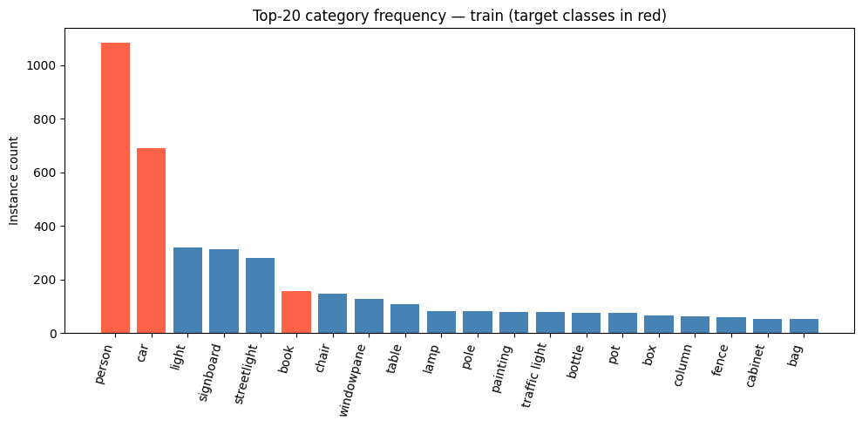
Figure 1: Top-20 category frequency in the training split (target classes in red).
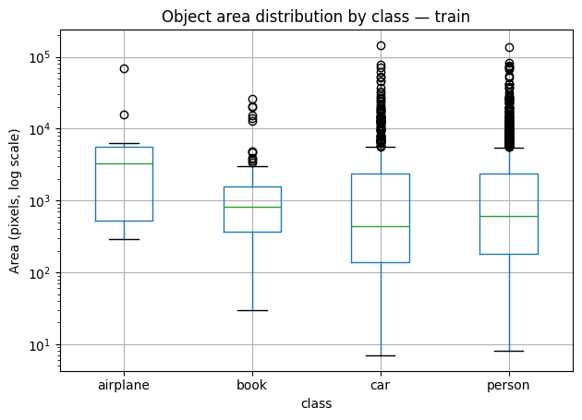
Figure 2: Object area distribution by target class (log scale), training split.
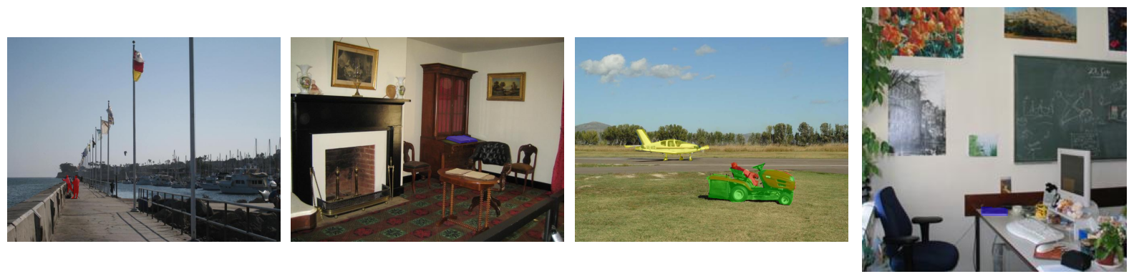
Figure 3: Sample images with ground-truth mask overlays (red = person, green = car, blue = book, yellow = airplane).

3. Methodology
Masks were built at full source-image resolution before any resizing, with overlapping instances handled by drawing larger objects first so that small objects were not erased underneath larger ones. Images and masks were then resized to 256x256 and passed through matched Albumentations transforms, so spatial augmentations (horizontal flip, brightness/contrast jitter) were applied identically to both image and mask. Images were normalised using ImageNet statistics to match the pretrained encoder weights.
Two U-Net models were trained using the segmentation-models-pytorch implementation with ImageNet-pretrained encoders: one with an EfficientNet-B0 backbone (6,252,049 trainable parameters) and one with a MobileNetV2 backbone (6,629,525 trainable parameters). Both used a five-class softmax output (background plus the four targets), the Adam optimiser with a learning rate of 1e-4, a batch size of 8, and 15 training epochs.

4. Results and discussion
Table 2 gives per-class IoU and Dice for both models on the validation set; Table 3 summarises foreground-only means and parameter counts.
Class | EffNet-B0 IoU | EffNet-B0 Dice | MobileNetV2 IoU | MobileNetV2 Dice
Background | 0.9462 | 0.9722 | 0.9545 | 0.9765
Person | 0.4490 | 0.5992 | 0.4592 | 0.6068
Car | 0.3946 | 0.5154 | 0.3990 | 0.5043
Book | 0.0643 | 0.1004 | 0.0000 | 0.0000
Airplane | 0.0000 | 0.0001 | 0.0050 | 0.0090
Table 2: Per-class validation IoU and Dice for each encoder.
Model | Mean IoU (fg) | Mean Dice (fg) | Trainable params
U-Net (EfficientNet-B0) | 0.2270 | 0.3038 | 6,252,049
U-Net (MobileNetV2) | 0.2158 | 0.2800 | 6,629,525
Table 3: Foreground-mean IoU/Dice (background excluded) and parameter counts.
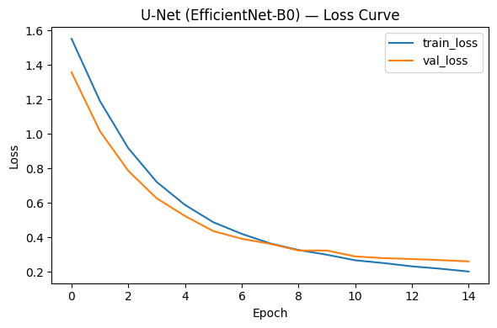
Figure 4: Training/validation loss, U-Net (EfficientNet-B0).
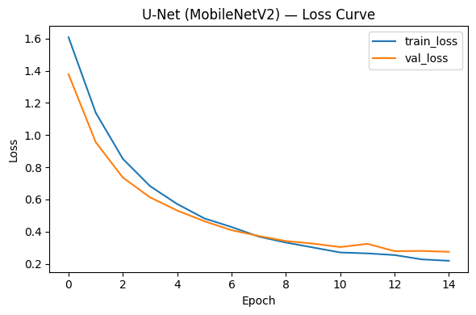
Figure 5: Training/validation loss, U-Net (MobileNetV2).
Background segmentation is easy for both encoders (IoU above 0.94). Person and car, the two classes with the most annotated instances, reach moderate IoU of 0.39-0.46. Book and airplane perform far worse: book IoU is 0.06 for EfficientNet-B0 and effectively zero for MobileNetV2, and airplane IoU is close to zero for both models. Foreground-mean IoU is 0.227 for EfficientNet-B0 against 0.216 for MobileNetV2, and foreground-mean Dice is 0.304 against 0.280, a small but consistent edge for the EfficientNet-B0 backbone despite its similar parameter count. Figure 6 lays the per-class scores from both models side by side.
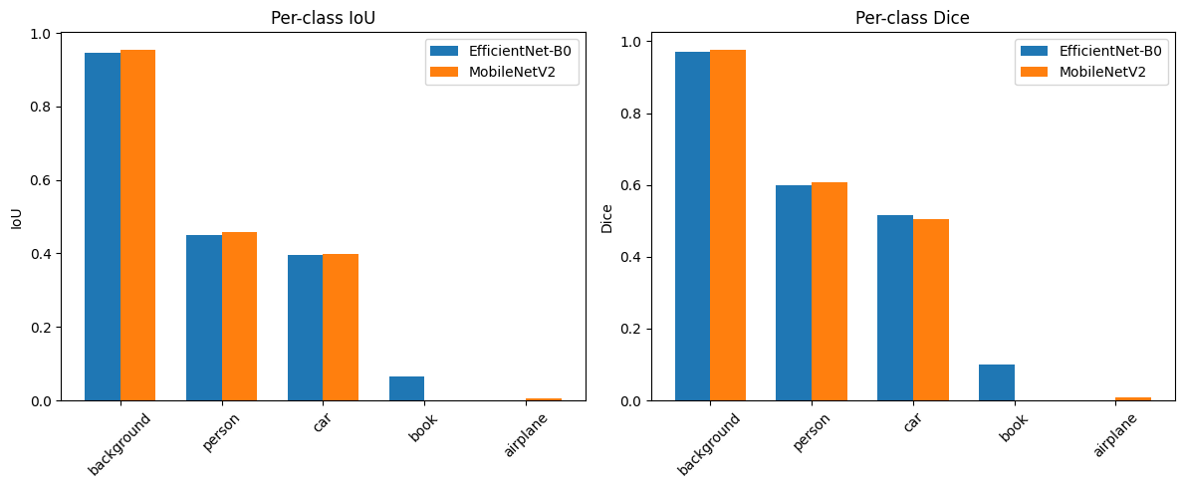
Figure 6: Per-class IoU (left) and Dice (right), EfficientNet-B0 vs MobileNetV2.
Figure 7 shows qualitative predictions against ground truth for three validation images, evaluated with both trained models. Both encoders pick out the dominant person and car regions with roughly the right shape, but boundaries are blurred compared with the ground-truth masks, and the smaller book and airplane regions are frequently missed or only partially recovered, consistent with the near-zero quantitative scores for those two classes.
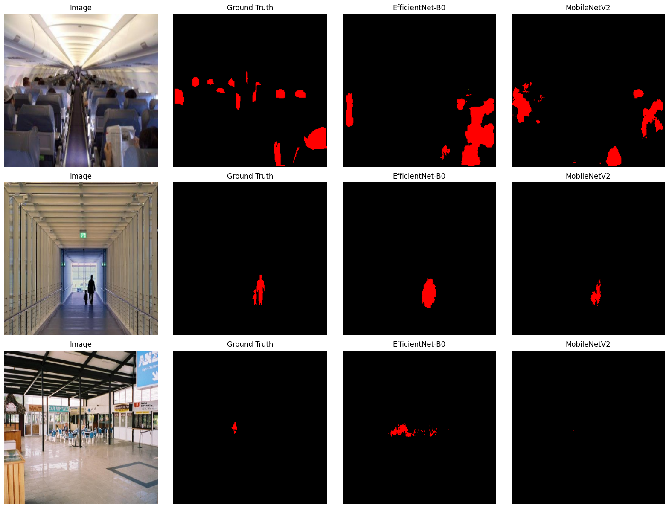
Figure 7: Qualitative comparison on three validation images: input, ground truth, EfficientNet-B0 prediction, MobileNetV2 prediction.
This pattern lines up with what the literature would predict. Zhou et al. (2017) reported that even full-scale scene-parsing models trained on the complete ADE20K benchmark, with tens of thousands of images, still struggle on the long tail of the label distribution; the effect here is more extreme because the training set contains only 13 airplane instances in total rather than being merely underrepresented within a 150-class label set.
The main limitation is the size of the training set itself: 350 images is small for a five-class segmentation task, and the airplane class in particular is close to unlearnable with 13 training instances.

References
- Ronneberger, O., Fischer, P. and Brox, T. (2015) 'U-Net: Convolutional Networks for Biomedical Image Segmentation', in Medical Image Computing and Computer-Assisted Intervention - MICCAI 2015. Cham: Springer, pp. 234-241.
- Sandler, M., Howard, A., Zhu, M., Zhmoginov, A. and Chen, L.-C. (2018) 'MobileNetV2: Inverted Residuals and Linear Bottlenecks', in Proceedings of the IEEE Conference on Computer Vision and Pattern Recognition (CVPR). Salt Lake City: IEEE, pp. 4510-4520.
- Tan, M. and Le, Q. (2019) 'EfficientNet: Rethinking Model Scaling for Convolutional Neural Networks', in Proceedings of the 36th International Conference on Machine Learning, PMLR 97, pp. 6105-6114.
- Zhou, B., Zhao, H., Puig, X., Fidler, S., Barriuso, A. and Torralba, A. (2017) 'Scene Parsing through ADE20K Dataset', in Proceedings of the IEEE Conference on Computer Vision and Pattern Recognition (CVPR). Honolulu: IEEE, pp. 633-641.

Appendix (Code):
# ADE20K — Semantic Segmentation

## 1. Setup & Installs
"""

from google.colab import drive
drive.mount('/content/drive')

!pip install -q pycocotools segmentation-models-pytorch albumentations

import os, json, zipfile
import numpy as np
import pandas as pd
import matplotlib.pyplot as plt
from collections import Counter, defaultdict

import torch
import torch.nn as nn
from torch.utils.data import Dataset, DataLoader

from pycocotools.coco import COCO
from pycocotools import mask as maskUtils
from PIL import Image
import albumentations as A
from albumentations.pytorch import ToTensorV2
import segmentation_models_pytorch as smp

device = "cuda" if torch.cuda.is_available() else "cpu"
print("Using device:", device)

EXTRACT_DIR = "/content/drive/MyDrive/dataset/image_segmentation_dataset"

if not os.path.exists(EXTRACT_DIR):
with zipfile.ZipFile(ZIP_PATH, "r") as z:
z.extractall(EXTRACT_DIR)

print(os.listdir(EXTRACT_DIR))

"""## 2. Load Annotations"""

TRAIN_ANN = os.path.join(EXTRACT_DIR, "instances_train.json")
VAL_ANN = os.path.join(EXTRACT_DIR, "instances_val.json")
TRAIN_DIR = os.path.join(EXTRACT_DIR, "train")
VAL_DIR = os.path.join(EXTRACT_DIR, "val")
TEST_DIR = os.path.join(EXTRACT_DIR, "test")

coco_train = COCO(TRAIN_ANN)
coco_val = COCO(VAL_ANN)

with open(TRAIN_ANN) as f:
train_json = json.load(f)
with open(VAL_ANN) as f:
val_json = json.load(f)

TARGET_CATEGORIES = {4: "person", 9: "car", 40: "book", 59: "airplane"}
CAT_ID_TO_LABEL = {4: 1, 9: 2, 40: 3, 59: 4}
CLASS_NAMES = ["background", "person", "car", "book", "airplane"]

print("Train images:", len(train_json["images"]), "| Train annotations:", len(train_json["annotations"]))
print("Val images:", len(val_json["images"]), "| Val annotations:", len(val_json["annotations"]))

"""## 3. Exploratory Data Analysis (EDA)
### 3.1 Missing value / data integrity checks
Checks required for a segmentation task specifically:
- Every image referenced in the JSON actually exists on disk
- Every image file opens correctly (not corrupt) and is real RGB
- No orphan annotations (annotation pointing to a non-existent image_id)
- No annotations with null/empty segmentation, zero area, or invalid RLE
- Recorded width/height in JSON match the actual image dimensions (mask/image shape mismatch is a common silent bug)
- No duplicate annotation IDs
- Images with zero target-class annotations (won't contribute foreground signal)
"""

def check_missing_images(json_data, img_dir, split_name):
missing = []
unreadable = []
dim_mismatch = []
for img in json_data["images"]:
path = os.path.join(img_dir, img["file_name"])
if not os.path.exists(path):
missing.append(img["file_name"])
continue
try:
with Image.open(path) as im:
im.verify()
with Image.open(path) as im:
w, h = im.size
if (w, h) != (img["width"], img["height"]):
dim_mismatch.append((img["file_name"], (w, h), (img["width"], img["height"])))
except Exception as e:
unreadable.append((img["file_name"], str(e)))

print(f"--- {split_name} ---")
print(f"Missing files: {len(missing)}")
print(f"Unreadable/corrupt files: {len(unreadable)}")
print(f"Width/height mismatches (JSON vs actual file): {len(dim_mismatch)}")
if missing: print(" e.g.", missing[:5])
if unreadable: print(" e.g.", unreadable[:5])
if dim_mismatch: print(" e.g.", dim_mismatch[:5])
return missing, unreadable, dim_mismatch

train_missing, train_unreadable, train_dim_mismatch = check_missing_images(train_json, TRAIN_DIR, "train")
val_missing, val_unreadable, val_dim_mismatch = check_missing_images(val_json, VAL_DIR, "val")

def check_annotation_integrity(json_data, split_name):
image_ids = set(img["id"] for img in json_data["images"])
ann_ids = [a["id"] for a in json_data["annotations"]]

orphan_anns = [a for a in json_data["annotations"] if a["image_id"] not in image_ids]
duplicate_ann_ids = [x for x, c in Counter(ann_ids).items() if c > 1]
zero_area = [a for a in json_data["annotations"] if a.get("area", 0) <= 0]
null_segmentation = [a for a in json_data["annotations"] if not a.get("segmentation")]

# Validate RLE decodes without error
bad_rle = []
for a in json_data["annotations"]:
try:
maskUtils.decode(a["segmentation"])
except Exception:
bad_rle.append(a["id"])

print(f"--- {split_name} ---")
print(f"Orphan annotations (bad image_id): {len(orphan_anns)}")
print(f"Duplicate annotation IDs: {len(duplicate_ann_ids)}")
print(f"Zero-area annotations: {len(zero_area)}")
print(f"Null/empty segmentation field: {len(null_segmentation)}")
print(f"Annotations with undecodable RLE: {len(bad_rle)}")

check_annotation_integrity(train_json, "train")
check_annotation_integrity(val_json, "val")

def images_without_target_classes(json_data, split_name):
target_ids = set(TARGET_CATEGORIES.keys())
imgs_with_target = set(a["image_id"] for a in json_data["annotations"] if a["category_id"] in target_ids)
all_imgs = set(img["id"] for img in json_data["images"])
no_target = all_imgs - imgs_with_target
print(f"{split_name}: {len(no_target)} / {len(all_imgs)} images contain NONE of person/car/book/airplane")
return no_target

train_no_target = images_without_target_classes(train_json, "train")
val_no_target = images_without_target_classes(val_json, "val")

"""### 3.2 Class distribution (all 100 categories, target classes highlighted)"""

def plot_class_distribution(json_data, split_name):
cat_map = {c["id"]: c["name"] for c in json_data["categories"]}
cnt = Counter(a["category_id"] for a in json_data["annotations"])
items = sorted(cnt.items(), key=lambda x: -x[1])[:20] # top 20 for readability
names = [cat_map[i] for i, _ in items]
counts = [n for _, n in items]
colors = ["tomato" if i in TARGET_CATEGORIES else "steelblue" for i, _ in items]

plt.figure(figsize=(10, 5))
plt.bar(names, counts, color=colors)
plt.xticks(rotation=75, ha="right")
plt.ylabel("Instance count")
plt.title(f"Top-20 category frequency — {split_name} (target classes in red)")
plt.tight_layout()
plt.show()

plot_class_distribution(train_json, "train")
plot_class_distribution(val_json, "val")

def target_class_counts(json_data, split_name):
cnt = Counter(a["category_id"] for a in json_data["annotations"] if a["category_id"] in TARGET_CATEGORIES)
print(f"--- {split_name} target-class instance counts ---")
for cid, name in TARGET_CATEGORIES.items():
print(f" {name:10s}: {cnt.get(cid, 0)}")

target_class_counts(train_json, "train")
target_class_counts(val_json, "val")

"""### 3.3 Object size / area distribution for target classes"""

def plot_area_distribution(json_data, split_name):
rows = []
for a in json_data["annotations"]:
if a["category_id"] in TARGET_CATEGORIES:
rows.append({"class": TARGET_CATEGORIES[a["category_id"]], "area": a["area"]})
df = pd.DataFrame(rows)

plt.figure(figsize=(8, 5))
df.boxplot(column="area", by="class")
plt.yscale("log")
plt.ylabel("Area (pixels, log scale)")
plt.title(f"Object area distribution by class — {split_name}")
plt.suptitle("")
plt.tight_layout()
plt.show()

return df.groupby("class")["area"].describe()

train_area_stats = plot_area_distribution(train_json, "train")
train_area_stats

"""### 3.4 Sample visualization — image with mask overlay"""

def show_sample(coco, img_dir, img_id, ax=None):
img_info = coco.imgs[img_id]
image = np.array(Image.open(os.path.join(img_dir, img_info["file_name"])).convert("RGB"))
mask = np.zeros(image.shape[:2], dtype=np.uint8)

ann_ids = coco.getAnnIds(imgIds=img_id, catIds=list(TARGET_CATEGORIES.keys()))
anns = sorted(coco.loadAnns(ann_ids), key=lambda a: -a["area"])
for a in anns:
m = coco.annToMask(a)
mask[m == 1] = CAT_ID_TO_LABEL[a["category_id"]]

overlay = image.copy()
colors = {1: (255,0,0), 2: (0,255,0), 3: (0,0,255), 4: (255,255,0)}
for label, color in colors.items():
overlay[mask == label] = color

blended = (0.6 * image + 0.4 * overlay).astype(np.uint8)
if ax is None:
plt.figure(figsize=(5,5))
plt.imshow(blended); plt.axis("off"); plt.show()
else:
ax.imshow(blended); ax.axis("off")

fig, axes = plt.subplots(1, 4, figsize=(16,4))
sample_ids = list(coco_train.imgs.keys())[:4]
for ax, img_id in zip(axes, sample_ids):
show_sample(coco_train, TRAIN_DIR, img_id, ax=ax)
plt.tight_layout()
plt.show()

"""## 4. Dataset & DataLoader Construction
### 4.1 Compulsory checks/requirements specific to a segmentation `Dataset` class
- Masks must be built at the **same resolution** as the source image before any resize
- Class-overlap handling: when instances overlap, decide a consistent priority (here: larger objects drawn first, smaller drawn last, so small objects aren't erased)
- Image and mask must receive the **same spatial transform** (flip/crop/resize) — using separate/uncoordinated augmentation pipelines for image vs mask is a common silent bug
- Normalization stats should match the encoder's pretrained backbone (ImageNet mean/std here)
"""

TARGET_CATEGORIES = {4: 1, 9: 2, 40: 3, 59: 4} # category_id -> label
CLASS_NAMES = ["background", "person", "car", "book", "airplane"]
NUM_CLASSES = len(CLASS_NAMES)
IMG_SIZE = 256

class ADE20KFourClass(Dataset):
def __init__(self, ann_file, img_dir, transform=None):
self.coco = COCO(ann_file)
self.img_dir = img_dir
self.transform = transform
self.image_ids = sorted(self.coco.imgs.keys())

def __len__(self):
return len(self.image_ids)

def __getitem__(self, idx):
img_id = self.image_ids[idx]
img_info = self.coco.imgs[img_id]
image = np.array(Image.open(os.path.join(self.img_dir, img_info["file_name"])).convert("RGB"))

h, w = img_info["height"], img_info["width"]
mask = np.zeros((h, w), dtype=np.uint8)

ann_ids = self.coco.getAnnIds(imgIds=img_id, catIds=list(TARGET_CATEGORIES.keys()))
anns = sorted(self.coco.loadAnns(ann_ids), key=lambda a: -a["area"])
for ann in anns:
m = self.coco.annToMask(ann)
mask[m == 1] = TARGET_CATEGORIES[ann["category_id"]]

if self.transform:
augmented = self.transform(image=image, mask=mask)
image, mask = augmented["image"], augmented["mask"]

return image, mask.long()

# Same spatial transform applied jointly to image + mask (Albumentations handles this)
train_transform = A.Compose([
A.Resize(IMG_SIZE, IMG_SIZE),
A.HorizontalFlip(p=0.5),
A.RandomBrightnessContrast(p=0.3),
A.Normalize(mean=(0.485, 0.456, 0.406), std=(0.229, 0.224, 0.225)),
ToTensorV2(),
])

val_transform = A.Compose([
A.Resize(IMG_SIZE, IMG_SIZE),
A.Normalize(mean=(0.485, 0.456, 0.406), std=(0.229, 0.224, 0.225)),
ToTensorV2(),
])

train_ds = ADE20KFourClass(TRAIN_ANN, TRAIN_DIR, transform=train_transform)
val_ds = ADE20KFourClass(VAL_ANN, VAL_DIR, transform=val_transform)

BATCH_SIZE = 8
train_loader = DataLoader(train_ds, batch_size=BATCH_SIZE, shuffle=True, num_workers=2)
val_loader = DataLoader(val_ds, batch_size=BATCH_SIZE, shuffle=False, num_workers=2)

print(f"Train samples: {len(train_ds)} | Val samples: {len(val_ds)}")
img, mask = train_ds[0]
print("Image tensor shape:", img.shape, "| Mask tensor shape:", mask.shape, "| unique labels:", torch.unique(mask))

# Class-weighted loss to address the severe airplane imbalance found in EDA (section 3.2)
def compute_class_weights(json_data):
counts = np.zeros(NUM_CLASSES)
for a in json_data["annotations"]:
if a["category_id"] in TARGET_CATEGORIES:
counts[TARGET_CATEGORIES[a["category_id"]]] += 1
counts[0] = counts[1:].sum() # rough background proxy so it isn't weighted absurdly high
weights = 1.0 / np.log(1.02 + counts / counts.sum())
weights = weights / weights.sum() * NUM_CLASSES
return torch.tensor(weights, dtype=torch.float32)

class_weights = compute_class_weights(train_json).to(device)
print("Class weights:", dict(zip(CLASS_NAMES, class_weights.tolist())))

"""## 5. Shared Training / Evaluation Utilities
Defined once, reused for both models — kept in their own cell so each model section only calls a function rather than duplicating logic.
"""

def dice_iou_per_class(preds, targets, num_classes=NUM_CLASSES):
intersection = torch.zeros(num_classes)
union = torch.zeros(num_classes)
pred_sum = torch.zeros(num_classes)
gt_sum = torch.zeros(num_classes)
for c in range(num_classes):
p = (preds == c)
g = (targets == c)
intersection[c] += (p & g).sum().item()
union[c] += (p | g).sum().item()
pred_sum[c] += p.sum().item()
gt_sum[c] += g.sum().item()
iou = intersection / union.clamp(min=1)
dice = (2 * intersection) / (pred_sum + gt_sum).clamp(min=1)
return iou, dice

def train_one_model(model, train_loader, val_loader, epochs=15, lr=1e-4, weights=None):
model = model.to(device)
criterion = nn.CrossEntropyLoss(weight=weights)
optimizer = torch.optim.Adam(model.parameters(), lr=lr)
history = {"train_loss": [], "val_loss": []}

for epoch in range(epochs):
model.train()
running_loss = 0.0
for images, masks in train_loader:
images, masks = images.to(device), masks.to(device)
optimizer.zero_grad()
outputs = model(images)
loss = criterion(outputs, masks)
loss.backward()
optimizer.step()
running_loss += loss.item() * images.size(0)
train_loss = running_loss / len(train_loader.dataset)

model.eval()
val_running_loss = 0.0
with torch.no_grad():
for images, masks in val_loader:
images, masks = images.to(device), masks.to(device)
outputs = model(images)
loss = criterion(outputs, masks)
val_running_loss += loss.item() * images.size(0)
val_loss = val_running_loss / len(val_loader.dataset)

history["train_loss"].append(train_loss)
history["val_loss"].append(val_loss)
print(f"Epoch {epoch+1}/{epochs} | train_loss={train_loss:.4f} | val_loss={val_loss:.4f}")

return history

@torch.no_grad()
def evaluate_model(model, loader):
model.eval()
all_iou = torch.zeros(NUM_CLASSES)
all_dice = torch.zeros(NUM_CLASSES)
n_batches = 0
for images, masks in loader:
images, masks = images.to(device), masks.to(device)
preds = torch.argmax(model(images), dim=1).cpu()
iou, dice = dice_iou_per_class(preds, masks.cpu())
all_iou += iou
all_dice += dice
n_batches += 1
return all_iou / n_batches, all_dice / n_batches

"""## 6. Model 1 — U-Net (EfficientNet-B0 encoder)"""

model_effnet = smp.Unet(
encoder_name="efficientnet-b0",
encoder_weights="imagenet",
classes=NUM_CLASSES,
activation=None,
)
print(sum(p.numel() for p in model_effnet.parameters() if p.requires_grad), "trainable parameters")

history_effnet = train_one_model(
model_effnet, train_loader, val_loader,
epochs=15, lr=1e-4, weights=class_weights
)

torch.save(model_effnet.state_dict(), "unet_efficientnet_b0.pth")

plt.figure(figsize=(6,4))
plt.plot(history_effnet["train_loss"], label="train_loss")
plt.plot(history_effnet["val_loss"], label="val_loss")
plt.xlabel("Epoch"); plt.ylabel("Loss"); plt.title("U-Net (EfficientNet-B0) — Loss Curve")
plt.legend(); plt.tight_layout(); plt.show()

"""## 7. Model 2 — U-Net (MobileNetV2 encoder)"""

model_mobilenet = smp.Unet(
encoder_name="mobilenet_v2",
encoder_weights="imagenet",
classes=NUM_CLASSES,
activation=None,
)
print(sum(p.numel() for p in model_mobilenet.parameters() if p.requires_grad), "trainable parameters")

history_mobilenet = train_one_model(
model_mobilenet, train_loader, val_loader,
epochs=15, lr=1e-4, weights=class_weights
)

torch.save(model_mobilenet.state_dict(), "unet_mobilenet_v2.pth")

plt.figure(figsize=(6,4))
plt.plot(history_mobilenet["train_loss"], label="train_loss")
plt.plot(history_mobilenet["val_loss"], label="val_loss")
plt.xlabel("Epoch"); plt.ylabel("Loss"); plt.title("U-Net (MobileNetV2) — Loss Curve")
plt.legend(); plt.tight_layout(); plt.show()

"""## 8. Model Comparison"""

iou_effnet, dice_effnet = evaluate_model(model_effnet, val_loader)
iou_mobilenet, dice_mobilenet = evaluate_model(model_mobilenet, val_loader)

results = {
"U-Net (EfficientNet-B0)": (iou_effnet, dice_effnet),
"U-Net (MobileNetV2)": (iou_mobilenet, dice_mobilenet),
}

rows = []
for cname_idx, cname in enumerate(CLASS_NAMES):
row = {"Class": cname}
for model_name, (iou, dice) in results.items():
row[f"{model_name} IoU"] = round(iou[cname_idx].item(), 4)
row[f"{model_name} Dice"] = round(dice[cname_idx].item(), 4)
rows.append(row)

comparison_df = pd.DataFrame(rows)
comparison_df

# Mean IoU/Dice over FOREGROUND classes only (excludes background — background
# dominates pixel count and would otherwise mask true foreground performance)
summary_rows = []
for model_name, (iou, dice) in results.items():
summary_rows.append({
"Model": model_name,
"Mean IoU (fg classes)": round(iou[1:].mean().item(), 4),
"Mean Dice (fg classes)": round(dice[1:].mean().item(), 4),
"Trainable Params": sum(p.numel() for p in (model_effnet if "EfficientNet" in model_name else model_mobilenet).parameters())
})
summary_df = pd.DataFrame(summary_rows)
summary_df

fig, axes = plt.subplots(1, 2, figsize=(12,5))
x = np.arange(len(CLASS_NAMES))
width = 0.35

axes[0].bar(x - width/2, iou_effnet.numpy(), width, label="EfficientNet-B0")
axes[0].bar(x + width/2, iou_mobilenet.numpy(), width, label="MobileNetV2")
axes[0].set_xticks(x); axes[0].set_xticklabels(CLASS_NAMES, rotation=45)
axes[0].set_ylabel("IoU"); axes[0].set_title("Per-class IoU"); axes[0].legend()

axes[1].bar(x - width/2, dice_effnet.numpy(), width, label="EfficientNet-B0")
axes[1].bar(x + width/2, dice_mobilenet.numpy(), width, label="MobileNetV2")
axes[1].set_xticks(x); axes[1].set_xticklabels(CLASS_NAMES, rotation=45)
axes[1].set_ylabel("Dice"); axes[1].set_title("Per-class Dice"); axes[1].legend()

plt.tight_layout()
plt.show()

"""### 8.1 Qualitative comparison — predictions vs. ground truth"""

@torch.no_grad()
def visualize_predictions(models_dict, dataset, num_samples=3):
fig, axes = plt.subplots(num_samples, 2 + len(models_dict), figsize=(4*(2+len(models_dict)), 4*num_samples))
colors = np.array([[0,0,0],[255,0,0],[0,255,0],[0,0,255],[255,255,0]], dtype=np.uint8)

for row in range(num_samples):
image, mask = dataset[row]
img_np = image.permute(1,2,0).numpy()
img_np = (img_np * np.array([0.229,0.224,0.225]) + np.array([0.485,0.456,0.406]))
img_np = np.clip(img_np, 0, 1)

axes[row, 0].imshow(img_np); axes[row, 0].set_title("Image"); axes[row, 0].axis("off")
axes[row, 1].imshow(colors[mask.numpy()]); axes[row, 1].set_title("Ground Truth"); axes[row, 1].axis("off")

for col, (name, model) in enumerate(models_dict.items(), start=2):
model.eval()
pred = torch.argmax(model(image.unsqueeze(0).to(device)), dim=1).squeeze(0).cpu().numpy()
axes[row, col].imshow(colors[pred]); axes[row, col].set_title(name); axes[row, col].axis("off")

plt.tight_layout()
plt.show()

visualize_predictions(
{"EfficientNet-B0": model_effnet, "MobileNetV2": model_mobilenet},
val_ds,
num_samples=3
)

