MUHAMMAD WAQAS  Full-Stack Software Engineer  Gujranwala, Pakistan | 0332-0772166 | github.com/waqas273 | iwaqass.xyz | 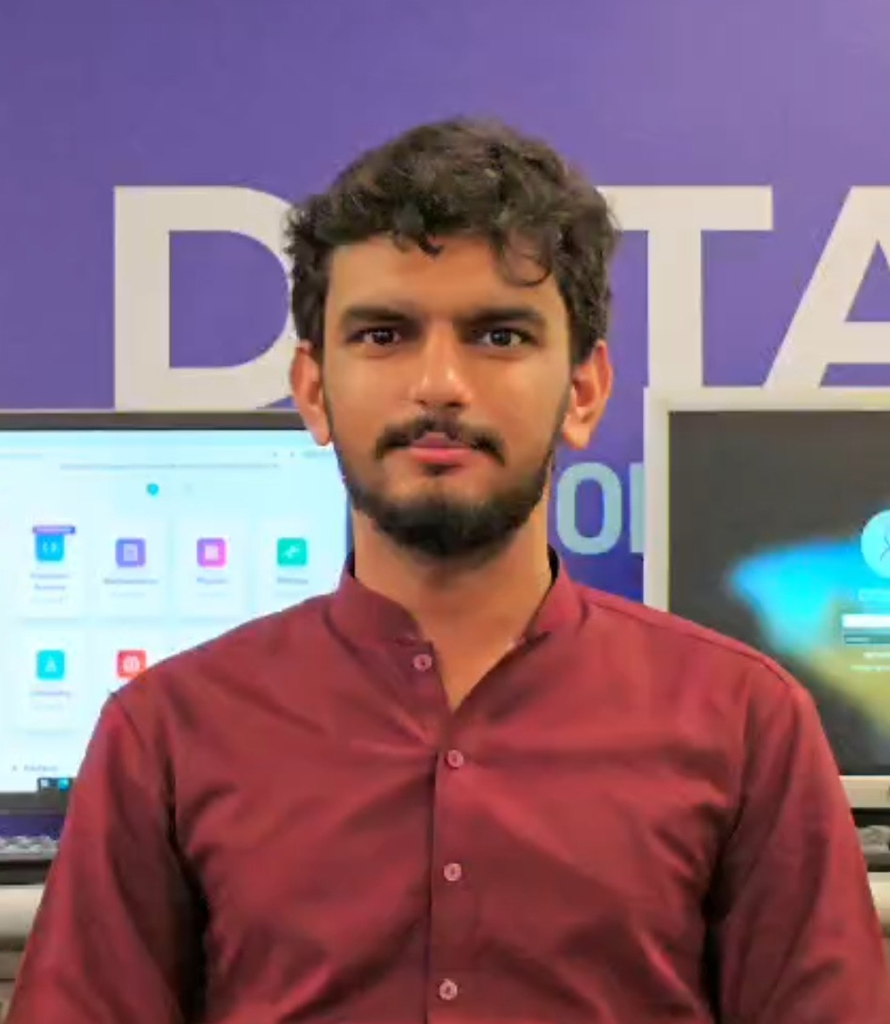

OBJECTIVE
Full-stack software engineer with hands-on experience building production-style web applications across AI/ML integration, real-time systems, and e-commerce. Seeking a Software Engineer / Full-Stack role to apply skills in React, Firebase, and Python-based backends to real-world engineering problems.
EDUCATION
BS Computer Science — GIFT University, Gujranwala (2022–2026)
Intermediate — Govt FMF College, People's Colony (2020–2022)
Matriculation — Govt. High School Denser Pain (2018–2020)
PROJECTS
EduNest — AI-Powered EdTech & University Discovery Platform | Final Year Project
- Built a full-stack platform combining a Random Forest ML model for career interest prediction and a RAG pipeline (ChromaDB + Groq Llama 3.3-70B) for AI-generated MDCAT/ECAT mock exams
- Implemented GIS-based university discovery using Leaflet.js with real-time GPS distance ranking
- Developed a three-portal RBAC system (Student, University Manager, Admin) with Firebase Auth and Firestore
- Integrated in-browser content moderation using TensorFlow.js
Stack: React 19, Vite, Tailwind CSS, Python/Flask, Scikit-Learn, ChromaDB, Groq API, Firebase
E-Voting System Pakistan — Digital Election Platform
- Developed a full-stack e-voting portal simulating the Election Commission of Pakistan's digital process
- Implemented role-based access control for four user types (Admin, Party Manager, Independent Candidate, Voter)
- Built real-time vote casting with cryptographic (SHA-256) audit hashing and duplicate-vote prevention
- Designed a live election results dashboard with constituency-level data sync via Firestore
Stack: React 18, Vite, Tailwind CSS, Firebase Firestore/Auth, EmailJS, Cloudinary
Sparkle Hub — E-Commerce Platform
- Built a full-stack e-commerce platform for a handmade resin-art business with product catalog, cart, and checkout
- Integrated EasyPaisa payment gateway with screenshot-based payment verification and order tracking pipeline
- Developed an admin dashboard with revenue analytics, order management, and CRM-style customer tracking
- Implemented client-side PDF invoice generation using jsPDF and html2canvas
Stack: React 19, Vite, Tailwind CSS, Firebase Firestore/Auth, Cloudinary, EmailJS
TECHNICAL SKILLS
Languages: JavaScript, Python
Frontend: React, Tailwind CSS, Vite, Framer Motion
Backend & Database: MERN Stack (MongoDB, Express.js, React, Node.js), Firebase (Firestore, Auth, Storage), Flask
AI/ML: Scikit-Learn, RAG (ChromaDB), Groq API, TensorFlow.js
Tools & Services: Cloudinary, EmailJS, Git/GitHub

