MedBridge Shared Medication Care App
Hackathon workflow and implementation brief prepared for Kashaf Noor Babar and a five person team

Recommended concept
Build an Urdu and English app that connects a patient, a doctor and a pharmacist around one verified medication plan. The patient uploads a prescription, receives approved instructions and reminders, finds participating pharmacies, and reports concerns through a shared consultation case.
The strongest distinction is the care loop: prescription → professional verification → understandable instructions → medicine access → patient feedback → coordinated review. Reminders alone are common; show how the three roles complete one patient journey.

Purpose and positioning
Present the app as a way to make pharmacists’ medication expertise visible and improve coordination with doctors. Avoid claiming that it will eliminate professional conflict. It gives each professional clear responsibilities, records their decisions, and helps the patient receive one consistent plan.
Suggested pitch: MedBridge connects patients, doctors and pharmacists so that every verified prescription becomes an understandable medication plan, a medicine access pathway and a shared follow up conversation.

What AI does
AI extracts a draft from the prescription, simplifies confirmed instructions into Urdu or English, supports voice questions, and summarises patient reports for the care team. It must identify missing or unclear information rather than guess. Professionals confirm clinical content; ordinary software schedules reminders and searches stock.

Demo scope and national ambition
Demonstrate one fictional patient, one doctor, one pharmacist and three fictional pharmacies in one city. Use synthetic records and a clear demo label. Design city and language fields for expansion, but describe nationwide coverage as a future goal requiring partners, verified professionals and reliable inventory updates.
No hackathon acceptance or award can be guaranteed. A complete, reliable care journey is more persuasive than many unfinished features. The concept is plausible; its usefulness and demand still need patient and professional feedback.

Patient workflow step by step

1 Register and choose access
The patient selects Urdu or English and creates an account. Collect minimum information, allergies and current medicines. Explain consent before sharing records. Offer optional caregiver access with patient permission; the demo can use precreated accounts.

2 Upload the prescription
The patient photographs or uploads the prescription. AI proposes medicine name, strength, formulation, dose, route, frequency, duration and any written food instructions. Show the original beside the extracted draft. Unreadable handwriting or missing fields remain marked for clarification.

3 Obtain professional verification
The prescription stays pending. The pharmacist checks the transcription and medicine instructions; the doctor resolves unclear orders and confirms the treatment plan. Pharmacist review cannot silently change prescribed treatment. Only the approved plan activates reminders.

4 Confirm the daily schedule
The patient sees approved instructions and chooses suitable reminder times within the confirmed dosing requirements. Fixed intervals, as needed medicines and short courses require different schedule rules. As needed medicines should not become automatic fixed dose alerts.

5 Find and obtain medicine
Search participating pharmacies for the exact product or a professionally approved equivalent. Display strength, dosage form, stock status and last update. The patient requests confirmation or reservation; the pharmacy confirms availability before travel.

6 Receive reminders and record use
The app displays the medicine, approved dose, time and relevant instructions, with Urdu or English text and optional audio. Buttons record taken, skipped or remind later. These are patient reports, not proof of consumption. Missed dose advice must come from approved medicine specific guidance.

7 Report progress or a problem
The patient selects a reason such as not improving, suspected side effect, medicine unavailable or missed doses, and can record a voice message. AI organises the report without diagnosing it. Do not imply that lack of immediate improvement automatically means treatment failure.

8 Receive the reviewed outcome
The care team reviews the case. The patient receives the doctor approved decision and pharmacist counselling. If a new prescription is issued, the previous plan is archived, future old reminders are cancelled, and the patient confirms the updated schedule.

Doctor and pharmacist collaboration
Role | Responsibilities in the proposed app
Patient | Upload records, approve access, record medicine use, report concerns and confirm understanding.
Doctor | Confirm diagnosis and prescribed treatment, resolve unclear orders, review progress and approve clinical treatment changes.
Care pharmacist | Verify medicine details, check counselling instructions, review adherence and availability, and document recommendations for the doctor.
Pharmacy operator | Update inventory and confirm reservations. Access stock tasks and only the patient information needed to fulfil a request.
AI assistant | Prepare drafts, translations and summaries. It has no prescribing or approval authority.

When the patient says the medicine is not helping

1 Open a shared case
Ask when treatment began, which doses were taken, what symptoms changed, and whether adverse effects occurred. Attach the active prescription and patient reported medication log with consent.

2 Route the concern
Use a clinician reviewed urgent symptom pathway. For potentially serious symptoms, show instructions to seek urgent care rather than wait for an asynchronous reply. The demo must not imply that clinicians are continuously available.

3 Pharmacist reviews and doctor decides
The pharmacist reviews adherence, access barriers, administration and relevant medicine concerns. The doctor assesses the clinical response and decides whether an examination, test or treatment change is required. AI summarises both contributions; it does not choose an alternative.

4 Publish one clear care decision
Record the recommendation, doctor decision, author and time. A disagreement remains unresolved until clarified; do not send contradictory plans to the patient. Provide the approved explanation in the chosen language.

Two different kinds of alternatives
Same ingredient alternative: a different brand may be considered after checking strength, formulation, route and any release characteristics. A qualified professional confirms suitability under applicable practice rules. A therapeutic alternative uses a different medicine or regimen and needs a doctor’s treatment decision. Neither should be offered as an automatic AI substitution.
Role permissions described here are proposed product rules, not a statement of Pakistani legal prescribing authority. Confirm professional scope, privacy requirements and teleconsultation arrangements before a real pilot.

Pharmacy availability and database design
Yes, a shared database is needed. A medicine catalogue identifies products; a separate inventory table says which pharmacy reports having them. DRAP’s registered product resources can help verify product identity, but registration information does not establish current stock at a particular pharmacy.
Record | Essential fields
Users and access | User ID, role, language, consent, caregiver permissions; verified credentials for a real pilot.
Prescriptions and plans | Patient ID, original file, extracted fields, reviewer, approval status, version, start and end dates.
Medicine catalogue | Product ID, brand, ingredient, strength, dosage form, route, release type and source.
Pharmacies and stock | Pharmacy ID, city, location, contact; product ID, quantity or status, updated time and updater.
Reminders and logs | Plan version, scheduled time, notification status and patient reported taken or skipped event.
Cases and decisions | Concern, assigned professionals, messages, recommendation, approved outcome and audit trail.
Reservations | Patient request, product, pharmacy confirmation, expiry and fulfilment status.

How stock becomes searchable
For the demo, seed three fictional pharmacies and around ten medicine records. A pharmacist updates stock through a simple dashboard or CSV upload. Search filters by location and exact product fields. Label results as reported availability, show the update time, and let the pharmacy confirm a reservation.
For a real pilot, recruit a small pharmacy network, verify participating pharmacies, agree on update frequency and define when stock becomes stale. Later, connect compatible pharmacy inventory systems with their permission. Do not assume a nationwide live stock feed or a public DRAP stock API exists.

Implementation approach
Use the stack the engineers already know: a mobile friendly app, a managed relational database, protected prescription storage, an OCR or vision service, and a language model for grounded explanations. Keep clinical approval, inventory matching and reminder timing in application logic. Demonstrate notifications inside the app first; real background delivery needs platform permissions and reliability checks.
Keep model credentials on the server. Restrict access by role and assigned patient, encrypt records, retain an audit trail and support consent withdrawal. A medicine search should not reveal a patient’s complete medical history to every pharmacy.

Build priorities and judge demonstration
Build now | Defer until after the hackathon
Three role dashboards and one patient record | Nationwide onboarding and credential verification integrations
Prescription draft with professional approval | Reliable recognition of every handwriting style
Approved bilingual instructions and reminder simulation | Full voice chat and production background notifications
Three pharmacy stock records and confirmation | Live nationwide inventory and delivery payments
Patient concern and shared review outcome | Video consultations and automated interaction screening

A focused four minute demo
First minute: the patient uploads a synthetic prescription; AI extracts it and flags one unclear field. Second minute: the pharmacist checks the draft and the doctor confirms the plan; Urdu instructions and a reminder appear. Third minute: one pharmacy reports no stock, another confirms availability. Final minute: a patient concern opens a shared case; pharmacist input and the doctor’s approved outcome update the plan. Use a clearly labelled follow up time jump.

Five person team allocation
Kashaf: patient journey, source material, pharmacy terminology, sample cases and pitch. Engineer 1: patient interface and language toggle. Engineer 2: professional dashboards and permission controls. Engineer 3: prescription extraction and grounded bilingual generation. Engineer 4: database, stock search, reminder simulation and integration. Agree on one shared data contract before coding.

Suggestions that strengthen the idea
Make shared professional review the main differentiator. Add patient teach back: ask the patient to explain the approved instructions in their own words and flag misunderstandings for review. Include caregiver support and large text if time allows. An availability timestamp is more valuable than a large map of unverified pharmacies.
To support national relevance, begin with Urdu and English, design for additional languages, minimise mobile data use and plan a carefully controlled pilot across community pharmacies and clinics. Present expansion as a phased pathway: one city pilot, additional partner cities, then wider coverage based on evidence and infrastructure.

What to verify before presenting
Check that unclear prescription fields block activation, translations preserve the approved meaning, unauthorised users cannot view records, exact strength and formulation govern stock matching, and old reminders stop after a plan changes. Measure extraction errors and task completion on synthetic cases. Explain which data and notifications are simulated; do not invent impact statistics or partner commitments.

Sources and limits
WHO Medication Without Harm and its patient engagement tools support the medication safety framing: https://www.who.int/initiatives/medication-without-harm
DRAP pharmaceutical product resources support catalogue verification, not pharmacy stock: https://www.dra.gov.pk/therapeutic-goods/drugs/pharmaceuticals/
Prepared 2 October 2026. This is a proposed demo workflow, not a validated clinical system or a confirmed nationwide service.

Benefits for doctors and pharmacists
The app helps patients follow a professionally approved plan. It does not diagnose, prescribe, decide that treatment has failed, or replace an examination. Patients still consult a doctor for clinical assessment and treatment decisions. The pharmacist supports medicine use, access and follow up within their verified professional scope.

How doctors benefit
Doctors receive an organised summary of the patient’s concerns, medication use and previous plan before consultation. They can identify who needs an appointment, provide appropriate follow up, and record decisions without repeatedly reconstructing the history. Appointment requests can connect patients to the doctor’s clinic.

How doctors can earn
Proposed options are paid in person appointments, paid teleconsultations where appropriate, and clearly priced follow up reviews. The app can show the fee and appointment time before booking. Income depends on real demand and completed services; it is not guaranteed. The doctor is paid for professional assessment and care, not for access to AI generated instructions.

How pharmacists benefit
Pharmacists have a visible professional role: checking prescription details, explaining approved instructions, reviewing adherence concerns, and communicating recommendations to the doctor. A shared record makes their contribution clear. Participating pharmacies can receive stock confirmation and reservation requests, reducing wasted patient visits.

How pharmacists and pharmacies can earn
Where permitted and accepted locally, a pharmacy or clinic can pay pharmacists for medication review and counselling services. Participating pharmacies can earn ordinary dispensing revenue from fulfilled medicine purchases. Counselling fees, medicine costs and any platform charges should be shown separately; the pilot must verify professional scope and local arrangements.

How the app could be funded
Start with free reminders and approved instructions for patients. Later, test a clinic or pharmacy subscription for dashboards, workflow and inventory tools. Any consultation booking charge should be disclosed and checked against applicable rules. Do not fund clinical recommendations through payments for selecting a particular medicine or pharmacy.

How to explain the idea to professionals
The app gives doctors a clearer patient history and a route to appropriate consultations. It gives pharmacists a documented role in medication care. The patient receives one coordinated plan. Professional decisions remain visible, attributable and reviewable.
For the hackathon, simulate booking and fees with fictional data. Do not collect money, promise doctor availability or claim that paid partnerships already exist. A professional review should be requested when useful, rather than making patients pay for every routine reminder or app question.

MedBridge prescription and medicine access workflow
Follow the arrows from registration to medicine use. Yellow diamonds show decisions; colours identify the patient, pharmacist and doctor steps.
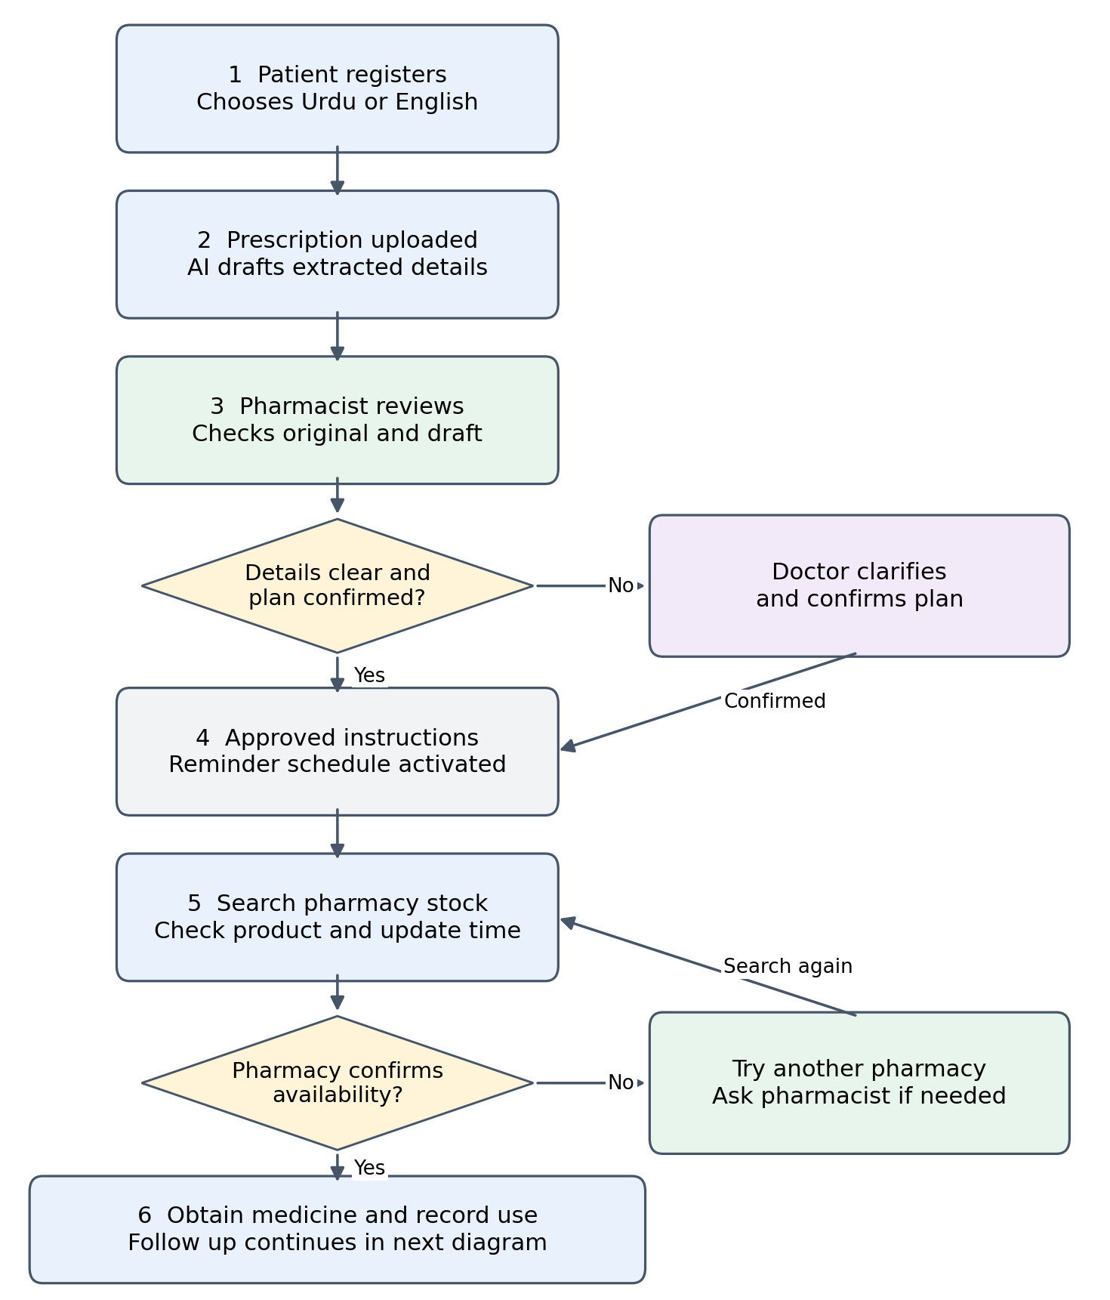

MedBridge follow up and consultation workflow
Patient concerns move through professional review. AI prepares summaries and translations; professionals confirm decisions. Appointments and fees are simulated in the demo.
