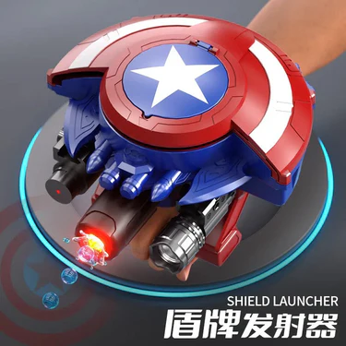
Rating :
Discription: Unleash superhero action with the Captain America Gel Ball Shooter Shield, inspired by Captain America. Designed with a bold shield style, it fires soft gel balls for safe and exciting play. Lightweight, easy to use, and made from durable materials, it’s perfect for kids who love heroic adventures and action-packed fun
Ball Shooter
Shield
Price : 4,890

