**GROUP MEMBERS:**

MEHTAB AHMED (SP21-BSE-058)

WAQAS KHALID (SP21-BSE-094)

**PROJECT NAME:**

ONLINE FOOD MANAGEMENT

**Scope:**

Our proposed system project will be designed to support following features: -

* The system will have a user-friendly interface.
* It will keep record of fast food
* Multiple customers can use it at same time due to different so.
* Each customer has different sections and also different automatically generated order number
* Customer can even edit their order i.e., remove or add anything any time before checkout.
* Payment method is up to customer.
* This system will automatically show the sub total of your order.

**Functionality:**

The basic functionality of our project is:

1. **Menu:**

Updated Menu with the options of sidelines plus deals menu.

1. **Update customer information:**

Customer can update their information and detail again if there is some mistake in it.

1. **Customer details:**

Whole detail of different customers saved individually.

1. **Generate bills:**

Whole order detail of individual customer is shown with their order and address, order number, date, total amount, payment mode in one click.

1. **Add/Remove Cart:**

Customer can even update (add or remove) any thing from their menu if they want

1. **Payment mode:**

The payment mode is up to customer rather it’s card payment or cash on delivery.

**Description:**

We are developing and trying to work on online food management system to firstly complete the customer’s craving of fast food and then keep the record of customers delivered in large number without getting crashed if used by multiple users at same time. This management system software is capable enough to keep records as well about particular person to store and retrieve any type of record with just a single click of mouse. Online Food management system software allows really creative, interactive and friendly Graphic User Interface environment where even minor users can use it in very cozy, comfortably and easy mode and can be delivered at their door step without having any tension of getting Covid.

**USECASE DIAGRAM:**

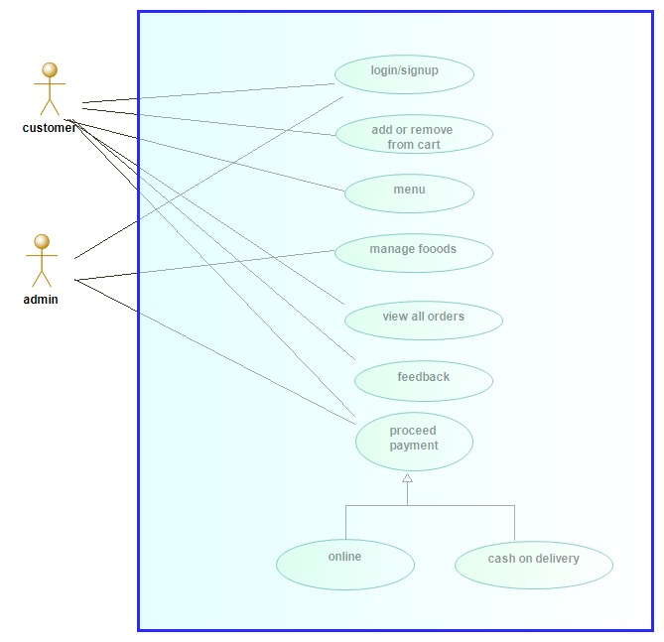

**Use-Case Description:**

## **Use case 1:** Login/Sign Up

### Login/Sign Up

|  |  |  |
| --- | --- | --- |
| **Use Case ID:** | | UC-1.01 |
| **Use Case Name:** | | Login/Sign Up |
| **Actors:** | Customer, Admin | |
| **Preconditions:** | 1. Login option has been selected. 2. System has good internet connection. | |
| **Postconditions:** | Success Guarantees:   1. Customer account created successfully 2. Admin account created successfully.   Minimal Guarantees:   1. Customer account already exist 2. Admin account already exits. | |
| **Normal Flow:** | 1. Customers and Admin select login/signup option 2. System will ask user to enter username 3. System will ask user to enter password 4. System will ask user and admin about their information e.g., name, address, contact number 5. System will send verification code and customer must verify the account 6. Account will be created | |
| **Alternative Flows:**  **[Alternative Flow 1 – Username already exist]** | 3a. In step 3 of the normal flow, if the Username already exist   1. System will display the message of Account Already Exist 2. User Click on OK button 3. Use Case resumes on step 6 | |
| **Exceptions:** | 5a. In step 5 of normal flow, if user enter the wrong verification code   1. System will display message of wrong verification code 2. System will give the option to resend the code 3. Use case resume on step 6 | |
| **Includes:** | 1. Enter Username 2. Enter Password | |
| **Quality Requirements** |  | |

## **Use case 2:** Add/Remove Cart

## Add/Remove Cart

|  |  |  |
| --- | --- | --- |
| **Use Case ID:** | | UC-1.03 |
| **Use Case Name:** | | Add/Remove Cart |
| **Actors:** | Customer | |
| **Preconditions:** | 1. Add/ Remove option has been selected. 2. Cart cannot be empty. | |
| **Postconditions:** | Success Guarantees:   1. Item is successfully added/removed   Minimal Guarantees:   1. You haven’t updated any item | |
| **Normal Flow:** | 1. Customer select add/remove item option 2. System will ask user to select any option whether add or remove 3. User will select any option 4. System will then ask user which item you want to add/remove 5. System will display the message of confirm order 6. System will update the cart 7. Item successfully added/removed | |
| **Alternative Flows:** |  | |
| **Exceptions:** |  | |
| **Includes:** | 1. Add Item 2. Remove Item 3. Confirm Order | |
| **Quality Requirements** |  | |

## **Use case 3:** View All Order

## View All Order

|  |  |  |
| --- | --- | --- |
| **Use Case ID:** | | UC-1.04 |
| **Use Case Name:** | | View All Order |
| **Actors:** | Customer | |
| **Preconditions:** | 1. User account must be login 2. Cart cannot be empty | |
| **Postconditions:** | Success Guarantees:   1. Whole order of the specific customer can be shown | |
| **Normal Flow:** | 1. Customer select View All Order option 2. Whole order of the customer will be displayed | |
| **Alternative Flows:** |  | |
| **Exceptions:** |  | |
| **Includes:** |  | |
| **Quality Requirements** | Food, Beverages and Side-line will be shown separately in different dialog-box. The total amount of each thing will also be shown | |

## **Use case 4:** Proceed Payment

|  |  |  |
| --- | --- | --- |
| **Use Case ID:** | | UC-1.051 |
| **Use Case Name:** | | Proceed Payment |
| **Actors:** | Customer | |
| **Preconditions:** | 1. User account must be login 2. System has good internet connection | |
| **Postconditions:** | Success Guarantees:   1. Payment method has been added | |
| **Normal Flow:** | 1. Customer select Proceed Payment Option 2. System will ask user doing payment by Cash on delivery or Online Payment 3. If user select online payment, System will ask user to enter branch card number 4. Verification code will be sent 5. Successfully accepted message will be displayed 6. Payment method has been added | |
| **Alternative Flows:**  **[Alternative Flow 1 –Verification Problem]** | 4a. In step 4 of the normal flow, if the User don’t verify it card number   1. System will display an error 2. System will send the verification code again 3. System will ask the user to enter the code again to verify it card 4. Successfully accepted message will be displayed 5. Use case resume at step 6 | |
| **Exceptions:** | 3a. In step 3 of normal flow, if user enter the wrong card number   1. System will display message of Invalid Card Number 2. Ask the user to enter the card again in correct format like BBBB-XXXXXXX-DD 3. Use case resume on step 4 | |
| **Includes:** | 1. Enter Card Number | |
| **Quality Requirements** | If Customer already have an account, the database will check it and display that card number and ask user to add another card number if user want | |

## **Use case 5:** Manage Food

|  |  |  |
| --- | --- | --- |
| **Use Case ID:** | | UC-1.06 |
| **Use Case Name:** | | Manage Food |
| **Actors:** | Manager | |
| **Preconditions:** | 1. Manager account must be login 2. Managers have complete database | |
| **Postconditions:** | Success Guarantees:   1. Will update menu and deals 2. Will update cart when customer add or remove something | |
| **Normal Flow:** | 1. Banker will go to the updating center 2. Three options will be appeared 3. System will ask manager to update menu, add or remove item 4. Manager will select the option according to what customer require 5. Menu, add or remove item will be updated. | |
| **Alternative Flows:** |  | |
| **Exceptions:** |  | |
| **Includes:** | 1. Update Food item | |
| **Quality Requirements** |  | |

## **Use case 6:** Feedback:

|  |  |  |
| --- | --- | --- |
| **Use Case ID:** | | UC-1.10 |
| **Use Case Name:** | | Feedback |
| **Actors:** | Customer | |
| **Preconditions:** | 1. Customer account must be login | |
| **Postconditions:** | Success Guarantees:   1. Your review has been saved | |
| **Normal Flow:** | 1. Customers select Rating option 2. System will ask user to either rate food or rate app 3. Users select the option 4. System will save the rating in database 5. System will display the message of “Your review has been saved” | |
| **Alternative Flows:** |  | |
| **Exceptions:** |  | |
| **Includes:** |  | |
| **Quality Requirements** |  | |