SMIT CLOUD DATA ENGINEERING BATCH – 3
SQL SERVER QUIZ # 1
QUERIES AND OUTPUT
NAME: HAFIZ MUHAMMAD WAQAS
ROLL NO: 465476

Q1. List top 5 customers by total order amount.
Retrieve the top 5 customers who have spent the most across all sales orders. Show CustomerID, CustomerName, and TotalSpent.
SQL QUERY:
select
TOP 5
c.CustomerID,
c.Name,
sum(s.TotalAmount) as TotalSales
from [dbo].[Customer] c
inner join SalesOrder s
on s.CustomerID = c.CustomerID
group by c.CustomerID, c.Name
order by TotalSales desc;
OUTPUT:
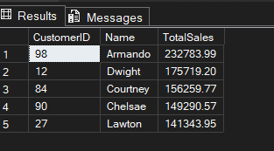

Q2. Find the number of products supplied by each supplier.

Display SupplierID, SupplierName, and ProductCount. Only include suppliers that have more than 10 products.
SQL QUERY:
select s.SupplierID, s.Name, count(p.ProductID) as ProductsCount
from [dbo].[Supplier] s
inner join [dbo].[PurchaseOrder] po
on s.SupplierID = po.SupplierID
inner join [dbo].[PurchaseOrderDetail] pod
on po.OrderID = pod.OrderID
inner join [dbo].[Product] p
on pod.ProductID = p.ProductID
group by s.SupplierID, s.Name
having count(p.ProductID) > 10;
OUTPUT:
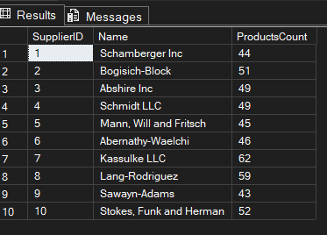

Q3. Identify products that have been ordered but never returned.
Show ProductID, ProductName, and total order quantity.
SQL QUERY:
select p.ProductID, p.Name, sum(sod.Quantity) as TotalOrderQuantity
from [dbo].[Product] p
left join [dbo].[ReturnDetail] r
on p.ProductID = r.ProductID
inner join [dbo].[SalesOrderDetail] sod
on p.ProductID = sod.ProductID
WHERE r.ProductID is null
group by p.ProductID, p.Name;

OUTPUT:
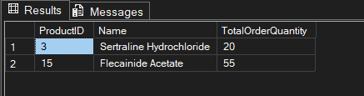
Q4. For each category, find the most expensive product.
Display CategoryID, CategoryName, ProductName, and Price. Use a subquery to get the max price per category.
SQL QUERY:
select c.CategoryID, c.Name, p.Name, p.Price
from [dbo].[Category] c
inner join [dbo].[Product] p
on c.CategoryID = p.CategoryID
where p.Price = (select Max(p1.Price) from [dbo].[Product] p1
where p.CategoryID = p1.CategoryID
)order by p.Price desc;

OUTPUT:
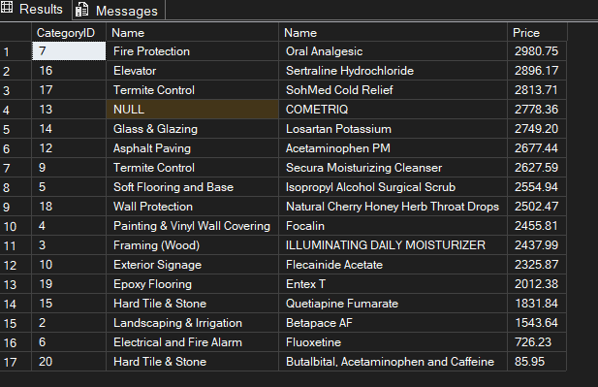
Q5. List all sales orders with customer name, product name, category, and supplier.
For each sales order, display:
OrderID, CustomerName, ProductName, CategoryName, SupplierName, and Quantity.
SQL QUERY:
select so.OrderID, cus.Name CustomerName, p.Name ProductName, c.Name CategoryName, s.Name SupplierName, sod.Quantity
from [dbo].[Supplier] s
inner join [dbo].[PurchaseOrder] po
on s.SupplierID = po.SupplierID
inner join [dbo].[PurchaseOrderDetail] pod
on po.OrderID = pod.OrderID
inner join [dbo].[Product] p
on pod.ProductID = p.ProductID
inner join [dbo].[Category] c
on p.CategoryID = c.CategoryID
inner join [dbo].[SalesOrderDetail] sod
on p.ProductID = sod.ProductID
inner join [dbo].[SalesOrder] so
on sod.OrderID = so.OrderID
inner join [dbo].[Customer] cus
on so.CustomerID = cus.CustomerID;

--- OR ----

SELECT
so.OrderID,
cus.Name AS CustomerName,
p.Name AS ProductName,
c.Name AS CategoryName,
m.Name AS SupplierName,
sod.Quantity
FROM dbo.SalesOrder so
INNER JOIN dbo.Customer cus
ON so.CustomerID = cus.CustomerID
INNER JOIN dbo.SalesOrderDetail sod
ON so.OrderID = sod.OrderID
INNER JOIN dbo.Product p
ON sod.ProductID = p.ProductID
INNER JOIN dbo.Category c
ON p.CategoryID = c.CategoryID
INNER JOIN dbo.Manufacturer m
ON p.ManufacturerID = m.ManufacturerID;
OUTPUT:
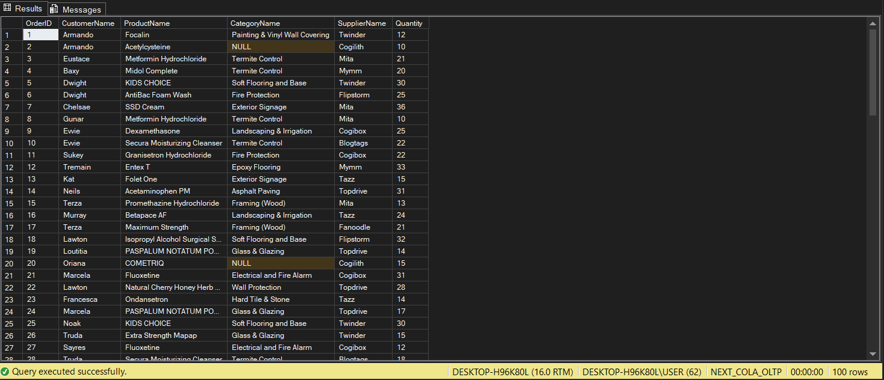
Q6. Find all shipments with details of warehouse, manager, and products shipped.
Display:
ShipmentID, WarehouseName, ManagerName, ProductName, QuantityShipped, and TrackingNumber.
SQL QUERY:
select
s.ShipmentID,
l.Name Warehouse_Name,
e.Name Manager_Name,
p.Name Product_Name,
sd.Quantity,
s.TrackingNumber
from [dbo].[Shipment] s
inner join [dbo].[Warehouse] w
on s.WarehouseID = w.WarehouseID
inner join [dbo].[Location] l
on w.LocationID = l.LocationID
inner join [dbo].[Employee] e
on w.ManagerID = e.ManagerID
inner join [dbo].[ShipmentDetail] sd
on s.ShipmentID = sd.ShipmentID
inner join [dbo].[Product] p
on sd.ProductID = p.ProductID
OUTPUT:
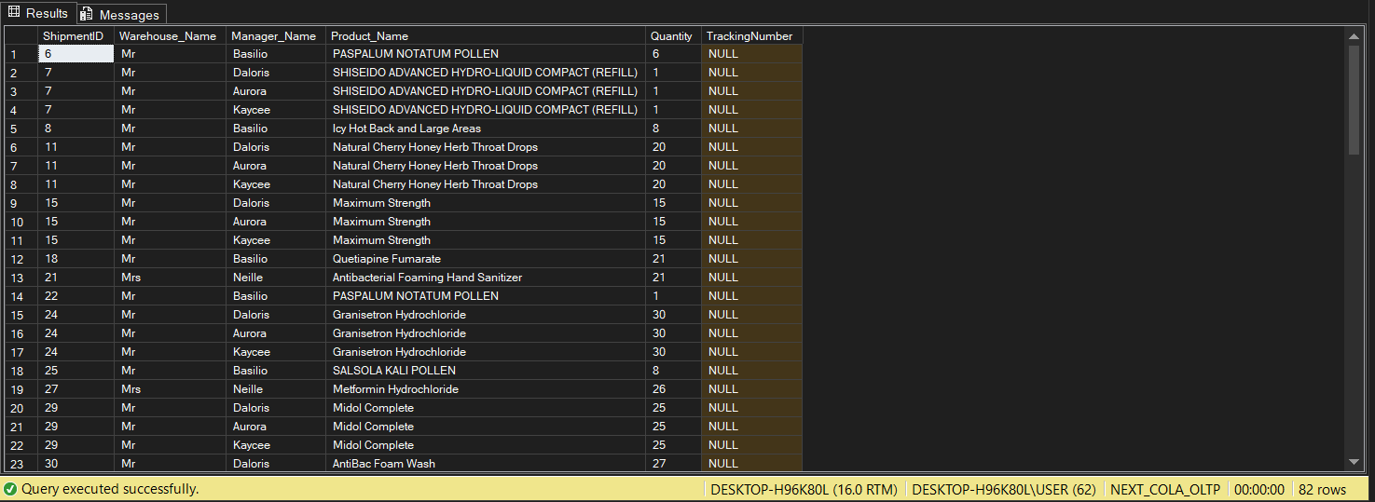
Q7. Find the top 3 highest-value orders per customer using RANK(). Display CustomerID, CustomerName, OrderID, and TotalAmount.
SQL QUERY:
with cte as (
select
c.CustomerID,
c.Name,
so.OrderID,
so.TotalAmount,
RANK() OVER (PARTITION BY so.CustomerID ORDER BY so.TotalAmount DESC) rnk
from
[dbo].[Customer] c
inner join [dbo].[SalesOrder] so
on c.CustomerID = so.CustomerID
)
select *
from
cte
where rnk <= 3
OUTPUT:
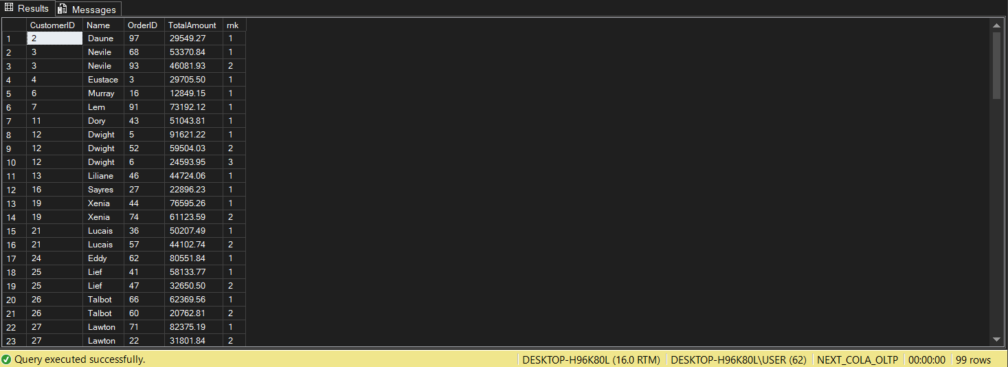
Q8. For each product, show its sales history with the previous and next sales quantities (based on order date). Display ProductID, ProductName, OrderID, OrderDate, Quantity, PrevQuantity, and NextQuantity.
SQL QUERY:
select
p.ProductID,
p.Name,
sod.OrderID,
so.OrderDate,
sod.Quantity,
LAG(sod.Quantity) OVER (PARTITION BY p.ProductID ORDER BY so.OrderDate) PrevQuantity,
LEAD(sod.Quantity) OVER (PARTITION BY p.ProductID ORDER BY so.OrderDate) NextQuantity
from
[dbo].[SalesOrderDetail] sod
inner join [dbo].[Product] p
on sod.ProductID = p.ProductID
inner join [dbo].[SalesOrder] so
on sod.OrderID = so.OrderID;
OUTPUT:
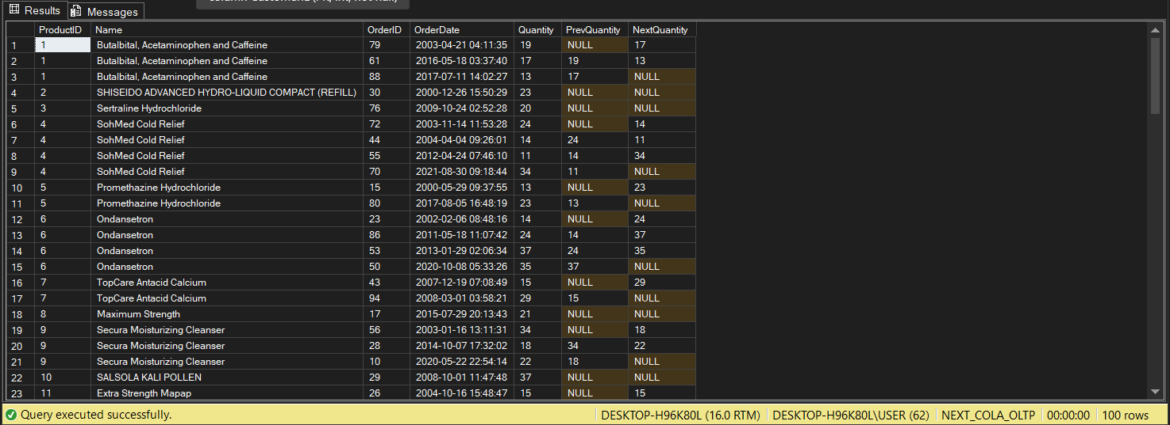
Q9. Create a view named vw_CustomerOrderSummary that shows for each customer:
CustomerID, CustomerName, TotalOrders, TotalAmountSpent, and LastOrderDate.
SQL QUERY:
create view vw_CustomerOrderSummary
as
select
c.CustomerID,
c.Name,
COUNT(so.OrderID) TotalOrders,
SUM(so.TotalAmount) TotalAmount,
MAX(so.OrderDate) LastOrderDate
from
[dbo].[Customer] c
inner join [dbo].[SalesOrder] so
on c.CustomerID = so.CustomerID
group by
c.CustomerID,
c.Name;

select * from vw_CustomerOrderSummary;
OUTPUT:
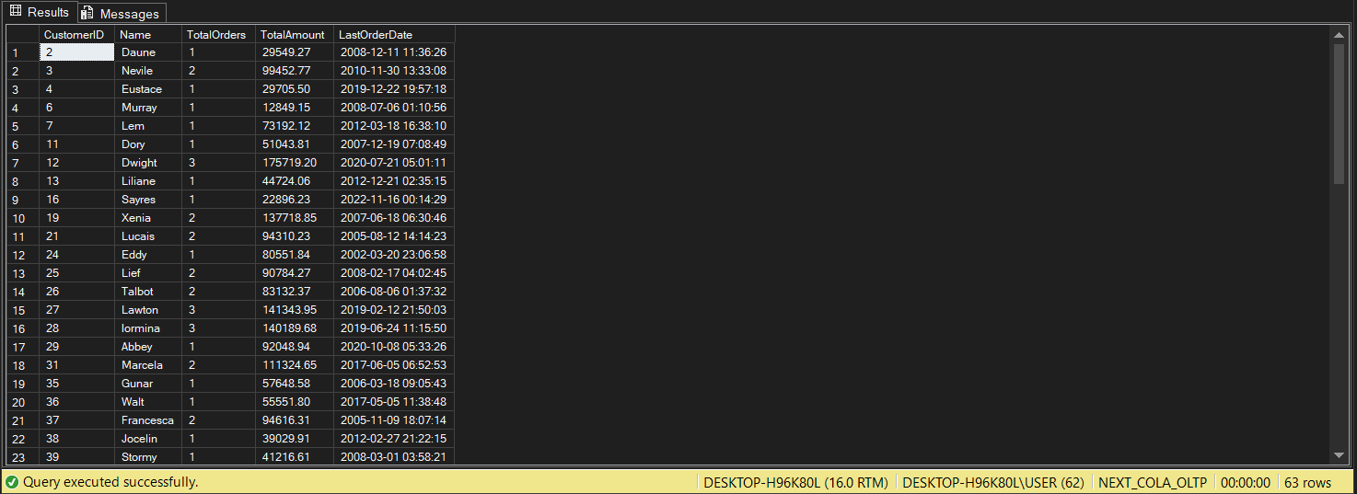
Q10. Write a stored procedure sp_GetSupplierSales that takes a SupplierID as input and returns the total sales amount for all products supplied by that supplier.
SQL QUERY:
alter procedure sp_total_sales
@SupplierID int
as
begin
select
ISNULL(SUM(pod.TotalAmount), 0) TotalSalesAmount
from
[dbo].[Supplier] sp
inner join [dbo].[PurchaseOrder] po
on sp.SupplierID = po.SupplierID
inner join [dbo].[PurchaseOrderDetail] pod
on po.OrderID = pod.OrderID
where sp.SupplierID = @SupplierID
end;

exec sp_total_sales 2;
OUTPUT:
