NewCrop Identity Proofing and Credentialing Service: Doctor’s Summary

Surescripts, the electronic pharmacy network, now requires identity proofing and credentialing *before you are able to transmit prescriptions.* Identity proofing is done through Verizon’s Universal Identity Service (UIS). (This is a separate division of the company from mobile phones.) NewCrop then confirms your license, practice, etc. Your EMR may allow prescription printing, but the following process must be completed before transmitting is activated. (This summary is followed by a detailed step-by-step document.)

**Question:** Have you ever signed up for EPCS with Verizon with any other hospital/nursing home/office before? If so, please note that you are NOT allowed to use the same email address or cell phone number when you go through this process. Make sure you use your own personal email address (gmail works well for this process) and you cannot share email addresses with anyone else in the office.

* Identity proofing
  + NOTE: UIS confirms that you are who you say you are. Thus, be sure and enter your personal information and address, not your practice information.
  + Start be using this link to the Verizon UIS site. <https://universalid.verizon.com/uid/index.php/issuanceservice/registration/individual/41511098-65c2-4cfb-8ee5-6e021671a669/ZFR>
  + Set up
    - Create a user name: this cannot be changed.
    - Create a password: this can be unique
  + Completion of the UIS process requires your entering a 6 digit one-time pass code. Enter your desired methods to receive this. The land line option is needed as a back-up method separate from the mobile phone.
    - Your mobile phone for text messages
    - Direct phone line, if available, for a voice message.
    - Download the app on your phone, see attached document.
    - FOBs or hard tokens are also available (Contact your EMR for more information)
  + Answer the Identity Confirmation questions: only 2 minutes are allowed.
    - If you successfully answer all question, your vetting level is “high.” You will now see the “Safe BioPharma page” (The “certificate” is a page of random characters that provides an unbreakable encryption method.)
    - If you fail the questions, your vetting level is “medium.” Follow the steps to submit a notarized attestation form.
  + Upon completion of ID proofing, NewCrop will continue with credentialing.
* Credentialing
  + Email [providerverification@newcroprx.com](mailto:providerverification@newcroprx.com) with the following:
    - The email address you used when signing up for your IDP profile.
    - Your personal mobile number which will be used once, only for verification purposes.
    - Your office address, phone number and contact person, such as office manager. (This contact CANNOT be the provider.) This will be used once to confirm you are in an active practice.
    - The EMR that you will be using.
    - Scanned copies or fax to 832-553-1889
      * Medical license, DEA, NPI
      * State ID such as driver’s license
* Upon completion, you will receive a confirming text message. NewCrop will inform your EMR that you may now transmit prescriptions electronically.

Thanks for your patience with this unavoidably complex process.

**NewCrop IDP Process and Policy**

Please read and complete this entire process.

You will need to click on the link below, go through the IDP process. When you are going through the process you will need to use their **home address** not their office address. You will also need to add you home/office/cell phone numbers. Each provider can only use 1 email address, this email address cannot be shared by anyone else in the practice. One email address per provider.

[https://universalid.verizon.com/uid/index.php/issuanceservice/registration/individual/](https://universalid-int.verizon.com/uid/index.php/issuanceservice/registration/individual/)41511098-65c2-4cfb-8ee5-6e021671a669/ZFR

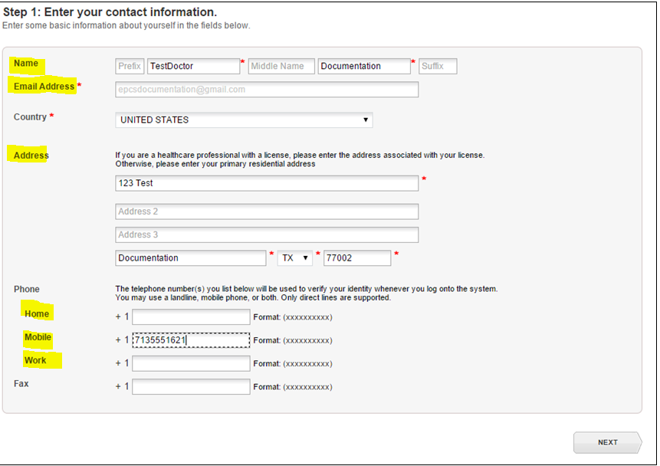

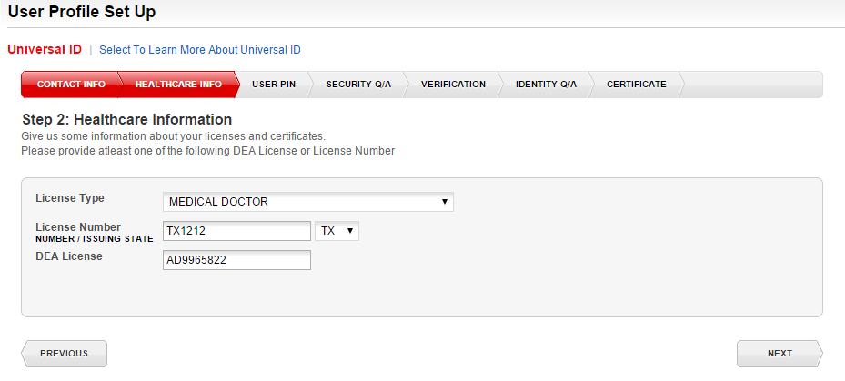

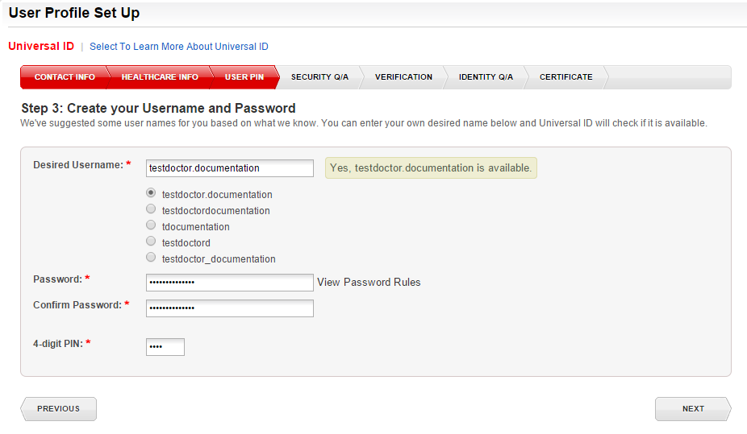

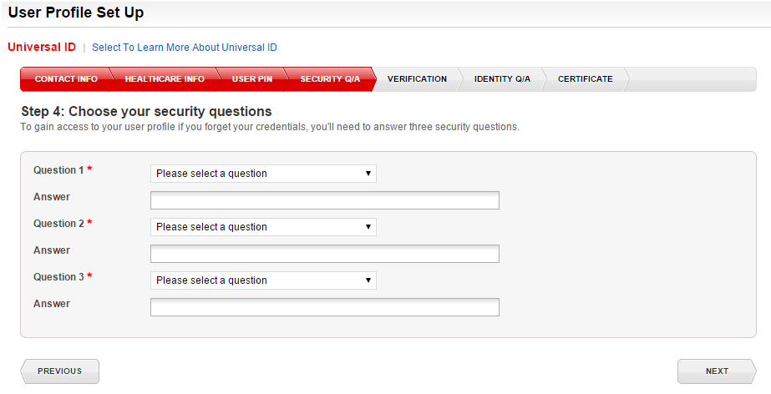

Provider will need to choose a way to receive their OTP (one time password) phone call/text message.

Select your passcode method – text or voice call. Review the confirmation message > Click <Yes>

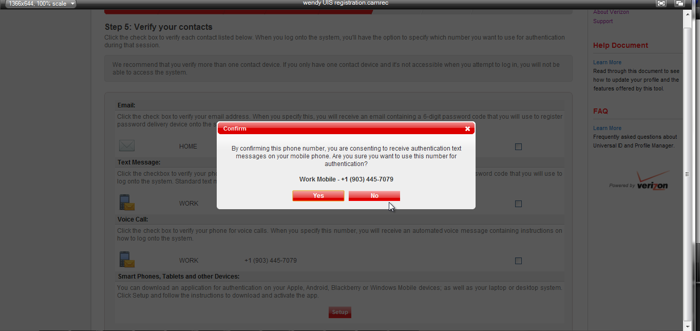

A confirmation/activation passcode will be sent via voice call or text message > Enter the 6-digit One Time Passcode. Click <Verify>

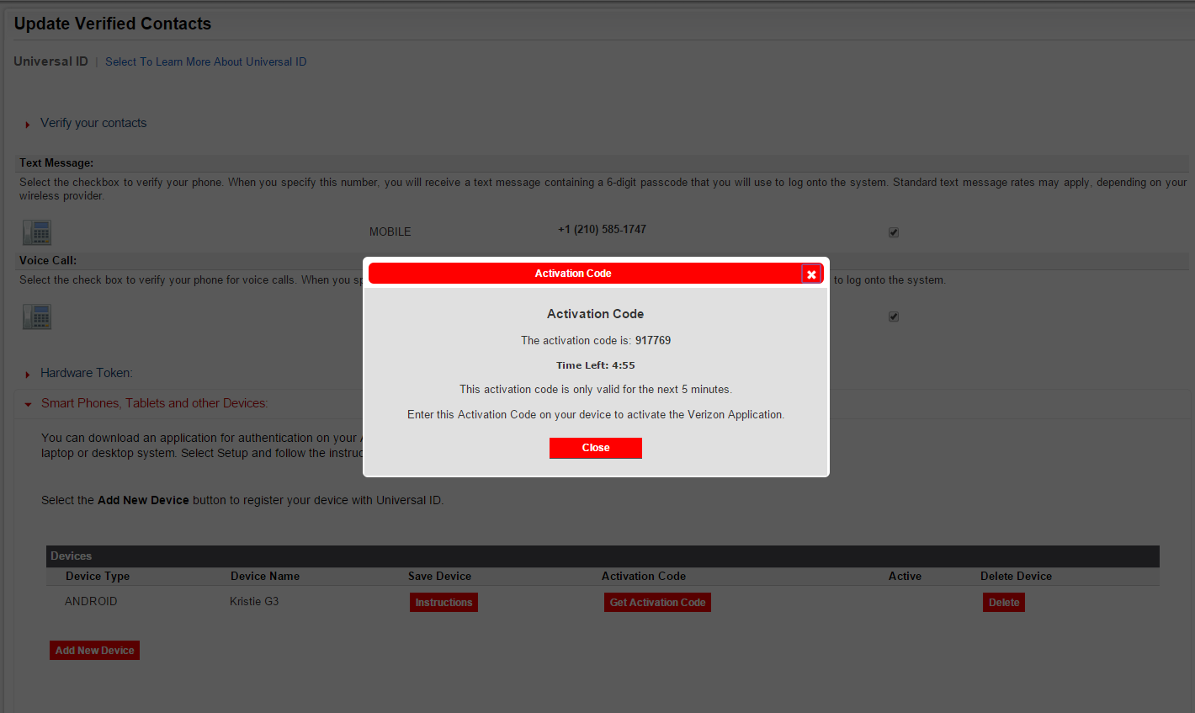

A check mark will confirm your selection > Click <Next>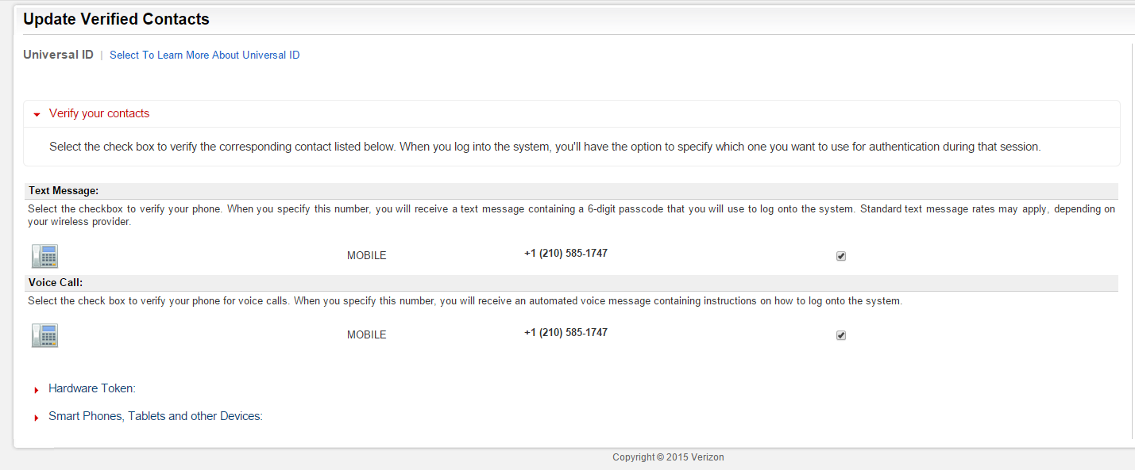

Enter the last 4 digits of your Social Security Number > Select the month and year of your birth from the drop down lists provided > Click <Next>

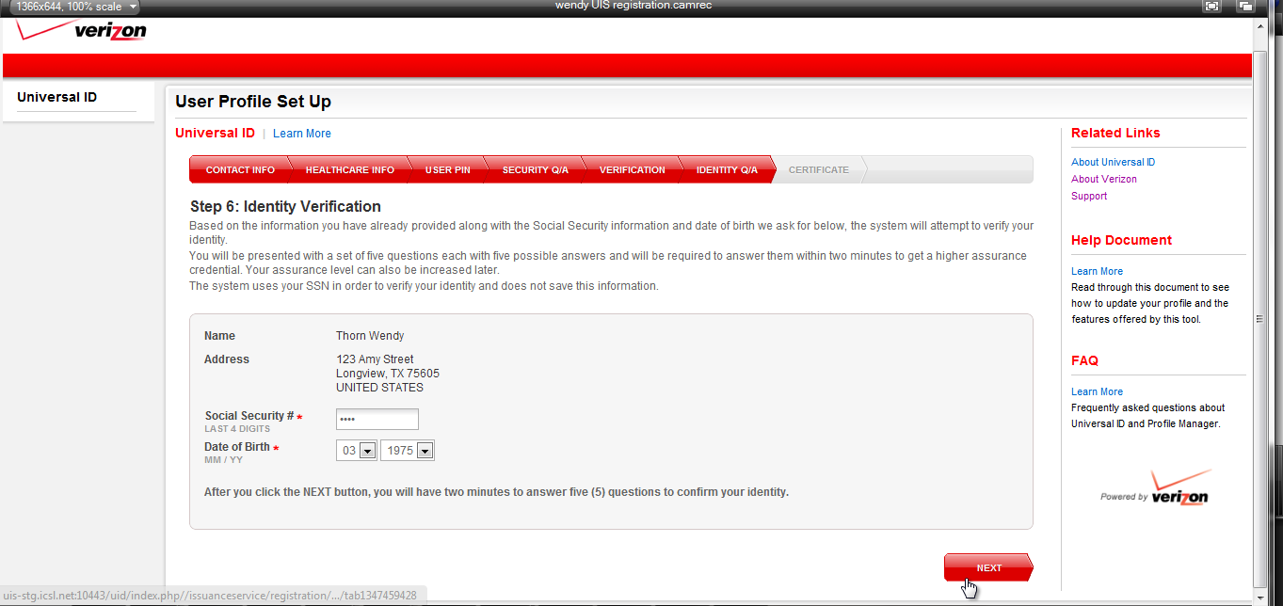

Now you will need to answer the security questions, this is a timed section so please pay attention to the time remaining and chose the correct responses:

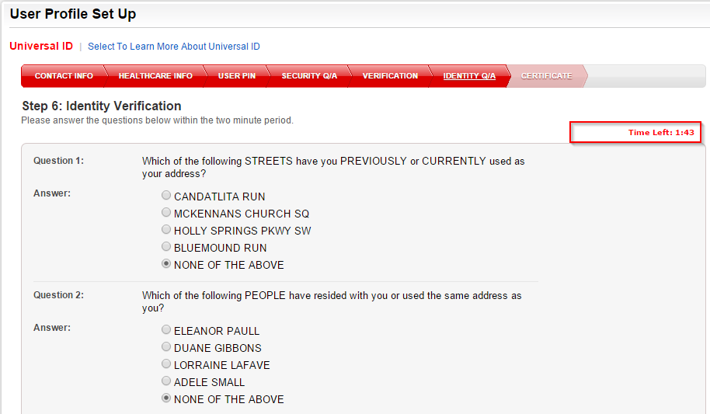

If you have successfully answered all the security questions you should now see the certificate page with the language indicating it has been provisioned. Enter your password created above and click the ‘Next’ button

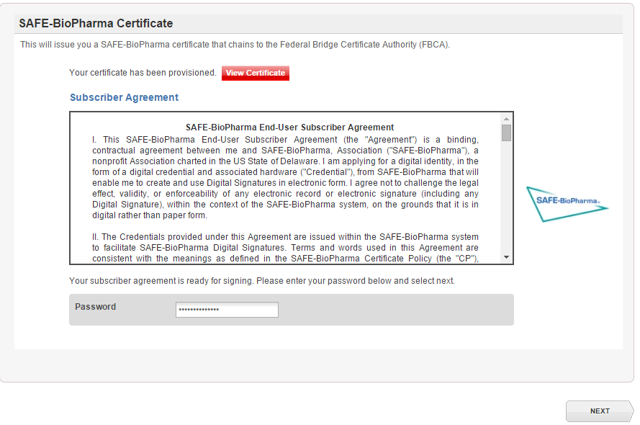

You should see a popup asking you if you agree to the terms of the certificate. Click sign

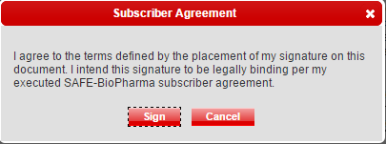

Your account has been successfully created. Your account has been successfully created. You are required to receive at least a medium assurance level with Verizon to complete your IDP process. If you received an LOA 2 (medium) or LOA 3 (high) then please follow the steps below. If you did not receive a medium or high then you will need to attempt again (under a different email address) or submit a notary form.

YOU DO NOT HAVE TO SUBMIT A NOTARY IF YOU RECEIVED AN LOA 2 OR MEDIUM ASSURANCE LEVEL.

You will be asked to print out an identity form to be signed by a notary. This form must be faxed to UIS at 1-800-701-9814 as well as mailed via certified mail so that it can be tracked if needed.

**Once you have completed the IDP profile process please email NewCrop the following information:**

Email address you used when you set up your IDP PROFILE, Office Address and contact name and phone number at the office (not the provider)

****Photo Copy of the following documents: DEA#/NPI#/State License# and state it is issued from/Drivers LicensePlease and the name of your cell phone carrier and cell phone number email NewCrop at: [PROVIDERVERIFICATION@NEWCROPRX.COM](mailto:PROVIDERVERIFICATION@NEWCROPRX.COM)

NewCrop will then valadate all of your creditials to verify you are truly a provider with active creditials.

Once NewCrop has validated all this inforamtion we will then send you a text message to your cell phone letting you know that you have been IDP succesfully and you can now work with your EMR to be added to their system.