Overview:
This lab guides you through the design and deployment of a secure, two-tier cloud infrastructure on Microsoft Azure. The architecture separates web-facing and database services into isolated network segments, enforcing strict access controls through Azure Network Security Groups (NSGs) and the principle of least privilege.
In real-world environments, one of the most common causes of data breaches is the exposure of sensitive backend systems particularly databases directly to the internet. This lab addresses that risk head-on by implementing a defense-in-depth strategy, where multiple layers of security controls work together to protect critical assets even if one layer is compromised.
Step 1: Create the Resource Group
A Resource Group is a logical container in Azure that holds all related resources for a solution. Every Azure resource virtual machines, networks, security groups, IP addresses must belong to a resource group. When you delete a resource group, every resource inside it is automatically deleted as well. This makes cleanup simple and ensures no orphaned resources are left running and incurring costs.
Instructions
- Sign in to the Azure Portal
- In the top search bar, type Resource Groups and select it from the results
- Click + Create
- Fill in the following details:
  - Subscription: Select your active subscription
  - Resource Group Name: CloudSecLab-RG
  - Region: Choose a region close to you (e.g., Canada Central)
- Click Review + Create, then Create

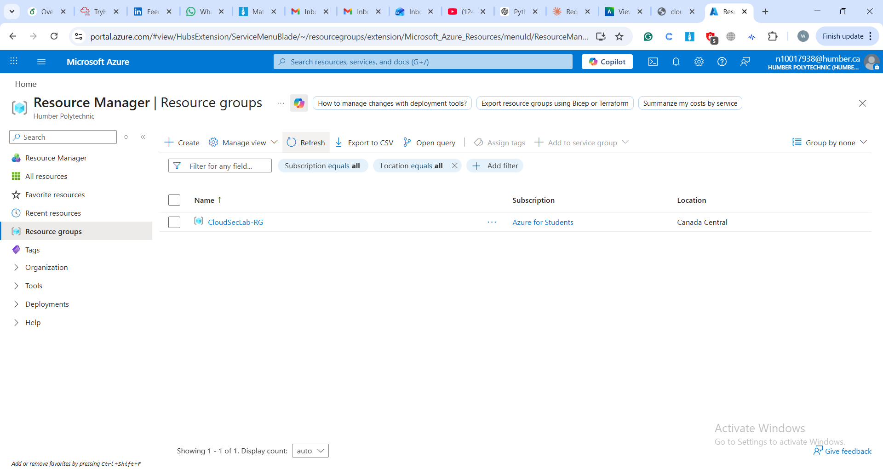

Step 2: Create the Virtual Network
Before creating subnets, we need a Virtual Network (VNet) to contain them. Think of the VNet as the private network boundary for your entire infrastructure nothing inside it is reachable from the internet unless you explicitly allow it.
Instructions
- In the Azure Portal search bar, type Virtual Networks and select it
- Click + Create
- Under the Basics tab:
  - Resource Group: CloudSecLab-RG
  - Name: CloudSecLab-VNet
  - Region: Same region as your resource group
- Under the IP Addresses tab:
  - Set the IPv4 address space to 10.0.0.0/16 — this gives the entire VNet a pool of 65,536 IP addresses
  - Delete any default subnet that Azure adds automatically — you will create your own in the next steps
- Click Review + Create, then Create

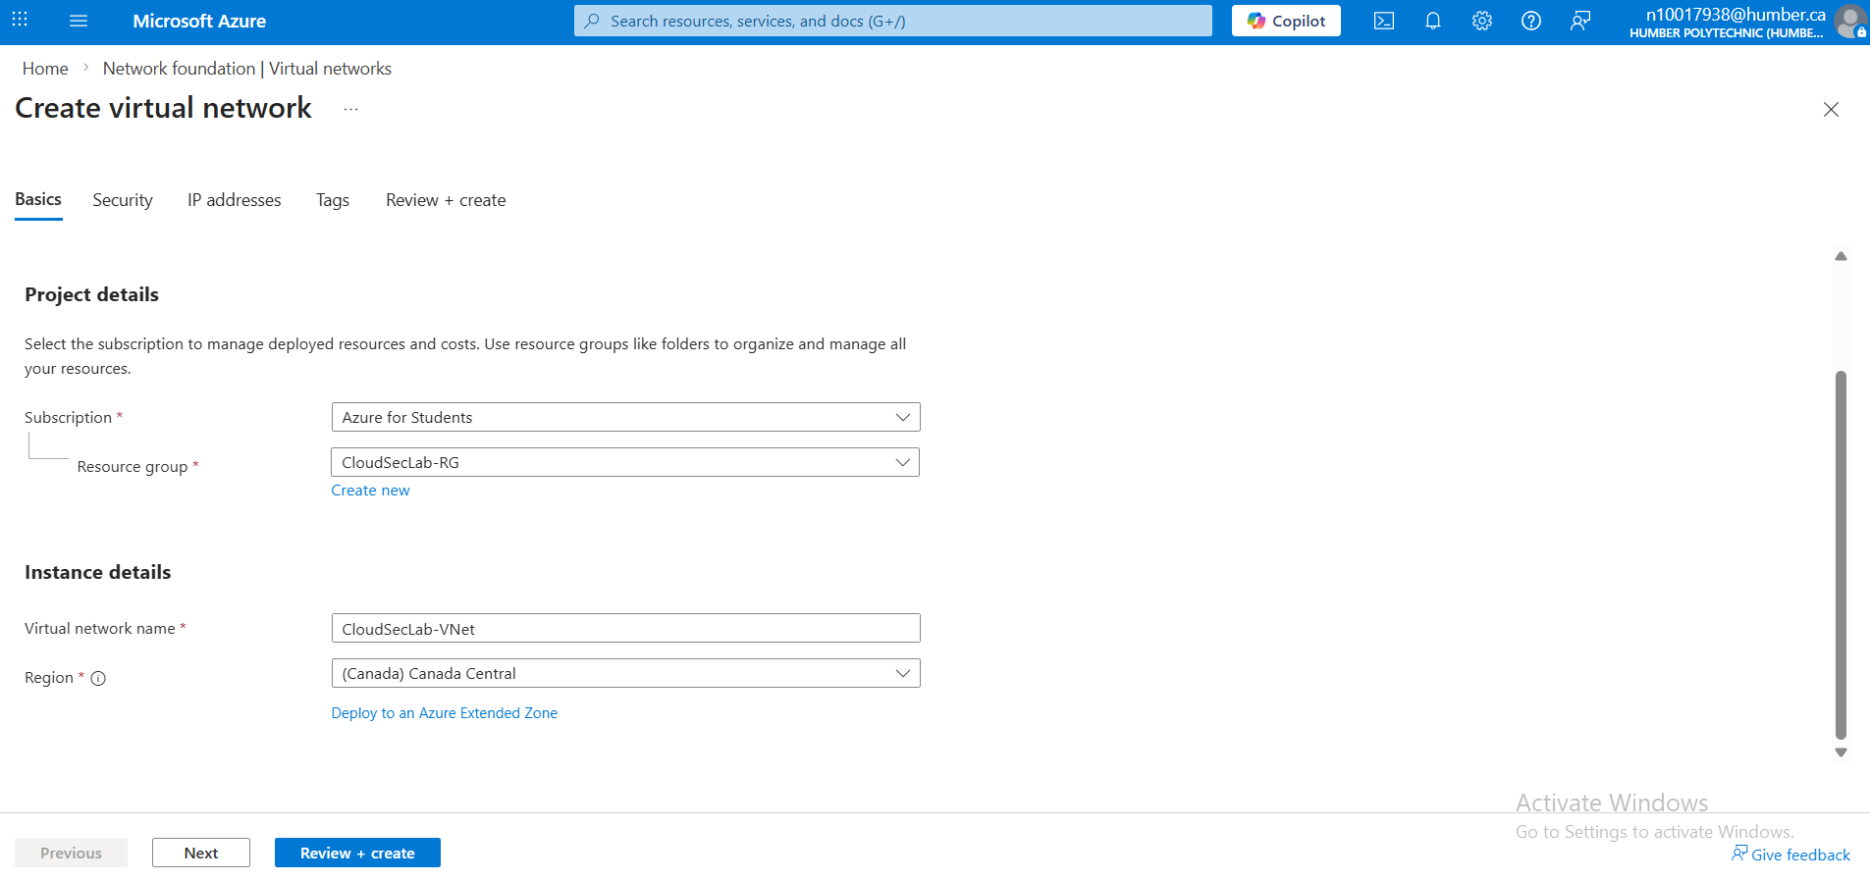

Step 3: Create the Web Tier Subnet
A subnet is a subdivision of your virtual network's address space. Segmenting your infrastructure into separate subnets is a core security practice it lets you apply different access rules to different parts of your system. The Web Tier subnet will host your public-facing web server.
Instructions
- Navigate to your newly created CloudSecLab-VNet
- In the left menu, select Subnets
- Click + Subnet
- Fill in the following:
  - Name: WebTier-Subnet
  - Subnet address range: 10.0.1.0/24
- Leave all other settings as default and click Save
Note: A /24 subnet provides 256 total IP addresses (ranging from 10.0.1.0 to 10.0.1.255). Azure reserves the first 4 and last 1 address for internal use, leaving 251 usable IPs for your resources.

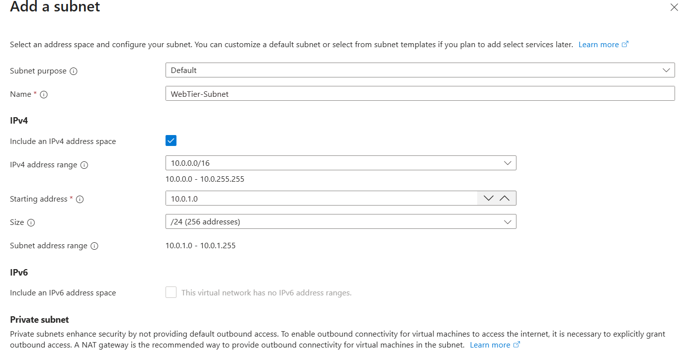
Step 4: Create the Database Tier Subnet
The Database Tier subnet is intentionally hidden from the public internet. No resource in this subnet will be assigned a public IP address all communication to the database will flow through the internal private network from the web tier.
Instructions
- Within CloudSecLab-VNet, go to Subnets
- Click + Subnet
- Fill in the following:
  - Name: DataTier-Subnet
  - Subnet address range: 10.0.2.0/24
- Leave all other settings as default and click Save
Note: Like the WebTier-Subnet, this /24 block provides 256 addresses (10.0.2.0 to 10.0.2.255) with 251 usable. Your database server will be assigned 10.0.2.4.

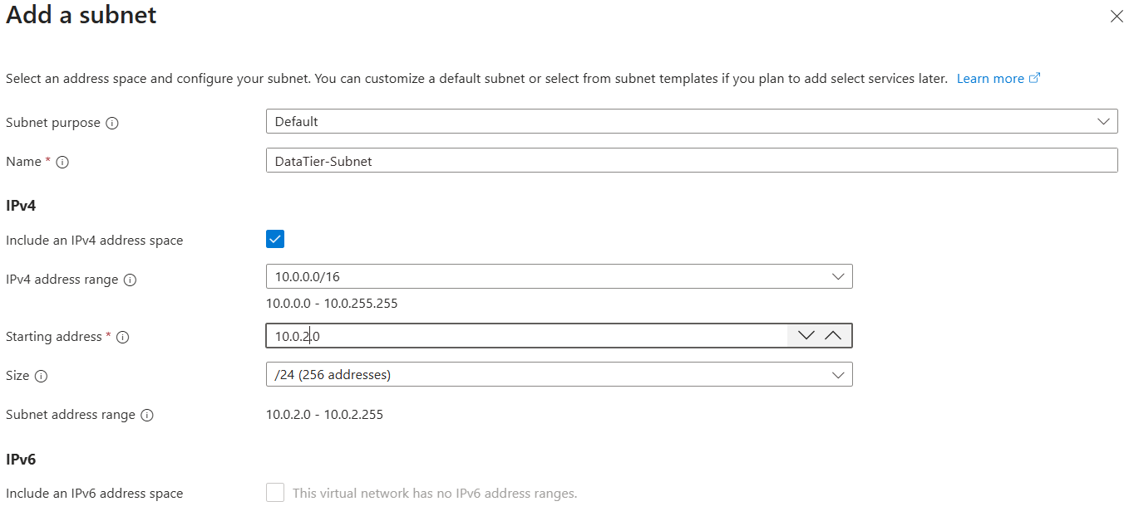

Step 5: Create the Web Server Virtual Machine
The Web Server VM is the public-facing component of your infrastructure. It runs Apache on Ubuntu and sits inside the WebTier-Subnet, acting as the only entry point for internet traffic into your architecture.
- In the Azure Portal search bar, type Virtual Machines → click + Create → Azure Virtual Machine
- Under the Basics tab, configure the following:
  - Resource Group: CloudSecLab-RG
  - Virtual Machine Name: WebServer-VM
  - Region: Same as your VNet
  - Image: Ubuntu Server 22.04 LTS
  - Size: Standard_B1s (Free Tier)
  - Authentication Type: SSH public key
  - Username: azureuser
  - Public Inbound Ports: Allow selected ports → HTTP (80), SSH (22)
- Click through Disks tab leaving all defaults, then proceed to Networking
- Under the Networking tab, configure:
  - Virtual Network: CloudSecLab-VNet
  - Subnet: WebTier-Subnet (10.0.1.0/24)
  - Public IP: (new) WebServer-VM-ip
  - NIC Network Security Group: Basic
  - Inbound Ports: HTTP (80), SSH (22)
- Click Review + Create → once validation passes, click Create
- Once deployed, go to the VM overview and note down the Public IP address and confirm the Private IP is 10.0.1.4

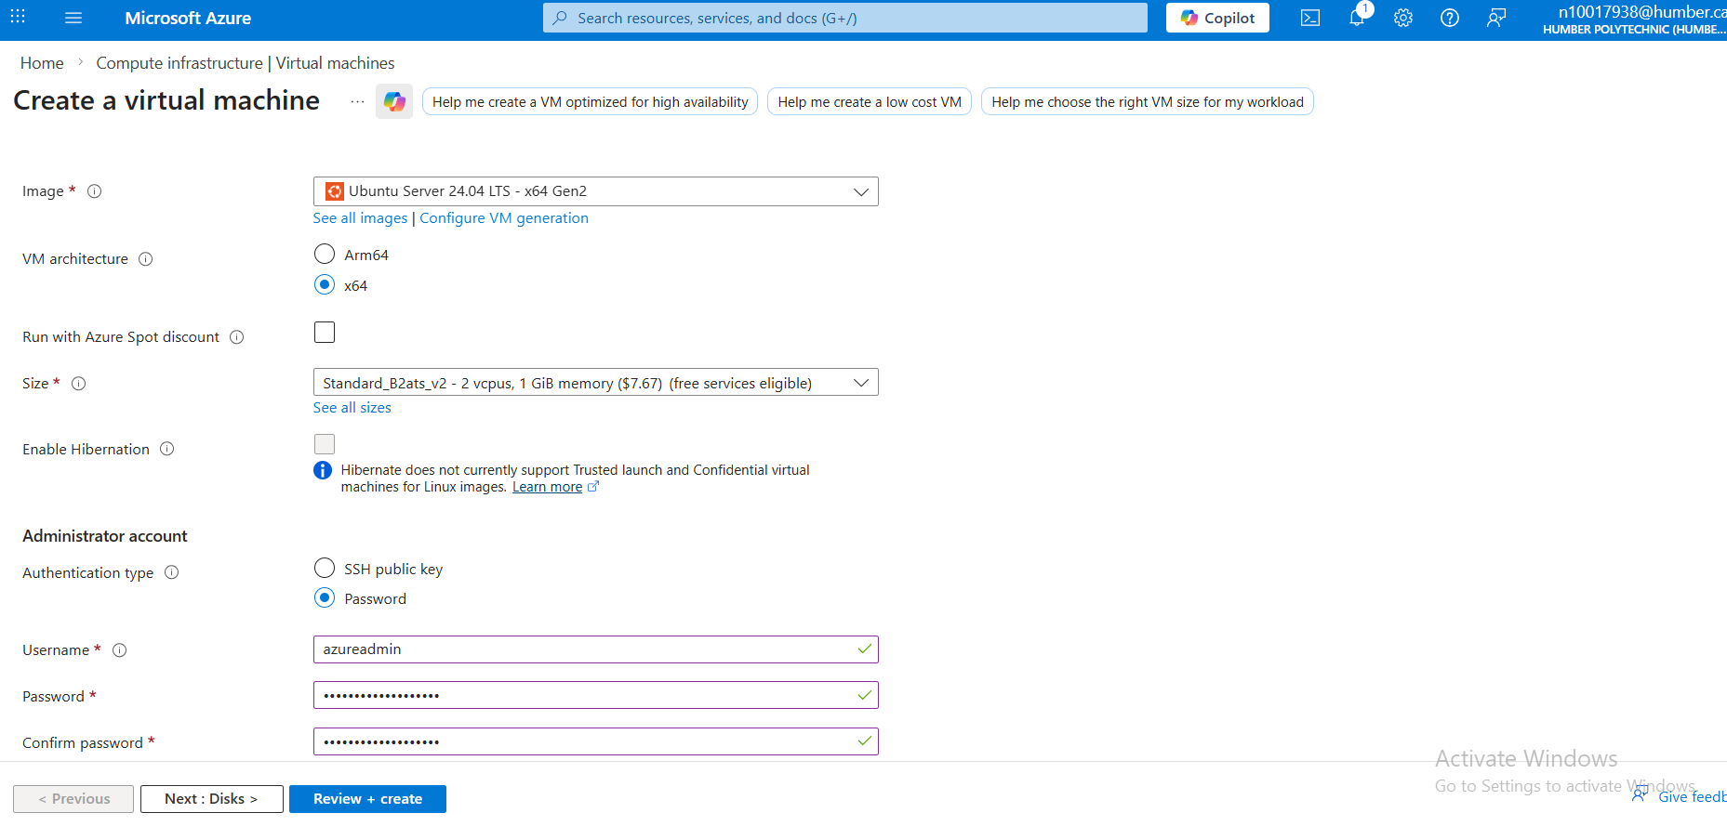

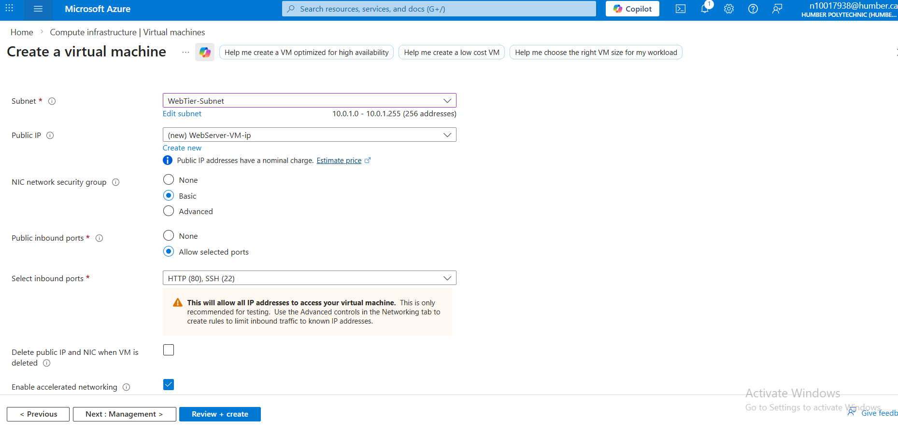

Step 6.1: Install Web Server
- Once deployed, click Go to resource
- Note the Public IP address (you'll need this)
- Click Connect > SSH
- Open your Azure CLI terminal on the bar and SSH to the VM:
- Write the Following commands on Bash
ssh azureadmin@<PUBLIC_IP>
sudo apt update
sudo apt install apache2 -y
sudo systemctl start apache2
sudo systemctl enable apache2
echo "<h1>Web Server - Cloud Security Lab</h1>" | sudo tee /var/www/html/index.html
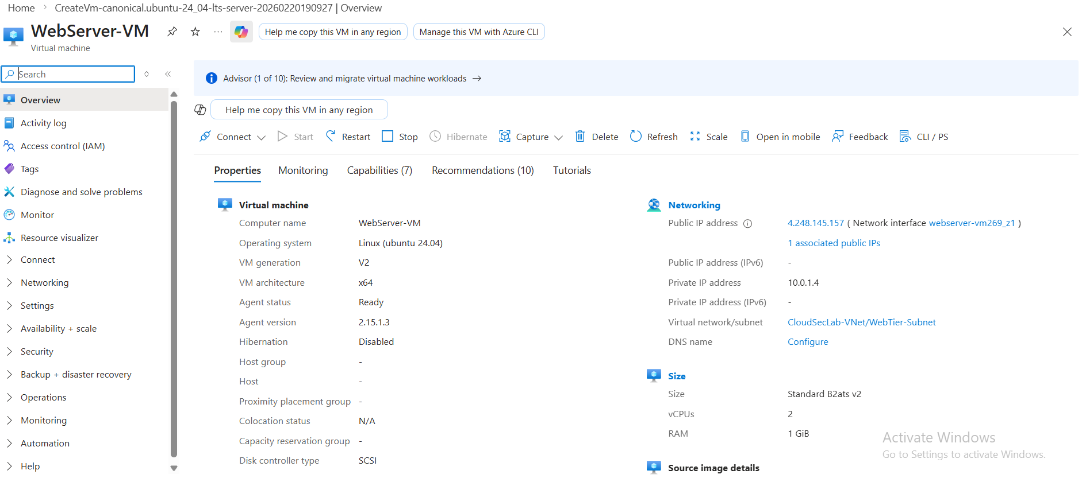
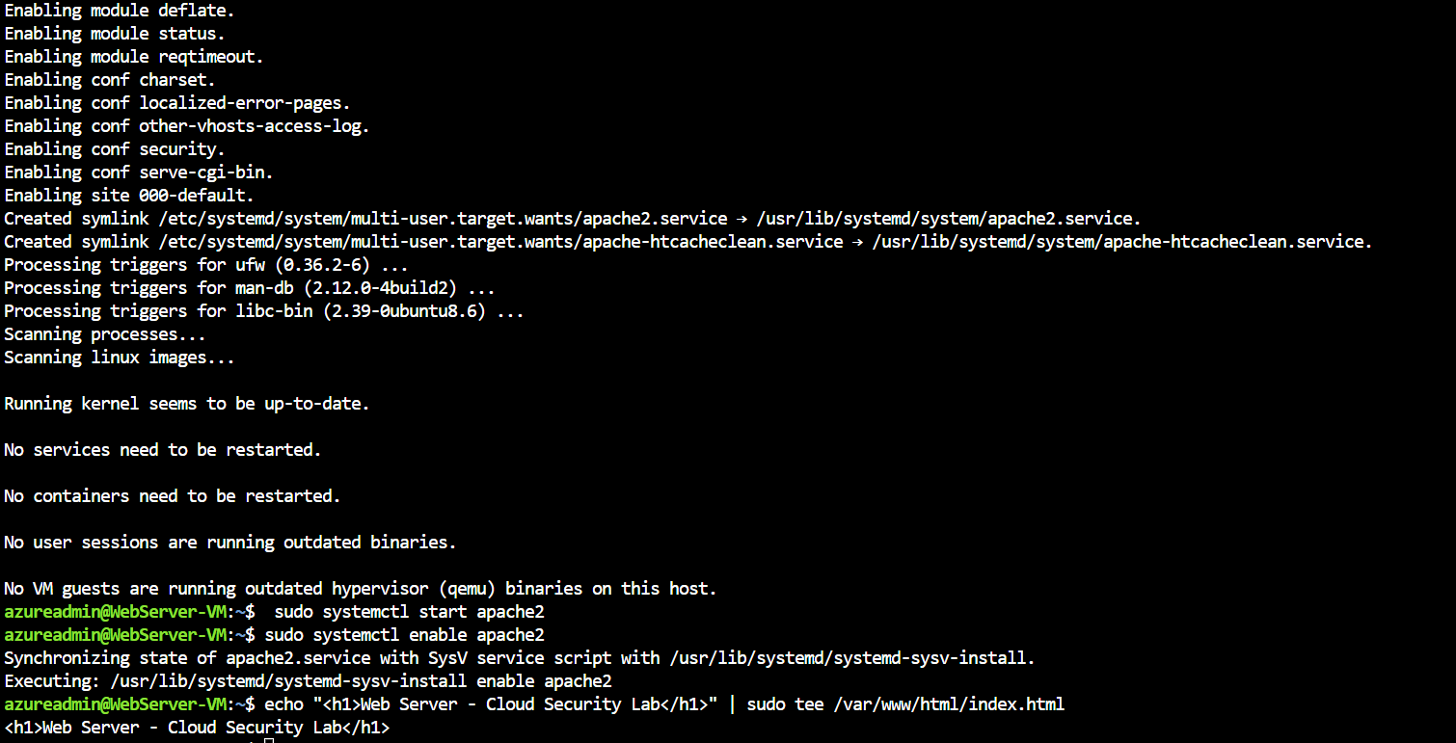
- Test by opening a browser and navigating to: http://<PUBLIC_IP>
  - You should see "Web Server - Cloud Security Lab"

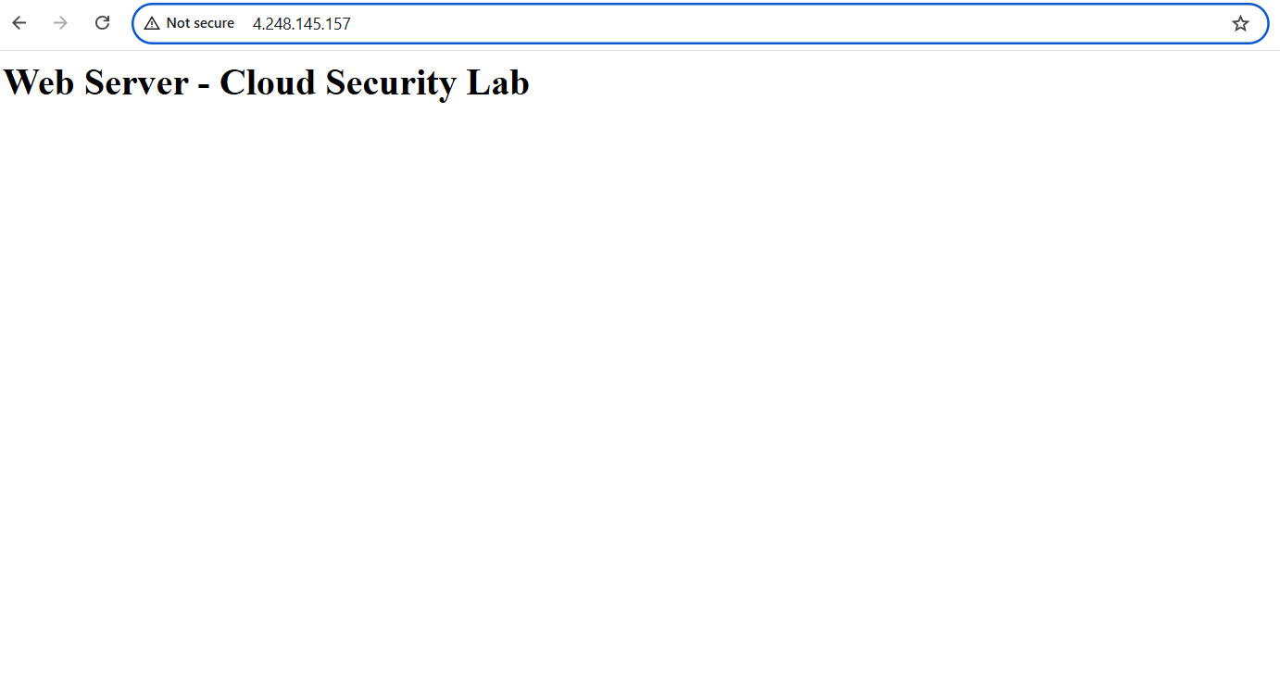

Step 7.1: Create Database Server
Unlike the Web Server, the Database VM is completely hidden from the internet. It has no public IP address and accepts no direct inbound connections from outside the virtual network. The only machine that can reach it is the Web Server, through the private internal network, this is the core of the defense-in-depth architecture you are building.
- Go back to Virtual machines > + Create
- Fill in the Basics tab:
- Resource group: CloudSecLab-RG
- Virtual machine name: DBServer-VM
- Region: Same as before
- Image: Ubuntu Server 22.04 LTS - x64 Gen2
- Size: Standard_B1s
- Authentication type: Password
- Username: azureadmin
- Public inbound ports: None
- Click Next: Networking:
- Virtual network: CloudSecLab-VNet
- Subnet: DataTier-Subnet (10.0.2.0/24)
- Public IP: None
- NIC network security group: Basic
- Public inbound ports: None
- Click Review + create > Create
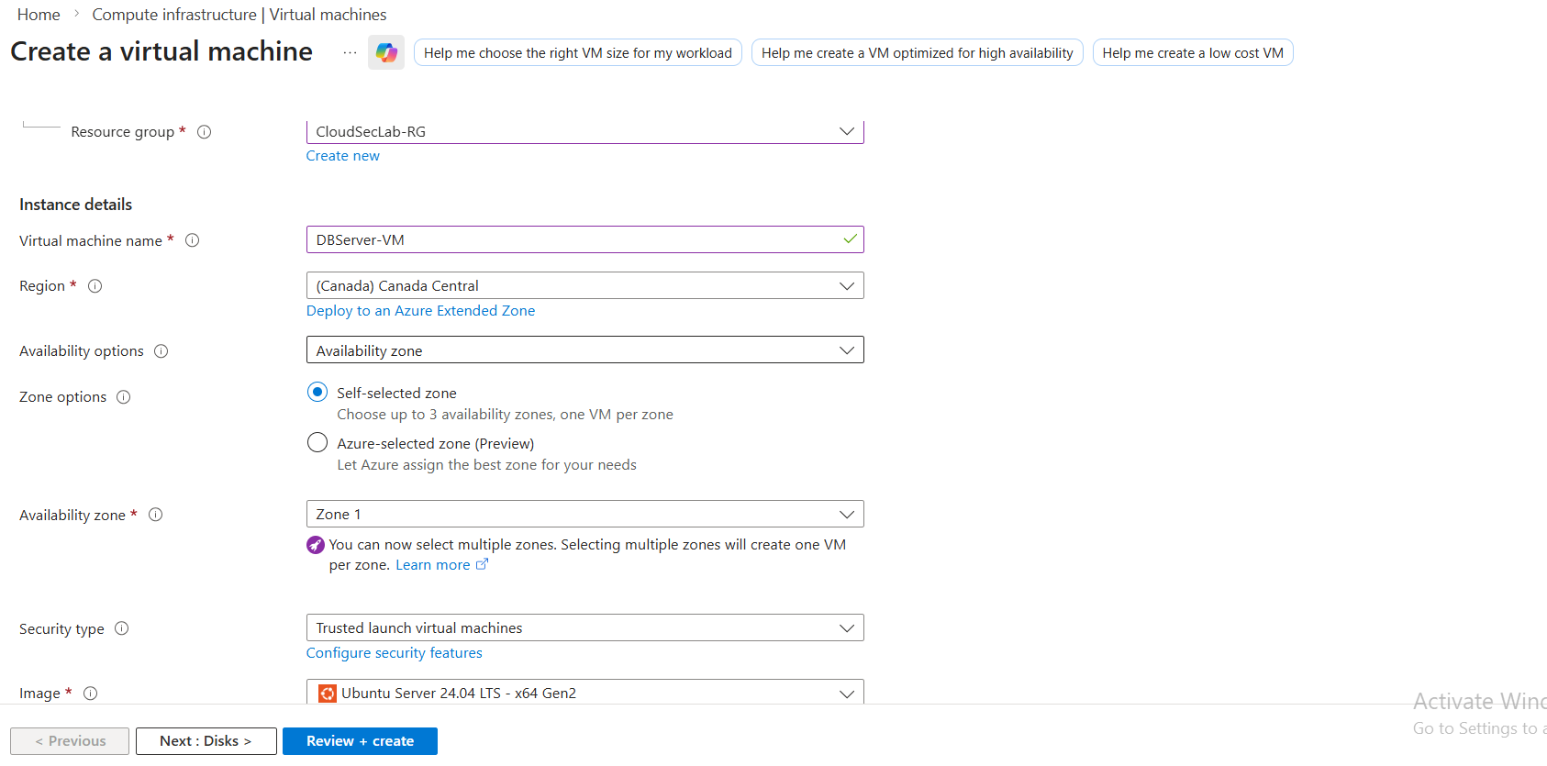

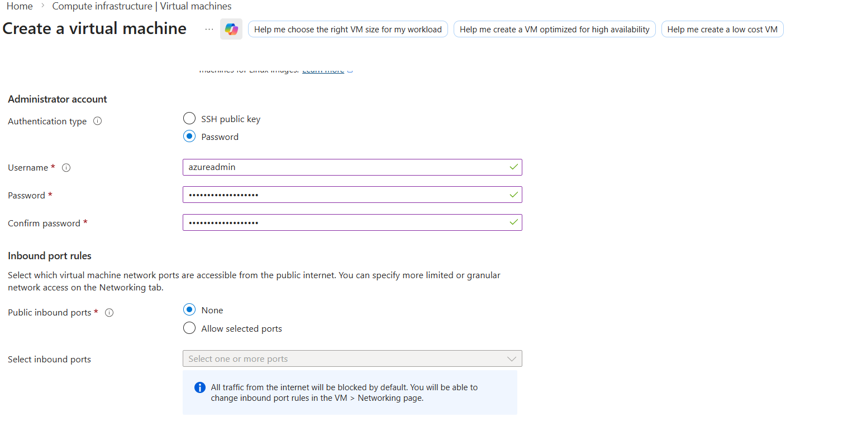
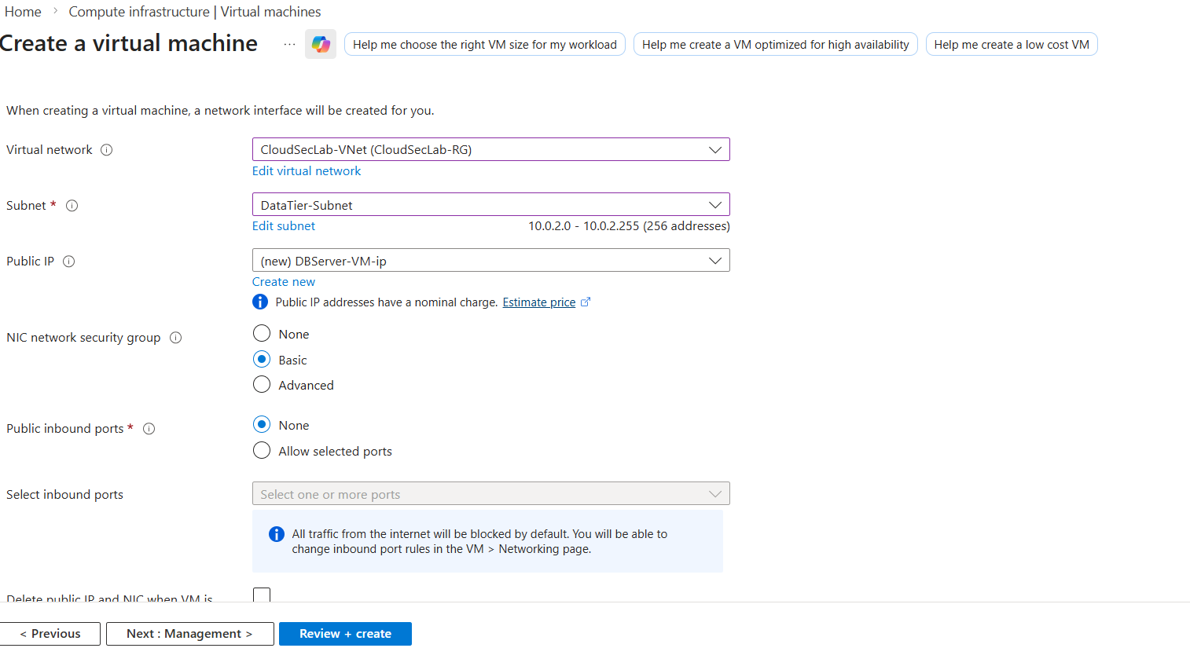

Step 7.2: Install MySQL
- Once deployed, you need to access this VM through the Web Server (since it has no public IP)
- SSH to your Web Server first using azure admin in your web server using Azure CLI:
ssh azureadmin@<WEB_SERVER_PUBLIC_IP>
- From the Web Server, SSH to the DB Server using its private IP:
- Find the DB Server's private IP in the Azure Portal (should be 10.0.2.4 or similar)
ssh azureadmin@10.0.2.4
Install MySQL:
sudo apt update
sudo apt install mysql-server -y
sudo systemctl start mysql
sudo systemctl enable mysql
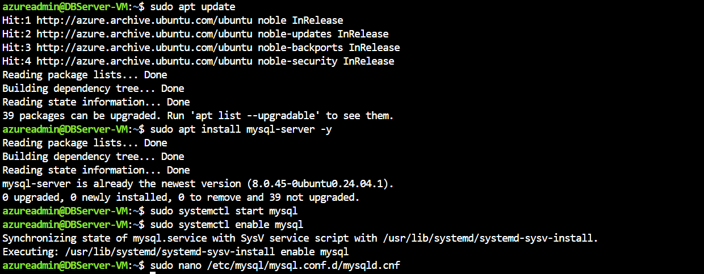
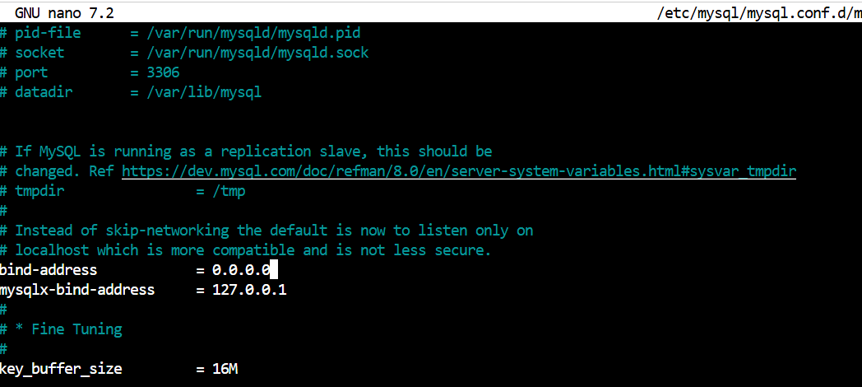

Part 8: Demonstrate Insecure Configuration
Step 8.1: Test Current Security Posture
Before applying proper Network Security Group rules, it is important to understand what our environment currently looks like from a security perspective. Right now, our VMs are running with minimal controls SSH is open to the entire internet on the web server, and no granular NSG rules are in place.
- From our Web Server, install a MySQL client:
bash
sudo apt install mysql-client -y
nc -zv 10.0.2.4 3306
-From your local machine, try to access the Web Server on different ports:
bash
# Test SSH (should work - this is a security risk!)
nc -zv <WEB_SERVER_PUBLIC_IP> 22
# Test MySQL (should fail - no public IP)
nc -zv <WEB_SERVER_PUBLIC_IP> 3306

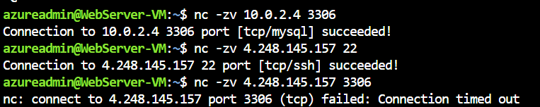

Step 9
Now that your VMs are deployed and you have seen the risks of an unsecured configuration, it is time to implement proper security controls. Network Security Groups (NSGs) act as virtual firewalls, they inspect every packet entering or leaving a subnet and either allow or deny it based on rules you define.

Rule 1: Allow HTTP from Internet
- Source: Any
- Source port ranges: *
- Destination: Any
- Service: HTTP
- Destination port ranges: 80
- Protocol: TCP
- Action: Allow
- Priority: 100
- Name: Allow-HTTP-Internet

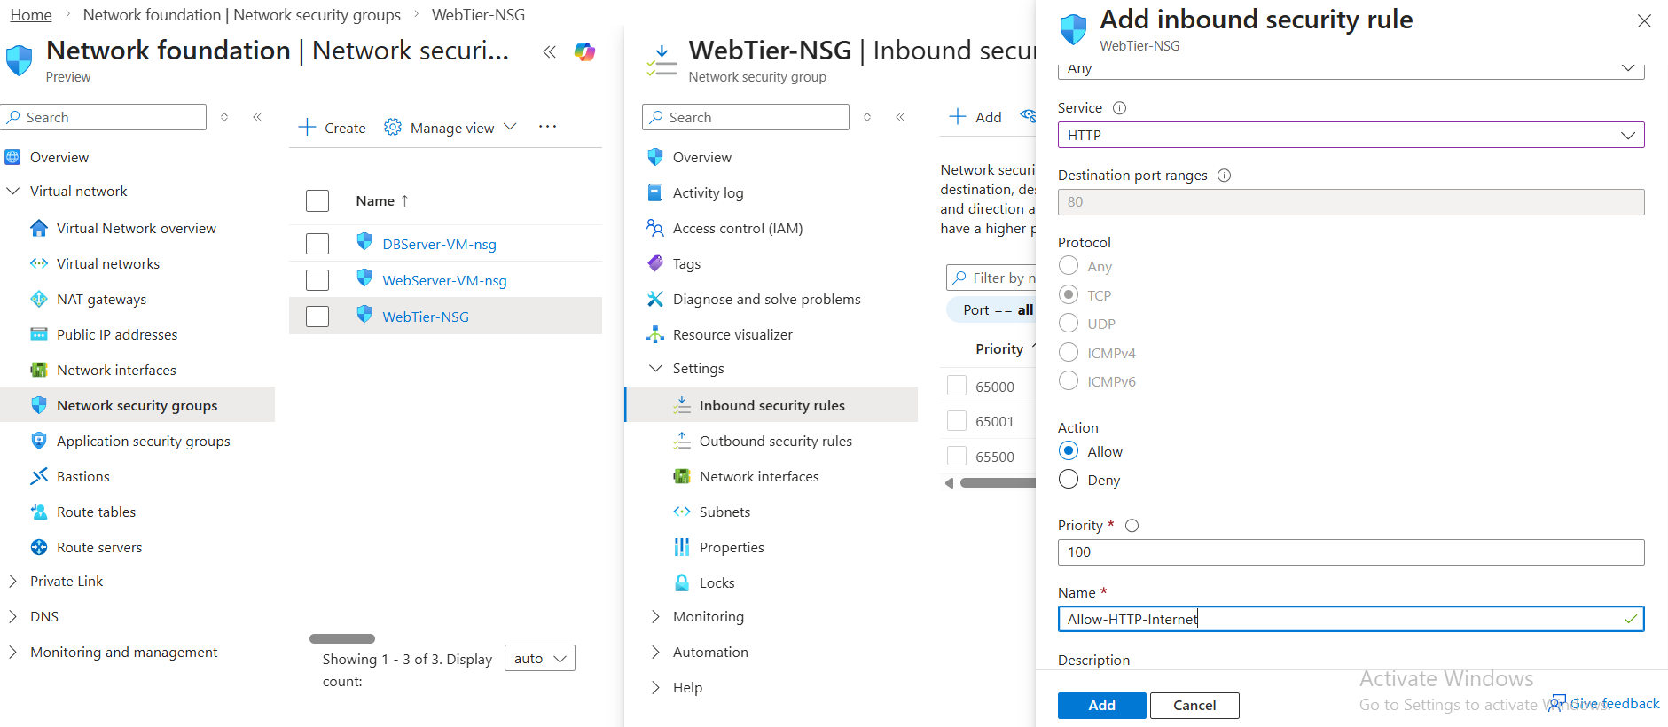
Rule 2: Allow HTTPS from Internet (for future use)
- Source: Any
- Source port ranges: *
- Destination: Any
- Service: HTTPS
- Destination port ranges: 443
- Protocol: TCP
- Action: Allow
- Priority: 110
- Name: Allow-HTTPS-Internet
- 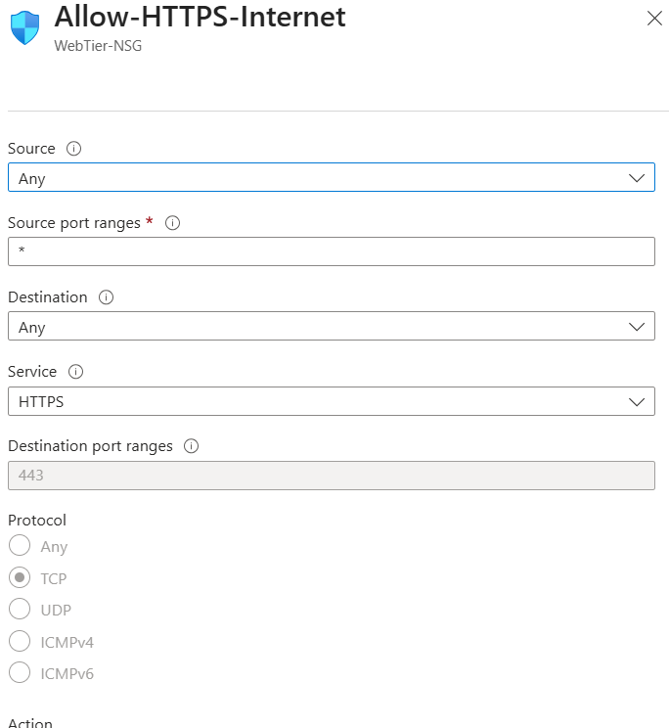

Rule 3: Allow SSH from Your IP Only (more secure)
- Source: IP Addresses
- Source IP addresses/CIDR ranges: [Your public IP - find at whatismyip.com]
- Source port ranges: *
- Destination: Any
- Service: SSH
- Destination port ranges: 22
- Protocol: TCP
- Action: Allow
- Priority: 120
- Name: Allow-SSH-MyIP

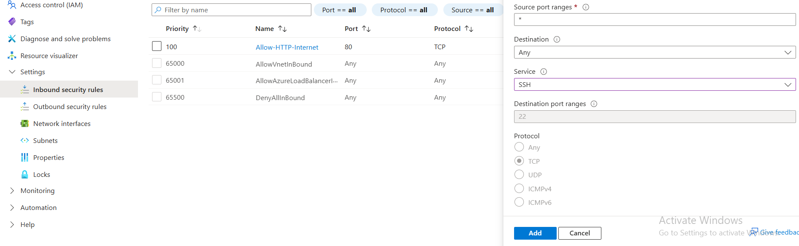
Rule 4: Deny All Other Inbound (explicit deny)
- Source: Any
- Source port ranges: *
- Destination: Any
- Service: Custom
- Destination port ranges: *
- Protocol: Any
- Action: Deny
- Priority: 4000
- Name: Deny-All-Inbound

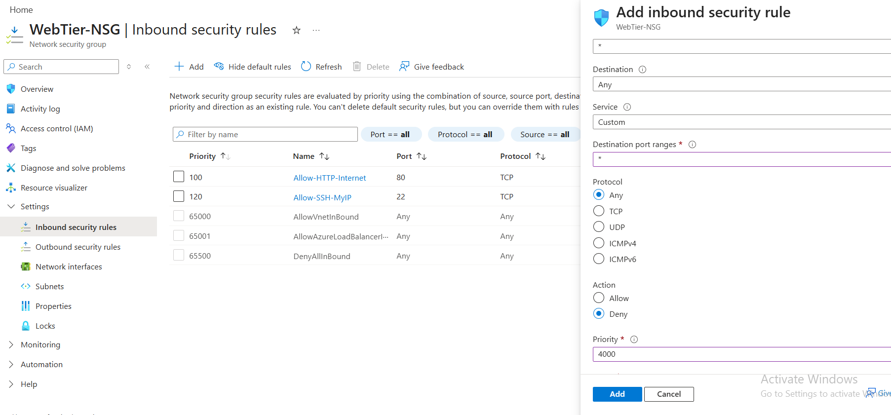
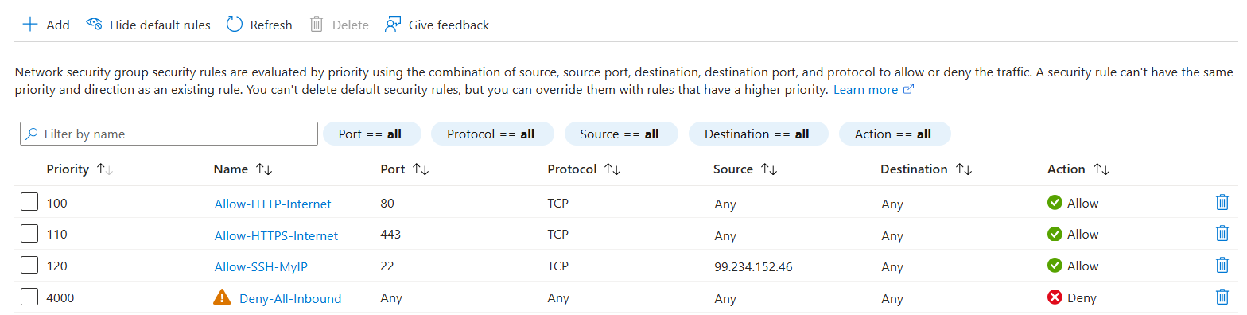
Step 10: Create NSG for Data Tier
- Create another NSG named DataTier-NSG (same steps as 5.1)
- Configure inbound rules:
Rule 1: Allow MySQL from Web Tier Only
- Source: IP Addresses
- Source IP addresses/CIDR ranges: 10.0.1.0/24
- Source port ranges: *
- Destination: Any
- Service: Custom
- Destination port ranges: 3306
- Protocol: TCP
- Action: Allow
- Priority: 100
- Name: Allow-MySQL-WebTier
- Click Add
Rule 2: Allow SSH from Web Tier Only (for management)
- Source: IP Addresses
- Source IP addresses/CIDR ranges: 10.0.1.0/24
- Source port ranges: *
- Destination: Any
- Service: SSH
- Destination port ranges: 22
- Protocol: TCP
- Action: Allow
- Priority: 110
- Name: Allow-SSH-WebTier
- Click Add
Rule 3: Deny All Other Inbound
- Source: Any
- Source port ranges: *
- Destination: Any
- Service: Custom
- Destination port ranges: *
- Protocol: Any
- Action: Deny
- Priority: 4000
- Name: Deny-All-Inbound
- Click Add

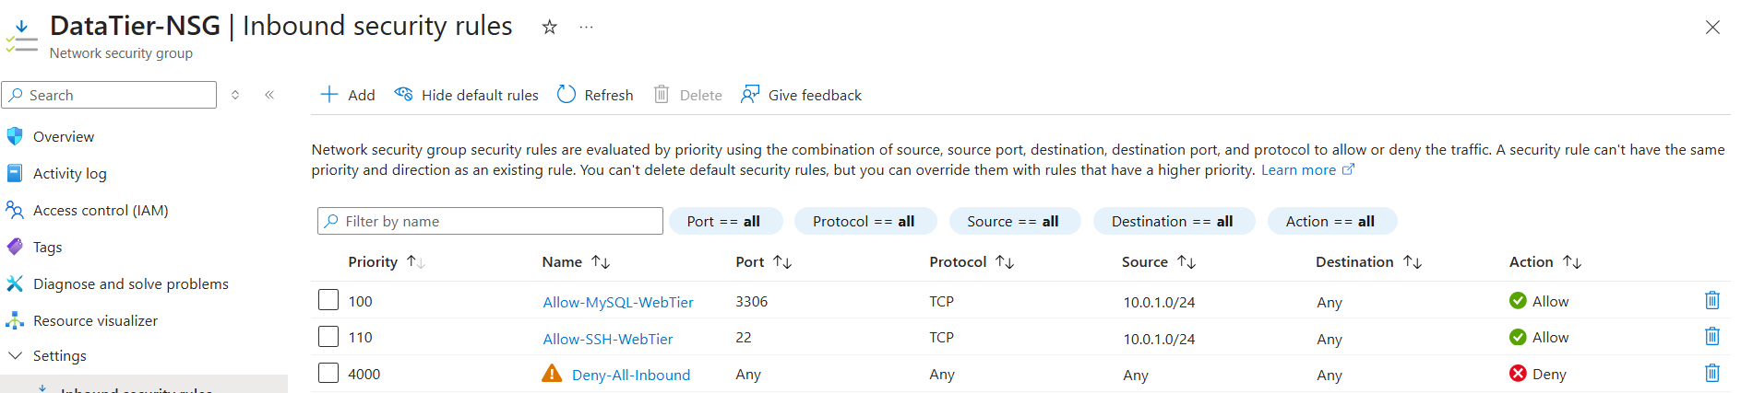
Step 11: Associate NSGs with Subnets
- Go to WebTier-NSG
- Click Subnets on the left
- Click + Associate
Select:
- Virtual network: CloudSecLab-VNet
- Subnet: WebTier-Subnet
Click OK
- Repeat for DataTier-NSG:
- Associate with DataTier-Subnet

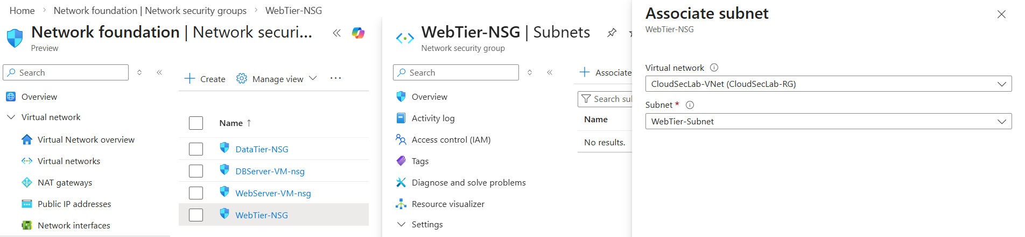
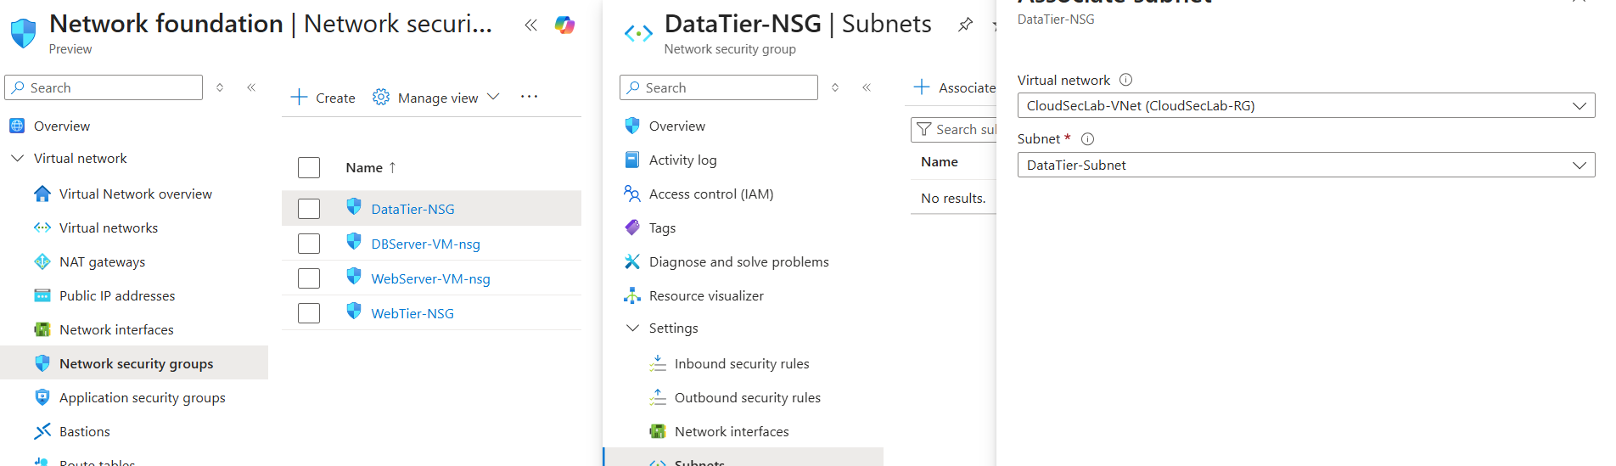
Test Security Controls
Step 12: Test Web Tier Access
From your local machine:
bash
curl http://<WEB_SERVER_PUBLIC_IP>
- Should display your web page
Test SSH from your your command prompt (it should work):
ssh azureadmin@<WEB_SERVER_PUBLIC_IP>
- Should connect successfully
- Test SSH from a different IP (should fail):
- Use a VPN or mobile hotspot to change your IP
- Try to SSH - it should timeout/fail
Step 12.1: Test Data Tier Access
- SSH to Web Server:

bash
ssh azureadmin@<WEB_SERVER_PUBLIC_IP>
- From Web Server, test MySQL connection to DB Server:

bash
nc -zv 10.0.2.4 3306
- Should succeed (connection from 10.0.1.0/24 is allowed)

- From Web Server, SSH to DB Server:
ssh azureadmin@10.0.2.4
- Should work

- Try to access MySQL directly from the internet:
- This should be impossible since DB Server has no public IP
