FINAL YEAR PROJECT



Project Title: Virtual Health Assistant

Supervisor:

Dr. Adil Khan

Submitted by

Muhammad Rehan Ishaq 01-134212-124 Syed Farman Ali 01-134222-181

Introduction
The Virtual Health Assistant is a browser-based system designed to help both clinical doctors and patients.
There is an urgent need for improved medical knowledge and quick access to expert medical counsel in the fast-paced, modern environment. Clinical physicians are particularly aware of this need as, in the course of their work, they frequently face patients who need assistance in diagnosing symptoms and choosing the best course of action. It provides a secure platform where doctors manage patient information efficiently without relying on paper files, can check and update patient history. The system incorporates AI-based suggestions for possible diseases and medicines.
While patients can log in to view their medical records, check prescriptions, and schedule appointments online, improving communication between doctors and patients.
Since it is web-based, both doctors and patients can access it from anywhere with a secure login.

Objectives

- Build a simple and effective web platform for clinical doctors and patients.
- Keep patient records organized and enable sharing between doctor and patient dashboards.
- Naïve Bayes, Random Forest, SVM, and XGBoost using the same dataset.
- Provide verified medicine suggestions.
- Allow patients login, check their medical history, review prescriptions, and book appointments with available doctors.
- Ensure a clean, secure, and user friendly interface for all users.

Problem Description
Many doctors still manage records manually, which is time-consuming and prone to errors. Tracking old reports or coordinating with other doctors becomes difficult. Additionally, finding accurate medicine information from multiple sources delays treatment decisions and increases the risk of mistakes.
Patients, on the other hand, often struggle to access their medical history, reports, and prescriptions while appointment scheduling is also difficult, requiring phone calls or in-person visits.
Our system solves these problems by providing an online patient login module where patients can access their health records and manage appointments.

Methodology
An agile approach will be followed to build and refine the system in stages:
1. Gather requirements from doctors and patients.
2. Design system architecture and database for two portals (Doctor and Patient).
3. Develop the frontend using React.js.
4. Implement backend using Flask or Django.
5. Integrate PostgreSQL and Firebase for storage and authentication.
6. Develop Patient Login Module:
- Secure authentication via Firebase.
- Patient dashboard to view medical history and lab results.
- Appointment booking and notifications system.
7.Train and test: Naïve Bayes, Random Forest, SVM, and XGBoost.
8. Test both portals using dummy data.
9. Deploy on a cloud server.

Project Scope

This project aims to provide a user-friendly platform that enables clinicians to input patient symptoms and receive exact medical advice by utilizing artificial intelligence and machine learning, ensuring that the prescriptions and the diagnosis are automatically recorded in the secured database. The integrated AI assists in diagnosis and medicine suggestions.
Its main goal is to use technology to give clinical professionals better access to healthcare and the resources they need to give patients the best care possible.
It enables doctors to view, edit, and share patient data, and patients to manage their own healthcare through a personal login, while the patient portal adds self-service features such as;
- Access to medical records and visit history.
- Viewing prescriptions and lab reports.
- Appointment scheduling and reminders.
This improves communication, transparency, and clinical efficiency across the entire healthcare workflow.
The project focuses on a web-based platform accessible through any browser.

Feasibility Study

The inclusion of a patient login system introduces new security and privacy considerations.
To mitigate risks:
- All user data will be encrypted before storage.
- Authentication will use Firebase for secure access.
- Role-based access control will ensure that patients only view their own data.
- Appointment data will be validated and stored securely in PostgreSQL.
These measures ensure high reliability, scalability, and compliance with healthcare privacy standards.

Summary of Existing Virtual Health Assistant Applications Around the World

Category / Type |  | Example Applications | Key Features & Technologies Used
1. Symptom Checkers & AI Health Assistants |  | Ada Health (Germany/UK)  Healthily (Your.MD) (UK)  Infermedica (Poland)  Sulli (US) | • AI-driven symptom analysis using medical databases and decision-tree logic.  • Machine learning triage systems.  • Some include doctor connectivity (Healthily).  • Voice-activated chronic disease management (Sulli for diabetes).
2. Mental Health & Therapy Applications |  | Woebot Health (US)  Wysa (India/UK)  Mind Beacon (Canada)  Hasu (Focus) (US) | • Use Cognitive Behavioral Therapy (CBT) techniques.  • Text and voice-based conversational interfaces.  • Some offer bilingual support (e.g., English/French).  • Real-time access to therapists via text, call, or video.

Solution Application Areas
• Hospitals & Clinics: Centralized system for managing both doctor and patient portals.
• Telehealth: Patients can book appointments and consult doctors remotely.
• Community Health Centers: Provide an affordable electronic health record solution for both healthcare staff and patients.
• Pharmacies: Enable patients to view prescribed medicines digitally.
• Research & Analytics: Support anonymized data analysis for AI improvement.
• Medical Education: Serve as a practical example of integrating AI and healthcare accessibility.

Tools / Technologies (Updated)

Component | Technology Used
Frontend | HTML, CSS, Bootstrap, React.js
Backend | Flask / Django (Python)
Database | PostgreSQL
Authentication | Firebase (for both doctor and patient logins)
AI Model | Naïve Bayes
Hosting | Cloud Server
Appointment Management | Integrated REST API
Notifications | Email / SMS via Firebase Cloud Messaging

Expertise of Team Members

• Muhammad Rehan Ishaq – Frontend & UI

• Skilled in React.js, HTML5, CSS3, and Bootstrap.

• Experience in UI/UX design and client-side validation.

• Syed Farman Ali – Backend & AI

• Proficient in Python, Flask/Django, and RESTful API design.

• Experienced in PostgreSQL integration and machine learning using Scikitlearn.

Shared Responsibilities

Testing, documentation, and deployment.

Version control using Git.

Knowledge of cloud deployment and data security practices.

Milestones & Timeline

Phase | Duration
Requirement Gathering | 1 Week
System & Database Design | 2 Weeks
Frontend Development | 3 Weeks
Backend Development | 3 Weeks
AI Integration & Testing | 3 Weeks
Final Deployment & Documentation | 2 Weeks

Gantt Chart

Below is a more detailed timeline for our web project:
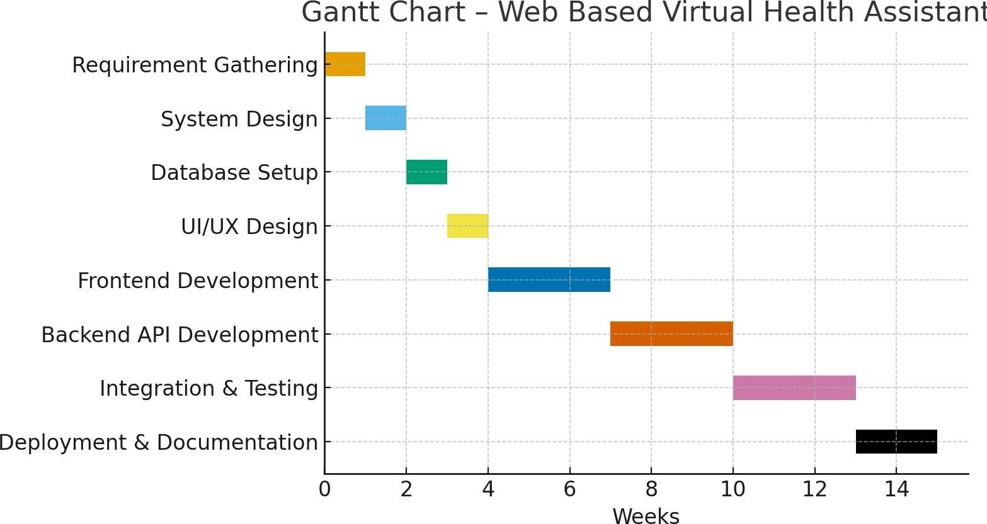

- References

- Alsadhan, A.O. and Shafi, M.M. (2014) “What is the importance ofdifferent e-learning tools and systems?: An Implementer’s point of view.” 2014International Conference on Multimedia Computing and Systems (ICMCS). doi:10.1109/icmcs.2014.6911364.

- Saran K B, “Traffic video surveillance: Vehicle detection andclassification”, 2015, Available at: https://ieeexplore.ieee.org/abstract/document/7432948

- DrugBank. “DrugBank Online Database.” 2025.Available at: https://o.drugbank.com/

- Drug Regulatory Authority of Pakistan. “National EssentialMedicine List.” 2025.
Available at: https://www.dra.gov.pk/publications/national-essential-medicine-lists/

