Spatial Filter-Based Noise Reduction and Its Impact on Edge Detection in Digital Images

S. No. | Name | Registration Number
1 | Waquar Ahmad | 20233319
2 | Varun Vikram Singh | 20233308
3 | Swastik Harsh | 20233284
4 | Sayali Chaudhari | 20233560

Abstract
Denoising before edge detection is standard advice, yet its effectiveness depends heavily on how noisy an image actually is. We evaluated this practice across a range of synthetic and low-light noise models using six standard denoising filters and three common edge detectors (Sobel, Canny, and LoG), benchmarking the resulting edge maps against clean ground-truth boundaries. While pre-filtering improved edge detection accuracy in most high-noise scenarios, the filter yielding the highest peak signal-to-noise ratio (PSNR) was rarely the optimal choice for preserving edge structure. Crucially, denoising degraded edge quality at low noise levels and proved beneficial only above a distinct noise crossover threshold. Standard consumer photographs fell well below this threshold, where smoothing erased a substantial portion of genuine edges; conversely, images suffering from raw sensor noise or heavy degradation benefited significantly. Ultimately, pre-denoising aids edge detection only under substantial noise and harms boundary preservation in relatively clean photographs.

1. Introduction

Because image noise introduces false boundaries, smoothing an image prior to edge detection is standard practice in computer vision. However, smoothing inevitably blurs genuine structural boundaries, meaning its net utility depends heavily on the underlying noise level. Furthermore, denoising algorithms are typically evaluated using pixel-fidelity metrics such as peak signal-to-noise ratio (PSNR) rather than their impact on downstream tasks, and real-world captures rarely offer a noise-free reference for objective benchmarking.

To address this gap, we evaluate the interaction between denoising and edge detection under controlled noise conditions to test two primary hypotheses:
- H1: Edge maps extracted from denoised images align more closely with ground-truth boundaries than those extracted directly from noisy inputs.
- H2: Pre-denoising is beneficial only above a critical noise threshold, making it valuable for severely degraded regimes (such as astronomical or low-light imaging) but counterproductive for standard, relatively clean consumer photographs.

2. Methodology
Dataset and Noise Models. We evaluate four standard $512×512$ grayscale benchmark images from scikit-image: Cameraman, Astronaut, Coins, and Chelsea (converted to grayscale). We corrupt these clean references using three primary degradation models: salt-and-pepper noise (5% impulse density), additive white Gaussian noise ($σ=25$), and mixed noise (Gaussian $σ=15$ combined with 2% impulse density). For our noise-level sweeps, we additionally introduce a photon-limited model simulating low-light and astronomical imaging, which combines Poisson shot noise (scaled to a target peak photon count), Gaussian read noise ($σ=3$), and 0.1% hot-pixel impulses. All pseudorandom number generators are explicitly seeded to ensure strict reproducibility.
Denoising Filters. We test six spatial and patch-based denoisers using fixed hyperparameters across all noise regimes to avoid per-distribution overfitting:
- Mean filter: 5 x 5 uniform box kernel
- Median filter: 5 x 5 neighborhood
- Gaussian filter: 5 x 5 kernel with $σ=1.5$
- Bilateral filter: Diameter $d=9$, with $σ_{\text{color}}=σ_{\text{space}}=75$
- Non-Local Means (NL Means): Filtering parameter $h=15$, $7×7$ patch size, and $21×21$ search window
- Hybrid Cascade: A 3 x 3 median filter followed by the bilateral filter to jointly suppress impulses and smooth continuous noise
Edge Detection. We benchmark three classic operators representing distinct detection paradigms: Sobel (gradient-magnitude thresholding), Canny (internal Gaussian smoothing with $σ=1.4$ followed by non-maximum suppression and hysteresis thresholding), and Laplacian of Gaussian (LoG, $σ=1.5$ with thresholded zero-crossings). Crucially, detector thresholds are calibrated once on each clean reference image and frozen across all noisy and denoised trials, ensuring that degraded inputs cannot be artificially rescued by threshold retuning.
Evaluation Metrics. Restoration fidelity is quantified using Peak Signal-to-Noise Ratio (PSNR) and the Structural Similarity Index Measure (SSIM) relative to the clean reference. Downstream edge quality is evaluated by computing pixel-wise Precision, Recall, and F1-score against the ground-truth edge map, permitting a 1-pixel spatial tolerance to account for minor localization shifts. To test H1 objectively, the designated "pipeline filter" for each image-noise pair is selected strictly as the denoiser maximizing PSNR, completely blind to downstream edge metrics.
Experimental Design. Our evaluation proceeds in four stages:
- Main Factorial Benchmark: A full grid evaluating 4 images x 3 noise types x 6 denoisers x 3 edge detectors.
- Sensitivity and Sweep Analysis: Broad noise-intensity sweeps coupled with a filter hyperparameter sensitivity study.
- Crossover Identification: Fine-grained noise sweeps to pinpoint the exact crossover threshold where pre-denoising outperforms direct detection on the noisy input. We compare a fixed default heuristic (Gaussian 5 x 5 for Gaussian noise; median 5 x 5 for impulse and photon-limited regimes) against an oracle selector that chooses the F1-optimal filter at each noise level, alongside an ablation where detector thresholds are adaptively recalibrated per input.
- Unreferenced Real-World Evaluation: Validation on real-world photographs lacking clean ground truth, assessed via Immerkaer’s fast noise variance estimator and Canny edge density relative to baseline clean-image densities.

3. Results and Discussion

3.1 Image and edge quality
Table 1. Mean PSNR (dB) / Canny edge F1 over 4 images.
Denoiser | Impulse (5%) | Gaussian (σ = 25) | Mixed
None (noisy) | 18.1 / 0.64 | 20.5 / 0.73 | 20.2 / 0.72
Mean 5×5 | 26.5 / 0.72 | 27.3 / 0.73 | 27.2 / 0.74
Median 5×5 | 30.0 / 0.80 | 27.5 / 0.75 | 28.8 / 0.77
Gaussian 5×5 | 27.0 / 0.77 | 28.1 / 0.79 | 28.0 / 0.79
Bilateral | 22.8 / 0.59 | 28.3 / 0.67 | 25.9 / 0.66
Non-local means | 19.0 / 0.67 | 24.2 / 0.81 | 22.6 / 0.77
Median→Bilateral | 29.2 / 0.65 | 28.2 / 0.65 | 28.7 / 0.65

Optimal denoiser performance is heavily dependent on the underlying noise distribution, and maximizing pixel fidelity (PSNR) frequently fails to maximize downstream edge detection accuracy. Under 5% impulse noise, the $5×5$ median filter dominates both restoration fidelity and boundary preservation, achieving 30.0 dB PSNR and boosting Canny edge F1 from the 0.64 noisy baseline to 0.80. However, fidelity and edge quality diverge under continuous and composite noise regimes. For Gaussian noise ($σ=25$), the bilateral filter yields the highest PSNR (28.3 dB) yet underperforms the noisy baseline in edge detection (0.67 vs. 0.73 F1), whereas Non-Local Means achieves the highest Canny F1 (0.81) despite a modest 24.2 dB PSNR. A similar discrepancy appears under mixed noise, where the median filter leads in PSNR (28.8 dB) while the $5×5$ Gaussian filter secures the top edge F1-score (0.79).
Two mechanistic limitations explain the poor downstream edge performance of certain edge-preserving smoothers:
- Impulse Retention: Because the bilateral filter weights pixels by radiometric similarity, isolated salt-and-pepper impulses exceed the intensity range parameter ($σ_{\text{color}}$) and are mistakenly preserved as high-contrast structural edges, depressing both PSNR (22.8 dB) and Canny F1 (0.59).
- Gradient Attenuation vs. Frozen Thresholds: Aggressive smoothing from the bilateral filter and the Median $→$ Bilateral cascade flattens local intensity gradients across genuine boundaries. Because detector thresholds remain frozen at their clean-image calibration, these weakened gradients fall below the detection cutoff, severely penalizing edge recall—most notably on the second-derivative LoG detector, where impulse F1 drops from 0.56 on the raw noisy input to 0.33 after filtering.

3.2 Hypothesis H1
Selecting the highest-PSNR filter for each image-noise pair improved downstream edge F1-scores in 27 of 36 test cases (75%, with a mean gain of $+0.088$). However, the magnitude and consistency of this improvement depend heavily on the edge detector's internal architecture:
- Sobel: Because the Sobel operator lacks built-in smoothing, pre-denoising improved edge detection across all 12 cases (12/12, mean gain $+0.164$).
- Canny and LoG: Pre-filtering yielded more modest and less consistent gains for Canny (8/12 cases, mean gain $+0.065$) and LoG (7/12 cases, mean gain $+0.033$).
The nine cases where pre-denoising failed to improve edge quality comprised five LoG trials and four Canny trials on Astronaut and Coins, where baseline Canny F1-scores on the raw noisy inputs were already high ($0.83\text{--}0.92$). Consequently, H1 holds strongly for unsmoothed gradient operators like Sobel, but holds only weakly for detectors that already incorporate internal Gaussian smoothing.
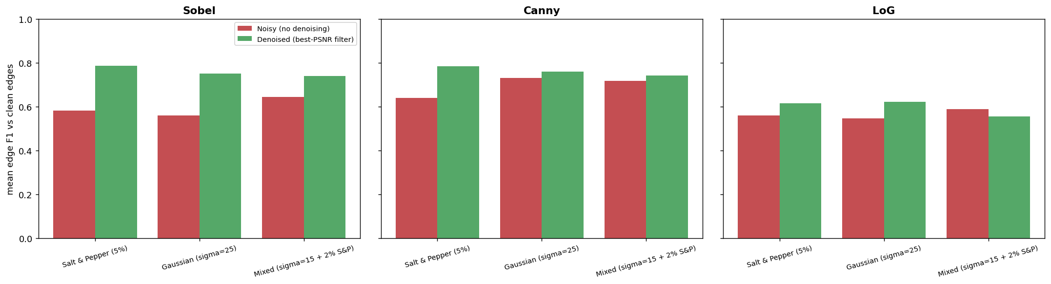
Figure 1. Mean edge F1 against the clean image’s edges for the noisy image and for the best-PSNR denoised image, by noise type and detector.

3.3 Hypothesis H2: the crossover
Table 2. Noise level above which denoising beats no denoising (mean of 4 images). Gaussian: default filter / best-of-six oracle. Impulse and photon-limited: default filter (median 5×5); for photon noise denoising helps when the peak photon count is at or below the value shown (estimated σ in brackets).
Measure | Gaussian σ | Impulse density | Photon-limited peak
PSNR | 8.3 / 6.7 | 0.3% | 872 (7.6)
SSIM | 4.4 / 4.4 | 0.6% | every level tested
Sobel F1 | 16.4 / 13.5 | 1.4% | 163 (14.4)
Canny F1 | 20.2 / 18.7 | 2.1% | 84 (19.1)
LoG F1 | 15.0 / 15.0 | 2.8% | 91 (18.5)
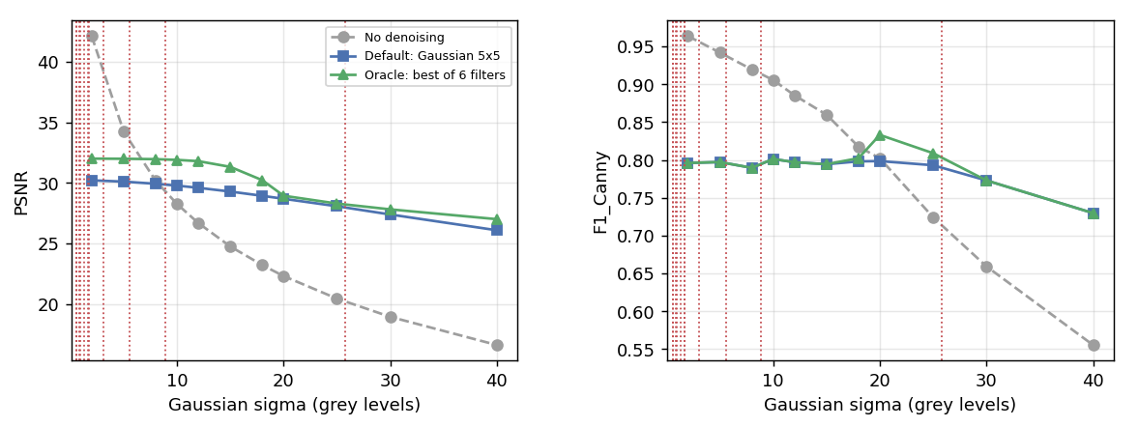
Figure 2. PSNR (left) and Canny F1 (right) against Gaussian σ, mean of 4 images. Dotted red lines mark the estimated σ of the real photographs.
Pre-filtering imposes an inherent "denoising tax" at low noise levels. At $σ=2$, applying a $5×5$ Gaussian filter reduces Canny F1 from $0.96$ to $0.80$ because spatial smoothing blurs and displaces genuine structural boundaries. Consequently, while denoising improves pixel-level fidelity at modest degradation levels ($σ≈8$ for PSNR and $σ≈4$ for SSIM), downstream edge detection only benefits once noise exceeds a substantially higher crossover of $σ≈15\text{-}20$.
Similar crossover behavior governs non-Gaussian regimes:
- Impulse Noise: The $5×5$ median filter improves PSNR above $0.3\%$ pixel corruption and LoG F1 above $2.8\%$. Across $1\text{--}30\%$ impulse density, median filtering stabilizes Canny F1 between $0.79$ and $0.81$, whereas the unfiltered baseline collapses from $0.86$ to $0.27$.
- Photon-Limited Noise: Edge detection benefits from pre-denoising only under severe photon starvation, below peak counts of roughly $84\text{--}163$ photons (equivalent to $σ≈14.4\text{-}19.1$).
Crucially, this low-noise penalty is not an artifact of frozen detector thresholds: adaptively recalibrating thresholds for every filtered output yielded comparable Gaussian crossovers (Sobel $15.4$, Canny $20.0$, LoG $8.8$) and still incurred a $0.06\text{--}0.11$ F1 loss at $σ=2$. Finally, hyperparameter sensitivity analysis indicates that our fixed filter parameters are near-optimal for edge preservation, with two notable exceptions: reducing the median kernel to $3×3$ under impulse noise boosts Canny F1 from $0.80$ to $0.91$ ($33.3\text{ dB}$ vs. $30.0\text{ dB}$ PSNR), while Non-Local Means with a fixed smoothing parameter ($h=15$) fails to suppress noise above $σ=40$.

Conclusion
Our findings demonstrate that the utility of pre-denoising for edge detection is strictly conditional on both the detector architecture and the underlying noise regime:
- Hypothesis H1 (Conditional Validity): Pre-denoising improved downstream edge F1-scores in 75% of test cases, proving universally effective for unsmoothed gradient operators like Sobel (12/12 cases), moderately effective for Canny, and only weakly beneficial for LoG. Because optimal filter selection depends heavily on the noise distribution—requiring median filtering for impulse noise and Non-Local Means or Gaussian smoothing for Gaussian degradation—denoisers for vision pipelines must be selected using task-specific edge metrics rather than pixel-fidelity measures like PSNR alone.
- Hypothesis H2 (The Noise Crossover): Spatial smoothing degrades boundary detection at low noise levels and yields net gains only above a critical crossover threshold of $σ≈15\text{-}20$ ($1.4\text{--}2.8\%$ impulse corruption, or peak photon counts below $84 \text{-}163$ photons in photon-limited regimes). Standard consumer photographs ($σ≈1\text{-}2$) fall well below this threshold and suffer structural boundary loss when pre-filtered, whereas severely degraded captures—such as raw sensor readouts, low-light photography, and astronomical imaging—benefit substantially.

Practical Recommendations and Future Work. In practical computer vision pipelines, practitioners should first estimate the noise variance ($σ$) and bypass denoising entirely when noise falls below the crossover threshold. When severe degradation is present, median filtering should be deployed for impulse noise, while Gaussian smoothing or Non-Local Means (with smoothing parameter $h$ scaled dynamically to $σ$) should be applied for strong continuous noise. Future work will extend this framework to noise-adaptive and deep learning denoisers, human-annotated boundary datasets, and paired real-world noisy-and-clean sensor captures.

