

Análise e Integração de dados

Ana Leitão 81365

João Ramos 80915

schema matching

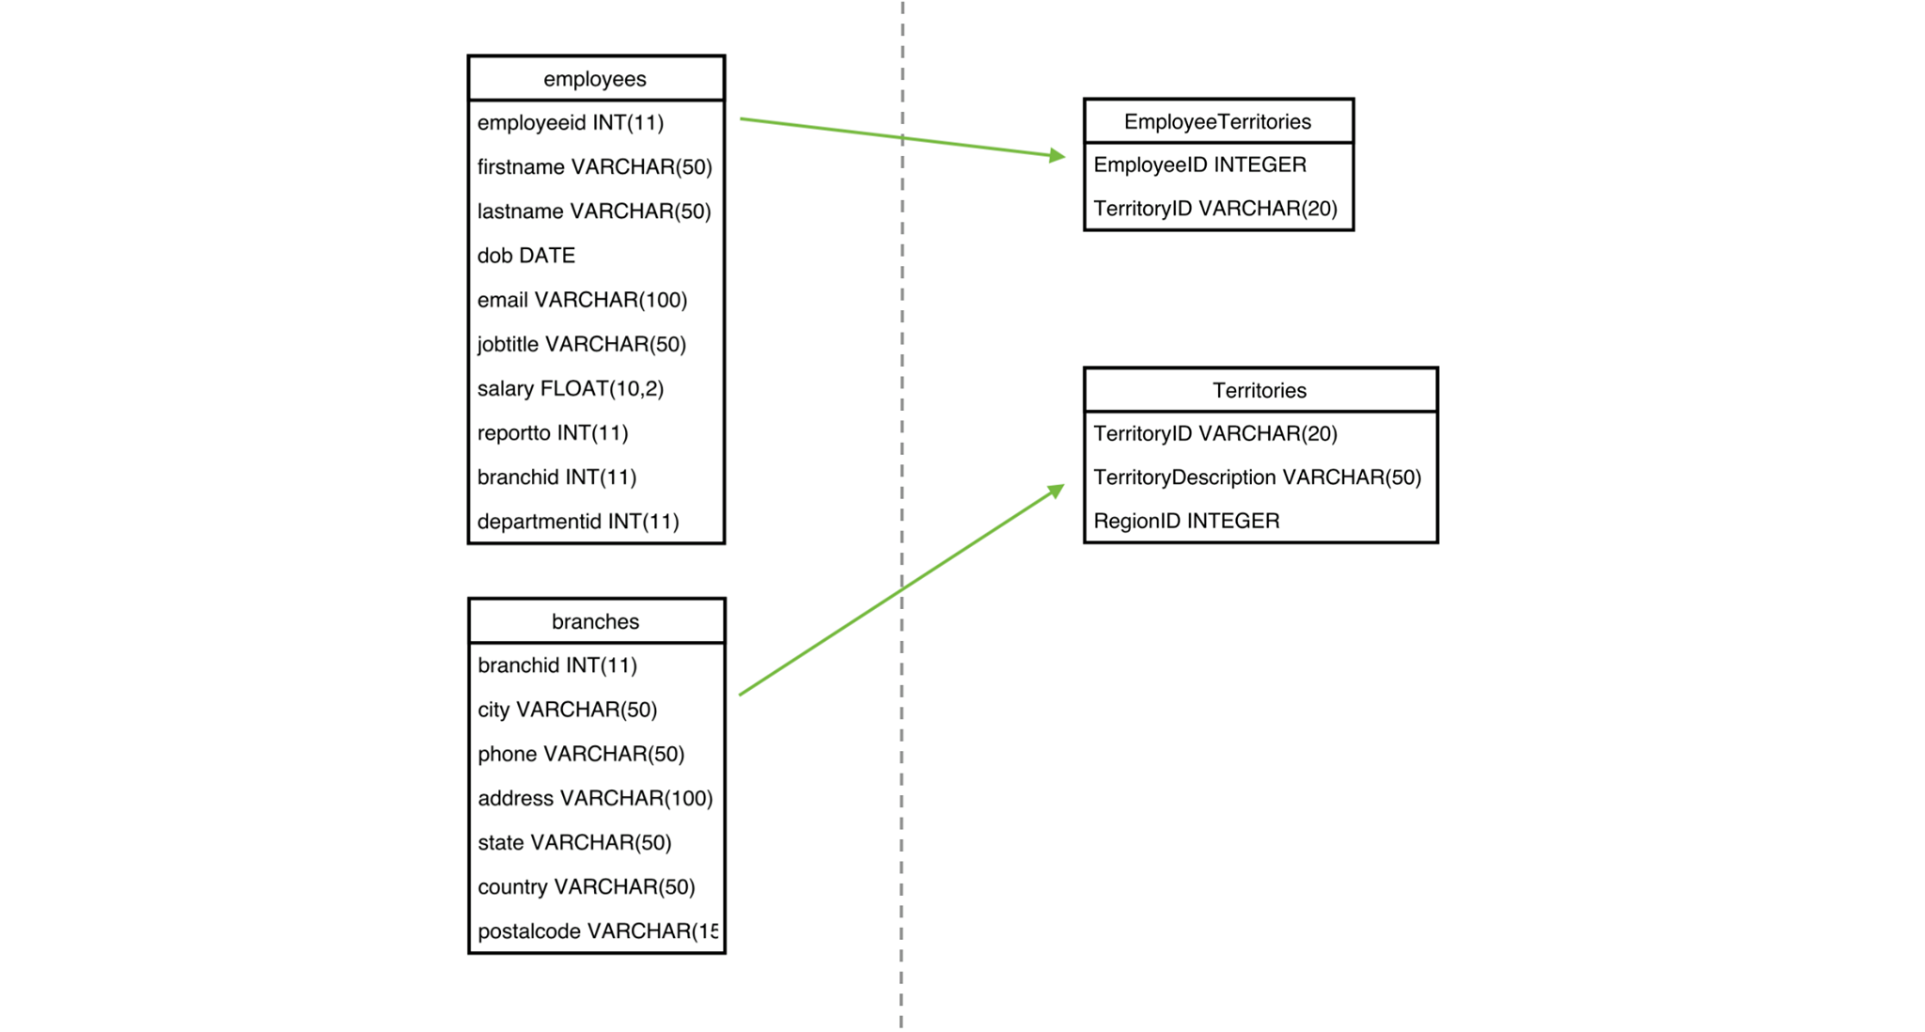

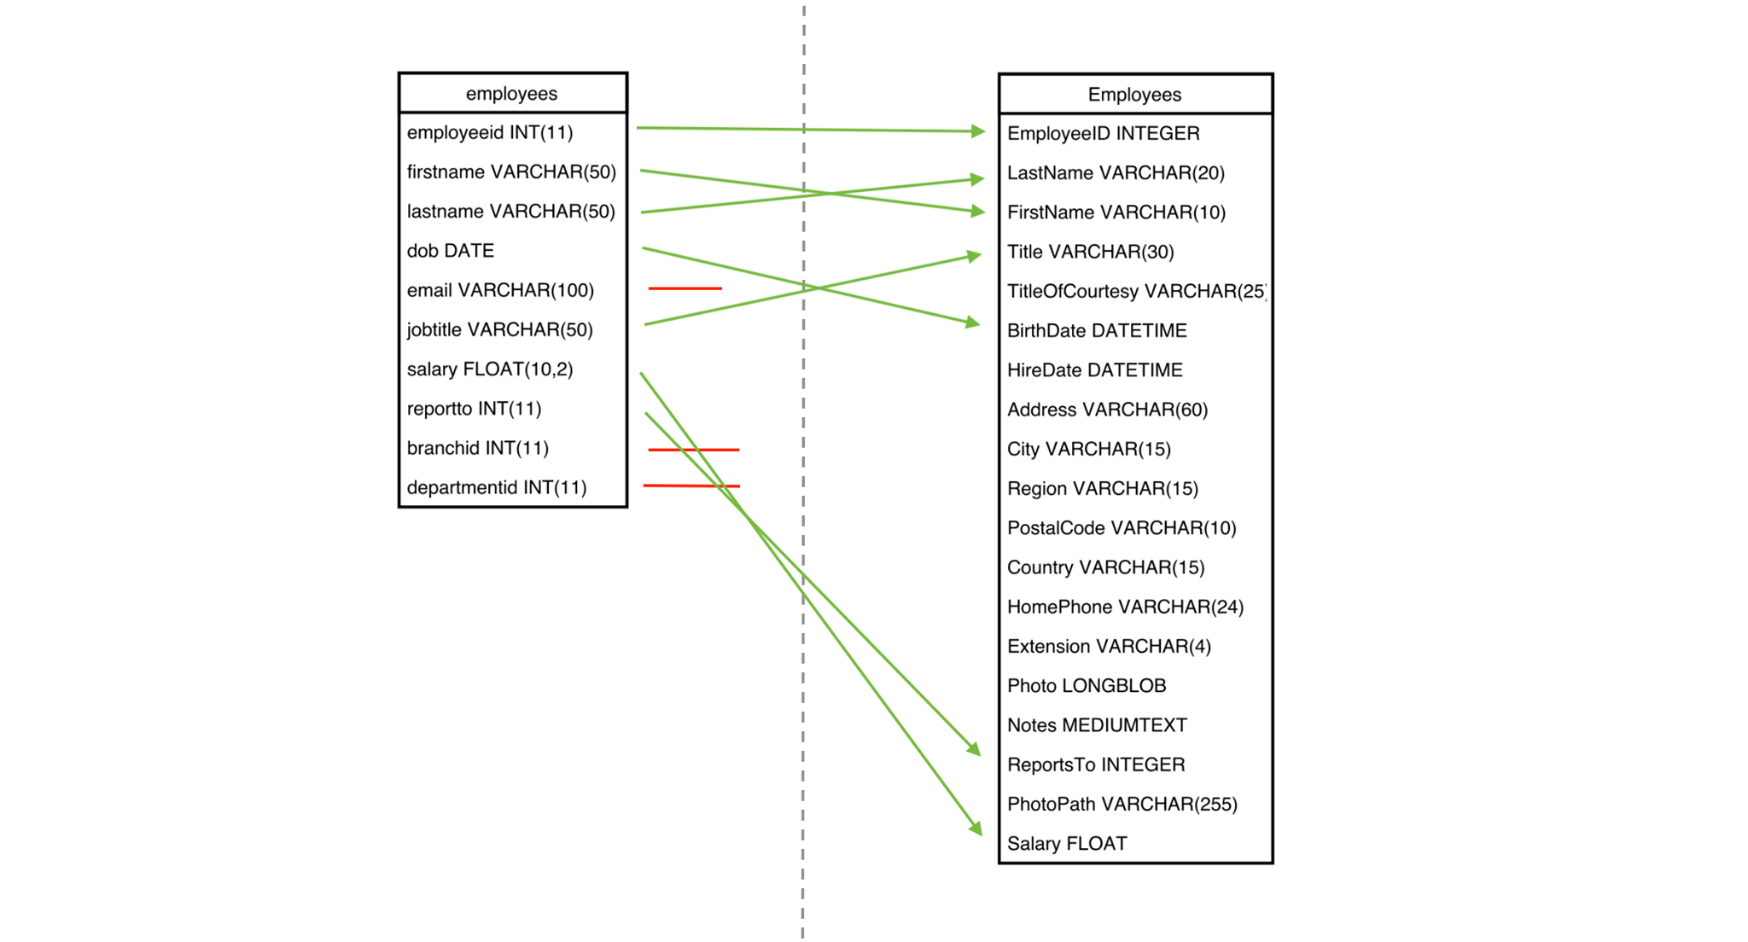

SQL views in text



mediated schema





Duplicated job titles

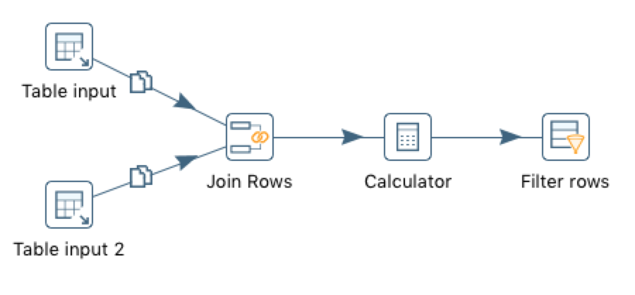

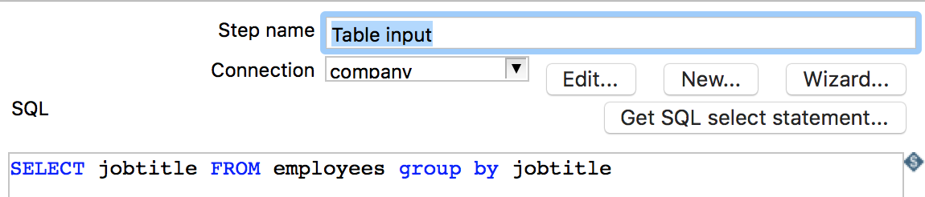

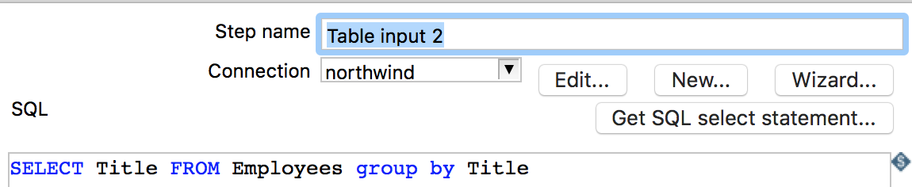

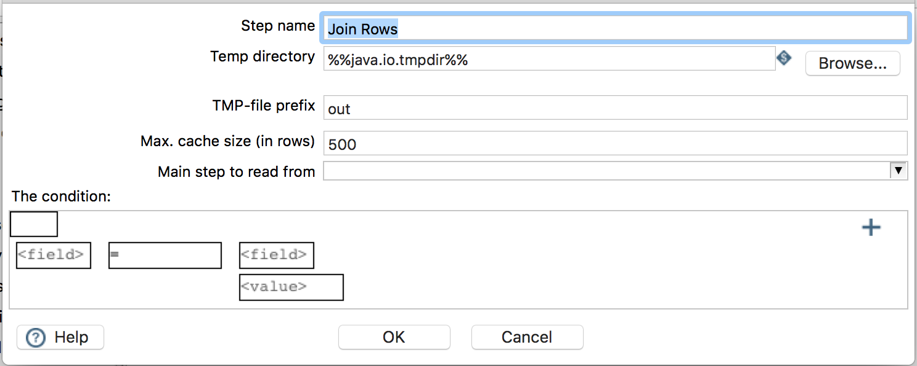

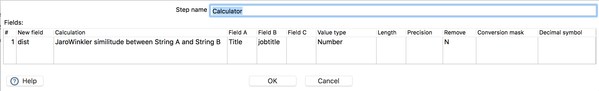

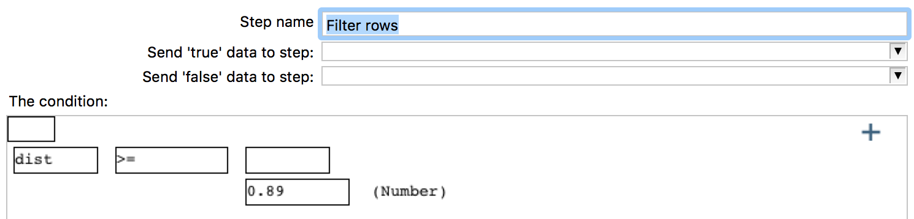

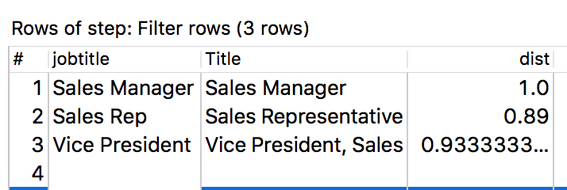

Comparing the job titles in both databases we concluded that a similarity measure would be more appropriate than a distance based one. For example we have the title “sales rep” and “sales representative”, they have the same meaning but a distance based string matching technique would have a high result which is the opposite of what is desired.

Northwind data warehouse



