

Supercell

**Culture and Entertainment**

**FSI 2018/2019**

**Grupo 14**

76175 – José Cândido

75948 - Gustavo Gomes

76462 – Vasco Fernandes

81757 - João Gandum

80915 - João Ramos

Índice

1. Culture and Entertainment In The Past 2

Conceptual Map

Conceptual Map Explanation

Descriptive Analysis

1. Case – Supercell 4

Business Model Canvas (BMC) of Supercell

BMC Explanation

Descriptive Analysis

1. References 6

Culture and Entertainment In The Past

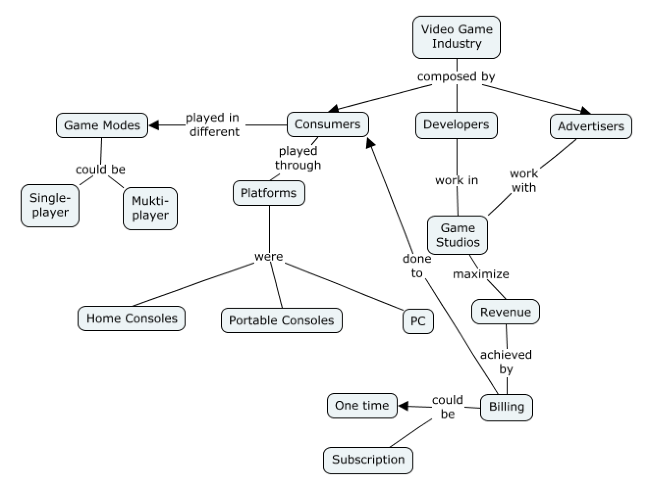Conceptual Map

Conceptual Map Explanation

|  |  |
| --- | --- |
| **Term** | **Definition** |
| Video Game Industry | The video game industry is the [economic sector](https://en.wikipedia.org/wiki/Economic_sector) involved in the [development](https://en.wikipedia.org/wiki/Video_game_development), marketing, and monetization of video games. It encompasses dozens of [job](https://en.wikipedia.org/wiki/Job) disciplines and its component parts employ thousands of people worldwide. [1] |
| Game Developers | A video game developer is a [software developer](https://en.wikipedia.org/wiki/Software_developer) that specializes in [video game development](https://en.wikipedia.org/wiki/Video_game_development) – the process and related disciplines of creating [video games](https://en.wikipedia.org/wiki/Video_game). [2, 3] |
| Advertisers | By advertisers we refer to companies that their only focus is to sell products or services. |
| Consumers | Consumers are the people that enjoy a product or service bought by them. |
| Platforms | By platforms, in this context, we refer to the vehicles for the consumers to play the game (in this particular case). Can vary between Home Consoloes, Portable Consoles and PC (Personal Computers). |
| Home Consoles | A home console, is a video game device that is primarily used for home gamers, as opposed to in arcades or some other commercial establishment. Home consoles are one type of video game consoles, in contrast to the handheld game consoles which are smaller and portable, allowing people to carry them and play them at any time or place, along with microconsoles and dedicated consoles. |
| Portable/Handheld Consoles | A portable game console is a small, portable self-contained video game console with a built-in screen, game controls, and speakers. For example, a GameBoy is a type of portable console. |
| PC | A personal computer (PC) is a multi-purpose computer whose size, capabilities, and price make it feasible for individual use |
| Game Modes | By “Game Mode”, we refer to the possibility, in a high level way, to the game modes massively available to players |
| Single-player | Single-player mode is the way to pkay when the player plays solo. |
| Multi-player | Multi-player game mode refers to the mode where players interact with each other when playing a video-game. |
| Game Studios | Game studios are software houses, composed by different roles, ranging from software engineers, architects, UX designers, etc. |
| Revenue | Video game monetization is the process by which a [video game](https://en.wikipedia.org/wiki/Video_game) product returns money for those involved in its creation or copyright ownership. |
| Billing | The process of preparing or sending invoices. |
| One time billing | One time bbilling happens when, in this case, the consumer only pays for the game once. |
| Subscription billing | Subscription billing happens when the consumer has to make payments from time to time to continue playing. |

Descriptive Analysis

The structure of the video game industry is a prototypical platform market where a video game console acts as a platform to two different end users, consumers and game developers [4]. A console permits two end users to interact via its platform creating externalities for each side of the market where the demand-side indirect network effects pertain to the effect that a game title has on a consoles value to the consumer as well as the benefit a game developer receives when an additional consumer joins the consoles owner base.

The game industry, in its earlier days, was a very modest industry. History of Video Game Industry Video game industry is a relatively new field of business. Although video games itself was invented around mid-1950s, it took two decades until it became a commercial product. In November 1972, PONG arcade game from ATARI came out. It was a simple tennis game with graphics of two sticks as paddles and a square as a ball, yet it was something completely new. PONG became a massive hit in 1970s, amounting to sales of 12,000 arcade units. This became first commercially successful video game ever. Success of PONG showed the world the business chance in video games, resulting in many companies copying the PONG format and making similar games which are said to sold about 100,000 units. This was the beginning of the video game industry. In 1975, ATARI remade PONG for home usage where user can purchase the console and simply plug it in to TV to play a video game at home. There was no need to go to arcade with pocket full of quarters. Home console PONG sold 150,000 units just in Christmas of 1975, and did not slowed down its sales for next year either. The home console video game market, which is the mainstream videogame market in today, has emerged.

In 1980s, numerous companies started entering market with their own version of home consoles, yet only one was victorious. Nintendo from Japan single handedly took over the market with NINTENDO ENTERNTAINMENT SYSTEM (NES). Interestingly, the NES did not have any cutting edge technology. Then why was it that this console so successful? The answer is the software. Nintendo had a very strict quality control on softwares that were released on their console. Yet, there was massive numbers of software released for it because development was so easy thanks to simple design of the system. Some of the most notable icons of video gaming appeared during this era such as Link from Legend of Zelda series and Mario from Super Mario Series.

If 1980s was age of growth in video game industry, 1990s is age of maturity. In 1990s, video game consoles gained sophisticated three dimensional graphics. Console came around this time such as Sony’s Playstation and Nintendo’s N64 featured 3D graphics which allowed developers with much more creative freedom. Before these 3D games, video games were mostly targeted a kids. They had simple story and simple game play. It was easy fun for everyone. But with introduction of 3D techno If the industry has matured in 1990s, where did it head in 2000s? characterizes video games in 2000s. In 2000s, mostly three companies dominate the videogame console market, Family friendly Nintendo, hardcore gaming Microsoft, and SNINTENDOGS to infamous crime actionGrand Theft Autoseries. Introduction of motion being sort of in b ony Wii c made games easy to play for everyone again, while wide spread of online gaming has apturing technology with Nintendo created virtual community for more dedicated gamers. Our survey also prove this by having various choices of videogames. By this era, the average budget of games has grown to out scale Hollywood movies. There are amazing visual effects, celebrity appearances, and global scale marketing. Users demand this and can purchase them because the age Diversity is what group is shifting as evident in the survey as well. It has grown into full scale entertainment industry.

Case – Supercell

Business Model Canvas (BMC) of Supercell

|  |  |  |  |  |  |
| --- | --- | --- | --- | --- | --- |
| **Key Partners** | **Key Activities** | **Value Propositions** | | **Customer Relationships** | **Customer Segment** |
| - Tencent (owner)  - Investors  - Hired work | - Marketing  - Contact with potential players  - Product development  - Testing | - World’s most successful mobile games  - Players who play one game, usually play the others too  - Increase retention  - Games that you could log into and play from any device | | - Online communication  - Social media | - Fans of games  - Casual and mod-core gamers  - Gamers who enjoy tablet and mobile game  - Gamers who enjoy PC |
| **Key Resources** | **Channels** |
| - Employees  - Know-how  - The best talent for every single position  - Zero bureaucracy  - Small and independent cells  - Different business model  - The organizational structure of the company is flat | - Mobile distribution portals  - Social media |
| **Cost Structure** | | | **Revenue Streams** | | |
| - Employees  - Licenses  - Hired work costs | | | - Advertising  - In-app purchase of virtual games  - Profits for players to unlock game levels | | |

BMC Explanation

|  |  |
| --- | --- |
| **Term** | **Definition** |
| Tencent | The bigger and most used internet service portal in China that has purchased Supercell. |
| Contact with potential players | To know the users, to perceive the types of games preferred by them, the tendencies and the interests. |
| The best talent for every single position | The company's policy is to have fewer workers, but the better ones in their areas. |
| Small and independent cells | Small teams are called Cells. Each game comes from a cell, and they all operate extremely independently and have complete control over their own roadmap. |
| Zero bureaucracy | The company think that often times when teams become bigger, processes, bureaucracy and even politics emerge, and the work just isn’t fun anymore, so they prefer have a small cells and have zero bureaucracy. |
| Different business model | Supercell instead of charging money for games, has its profits through the unlocking of levels in games with micropayments. |
| The organizational structure of the company is flat | As the structure of the company is organized by cells where everyone has the same weight at work, the company structure is flat. |

Descriptive Analysis

Supercell is a software development company whose main goal is to work in an environment where small and independent teams create games for as many people as possible. The company is focused on making the game a worldwide success as well as making sure that it will remain popular over the years.

One of the peculiarities of this company is that the profits are not gained with the game sales, since they are free, but rather through the micropayments that show up during those games. This way, the teams focus is not on revenues but on creating a long-lasting addictive game that users will love to play for many years.

At the level of the company's employee organization, Supercell also uses something different than usual. The company believes that with a vertical organization and with large teams, communication and bureaucratic issues increase significantly leading to lower productivity and employee satisfaction. Thus, they prefer to opt for small teams (cells) where each one is responsible for working in a different game. Supercell believes that this way it can make the teams more productive and motivated and that way they can achieve greater success in the final products. Another particularity of the team is that since they have fewer workers, they only hire the best and the ones most passionate about what they do, keeping all projects running smoothly.

References

[1] - Zackariasson, P. and Wilson, T.L. eds. (2012). The Video Game Industry: Formation, Present State, and Future. New York: Routledge.

[2] - McGuire, Morgan; Jenkins, Odest Chadwicke (2009). Creating Games: Mechanics, Content, and Technology. Wellesley, Massachusetts: A K Peters. p. 25. ISBN 978-1-56881-305-9.

[3] - Bethke, Erik (2003). Game development and production. Texas: Wordware Publishing, Inc. p. 4. ISBN 1-55622-951-8.

[4] - 7See i.e. Kaiser (2002), Caillaud and Jullien (2003), Rochet and Tirole (2004), Rysman (2004), Kaiser

and Wright (2005), Armstrong (2006), Hagiu (2006)