What is DataTable:

When We work with disconnected architecture, we open connection to the database, retrieve data from database and then close connection.

Here we need something to hold data in memory. For that we can use Dataset and DataTable.

[DataTable](https://docs.microsoft.com/en-us/dotnet/api/system.data.datatable?view=netcore-3.1): It holds data in the form of rows and column just like a table in database. We can call them as a virtual table. It is a class present in System.Data .

[DataRow](https://docs.microsoft.com/en-us/dotnet/api/system.data.datarow?view=netcore-3.1) : Represents a row of data in a [DataTable](https://docs.microsoft.com/en-us/dotnet/api/system.data.datatable?view=netcore-3.1).

We can use [DataRow](https://docs.microsoft.com/en-us/dotnet/api/system.data.datarow?view=netcore-3.1) object and its properties ,methods to retrieve ,evaluate;

We can insert, delete, and update the values in the [DataTable](https://docs.microsoft.com/en-us/dotnet/api/system.data.datatable?view=netcore-3.1) using DataRow class.

Create Datatable



Add columns to DataTable

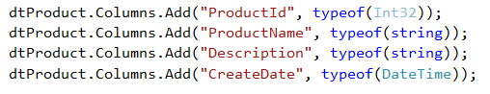

Add rows to datatable

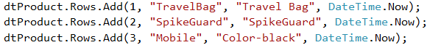

We can see DataTable with values while runtime.

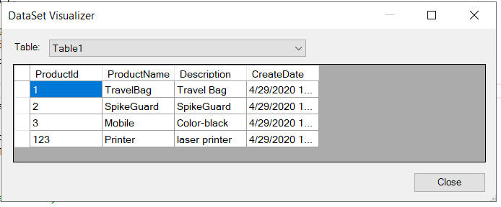

Retrieve data from datatable

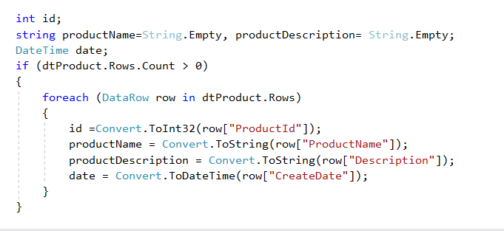

How to add row dynamically:

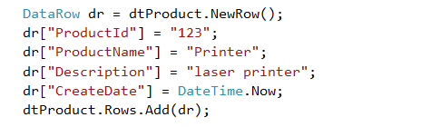

DataView **:**DataView is a view of table available in DataTable. It is used to find a record, sort therecords and filter the records. By using dataview, we can also perform insert, update and delete on DataTable.

We can sort, filter data using this class. Here we can get distinct list of product names, which we can hold in another DataTable



DefaultViewis a property of type DataView.

DataView.RowFilter property allow us to get or set the expression used to filter.

RowFilter property value data type is System.String which represents a string that specifies how rows are to be filtered.



If we want to change value for particular cell in DataTable.

e.g. If we want to change product description for product id 123

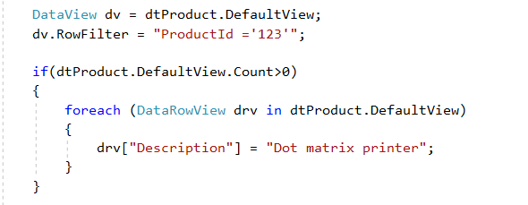

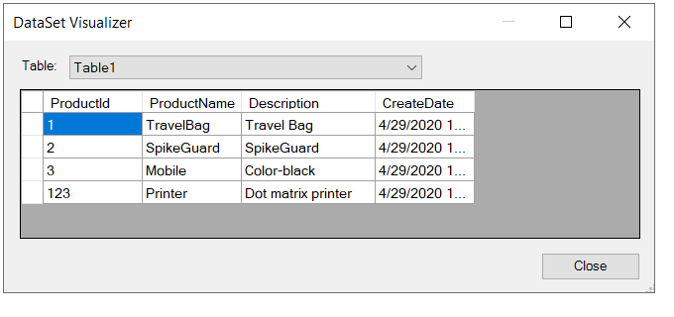

[DataRowView](http://msdn.microsoft.com/en-us/library/system.data.datarowview.aspx) :

[DataRowView](http://msdn.microsoft.com/en-us/library/system.data.datarowview.aspx) object represents DataView rows of the original DataTable.

Here we used DataView object to loop through DataView rows.