https://khoahoc.vietjack.com/thi-online/trac-nghiem-con-lac-lo-xo-co-dap-an-thong-hieu/64181

$c$1 C

$\*$ A

#h#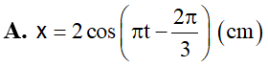

$$B

#h#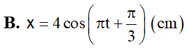

$$C

#h#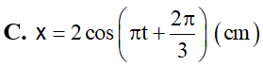

$$D

#h#