Download from : https://github.com/wara-ps/Streaming_Map_Demo

licApp

This is a guide on how to run licApp to activate GIZMO_LICENSE and SCENEBUILDER_LICENSE

Getting license keys

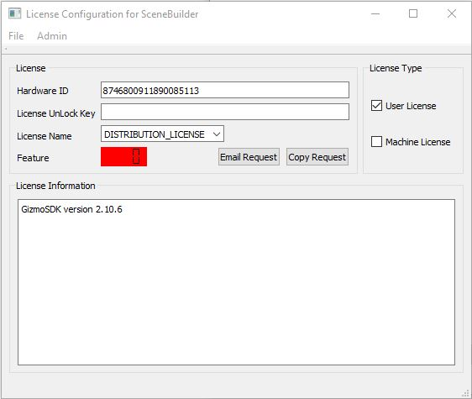
Start by open licApp.

Use “Email Request” and then “Copy Request”.
Mail the ”request” to Anders Modén. Mail: anders.moden@saabgroup.com

Se example below:
______________________________________________________

GizmoSDK license auto generated request 2020-06-17 07:54:44
HWD:8746800911890085113
LIC:SCENEBUILDER_LICENSE
FEAT:1
REF:License Configuration for SceneBuilder
PO:<enter your customer and purchase ref here>
______________________________________________________

Licens key for ”GIZMO_LICENSE” will give you a green ”7” in the ”Feature” window
Licens key for ”SCENEBUILDER_LICENSE” will give you a green ”1” in the ”Feature” window

When done, close the LicApp.

