Jong Tai Kim

10/13/2018

Info 330

Assignment 2

Database Design

Introduction

For this paper, we will examine the importance of data constraints and abstract layer, the impact of ERD and Meta-Data worksheets on managing databases, and the steps involving simple databases.

Question 1: Purpose of Data Constraints

Data constraints exists to ensure that the data in the tables are consistent throughout the whole databases. To do so, the data constraints are constructed to secure entity integrity, which forces data throughout the rows are consistent, to secure domain integrity, which forces data throughout the columns of tables are consistent, and to secure referential integrity to connect the relationship between tables consistently (Root R, Module02Notes, 2018). For instance, abstractly, data constraints help us to clarify what the data is for, such as that primary key constraints makes the column as primary key of normalized table--, and practically data constraints help us reduce our human errors such as putting names into hours --hours are limited to have only nonnegative numbers.

Question 2: Benefit of Abstract Layer

As computer takes a lot of 0s and 1s to operate, it is inevitable for us who speak human languages rather than binaries to create some system that allows us to understand what is going on in the codes that we have written. That is, we need to be ensure if our intention of coding matches with the operation done by computer. Moreover, our implementation of coding needs to be somewhat repeatable in different situations; in other words, we need to be sure if our implementation is general to any case as well. One way to attack this problem of ensuring is that we create the separate layers that operate separate functions or operations, to call and depend on each layer such allowing that the implementation of our coding is as same as the results from computer for any case that is handled by our implemented algorithm. This whole concept of layers is called as abstraction layer; our intention of coding can work in any similar cases by simplifying our algorithms using those abstraction layers that rely on each other. For the example of SQL, the views are abstraction layer for the databases by enabling us to present data, which is view’s function as abstraction layer.

\* Note: computer is mentioned but it can be any machine

\* Source that I used: wikipedia, abstraction layer, <https://en.wikipedia.org/wiki/Abstraction_layer>, 2018

Question 3: Purpose of ERD and Meta-Data Worksheet

Entity Relationship Diagram, also known as ERD, is useful to visualize the databases in terms of abstract layers and their relationships. For each entity in ERD, we can observe the very brief characteristics of its columns; for instance, we can see which column represents primary keys. In addition, the most significant feature of ERD is that we are able to see how each entity is related to others. That is, in ERD it is very easy to see the connection between entities by drawing the lines that connects entities; the lines are consist of infinity sign and the key, representing one (key) to many (infinity) relationship between the entities.

On the other hand, metadata worksheet serves the distinguishable roles, compared to ERD. Metadata worksheet is usually to describe the structure of databases in regards to the purpose of each abstract layer by showing us the structure of each abstract layer and the detailed characteristics of each entity of databases. For instance, each row of tables of metadata worksheet on tables of databases represents the constraints and data type of each column of tables. Similar to the example below, the tables of metadata worksheets show each variable’s constraints, where the purpose of the entities as the abstract layer is to store the data such that viewers need to understand how data is stored via those variables and their constraints. 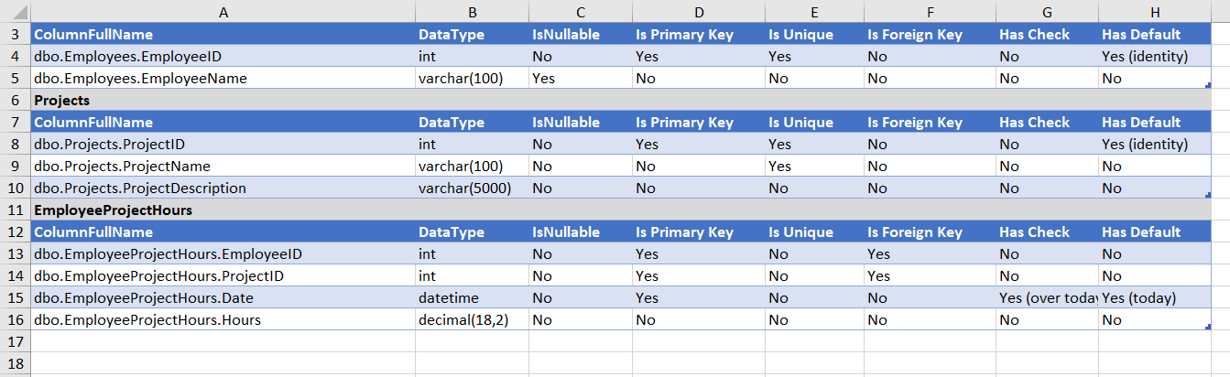

Figure 1: example of Meta-Data Worksheet(from Module02 Lab04 exercise)

In summary, ERD focuses on concise visualization of relationship between entities of databases and metadata worksheet focuses on the detailed description of the entities of different abstract layers of databases.

Question 4: Designing Simple Database

To create a simple database, we need to justify why we want to create the simple database. That is, we are trying to convey the purpose of our database. Then, based on the purpose of database and the information related to the database, we need to find a significant way to distinguish each information into unique subjects and those data (rows) in entities are divided into its attributes. By that way, we are able to see what and how information is stored in each tables, such that now we can define the relationship among each entity with others. With acknowledging usage of tables and their relationship to other tables, we can normalize those entities to efficiently represent data we need to store; for instance, we are required to divide the columns of table further into atomic values, to create the primary key that represent unique rows, and define relationships of tables to avoid the violation of normalization rules. Then, now we can store the actual data into our databases.

\*Source that I used: Microsoft Office, Database design basics,

<https://support.office.com/en-us/article/database-design-basics-eb2159cf-1e30-401a-8084-bd4f9c9ca1f5>, 2018

Summary

In this paper, we have explained the significance of data constraints on structuring the tables efficiently, the positive effect of abstract layers on using databases for different purposes, the description of presenting the structure of databases, and designing the simple databases.