Student: Jong Tai Kim

Date: 2018-11-17

Class: Info 330

Assignment 07

PatientAppointments DataBase

The entity relationship diagram below represents the prototype of the PatientAppointments Database

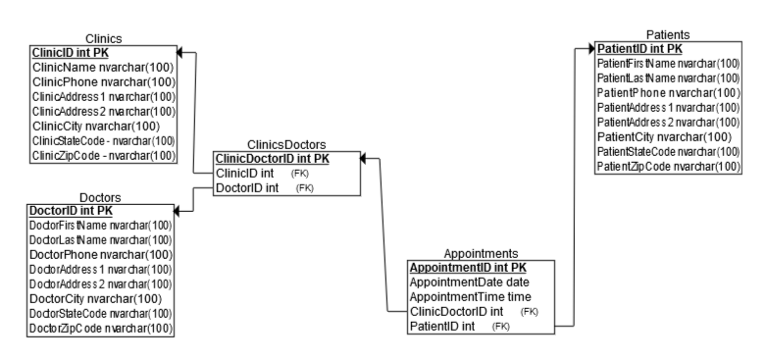

Justification on Database Design Outside of Given Information:

As the user will select the data of a doctor or a clinic, this might imply that the user is trying to look up the address and phone numbers of the doctor or the clinic, not just names of the doctor and clinic.

As the user can select date and time separately, it might be good if we can separate those data into date and time, rather than combined as datetime datatype.

Also, the bridge table of clinic and doctor can be used to link to the appointment instead of using table of clinic and doctor separately, since it is concise as well as the clinicdoctor can have many patients and patients can have many clinicdoctor – the bridge table still has many-to-many relationship with patients.