Effective Implementation of King County Safe Injection Sites

| Kyle Goodwin  University of Washington  Seattle, WA  kjgood1@uw.edu | Conor Reiland  University of Washington  Seattle, WA  creiland@uw.edu | Warren Cho  University of Washington  Seattle, WA  wcho@uw.edu |
| --- | --- | --- |

# ABSTRACT

March 7th 2017. This research paper analyzes the trend of heroin use and overdose in King County, and attempts to demonstrate how the creation of a safe injection site in the area could alleviate the problem. Finally, this paper proposes guidelines for the implementation of said site to maximize its effectiveness.

## Author Keywords

Public Health; Overdose; Heroin; King County

# INTRODUCTION

In efforts to combat epidemics of Human Immunodeficiency Virus (HIV) and the hepatitis C virus (HCV) as well as the effects of heroin/prescription opioid use (the two are molecularly indistinguishable) on public health and impacted communities, European and Canadian cities have implemented safe injection facilities (SIF) for injection drug users (IDU). Safe injection facilities allow IDUs to use pre-obtained drugs in a supervised setting to limit the potential impact on the community and its public health. Despite not yet having any committed funding or locations, Seattle and King County approved two of said facilities in January 2017. These establishments’ primary purpose is to provide a more controlled environment to reduce public drug use, create relationships between the highly marginalized “at-risk” population and healthcare, and encourage the seeking out of medical care and addiction treatment - all fueling the debate for decriminalization of drugs. There are many motives for investing in facilities for sole purpose of injection drug consumption. One of which can be summed up by Caleb Banta-Green, a public health professor at the University of Washington specializing in drug abuse, who says that “People use in public; they don’t want to use in public, and the public doesn’t want them to use in public” which is largely true for many public health and perception reasons. Other motives would include reducing the number of overdoses and overdose related deaths, limiting the spread of disease, reducing the amount of injection drug related litter, and increasing the number of IDUs entering treatment in the Greater Seattle Area. In areas where SIFs have been established, they have been credited with “improving the health and social functioning of their clients, while reducing overdose deaths, risk behaviors known to transmit infectious diseases, improperly discarded syringes, and public drug use.” (Wood, Harm Reduction Journal) It is necessary to combat illicit injection drug use, costly tips to the emergency room, acute hospitalizations, and public drug use - safe injection facilities are an investment for the community in which they are and they have the potential to help a large number of people.

# Related work

Two papers related to the establishment of Seattle SIFs in Vancouver, British Columbia will be highlighted. There are many parallels between Seattle and the city just up the interstate, across the American-Canadian border - this makes it a reasonable and relevant comparison in context of establishing SIFs in Seattle/King County.

The first paper comes from the Harm Reduction Journal (2004) examining the methodology for evaluating Insite, the SIF in Vancouver, BC. This evaluation followed a prospective cohort of anonymous SIF users to examine risk behavior, blood-borne infection transmission, and health service use with data from the SIF itself as well as surveys/interviews with local residents/uses/staff. This preliminary evaluation attempts to evaluate a number of measures: client satisfaction, process measures, community and staff satisfaction, and public order. Early observations of the facility were optimistic. The facility’s demand quickly grew, clients and staff alike were satisfied, syringe sharing hadn’t been an issue within the site, and they facility even attracted cocaine users. This evidence suggests that the community effects of the Vancouver site were on par with those of over two dozen European sites.

The second is a summary of findings from the evaluation of the Vancouver site published for the Canadian Medical Association Journal (2006). This publication examined more quantitative observations for the Vancouver SIF. This evaluation was also very promising for the future of safe injection sites. 95% of IDUs reported high levels of satisfaction with the facilities and staff. Additionally, there was an observed relationship between SIF users going up and public use going down, a decrease in number of injection-related litter around the city, a low rate of overdose, and a high number of referrals to various forms of healthcare services and addiction treatment. This evaluation reinforces that SIFs can bring many benefits, as well as no observable harms, to an area where injection drug use is prevalent.

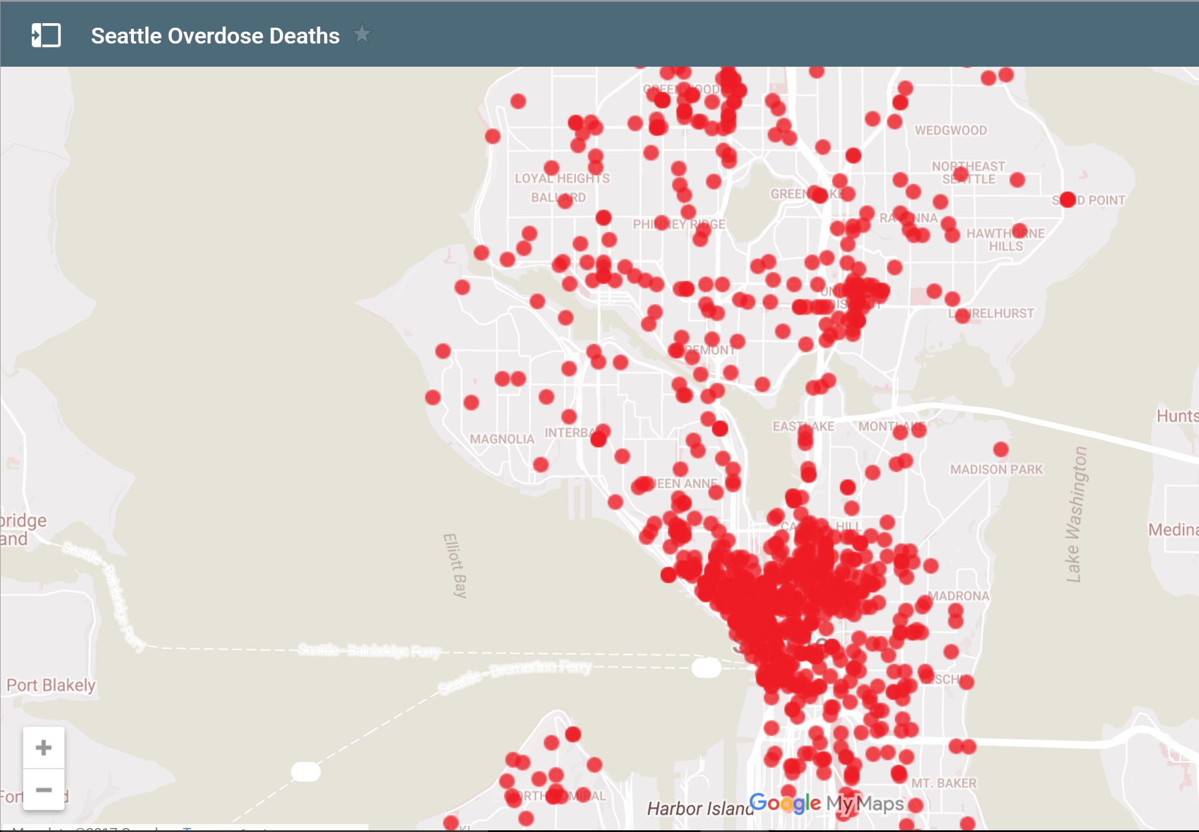

*Figure 1: Map of Seattle Overdose Deaths*

# Methods

The main source of data used in this analysis was the Seattle Police Department Incident Response data, which was filtered to show only incidents that involved fatal drug overdoses. From this filtered data, we created an interactive map of Seattle showing the location of each overdose in the dataset, denoted by a red circle as shown in Figure 1. The data was further filtered by year, month, and time of day in order to examine trends in overdoses across those 3 variables. Data from the Vancouver Safe Injection Facility was used along with the equation for the odds ratio (Figure 2) of specific risk behaviors was used to compute odds ratios for IDUs given that they do or do not attend the Vancouver SIF. Data from the CDC was used to make a chart showing trends in prescription opioid related deaths versus heroin related deaths. Because of the lack of raw data, in addition to our analysis, we chose to summarize data from other sources such as the King County Community Health Trends report in order to establish a foundation for our analysis of the SPD data.

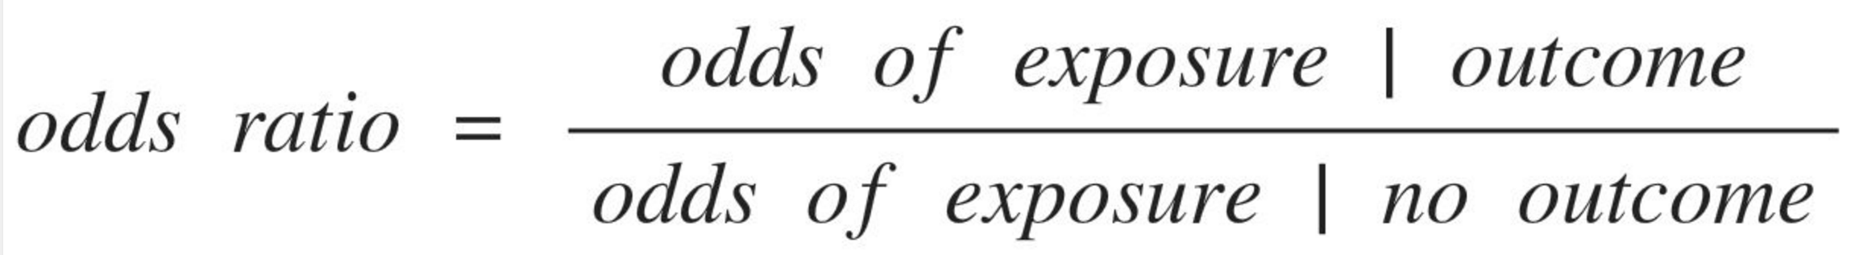

*Figure 2: Equation for Calculating Odds Ratios*

# Results

Based on the geographic mapping on individual overdoses, we found that, although widespread, overdose deaths have a high concentration in 3 distinct areas. Downtown sees the largest number of overdoses, nearly ⅓ of all overdoses in Seattle despite the fact that the area of downtown is only about 3.5% of Seattle’s total area. Based on the map, the other two areas with the highest incidence of overdose death are the 1200 block of Aurora Ave N and the University District.

Our analysis of data from the Insite study allowed us to compute odds ratios that quantified the potential impact of SIFs in King County. By studying odds ratios of the use of the same type of facility in a city very similar to Seattle, we were able to accurately predict the positive health impact of such a facility in Seattle.

Further, along with an understanding of the geographical impact of heroin overdoses, our analysis of trends in overdose across multiple variables of time allowed us to create a guide for effectively implementing Safe Injection Facilities. Analysis of total overdoses by time of day yielded useful data on the most effective schedule for operating an SIF on a daily basis. In looking at data about overdoses by month, we found that the summer months have the highest incidence of overdose. This data put into perspective the necessity of implementing the facilities before the summer so that they can be as effective as possible in saving lives and improving public health in the first few months of opening.

# Implications of Results

King County health board officials have recently voted to implement two safe injection facilities in the county. As demonstrated in our research, we have found that these sites would be effective at preventing deaths due to opioid overdose, as well as help alleviate the impact that the opioid crisis has had on the community. Culturally and geographically similar to the Seattle area, Vancouver BC has achieved very promising results with their Insite safe injection site, and we believe the Seattle area would notice a similar impact.

We hope that our findings will help influence the voting public to take action, and vote for public officials that support the site. Our hope is that our findings on the widening scope of the problem will also convince more people to take action and make a difference in their community. Our findings about the switch from prescription drug use to heroin use should also be considered in policy making, it is important for lawmakers to know that their well intentioned move to decrease prescription drug use has had unintended consequences.

The final portion of this project gives some guidelines for how such a site should be implemented to maximize its effectiveness. Our analysis of the Seattle Police Incident reports has shown that there are two main epicenters of overdose in the Seattle Area. We believe that officials in charge of building the site should use this data to help place the site in an area that would draw the most injection drug users out from the streets, while being cautious about the impact it may have on the surrounding community. We believe our location choices of the SODO district and University District meet these criteria, and should be looked at in the planning process of the County. Officials should carefully study the findings of Insite, and look to improve the process of getting incoming users placed in addiction treatment programs. are formatted using the Normal style.

## FUTURE WORK

While we were able to deduce some interesting insights with available data, our project could have greatly benefited from access to large data sets from King County and the CDC. We made requests to access their data on multiple occasions, but the time it would take them to get it to use was not inline with our time frame. We could draw many more interesting conclusions, such as rates of addiction across different demographic and changes in types of opioid abuse, if we had access to the large mortality database at the CDC. While we were able to access the some of the data through a hacky Python script, it did not include the correct cause labeling or geographic encoding to make it useful in our project. Access to King County death records could have also been beneficial.

Machine learning could also be implemented to look at past crime reports and mortality data, and project into the future to see how things will change, and how policy makers can plan for said changes. This type of model could help choose a better location for building the site, and could even help authorities predict where a future overdose death might occur.

If we truly want to accomplish the mission of our project proposal, which was to influence public opinion in support of safe injection sites, it would be important to distribute and market our research so that it reaches a large number of people. Getting our research in the hands of Washington politicians would bring attention to the scale of the problem at hand, and lead them to support resources that contribute to a solution.

# ACKNOWLEDGMENTS

A special thank you to Mike Freeman and Rosemary Adams for their tireless effort in bestowing upon us the knowledge required to complete this study.

# REFERENCES

1. King County Heroin and Opioid Trends. (2015). Retrieved March 7, 2017, from http://www.kingcounty.gov/~/media/depts/community-human-services/behavioral-health/documents/herointf/heroin_opioid_trends_infographic.ashx?la=en
2. Seattle Police Department 911 Incident Response. (2017, March 7). Retrieved March 7, 2017, from https://data.seattle.gov/Public-Safety/Seattle-Police-Department-911-Incident-Response/3k2p-39jp/data
3. Wood, E., Tyndall, M. W., Montaner, J. S., & Kerr, T. (2006). Summary of findings from the evaluation of a pilot medically supervised safer injecting facility. *CMAJ : Canadian Medical Association Journal*, 175(11), 1399–1404. http://doi.org/10.1503/cmaj.060863
4. Banta-Green, C. (2015). 2015 Drug Trends for King County. *University of Washington Alcohol & Drug Abuse Institute*. Retrieved March 7, 2017, from http://adai.uw.edu/pubs/pdf/2015drugusetrends.pdf
5. Opioid-related Deaths in Washington State, 2006–2015. (2016). Retrieved March 7, 2017, from http://www.doh.wa.gov/Portals/1/Documents/Pubs/346083.pdf