

**NUST COLLEGE OF ELECTRICAL AND MECHANICAL ENGINEERING**

Computer Networks

Project Report

Multi-user chat room

*Warda Ahmed*

*00000129112*

***DE-CE-37***

***Syndicate B***

Contents

Abstract 2

Features implemented 2

Application Protocol 3

I. Transport Layer Protocol: 3

II. Program flow 3

• Tools used: 3

• Server side: 3

• Client side: 5

• MySQL Database “Users” on TCP Port 3306: 6

# Abstract

The objectives of this project were as follows:

* **To design a group chat application:**

1. The application must allow addition of new members to the chat room
2. The application must allow removing of members from chat room
3. The messages sent to the chat group must be delivered to all group members

* **Additional features for bonus points:**

1. Message delivery / Message read receipts
2. Offline messages
3. File Sharing etc.

# Features implemented

* Application allows addition/removal of users from chat room
* Messages are broadcast to all group members via UDP
* Number of online users
* Pinging clients every 2 seconds to check for random disconnects
* Offline messages
* File sharing via TCP

# Application Protocol

## Transport Layer Protocol:

**User Datagram Protocol (UDP)** was used for broadcasting text messages to all users.

As the application is intended to be used as a live gaming chat which does not require a user to receive messages sent while he was offline as he is only concerned with live updates.

Network communication for video games is almost always done over UDP.

Speed is of utmost importance and it doesn't really matter if updates are missed since each update contains the complete current state of what the player can see.

* Achieve higher throughput than TCP as long as the network drop rate are within limits that the application can handle.
* Deliver packets faster than TCP with less delay.
* Game Setup connections faster as there is no initial handshake to setup the connection
* Low congestion which is essential for gaming that requires more bandwidth for the actual gameplay

**Transmission Control Protocol (TCP)** was used for transferring files to all users because:

* We require that file was sent without any error (We trade performance for reliability as we can not allow any modifications or byte loss in file transfer)

## Program flow

### Tools used:

* Java Swing GUI (Eclipse Luna IDE)
* MySQL Database (to store usernames, passwords, and messages)

### Server side:

* /quit (closes the server)
* /kick <clientID> (kick a user from the chat)
* /clients (view all online clients and their details (ip, port etc)
* Server can also broadcast its own messages to all users
* Server notifies all users that a file was sent by <sender Name> and tells the sender the file was sent

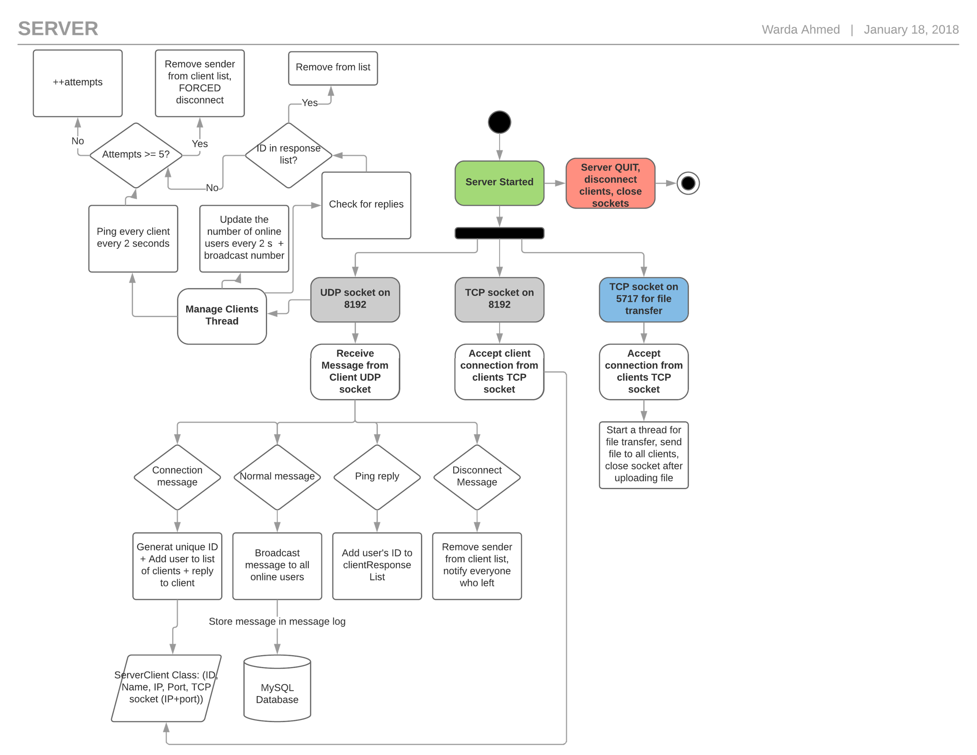

### Client side:

* After logging in, user chooses a download directory to save received files to

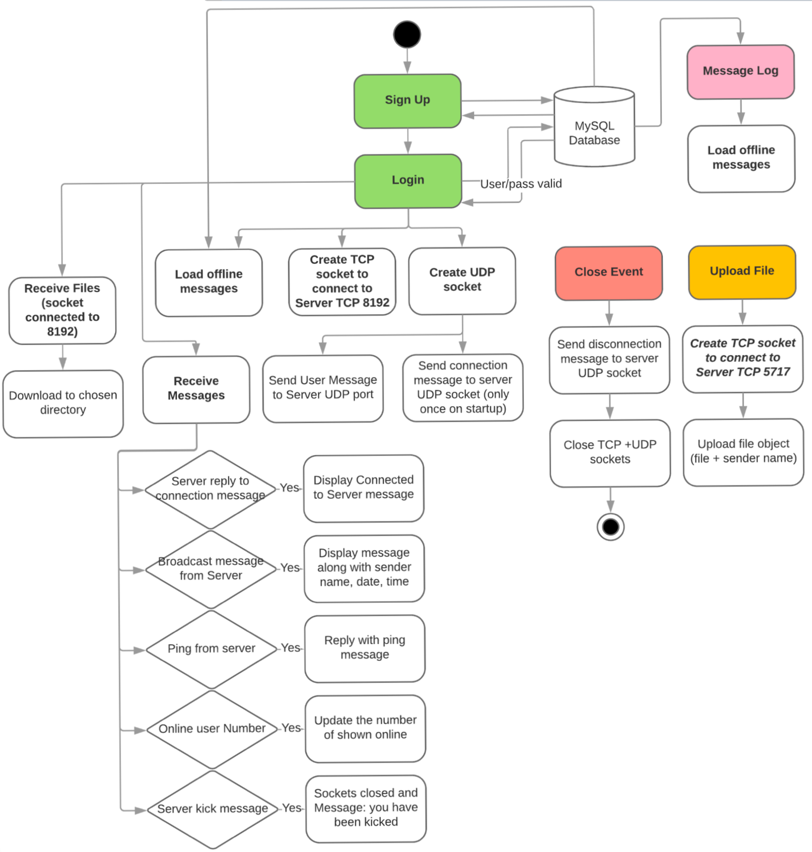

### MySQL Database “Users” on TCP Port 3306:

