DAY:☺3

API INTEGRATION AND DATA MIGRATION REPORT-

Elite Food-Tuck

API integration means connecting one application with another to share data or use specific functionalities. we build a functional marketplace backend & learn how to utilize APIs for reference, migrate data into Sanity CMS, and ensure compatibility with their templates

|  |  |
| --- | --- |
|  | Understand how to integrate APIs into your Next.js project.  Learn to migrate data from APIs into Sanity CMS.  Explore how to use existing data from Q-Commerce platforms like Food panda, WordPress, Salesforce, Custom Backend, Sanity.  Develop skills to handle and validate schema with data sources |

# Q-commerce API Overview

MY API reference from Template 9 Elite Food Tuck. We Are integrating API and migrating data into Sanity CMS to build a functional marketplace backend In Next.js Project. We Use these Provided APIs to populate their Sanity CMS .

Template 09:

<https://github.com/mubashirimtiaz/sanity-nextjs>

# External Data Sources

We integrate data from popular Q-Commerce platform and custom back end using their headless API & data export features

* Cms (Sanity)

Steps for Day 3:

Provide the API

We have identified the key endpoints:

* **Food Listings** (e.g., /food)
* **Chefs** (e.g., /categories)

Validate and Adjust Our Schema

our existing Sanity CMS schema Day 2 with the API data structure.

Adjust field names, types & category (example) API Field: foods-names, Chefs-details

Our schema to match or map fields during migration

Data Migration

Using the Provided API Type [Food, Chef]:

We are manually Import Our sanity’s built-in import tools to upload the data & Include validation check & migrate scripts to handle errors gracefully.

Map fields to your Sanity schema API

API Integration in Next.js:

Test API Integration in thunder client & postman

We Render Data in Components & Utility Functions

Output:

1. Sanity CMS populated with imported data from Provided API

2. Functional API integration in Next.js displaying Our Food Categories & Chefs Details.

Screenshots of:

♣ API calls.

♣ Data successfully displayed in the frontend.

♣ Populated Sanity CMS fields.

API INTEGRATION & DATA MIGRATION (Backend)

* Create Sanity Project

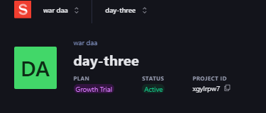

* Install Sanity on my Terminal

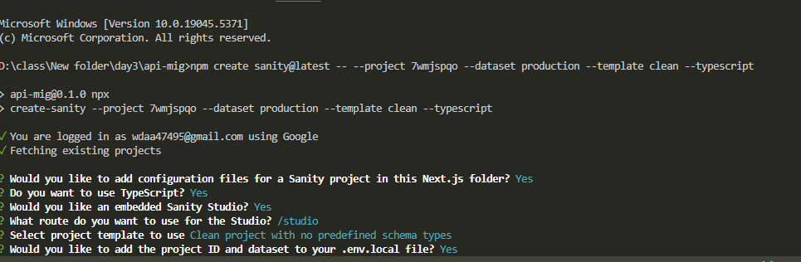

* Our Sanity Files

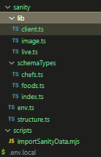

* API Token  
   Generate a Sanity API token &  Copy the generated token Paste your .env.local file

Add CORS

API

Token

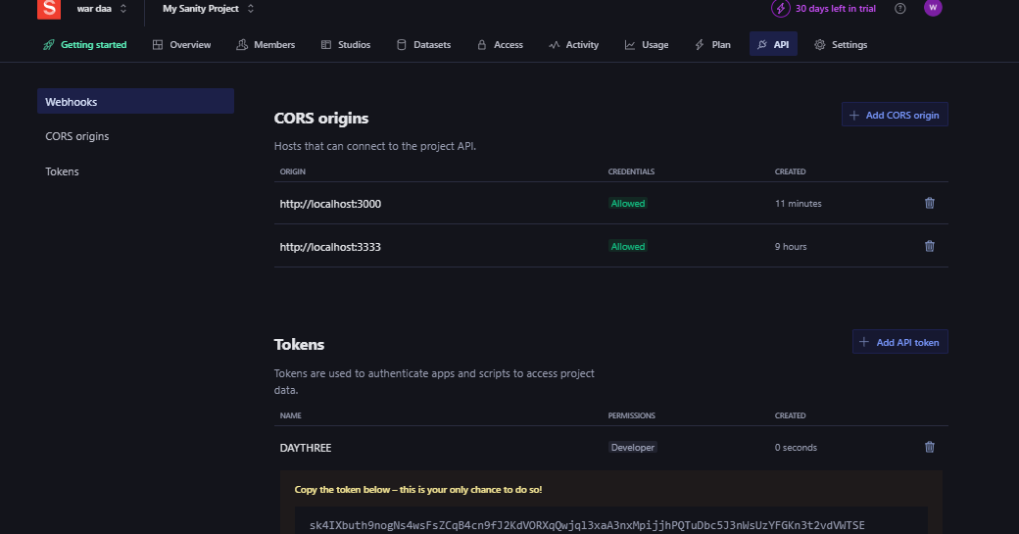

Add our Token in .env.local file

API Token

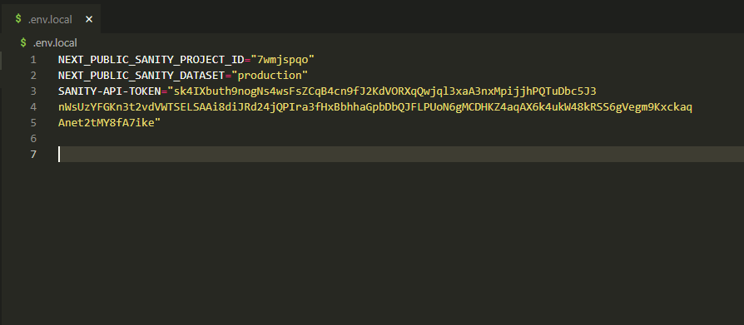

Create the sanity schema

Step 1. Create a file called Foods.ts In sanity/schematypes

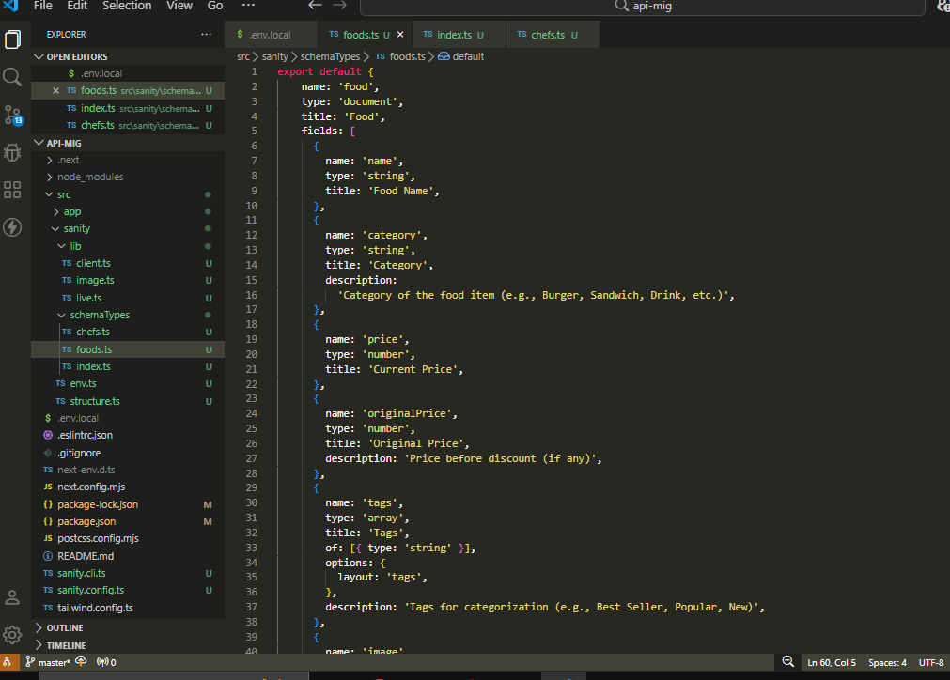

Step 2. Create a file called Chef.ts In sanity/schematypes

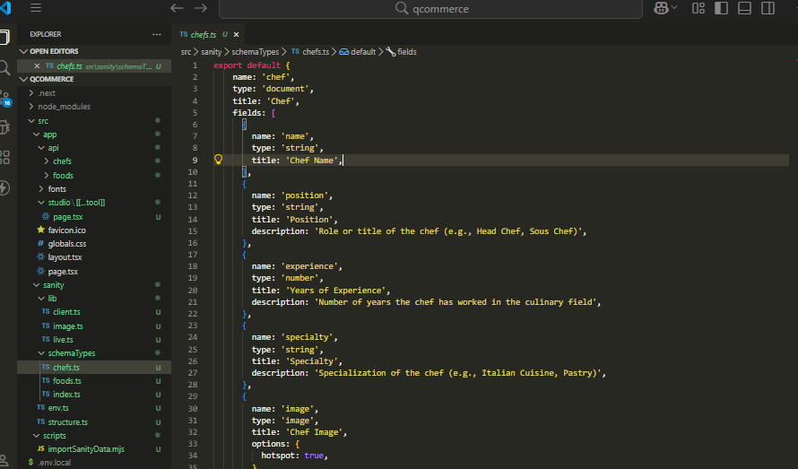

Step 3. Add types sanity/schematypes/index.ts

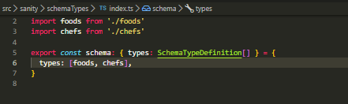

Step 4. Set up the Data import Script & install sanity/client axios

npm install @sanity/client axios dotenv

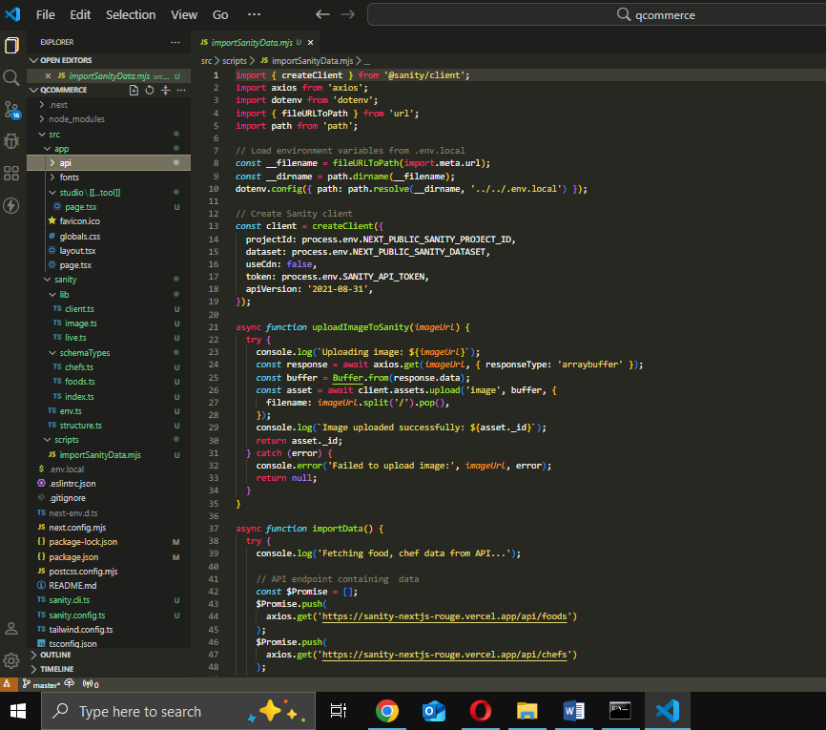

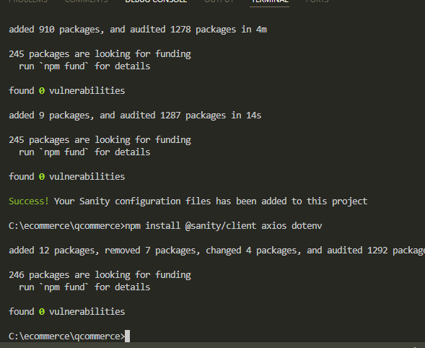

Step 5. Add a new Import-data script

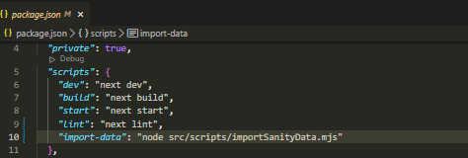

Step 5. Run Project in terminal

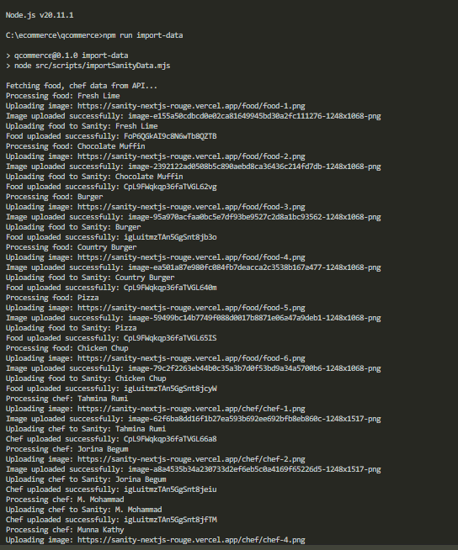

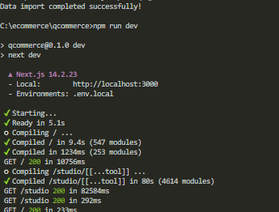

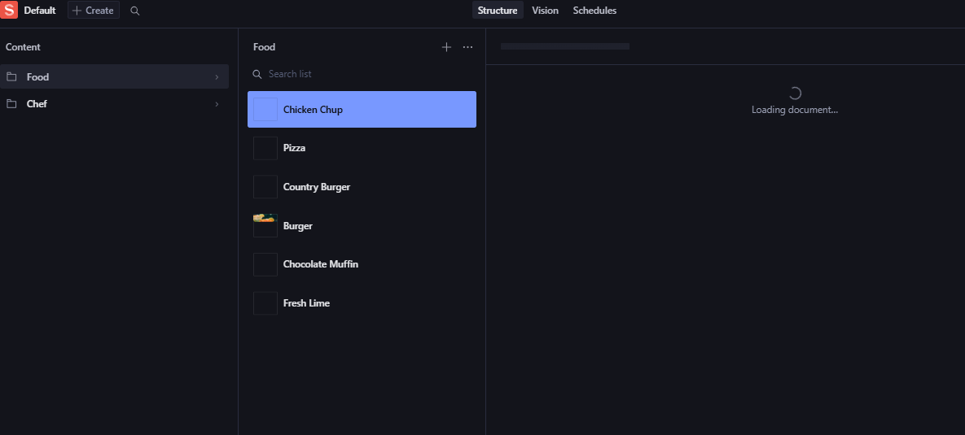

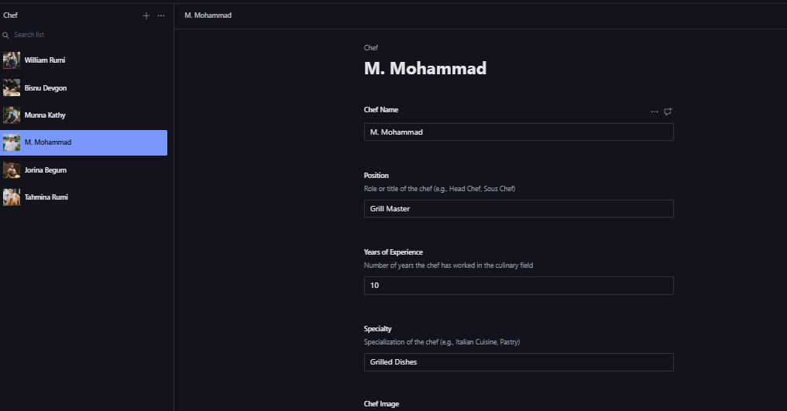

vession

Fetch our data On Vession

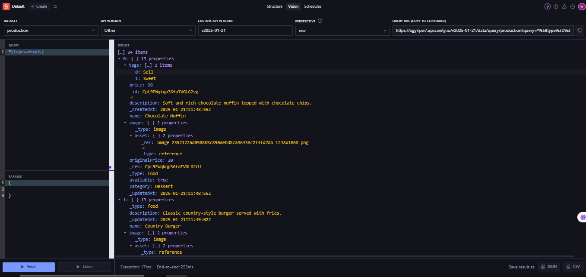

Data Fetch

Data

Data successfully displayed in the frontend.

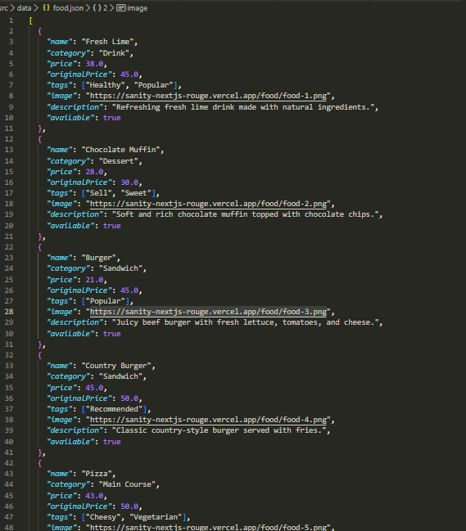

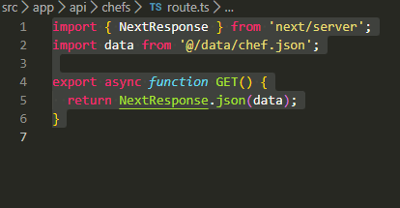

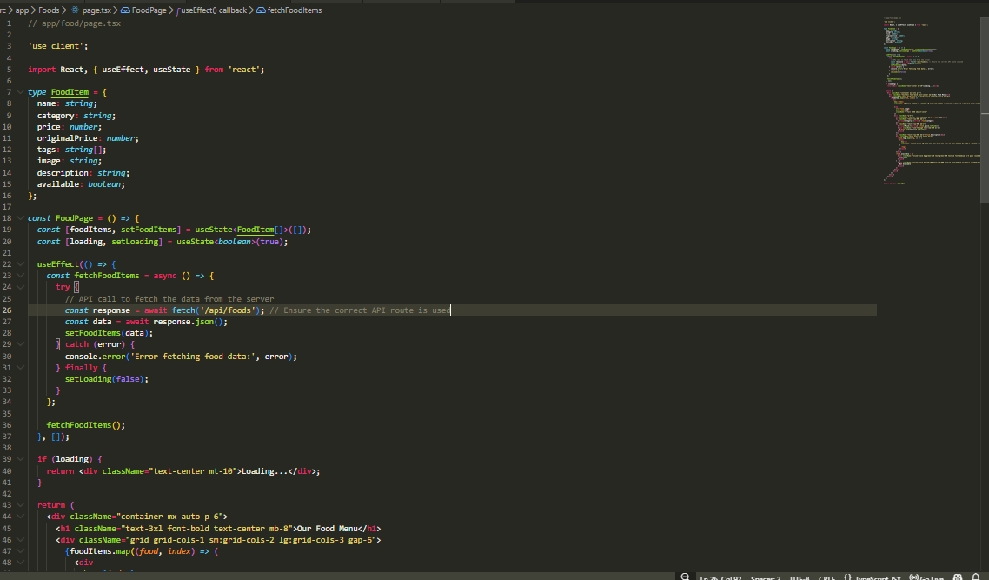

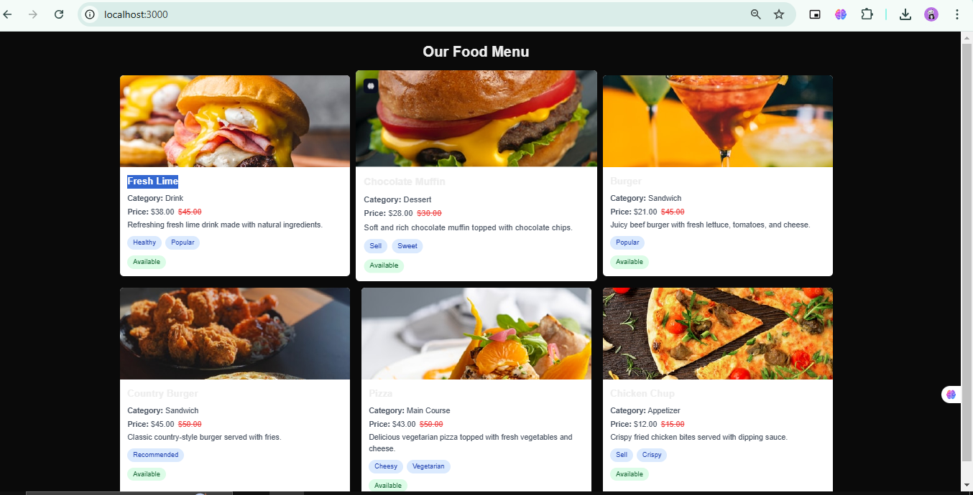

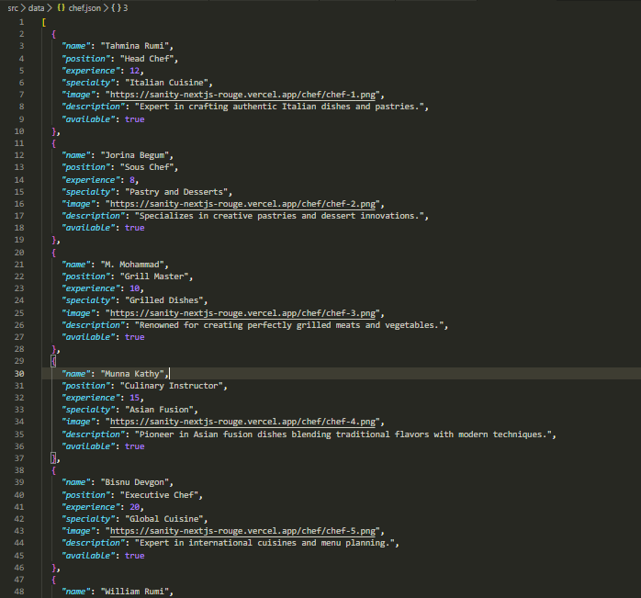

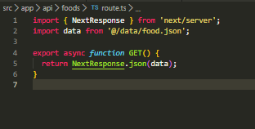

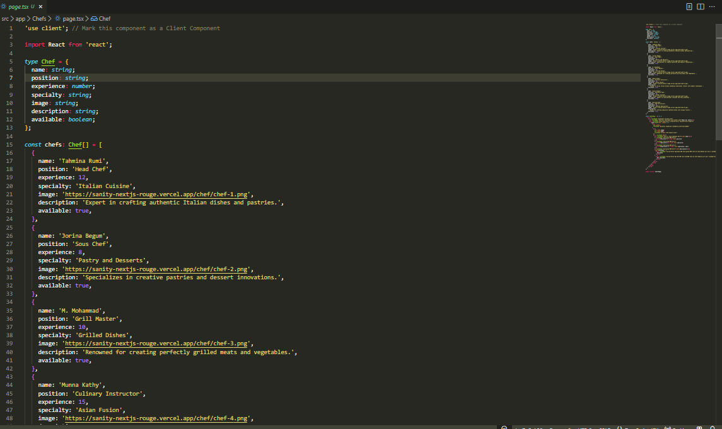

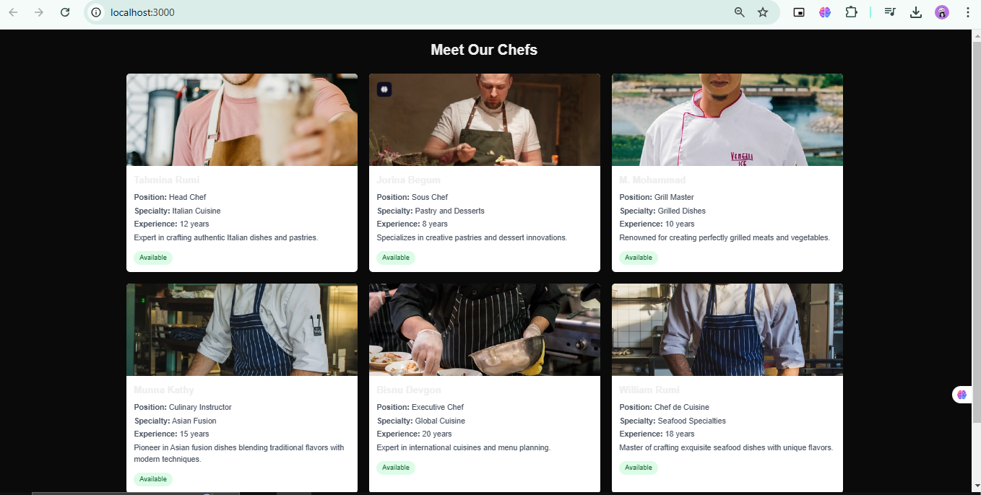

Day 3 Checklist:

Self-Validation Checklist:

|  |  |
| --- | --- |
| API Understanding | ✔ |
| Schema Validation | ✔ |
| Data Migration | ✔ |
| API Integration in Next.js | ✔ |
| Submission Preparation: | ✔ |

**Hackhton3 Day3**

MARKETPLACE API INTEGRATION AND DATA MIGRATION REPORT BY WARDA

**Shift: Tuesday 2 to 5**

[**https://www.linkedin.com**](https://www.linkedin.com/in/syeda-a-2ab623344/)