電通二乙微處理器實驗 實驗結報

實驗名稱 | ４ｘ４鍵盤
組別 | １７ | 組員 | 林思宇／蔡照森

- 實驗目的
1. Arduino 接喇叭如何接線?
2. 如何使用 tone library?
3. 如何演奏一段音樂?
4. 如何使用 4x4 鍵盤演奏音樂?
5. 如何發報摩斯電碼?
- 實驗步驟
(1)Arduino 演奏一段特定的音樂, 旋律不得是小蜜蜂(2)顯示在 PC 上 * 4x4 鍵盤之按鍵值顯示在七段顯示器上
(2)使用 4x4 鍵盤演奏音樂
(3) 如何發報摩斯電碼
- 程式碼

(1)
#define do1 261
#define re1 294
#define me1 329
#define fa1 349
#define so1 392
#define la1 440
#define si1 493
#define do2 523
#define re2 587
#define me2 659

int tune[] = {so1,la1,si1,so1,
so1,la1,si1,so1,0,
si1,do2,re2,0,
si1,do2,re2,0,
re2,me2,re2,do2,si1,so1,0,
re2,me2,re2,do2,si1,so1,0,
so1,re1,so1,
so1,re1,so1};

float duration[] = {0.25,0.25,0.25,0.25,
0.25,0.25,0.25,0.25,0.03,
0.25,0.25,0.5,0.03,
0.25,0.25,0.5,0.03,
0.25,0.25,0.25,0.25,0.25,0.25,
0.25,0.25,0.25,0.25,0.25,0.25,
0.25,0.25,0.5,0.01,
0.25,0.25,0.5,0.01};
int length;
void setup() {
pinMode(5, OUTPUT);
length = sizeof(tune) /sizeof(tune[0]);

}

void loop() {
for (int x=0; x<length; x++)
{
tone(5, tune[x]);
delay(2000 *duration[x]);
noTone(5);
}
delay(5000);

}
(2)

#define do1 261
#define re1 294
#define me1 329
#define fa1 349
#define so1 392
#define la1 440
#define si1 493

#define do2 523
#define re2 587
#define me2 659
#define fa2 698
#define so2 784
#define la2 880
#define si2 988

#define do3 1046
#define re3 1175
int tune[] = {do1,re1,me1,fa1,so1,la1,si1,do2,re2,me2,fa2,so2,la2,si2,do3,re3};
#include<Keypad.h>
const byte ROWS = 4; // 4 Rows
const byte COLS = 4; // 4 Columns // 定義 Keypad 的按鍵

char keys[ROWS][COLS] = {
{'F', 'B', '7', '3'},
{'E','A','6','2'},
{'D', '9', '5', '1'},
{'C', '8', '4', '0'} }; // 定義 Keypad 連到 Arduino 的接腳
byte rowPins[ROWS] = {13, 12, 11, 10}; // 連到 Keypad 的 4 個 Rows
byte colPins[COLS] = {9, 8, 7, 6}; // 連到 Keypad 的 4 個 Columns
// 建立 Keypad 物件
Keypad keypad = Keypad(makeKeymap(keys), rowPins,colPins,ROWS, COLS );
void setup(){
Serial.begin(9600);
}
void loop(){
char key = keypad.getKey(); // 讀取 Keypad
if(key != NO_KEY){
if(key>='A'&&key<='F')
{
Serial.println(key);
tone(5, tune[key-'A'+10]);
delay(100);
noTone(5);
}
else
{
Serial.println(key);
tone(5, tune[key-'0']);
delay(100);
noTone(5);
}
}
}
(3)
char *morse[]={
"01","1000","1010","100", //A~D
"0","0010","110","0000", //E~H
"00","0111","101","0100", //I~L
"11","10","111","0110", //M~P
"1101","010","000","1", //Q~T
"001","0001","11","1001", //U~X
"1011","1100" //Y~Z
};

const byte Buzzer=5;
char chr,index;
char *ptr;

void setup() {
pinMode(Buzzer,OUTPUT);
Serial.begin(9600);
}

void loop() {
if( Serial.available() ){
chr=Serial.read();
Serial.println(chr);
if( (chr-'A')>=0 && (chr-'Z')<=0 ){
index=chr-'A';
ptr=morse[index];
while(*ptr!='\0'){
if(*ptr=='0'){
tone(Buzzer,440,100);
delay(100);
}
else{
tone(Buzzer,440,300);
delay(300);
}
ptr++;
delay(100);
}
delay(300);
}
else
delay(700);
}
}
- 實驗結果及分析
使用 tone()函數,設定音調,和持續時間,就可以輕鬆的使喇叭發出聲音。
使用序Ｓｅｒｉａｌ，得入就可以將４ｘ４鍵盤的質設定為ｄｏ，ｒｅ，ｍｅ….等等的音調。
加上電駔可以使得音量變小。
- 心得討論
這次實驗程式碼都給得很完全，稍為更改移下就可以完成，一切算是順利，
除了復習４ｘ４鍵盤花了點時間，最難的就是看譜了！有種回到小時後吹直笛的感覺。

修正電路圖

(1)
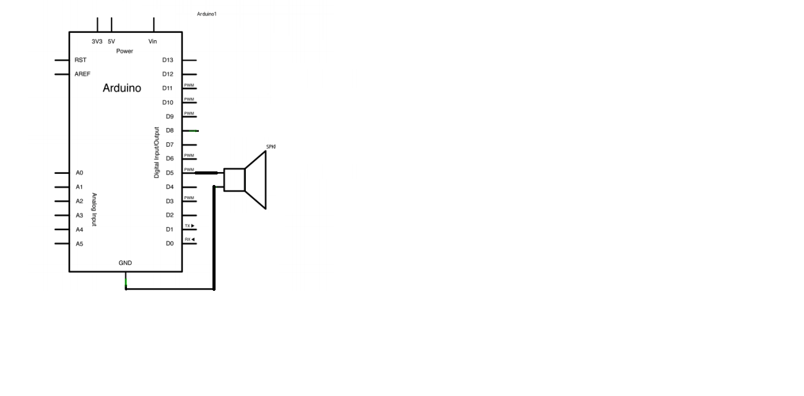
（２）
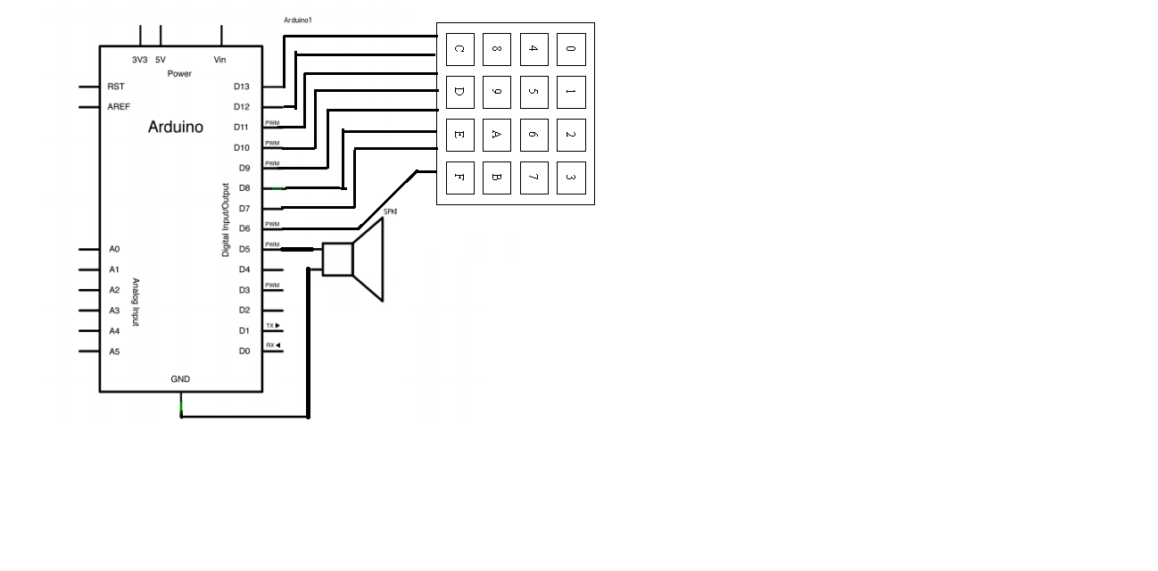
（３）

