|  |  |  |
| --- | --- | --- |
| Лабораторная работа №4  Реализация SQL – запросов базы данных | Ф.И.О. | Куканов А.Д. |
| Группа | ИВТ-263 |
| Преподаватель | Соколов А.А. |
| Дата сдачи |  |

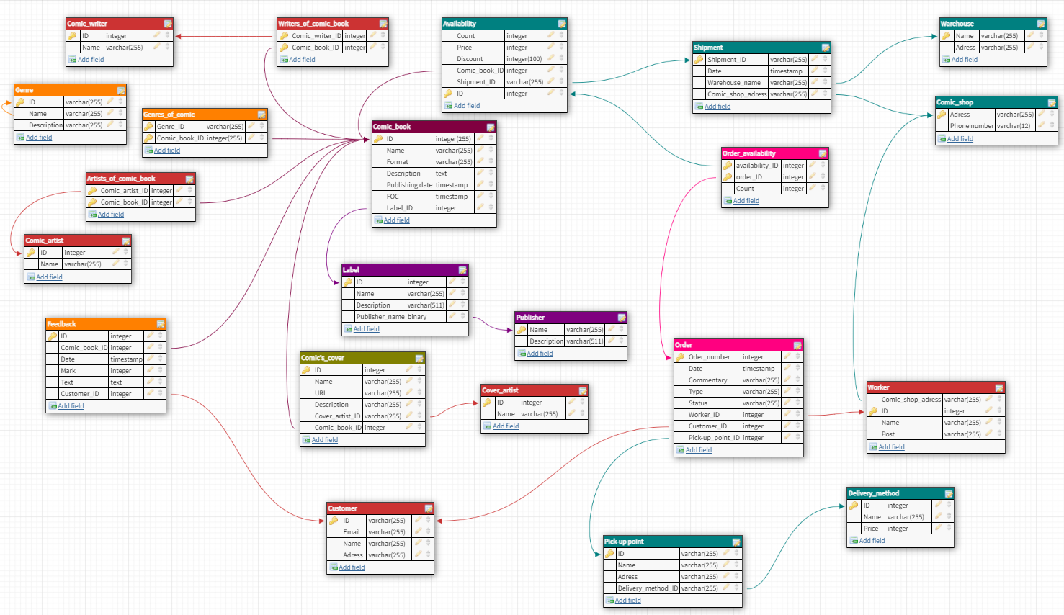

USE comic_shop_network;

UPDATE:

UPDATE `comic_book` SET `format` = 'tpb' WHERE `format` = 'Trade paperback';

UPDATE `availability` SET `discount` = '35' WHERE `price` > 1000;

UPDATE `order` SET `Status` = 'Отправлен' WHERE `type` = 'Предзаказ';

UPDATE `feedback` SET `mark` = 7 WHERE `mark` < 5;

UPDATE `worker` SET `post` = 'Уволен' WHERE `comic_shop_id` = 5;

UPDATE `order` SET `status` = 'Доставлен' WHERE `status` = 'Отправлен';

UPDATE `label` SET `description` = '' WHERE `publisher_id` = 5;

DELETE:

DELETE FROM `worker` WHERE `Comic_shop_ID` = 4;

DELETE FROM `delivery_method` WHERE `price` = 0;

DELETE FROM `feedback` WHERE `mark` < 8;

DELETE FROM `Comic_shop` WHERE `adress` LIKE 'Вологодская область';

DELETE FROM `availability` WHERE `price` between 200 and 250;

DELETE FROM `worker` WHERE `post` = 'Уволен';

DELETE FROM `warehouse` WHERE `adress` LIKE 'Пермская область';

SELECT:

SELECT `id` FROM `comic_book` WHERE `FOC`> '2021-08-08' ;

SELECT `id` FROM `order` WHERE `date` BETWEEN '2021-12-14' AND '2021-12-16';

SELECT `name` FROM `comic_book` WHERE `FOC` BETWEEN '2021-08-09' AND '2021-08-13';

SELECT `comic_book_id`, `text` from `feedback` WHERE `mark` > 8;

SELECT `name` FROM `label` WHERE `publisher_id` = 1;

SELECT `name` FROM `label` WHERE `publisher_id` = 2;

SELECT `id`,`price`,`shipment_id` FROM `availability` WHERE `price` > 1000;

SELECT `Comic_Book_Id`, `mark` FROM `feedback` WHERE `customer_id` = 1;

SELECT `name` FROM `genre` WHERE `Description` IS NULL;

SELECT `name`, `FOC` FROM `comic_book` WHERE `FOC` BETWEEN '2021-06-01' AND '2021-09-01' AND `label_id` = 2;

SELECT `name` FROM `comic_book` WHERE `Label_ID` NOT IN (1,2);

SELECT `name`, `price` FROM `delivery_method` WHERE `price` BETWEEN '500' AND '1000';

SELECT `order_id`, `count` FROM `order_availability` WHERE `count` > 5 AND `availability_id` = 4;

SELECT `comic_book_id` FROM `genres_of_comic` WHERE `genre_id` = 1;

SELECT `name`,`description` FROM `Comic_book` WHERE `publishing_date` > '2021-12-01' and `format` = 'hardcover';

SELECT `id`,`shipment_id` FROM `availability` WHERE `price` < 1000 AND `discount` > '15';

SELECT `name` FROM `worker` WHERE `Comic_shop_ID` = 2 and `post` = 'Кассир';

SELECT `date` FROM `shipment` WHERE `Comic_shop_ID` = 2 AND `warehouse_id` = 1;

SELECT `text` FROM `feedback` WHERE `comic_book_ID` = 6 AND `mark` < 6;

SELECT `name`, `URL` FROM `comic_cover` WHERE `comic_book_id` = 1;

SELECT `comic_book_id` FROM `artists_of_comic` WHERE `comic_artist_id` = 1;

SELECT `name`,`price1` FROM `delivery_method` WHERE `price` < 300;

SELECT CB.`name`, count FROM `availability` AV INNER JOIN `comic_book` CB ON CB.`id` = AV.`comic_book_id` WHERE `count` > 5;

SELECT `id`,`date` FROM `order` WHERE `date` BETWEEN 2021-10-01 AND 2021-12-01;

SELECT O.`id`, `status` FROM `order` O INNER JOIN `customer` C ON C.`id` = O.`customer_id` WHERE `customer_id` = 1;

LIKE:

SELECT `name` FROM `comic_book` WHERE `description` LIKE '%Batman%';

SELECT `name` FROM `warehouse` WHERE `adress` LIKE '%Ростовская область%';

SELECT `name` FROM `label` WHERE `Description` LIKE '%american%' or '%American%';

SELECT `name` FROM `customer` WHERE `adress` LIKE '%Костромская%';

SELECT `name` FROM `pick_up_point` WHERE `adress` LIKE '%Тульская%';

SELECT `phone_number`,`adress` FROM `comic_shop` WHERE `adress` LIKE '%Ступино%';

SELECT `name`, `description` FROM `label` WHERE `description` LIKE '%Image%';

create table `CustomerBackup` ( id int NOT NULL AUTO_INCREMENT,

`Name` varchar(512),

`adress` varchar(512),

`email` varchar(255),

PRIMARY KEY(id)

);

INSERT SELECT:

INSERT INTO `customerbackup` SELECT * FROM `Customer` WHERE `adress` LIKE '%Костромская%';

INSERT INTO `customerbackup` SELECT * FROM `Customer` WHERE `adress` LIKE '%Ногинск%';

INSERT INTO `cover_artist`(`name`) SELECT `name` FROM `comic_artist`;

DELETE FROM `customerbackup`;

JOIN:

SELECT * FROM `comic_artist` CROSS JOIN `comic_writer` USING (id);

SELECT A.`name` as `Comic book`, B.`name` as `label` FROM `comic_book` A LEFT JOIN `label`B ON a.`label_id` = b.`id`;

SELECT `order`.`date`, `worker`.`name` FROM `worker` JOIN `order` ON `worker.id` = `order`.`worker_id` WHERE `order`.`date` > '2021-12-01';

SELECT `comic_book`.`name`, `label`.`name`, `publisher`.`name` FROM `comic_book` INNER JOIN `label` ON `label_id` = `label`.`id` INNER JOIN `publisher` ON `publisher`.`id` = `publisher_id`;

SELECT C.`name` as `Comic book`, CA.`name` as `Cover artist` FROM `Comic_Book` C INNER JOIN `artists_of_comic` AC on C.`id` = AC.`comic_book_id` INNER JOIN `comic_artist` CA ON AC.`comic_artist_id` = CA.`id`;

SELECT C.`name`, CW.`name` FROM `Comic_Book` C INNER JOIN `writers_of_comic_book` WC on C.`id` = WC.`comic_book_id` INNER JOIN `comic_writer` CW ON WC.`comic_writer_id` = CW.`id`;

SELECT C.`name`as `comic book`,G.`name` as `genre` FROM `Comic_book` C INNER JOIN `genres_of_comic` GC ON C.`id` = GC.`Comic_book_id` INNER JOIN `genre` G ON GC.`genre_id` = G.`id`;

SELECT PUP.`name`,PUP.`adress`, DM.`price` FROM `pick_up_point` PUP LEFT JOIN `delivery_method` DM ON PUP.`delivery_method_id` = DM.`id`;

SELECT S.`id`, S.`date`, S.`comic_shop_id`, W.`name` FROM `shipment` S NATURAL JOIN `warehouse` W;

SELECT C.`name` as `Customer`, CB.`name` as `Comic book`, F.`text` as `review`, F.`mark` FROM `customer` C INNER JOIN `feedback` F ON C.`id` = F.`customer_id` INNER JOIN `comic_book` CB ON F.`comic_book_id` = CB.`id`;

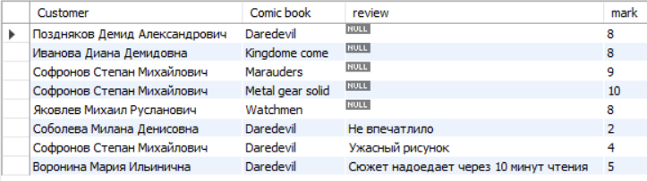

SELECT CB.`name` as `Comic book`, CC.`name` as `Cover name` FROM `comic_book` CB INNER JOIN `comic_cover` CC ON CB.`id` = CC.`comic_book_id` AND CC.`name` LIKE '%variant%';

SELECT CB.`name`, AV.`count` ,AV.`price` FROM `comic_book` CB INNER JOIN `availability` AV ON CB.`id` = AV.`comic_book_id`;

SELECT CCv.`name` as `Comic cover`, CVA.`name` as `Cover artist` FROM `comic_cover` CCv INNER JOIN `cover_artist` CVA ON CCv.`cover_artist_id` = CVA.`id`;

SELECT O.`date`, DM.`name`, PUP.`adress`, DM.`price` FROM `order` O INNER JOIN `pick_up_point` PUP ON O.`picK_up_point_id` = PUP.`id` INNER JOIN `delivery_method` DM ON PUP.`delivery_method_id`= DM.`id` AND price < 500;

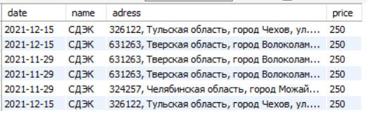

SELECT OA.`order_id`,CB.`name`, AV.`price`, OA.`count` FROM `order_availability` OA INNER JOIN `availability` AV ON OA.`availability_id` = AV.`id` AND oa.`count` > 2 INNER JOIN `Comic_book` CB ON AV.`comic_book_id` = CB.`id`;

SELECT `name` FROM `cover_artist` NATURAL JOIN `comic_artist`;

SELECT CS.`adress`, CS.`phone_number`, W.`name` FROM `comic_shop` CS INNER JOIN `worker` W ON CS.`id` = W.`comic_shop_id`;

GROUP BY:

SELECT `comic_book_id`, AVG(mark) from `feedback` GROUP BY `comic_book_id`;

SELECT `shipment_id`, SUM(price) FROM `availability` GROUP BY `shipment_id`;

SELECT `comic_book_id`, MIN(mark) from `feedback` GROUP BY `comic_book_id` order by MIN(mark);

SELECT O.`date`, SUM(A.price * OA.count) FROM `availability` A INNER JOIN `order_availability` OA ON A.`id` = OA.`availability_ID` INNER JOIN `order` O ON OA.`order_id` = O.`id` group by date;

SELECT `id`, price * count FROM `availability` order by price * count;

SELECT `adress`, pick_up_point.`name` , `price` FROM `delivery_method` INNER JOIN `pick_up_point` ON pick_up_point.delivery_method_id = delivery_method.id ORDER BY `price`;

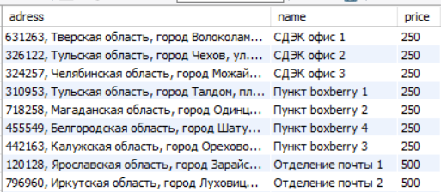

SELECT `pick_up_point`.`name`, MIN(`price`) FROM `delivery_method` INNER JOIN `pick_up_point` ON `pick_up_point`.`delivery_method_id` = `pick_up_point`.`id` GROUP BY `delivery_method_id`;

SELECT `comic_book_id`, max(mark) from `feedback` GROUP BY `comic_book_id` order by MIN(mark);

SELECT `name`, COUNT(id) FROM `pick_up_point` GROUP BY `delivery_method_id` ORDER BY COUNT(id) DESC;

SELECT `publisher`.`name`, COUNT(`label`.id) as `количество` FROM `label` INNER JOIN `publisher` ON `publisher`.`id` = `label`.`publisher_id` GROUP BY `publisher_id` ORDER BY COUNT(ID);

SELECT `post`, count(id) FROM `worker` GROUP BY `post` ORDER BY count(id) DESC;

SELECT CB.`name` as `comic book`, count(`comic_book_id`) FROM `feedback` FB INNER JOIN `comic_book` CB ON FB.`comic_Book_id` = CB.`id` GROUP BY `comic_Book_id`;

SELECT `label`.`name`, count(`comic_book`.`id`) as `Кол-во` FROM `comic_book` INNER JOIN `label` ON `label`.`id` = `comic_book`.`label_id` GROUP BY (label_id);

SELECT `comic_book`.`name`, count(comic_book_id) as `кол-во` FROM `availability` INNER JOIN `comic_book` ON `availability`.`comic_Book_id` = `comic_book`.`id` GROUP BY (comic_book_id);

SELECT `type`, count(id) as `кол-во` FROM `order` GROUP BY `type`;

SELECT `format`, count(id) as `кол-во` FROM `comic_book` GROUP BY `format` ORDER BY count(id) DESC;

SELECT PUP.`name`, avg(price) as `price` FROM `pick_up_point` PUP INNER JOIN `delivery_method` DM ON PUP.`delivery_method_id` = DM.`id` GROUP BY `delivery_method_id`;

UNION:

SELECT * FROM `customer` union SELECT * FROM `customerbackup`;

SELECT `name` FROM `comic_writer` UNION SELECT `name` FROM `comic_artist`;

SELECT `adress` FROM `comic_shop` WHERE `adress` LIKE '%Тамбовская область%' UNION SELECT `adress` FROM `WAREHOUSE` WHERE `adress` LIKE '%Тамбовская область%';

SELECT `name` FROM `comic_artist` UNION SELECT `name` FROM `cover_artist` ORDER BY `name`;

SELECT ANY, ALL

SELECT `comic_book`.`name` as `Comic book`, `feedback`.`text` FROM FEEDBACK INNER JOIN `comic_book` ON `comic_book`.`id` = `feedback`.`comic_book_id` WHERE `text` = ANY(SELECT `text` FROM `feedback`);

SELECT `name`, `price` FROM `delivery_method` WHERE `price` > ANY ( SELECT `price` FROM `delivery_method`);

SELECT `name`,`publishing_date` from `Comic_Book` WHERE `FOC` > ANY (SELECT `date` FROM `Order`);

GROUP_CONCAT:

SELECT `comic_book_id`, GROUP_CONCAT(`comic_artist_id`) as `comic_artists` FROM `artists_of_comic` GROUP BY `comic_book_id`;

SELECT DM.`name`,DM.`price`, group_concat(PUP.`name`) as `pick_up_points` FROM `delivery_method` DM INNER JOIN `pick_up_point` PUP ON DM.`id` = PUP.`delivery_method_id` GROUP BY DM.`name`;

SELECT CB.`name`, group_concat(G.`name`) as `genre_name` FROM `comic_book` CB INNER JOIN `genres_of_comic` GC ON GC.`comic_book_id` = CB.`id` INNER JOIN `genre` G ON G.`id` = GC.`genre_id` GROUP BY CB.`name`;



SELECT `Publishing_date`, Group_concat(`name`) as `Comic book` FROM `comic_book` GROUP BY `publishing_date`;



SELECT CB.`name`, P.`name` as `publisher`, L.`name` as `label` FROM `comic_book` CB INNER JOIN `label` L ON L.`id` = CB.`label_id` INNER JOIN `publisher` P ON P.`id` = L.`publisher_id`;



Модификации

1)Вывести полный ассортимент магазина для магазина вывести все комиксы (магазин, комикс, лэйбл)

SELECT CS.`adress`, CB.`name`, CB.`Format`, CB.`description`, CB.`Publishing_date`, CB.`FOC`, L.`name` as `Label`, AV.`count`, AV.`price`, AV.`discount` FROM `comic_shop` CS

JOIN `shipment` SH ON SH.`comic_shop_id` = CS.`id`

JOIN `availability` AV ON AV.`shipment_id` = SH.`id`

JOIN `comic_book` CB ON AV.`comic_book_id` = CB.`id`

JOIN `label` L ON CB.`label_id` = L.`id` WHERE CS.`adress` LIKE '%Новосибирская%';

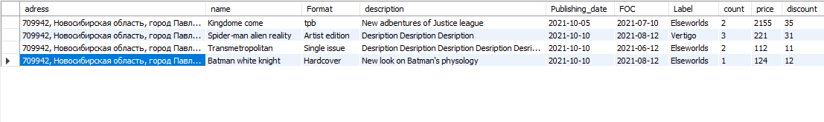

2. Топ - 5 комиков по средней оцнке + вся информация о комиксе.

SELECT CB.`name`, CB.`Format`, CB.`description`, CB.`Publishing_date`, CB.`FOC`, AVG (Mark) as `average mark`,GROUP_CONCAT( distinct CA.`name`) as `Artist`, GROUP_CONCAT(distinct CVA.`name`) as `cover artist` , GROUP_CONCAT(distinct CW.`name`) as `Writer`, L.`name` as `label`, PB.`name` as `publisher` FROM

`feedback` FB JOIN `comic_book` CB ON FB.`comic_book_id` = CB.`id`

JOIN `artists_of_comic` AOC ON AOC.`comic_book_id` = CB.`id`

JOIN `comic_artist` CA ON CA.`id` = AOC.`comic_artist_id`

JOIN `writers_of_comic_book` WOC ON WOC.`comic_book_id` = CB.`id`

JOIN `comic_writer` CW ON CW.`id` = WOC.`comic_writer_id`

JOIN `comic_cover` CC ON CC.`comic_book_id` = CB.`id`

JOIN `cover_artist` CVA ON CVA.`id` = CC.`cover_artist_id`

JOIN `label` L ON L.`id` = CB.`label_id`

JOIN `publisher` PB ON PB.`id` = L.`publisher_id`

GROUP BY CB.`name` ORDER BY AVG(mark) DESC LIMIT 5;



Исправленный вариант ( добавлен жанр, убраны повторения)



3) Для работника за период времени суммарная выручка с учётом кол-ва в заказе и скидки

SELECT W.`name`, sum(OA.`count` * A.`price`*(1-A.`discount`)) as `Выручка` FROM worker W

inner join `order` O ON W.`id` = O.`worker_id`

INNER JOIN order_availability OA ON O.`id` = OA.`order_id`

INNER JOIN `availability` A ON OA.`availability_id` = A.`id`

WHERE (O.`date` BETWEEN '2022-12-12' AND '2023-12-12') AND (W.`id` = 992) ;

