Cross-platform mobile development

SE-2322 https://github.com/warder9/Timer

Alisher Mukhamedov  
Maral Kuanysh  
Yerkanat Manassov

Simple Timer

**Programming Language:** Dart

**Framework:** Flutter

**Packages Used:**

**shared_preferences** — for local storage of timers  
**intl** — for date and time formatting  
**timezone** — for time zone support

**Architecture:** StatefulWidgets + local persistence

**Features:**

***Create Timer* -** Users can add a new countdown timer by specifying an event name, selecting a date and time, choosing a color, and setting the time zone.

***Edit and Delete* -** Existing timers can be edited or deleted through the user interface.

***Time Zone Support* -** Users can select a time zone in which all timers will be displayed. Time zone data is handled via the timezone package.

***Data Persistence* -** All timer data and the selected time zone are stored locally on the device using SharedPreferences.

***Responsive UI* -** The app supports both portrait and landscape modes. In portrait mode, timers are displayed in a grid; in landscape mode, as a list.

***Navigation* -** Includes a separate "About" page accessible via the app menu.

The application provides a convenient way to keep track of important events using countdown timers. It incorporates features like date and time management, user input, state persistence, time zone handling, and responsive UI — making it a solid project for learning Flutter and building a real-world product.

**Phone Pixel 9 Pro XL:**

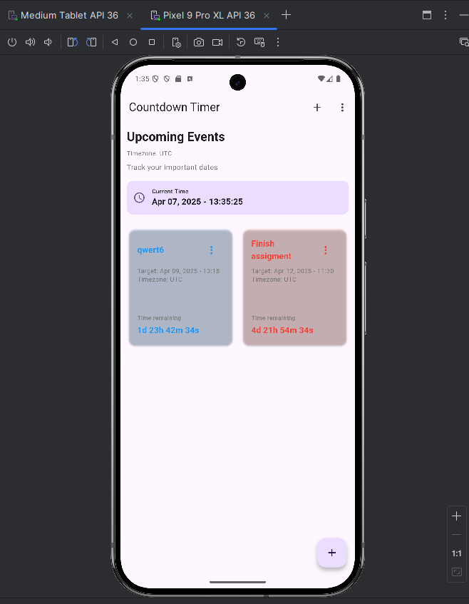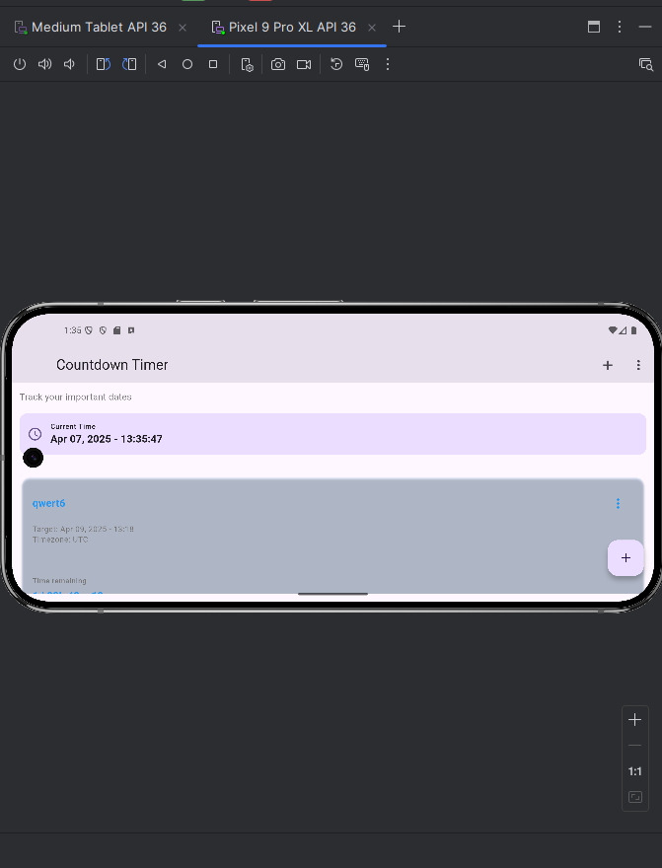

**Tablet:**

