Triscope

The goal of this project is to create a telescope design that will accommodate scaling from small mirror diameters of say 100mm to larger diameters of 300 or more. Additionally, the telescope will accommodate a sensor system which will support both ‘push to’ and autonomous operations for motor drives and imaging.

The current focus is building a model version with a 100mm mirror. That version will be used to demonstrate the structure, mechanics, and instrumentation.

The triscope saw first light in November 2020.
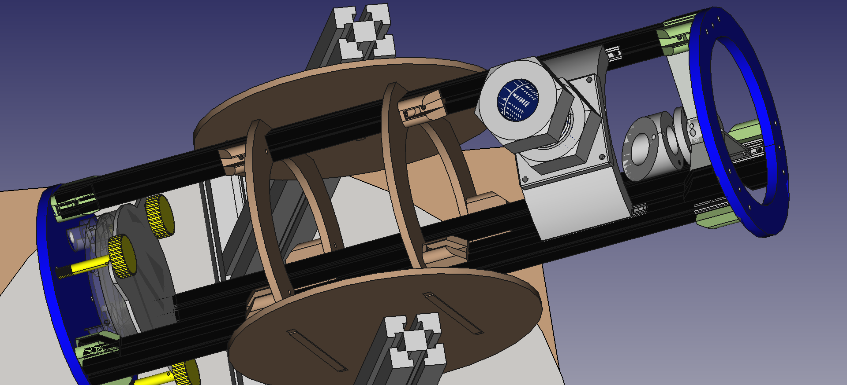
Plans and code available on github.com. The intent is to manufacture in Makespace as many of the components as possible using 3D printers, laser cutters, mills and lathe. The open source design software FreeCAD is being used for mechanical and optical design, Python for code and Stellarium for integration with astronomical models and pointing. Control hardware is Raspberry Pi, Pico with Arduino as an option

Collaborators welcome: https://github.com/albioninnovate/triscope or triscope@wardhills.space


