How to generate a Web-Service Proxy from WSDL file or URL

# Generator Setup

1. Download Apache CXF (binary distribution)

<http://cxf.apache.org/download.html>

1. Extract the zip file.
2. Set new environment variable on your machine

Example:

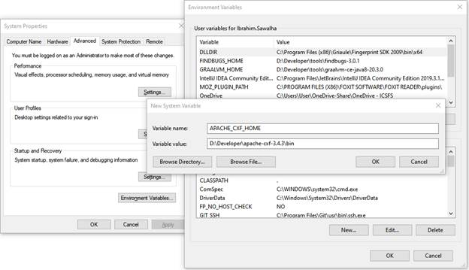

# Generate Java Proxy

1. Open new terminal “command prompt”
2. Make new directory that will contain the Java classes that will be generated.
3. Go to the new directory.
4. Run the following command:

|  |
| --- |
| **%APACHE_CXF_HOME%\wsdl2java -client -verbose -d src\main\java wsdl-file-or-url** |

WSDL-file-or-URL should be replaced by the physical file path OR wsdl URL.

After executing this command a new directory (SRC\main\java) will created contains all Java classes for the web service.