<https://docs.kentico.com/k9/custom-development/working-with-physical-files-using-the-api/configuring-file-system-providers/configuring-azure-storage>

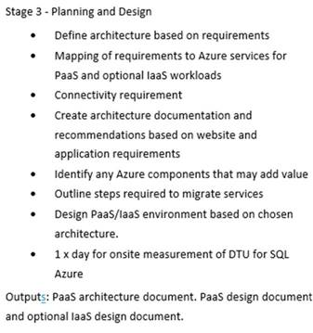

* Where on the roadmap to Office365 is ECA.
* Where are you wanting to go with your Silverlight applications in regard to re-engineering – just lift and shift or re-write to Web Apps /html5
* File per user in blob store – an individual is identified from code and only those files that he is the owner are accessible
* Kentico – upgrade on premise then migrate to Azure or Azure Market Place installation – does this support AAD SQL Authentication
* Watchdog – running as an upgraded service in a VM or re-engineering into web app/web job or green field PaaS: Azure WebApp/Logic Apps/Azure Functions
* SQL Azure – Managed Service Identity for SQL Authentication
* SSRS