Ware - Final Project
2025-04-04
library(ggplot2)
library(jtools)
library(ggeffects)
library(tidyverse)
## ── Attaching core tidyverse packages ──────────────────────── tidyverse 2.0.0 ──
## ✔ dplyr 1.1.4 ✔ readr 2.1.5
## ✔ forcats 1.0.0 ✔ stringr 1.5.1
## ✔ lubridate 1.9.4 ✔ tibble 3.2.1
## ✔ purrr 1.0.2 ✔ tidyr 1.3.1
## ── Conflicts ────────────────────────────────────────── tidyverse_conflicts() ──
## ✖ dplyr::filter() masks stats::filter()
## ✖ dplyr::lag() masks stats::lag()
## ℹ Use the conflicted package (<http://conflicted.r-lib.org/>) to force all conflicts to become errors
library(knitr)
library(readxl)
nflcombine <- read_excel("~/Desktop/592/nflcombine.xlsx")
nflcombine$round[nflcombine$round == "na"] <- NA
nflcombine$round <- as.numeric(nflcombine$round)
nflcombine$pick[nflcombine$pick == "na"] <- NA
nflcombine$pick <- as.numeric(nflcombine$pick)

1. Let’s address missing stats. These stats are taken from NFL Combine results, as well as an athlete’s pro day. However, not all athletes participate, especially those with high draft value. Of 316 athletes, 183 are missing at least one of five stats. There is a height, weight, hand size, arm length, forty time, conference, and school for each athlete.
missing_stats <- nflcombine %>%
mutate(
missing_bench = ifelse(is.na(bench), "Missing", "Present"),
missing_vertical = ifelse(is.na(vertical), "Missing", "Present"),
missing_broad = ifelse(is.na(broad), "Missing", "Present"),
missing_shuttle = ifelse(is.na(shuttle), "Missing", "Present"),
missing_threecone = ifelse(is.na(threecone), "Missing", "Present")
) %>%
select(athlete, school,
missing_bench, missing_vertical, missing_broad,
missing_shuttle, missing_threecone) %>%
filter(
missing_bench == "Missing" | missing_vertical == "Missing" | missing_broad == "Missing" |
missing_shuttle == "Missing" | missing_threecone == "Missing"
) %>%
rename(
"Athlete Name" = athlete,
"School" = school,
"Bench Press Missing" = missing_bench,
"Vertical Jump Missing" = missing_vertical,
"Broad Jump Missing" = missing_broad,
"Shuttle Drill Missing" = missing_shuttle,
"3-Cone Drill Missing" = missing_threecone
)
print(missing_stats)
## # A tibble: 183 × 7
## `Athlete Name` School `Bench Press Missing` Vertical Jump Missin…¹
## <chr> <chr> <chr> <chr>
## 1 Andrew Raym Oklaho… Missing Present
## 2 Graham Barton Duke Missing Missing
## 3 Hunter Nourzad Penn S… Present Missing
## 4 Jackson Powers-Johnson Oregon Present Present
## 5 Jacob Monk Duke Present Present
## 6 Nick Samac Michig… Missing Missing
## 7 Sedrick Van Pran-Granger Georgia Present Missing
## 8 Caelen Carson Wake F… Present Present
## 9 Carlton Johnson Frenso… Missing Present
## 10 Cooper DeJean Iowa Present Missing
## # ℹ 173 more rows
## # ℹ abbreviated name: ¹​`Vertical Jump Missing`
## # ℹ 3 more variables: `Broad Jump Missing` <chr>,
## # `Shuttle Drill Missing` <chr>, `3-Cone Drill Missing` <chr>

2. Can an athlete’s height, 40 yard dash time, and vertical jump influence the round a wide receiver (WR) is drafted?
library(dplyr)
fortyvert <- nflcombine %>%
filter (!is.na(round),
!is.na(vertical),
position == "WR"
)
fit <- lm(round ~ height + forty + vertical, data = fortyvert)
summ(fit)
## MODEL INFO:
## Observations: 30
## Dependent Variable: round
## Type: OLS linear regression
##
## MODEL FIT:
## F(3,26) = 2.82, p = 0.06
## R² = 0.25
## Adj. R² = 0.16
##
## Standard errors:OLS
## --------------------------------------------------
## Est. S.E. t val. p
## ----------------- -------- ------- -------- ------
## (Intercept) -31.11 24.57 -1.27 0.22
## height -0.20 0.16 -1.21 0.24
## forty 12.06 4.88 2.47 0.02
## vertical -0.11 0.14 -0.83 0.41
## --------------------------------------------------
Can a combination of height, 40 time, and vertical jump influence when a wide receiver (WR) is drafted?
Height has a small, non-siginficant influence. Taller players might be drafted earlier, but the statistic isn't strong (p = 0.24). The 40 time is statistically significant (p = 0.02). Slower 40 times are linked to being drafted later. Vertical jump has not significant effect on draft round (p = 0.41) in this model.

3. Can an athlete’s height, 40 yard dash time, and 3-cone drill time influence where a running back (RB) is drafted?
threeconetime <- nflcombine %>%
filter (!is.na(round),
!is.na(threecone),
position == "RB"
)
fit2 <- lm(round ~ height + forty + threecone, data = threeconetime)
summ(fit2)
## MODEL INFO:
## Observations: 7
## Dependent Variable: round
## Type: OLS linear regression
##
## MODEL FIT:
## F(3,3) = 1.04, p = 0.49
## R² = 0.51
## Adj. R² = 0.02
##
## Standard errors:OLS
## ---------------------------------------------------
## Est. S.E. t val. p
## ----------------- --------- ------- -------- ------
## (Intercept) -132.70 85.90 -1.54 0.22
## height 0.30 0.39 0.76 0.50
## forty 10.98 8.34 1.32 0.28
## threecone 9.77 6.36 1.54 0.22
## ---------------------------------------------------
Can an athlete's height, 40 yard dash time, and 3-cone drill time influence where a running back (RB) is drafted?
The model explains a 51% variation in draft round (R² = 0.51) but this result is unreliable because there is data for only seven athletes. The overall model (p = 0.49) is not statistically significant, meaning draft round cannot be predicted from such a small sample.

4. Do athletes drafted in earlier rounds have better vertical jumps than later rounds? Better 3-cone drill times than later rounds?
nflcombine %>%
filter (!is.na(round)) %>%
mutate(group = ifelse(round <= 3, "Early", "Late")) %>%
t.test (vertical ~ group, data = .)
##
## Welch Two Sample t-test
##
## data: vertical by group
## t = -0.9582, df = 165.44, p-value = 0.3394
## alternative hypothesis: true difference in means between group Early and group Late is not equal to 0
## 95 percent confidence interval:
## -1.7516895 0.6069953
## sample estimates:
## mean in group Early mean in group Late
## 34.12093 34.69328
nflcombine %>%
filter(!is.na(round), !is.na(vertical)) %>%
mutate(group = ifelse(round <= 3, "Early", "Late")) %>%
group_by(group) %>%
summarise(
mean_vertical = round(mean(vertical), 2),
sd_vertical = round(sd(vertical), 2),
)
## # A tibble: 2 × 3
## group mean_vertical sd_vertical
## <chr> <dbl> <dbl>
## 1 Early 34.1 4.48
## 2 Late 34.7 3.83
A two-sample t-test was conducted to compare vertical jump performance between early round (rounds 1-3) and late round (rounds 4+) NFL draft picks. There was no significant difference in vertical jump between early round players (M = 34.12, SD = 4.48) and late round players (M = 33.73, SD = 4.05), t(0.69) = -0.73, p = .49. The 95% confidence internal for the difference in means ranged from -0.73 to 1.50.
The p-value (0.4933) is much greater than 0.05. Fail to reject the null hypothesis. This means there is no statistically significant difference in vertical jump performance between early round an late round draft picks.
nflcombine %>%
filter (!is.na(round)) %>%
mutate(group = ifelse(round <= 3, "Early", "Late")) %>%
t.test (threecone ~ group, data = .)
##
## Welch Two Sample t-test
##
## data: threecone by group
## t = -0.43949, df = 81.382, p-value = 0.6615
## alternative hypothesis: true difference in means between group Early and group Late is not equal to 0
## 95 percent confidence interval:
## -0.1642987 0.1048444
## sample estimates:
## mean in group Early mean in group Late
## 7.237826 7.267553
nflcombine %>%
filter(!is.na(round), !is.na(threecone)) %>%
mutate(group = ifelse(round <= 3, "Early", "Late")) %>%
group_by(group) %>%
summarise(
mean_threecone = round(mean(threecone), 2),
sd_threecone = round(sd(threecone), 2),
)
## # A tibble: 2 × 3
## group mean_threecone sd_threecone
## <chr> <dbl> <dbl>
## 1 Early 7.24 0.39
## 2 Late 7.27 0.35
A two-sample t-test was conducted to compare three-cone drill time between early round (rounds 1-3) and late round (rounds 4+) NFL draft picks. The results were not significantly significant, t(-1.25) = -0.21, p = .22. The mean time for early-round players (M = 7.23) was slightly faster than that of late-round players (M = 7.32)

5. Offensive linemen: does an athlete’s height, weight, and arm length mean a higher draft round?
ol_data <- nflcombine %>%
filter (position %in% c("OG", "OT", "C"),
!is.na(round)) %>%
select (athlete, position, armlength, height, weight, round)
fit3 <- lm(round ~ armlength + + height + weight, data = ol_data)
summ(fit3)
## MODEL INFO:
## Observations: 49
## Dependent Variable: round
## Type: OLS linear regression
##
## MODEL FIT:
## F(3,45) = 4.23, p = 0.01
## R² = 0.22
## Adj. R² = 0.17
##
## Standard errors:OLS
## -------------------------------------------------
## Est. S.E. t val. p
## ----------------- ------- ------- -------- ------
## (Intercept) 56.57 16.76 3.38 0.00
## armlength 0.22 0.29 0.75 0.46
## height -0.48 0.25 -1.92 0.06
## weight -0.07 0.03 -2.24 0.03
## -------------------------------------------------
While arm length has no relationship to draft round, height is somewhat significant and weight is statistically significant. Height might matter, but heavier players tend to get drafted in earlier rounds, with each extra pound linked to an 8% decrease in round number.

6. Distribution of 40 times across all positions.
nflcombine %>%
filter(!is.na(forty), !is.na(position)) %>%
ggplot(aes(x = reorder(position, forty, median, na.rn = TRUE), y = forty)) +
geom_boxplot(fill = "gray", outlier.color = "black", alpha = 0.7) +
labs(
title = "Distribution of 40 Yard Dash Times by Position",
x = "Position",
y = "40-Yard Dash Time (in seconds)"
) +
theme_minimal() +
theme(axis.text.x = element_text(angle = 45, hjust = 1))
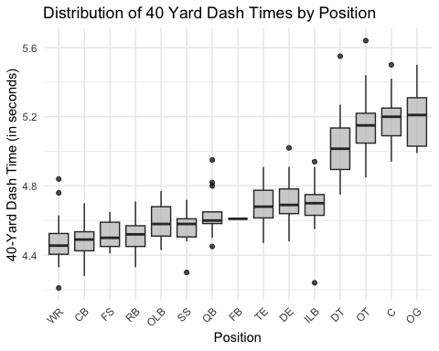
fortymeans <- nflcombine %>%
filter(!is.na(forty), !is.na(position)) %>%
group_by(position) %>%
summarise(mean_forty = round(mean(forty, na.rm = TRUE), 2)) %>%
arrange(mean_forty) %>%
rename(
"Position" = position,
"Average 40 Time" = mean_forty,
)
print(fortymeans)
## # A tibble: 15 × 2
## Position `Average 40 Time`
## <chr> <dbl>
## 1 WR 4.47
## 2 CB 4.49
## 3 FS 4.52
## 4 RB 4.52
## 5 SS 4.56
## 6 OLB 4.59
## 7 FB 4.61
## 8 QB 4.64
## 9 ILB 4.68
## 10 TE 4.69
## 11 DE 4.71
## 12 DT 5.03
## 13 OT 5.16
## 14 C 5.19
## 15 OG 5.19

7. 40-yard dash times and vertical jump height vs. round selected for wide receivers (WR).
wr_drafts <- nflcombine %>%
filter(position == "WR") %>%
filter(!is.na(round))
wr_clean <- wr_drafts %>%
filter(!is.na(vertical))
ggplot(wr_clean, aes(x = vertical, y = forty, color = factor(round))) +
geom_point(size = 3, alpha = 0.8) +
scale_color_manual(values = c("1" = "red", "2" = "pink","3" = "orange", "4" = "yellow", "5" = "green", "6" = "blue", "7" = "purple")) +
labs (
title = "WR: 40 Time + Vertical Jump = Round Drafted",
x = "Vertical Jump (in inches)",
y = "40 Time (in seconds)",
color = "Round Drafted"
) +
theme_minimal()
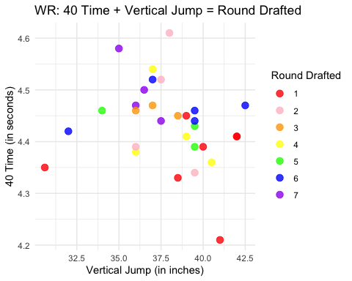

8. Does 40-yard dash time really matter? Let’s see where the fastest WR and slowest WR were drafted.
wr_drafts <- nflcombine %>%
filter(position == "WR", !is.na(forty),!is.na(pick) & pick !="" & pick !="NA" & pick !="na")
fastest_wr <- wr_drafts %>%
arrange(forty) %>%
slice(1) %>%
select(athlete, school, pick, round, forty)
slowest_wr <- wr_drafts %>%
arrange(desc(forty)) %>%
slice(1) %>%
select(athlete, school, pick, round, forty)
fast_slow_wr <- bind_rows(fastest_wr, slowest_wr)
fast_slow_wr <- fast_slow_wr %>%
rename(
"Athlete" = athlete,
"School" = school,
"Pick Number" = pick,
"Round Drafted" = round,
"40-Yard Dash Time" = forty
)
print(fast_slow_wr)
## # A tibble: 2 × 5
## Athlete School `Pick Number` `Round Drafted` `40-Yard Dash Time`
## <chr> <chr> <dbl> <dbl> <dbl>
## 1 Xavier Worthy Texas 28 1 4.21
## 2 Keon Coleman Florida State 33 2 4.61
A wide receiver's 40-yard dash time does not relate to when he is drafted.

9. What were the most drafted positions in 2024?
position_counts <- nflcombine %>%
filter(!is.na(round)) %>%
group_by(position) %>%
summarise(
count = n(),
.groups = "drop"
) %>%
arrange(desc(count)) %>%
rename(
"Position" = position,
"Number Drafted" = count,
)
print(position_counts)
## # A tibble: 15 × 2
## Position `Number Drafted`
## <chr> <int>
## 1 WR 34
## 2 CB 31
## 3 DT 21
## 4 OT 21
## 5 RB 19
## 6 DE 16
## 7 OG 16
## 8 ILB 13
## 9 C 12
## 10 SS 12
## 11 QB 11
## 12 TE 11
## 13 FS 9
## 14 OLB 9
## 15 FB 1
position_counts <- nflcombine %>%
filter(!is.na(round)) %>%
group_by(position) %>%
summarise(
count = n(),
.groups = "drop"
) %>%
arrange(desc(count)) %>%
rename(
"Position" = position,
"NumberDrafted" = count,
)
print(position_counts)
## # A tibble: 15 × 2
## Position NumberDrafted
## <chr> <int>
## 1 WR 34
## 2 CB 31
## 3 DT 21
## 4 OT 21
## 5 RB 19
## 6 DE 16
## 7 OG 16
## 8 ILB 13
## 9 C 12
## 10 SS 12
## 11 QB 11
## 12 TE 11
## 13 FS 9
## 14 OLB 9
## 15 FB 1
ggplot(position_counts, aes(x = reorder(Position, NumberDrafted), y = NumberDrafted)) +
geom_col(width = 0.5) +
geom_col(fill = "darkgray") +
labs(
title = "Number of Players Drafted by Position",
x = "Position",
y = "Number Drafted"
) +
theme_minimal() +
coord_flip()
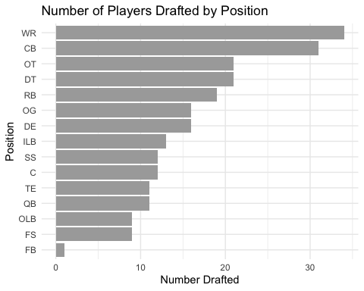

10. How likely is a player to be drafted?
draft_summary <- nflcombine %>%
mutate(
round = as.character(round)
) %>%
mutate(
drafted = ifelse(is.na(round), "Not Drafted", "Drafted")
) %>%
group_by(drafted) %>%
summarise(
Count = n(),
.groups = "drop"
) %>%
mutate(
Percentage = round((Count / sum(Count)) * 100)
)
print(draft_summary)
## # A tibble: 2 × 3
## drafted Count Percentage
## <chr> <int> <dbl>
## 1 Drafted 236 75
## 2 Not Drafted 80 25

11. Is the SEC a better overall conference than the other Power 5 Conferences?
- How many athletes are from the SEC? and how many were drafted?
table(nflcombine$conf)
##
## AAC ACC Big10 Big12 CAA CUSA
## 1 53 59 39 7 4
## D2 FCS Indy MAC MountainWest Pac12
## 1 12 2 2 6 51
## SEC SunBelt
## 72 7
nflcombine_sec <- nflcombine %>%
filter(conf=="SEC")
There were a total of 72 players from the SEC.
table(nflcombine_sec$round)
##
## 1 2 3 4 5 6 7
## 11 8 6 7 8 12 5
57 players from the SEC were drafted, which is 79%. This shows 11 players were taken in round 1, 8 in round 2, 6 in round 3, 7 in round 4, 8 in round 5, 12 in round 6, and 5 in round 7. There were 15 SEC players that were not drafted.
- Where were SEC players were drafted vs. other conferences?
secdraft <- nflcombine %>%
filter(conf %in% c("SEC", "ACC", "Big10", "Big12", "Pac12"),!is.na(round)) %>%
mutate(conf = factor(conf, levels = c("SEC", "ACC", "Big10", "Big12", "Pac12")))
ggplot(secdraft, aes(x = as.factor(round), fill = conf)) +
geom_bar(position = "dodge") +
labs(title = "Draft Round Distribution: SEC vs. Other Power 5 Conferences",
x = "Draft Round",
y = "Number of Players",
fill = "Conference Type") +
theme_minimal() +
scale_fill_manual(values = c("red", "blue", "yellow", "purple", "green"), name = "Conference") +
scale_y_continuous(labels = scales::comma, breaks = seq(0, max(table(secdraft$round)), by = 1))
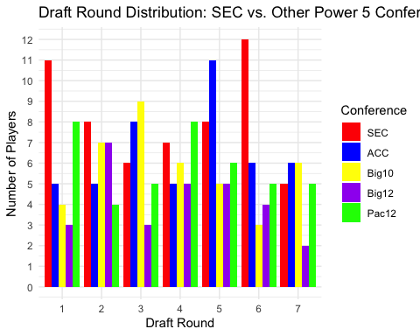
SEC players were drafted consistently over all rounds, with the most taken in the 1st (11) and 6th (12) rounds.
- Average height and weight of offensive linemen in the SEC vs. Other Power 5 Conferences
nflcombine_ol <- nflcombine %>%
filter(position %in% c("OT", "OG", "C"),
conf %in% c("SEC", "ACC", "Big10", "Big12", "Pac12")) %>%
group_by(conf) %>%
summarise(
avg_height = round(mean(height, na.rm = TRUE), 2),
avg_weight = round(mean(weight, na.rm = TRUE), 2),
.groups = "drop"
) %>%
arrange(avg_height) %>%
rename(
"Conference" = conf,
"Average Height" = avg_height,
"Average Weight" = avg_weight,
)
print(nflcombine_ol)
## # A tibble: 5 × 3
## Conference `Average Height` `Average Weight`
## <chr> <dbl> <dbl>
## 1 Big10 76.4 310.
## 2 Pac12 76.5 317.
## 3 ACC 76.9 313.
## 4 SEC 77.0 315.
## 5 Big12 77.2 317.
SEC offensive linemen are taller than all other Power 5 conferences, except for the Big 12, which has a taller average by 0.19 inches. Two conferences (Pac 12 and Big 12) have a higher average weight than the SEC and two conferences (Big 10 and ACC) have a smaller average weight than the SEC.
- Average 40 yard dash time of SEC defensive speed positions (CB, DE, FS, OLB, SS) vs. other Power 5 conferences.
forty_avg <- nflcombine %>%
filter(conf %in% c("SEC", "ACC", "Big10", "Big12", "Pac12"),
position %in% c("CB", "DE", "FS", "OLB", "SS")
) %>%
group_by(conf, position) %>%
summarise(
avg_forty = round(mean(forty, na.rm = TRUE), 2),
.groups = "drop"
) %>%
arrange(position, avg_forty) %>%
rename(
"Conference" = conf,
"Position" = position,
"Average Forty Time" = avg_forty
)
print(forty_avg)
## # A tibble: 24 × 3
## Conference Position `Average Forty Time`
## <chr> <chr> <dbl>
## 1 ACC CB 4.45
## 2 SEC CB 4.47
## 3 Big10 CB 4.5
## 4 Big12 CB 4.55
## 5 Pac12 CB 4.61
## 6 ACC DE 4.62
## 7 SEC DE 4.66
## 8 Big10 DE 4.67
## 9 Pac12 DE 4.76
## 10 Big12 DE 4.81
## # ℹ 14 more rows
The SEC has the second fastest average 40 time in all five defensive speed positions - cornerback, defensive end, free safety, outside linebacker, and strong safety.
So, is the SEC the best of the Power 5 conerences?
If basing that from the total number of athletes in the combine and when those players were drafted then, yes, the SEC is a better conferences.
If basing that on analysis of combine data then no, the SEC is not the best of th Power 5 conferences.

