**Introduction To Computing**

**Section B**

**Spring 2018**

**Assignment #2**

**Deadline: 16th March 2018**

**Question #1:**

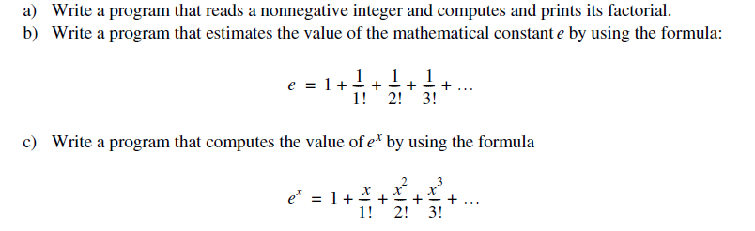

**Question #2:**

Given n and x, write a C++ program to compute the series



**Question# 3:**

One of the most interesting Number Patterns is Pascal's Triangle. In Pascal triangle ith row contains the total number of combinations of i objects taken j at a time for all j such that . The total number of combinations of i objects taken j at a time are computed as  


Below is the Pascal triangle containing all combinations of i objects for 

1

1 1

1 2 1

1 3 3 1

1 4 6 4 1

Write a C++ program which takes an integer n from the user and output the first n+1 rows of Pascal triangle.

**Question #4:**

**Print table from 2 to 10 in the form of table like below. (only two are given in you have to print from 2 to 10)**

|  |  |  |  |  |  |  |  |  |  |
| --- | --- | --- | --- | --- | --- | --- | --- | --- | --- |
| **2** | **4** | **6** | **8** | **10** | **12** | **14** | **16** | **18** | **20** |
| **3** | **6** | **9** | **12** | **15** | **18** | **21** | **24** | **27** | **30** |

**Question #5:**

**\***

**\*\***

**\*\*\***

**\*\*\*\***

**\*\*\*\*\***

**\*\*\*\*\*\***

**\*\*\*\*\*\*\***

**\*\*\*\*\*\*\*\***

**\*\*\*\*\*\*\*\*\***

**\*\*\*\*\*\*\*\*\*\***

**\*\*\*\*\*\*\*\*\*\***

**\*\*\*\*\*\*\*\*\***

**\*\*\*\*\*\*\*\***

**\*\*\*\*\*\*\***

**\*\*\*\*\*\***

**\*\*\*\*\***

**\*\*\*\***

**\*\*\***

**\*\***

**\***

**\*\*\*\*\*\*\*\*\*\***

**\*\*\*\*\*\*\*\*\***

**\*\*\*\*\*\*\*\***

**\*\*\*\*\*\*\***

**\*\*\*\*\*\***

**\*\*\*\*\***

**\*\*\*\***

**\*\*\***

**\*\***

**\***

**\***

**\*\***

**\*\*\***

**\*\*\*\***

**\*\*\*\*\***

**\*\*\*\*\*\***

**\*\*\*\*\*\*\***

**\*\*\*\*\*\*\*\***

**\*\*\*\*\*\*\*\*\***

**\*\*\*\*\*\*\*\*\*\***