Origin of the Maize Genome

This study will consider several possible origins of the 2 genomes that contributed to tetraploidy in the lineage leading to maize, an event that occurred approximately 11-20 million years ago. Figure 1 shows several possible models.

Figure 1. Models of maize genome evolution

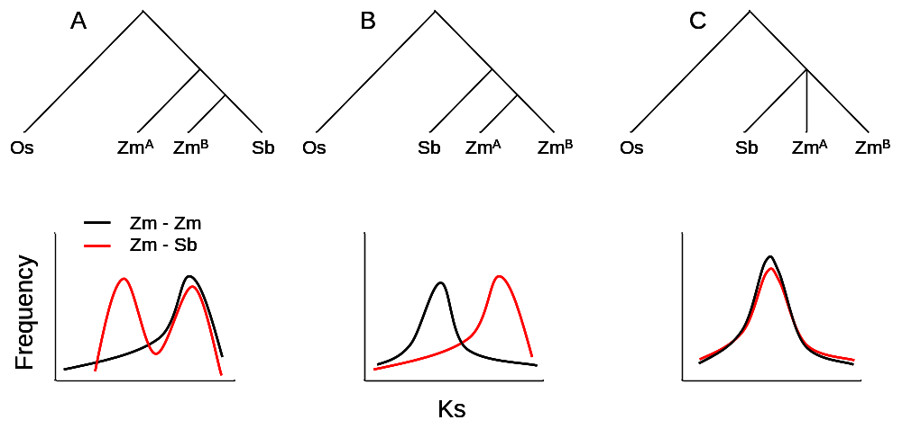

Legend: Three models of the origin of the maize genome are shown. In A, the two maize genomes, ZmA and ZmB, diverged from the sorghum lineage at different times, resulting in one of the maize genomes being more closely related to sorghum than to two maize genome are to one another. The Ks plot shows a bimodal distribution of distances of maize genes to sorghum; maize to maize distances are unimodal and follow the second maize-sorghum peak. However this pattern can be obscured by a period of tetrasomic inheritance in which the four gene copies act as alleles of one locus, during which time alleles from one genome can become fixed to the exclusion of the other. Evidence for this model was published by Gaut and Doebley (1997). In B, the two maize genome are derived from a common ancestor after the split with sorghum. The two maize genomes are more closely related to one-another than either are to sorghum. In C, the sorghum, ZmA, and ZmB genomes diverged within a very short period of time which cannot be resolved by either phylogenetic trees or Ks distributions. Model C is supported by Swigoňová et al. (2004).

Requirements:
- Identification of orthologues corresponding to the A and B genomes of maize, sorghum, and rice.
  - Compara orthologue/paralogue designations
  - Combine with collinear mapping data, e.g. synteny maps, to define orthology based on both protein data and map-position.
  - Ability to discriminate false positive orthologues. For example there are cases in which a gene is tandemly duplicated in the progenitor of grasses, but which has undergone reciprocal gene loss in the maize A and B genomes. Thus the A and B genes will share the same map position and will give reciprocal best hits but are not orthologous. Requires phylogenetic analysis with sorghum and rice.
  - Decision on whether to directly store information in database.
- Address annotation artifacts
  - Is there an ascertainment bias associated with inadvertent selection of well-annotated genes?
  - Generate a highly curated set of randomly selected genes (100 to 300). Utilize existing resources (Debra Burhans; Dynamic Gene; high school outreach programs).
- Statistics and computation:
  - Position effect. Do phylogenetic trees and Ks distributions correlate with geographic position of gene? That is, do sets of genes within syntenic blocks behave in a characteristic way depending on whether they are derived from the A or B genome.
    - Bootstrapping randomization
  - Phylogenetic analysis:
    - Methods
      - PAUP: Maximum parsimony.
      - PAUP: Maximum likelihood.
      - PAML?
    - Statistical significance: non-parametric bootstrapping w/ 1000 pseudoreplicates.
  - Ka/Ks analysis:
    - PAML codon model
    - Test homogeneity of distance estimates (chi-square test incorporating variance of distance estimates (Gaut & Doebley, 1997)).
    - Test for differences between individual pairwise comparisons (Z-test, Swiganova et al (2004)).
    - Assume a constant substation rate, based on Adh gene (Gaut & Doebley 1997) or compute gene-specific rates based on weighted mean distances of the gene to the other genomes (Swiganova et al 2004).
    - Calculate Divergence times (Swiganova et al 2004).
  - Additional requirements?
- Additional requirements?

References:
Gaut BS, Doebley JF. DNA sequence evidence for the segmental allotetraploid origin of maize. Proc Natl Acad Sci U S A. 1997 Jun 24;94(13):6809-14. PMID: 11038553.

Swigonova Z, Lai J, Ma J, Ramakrishna W, Llaca V, Bennetzen JL, Messing J. Close split of sorghum and maize genome progenitors. Genome Res. 2004 Oct;14(10A):1916-23. PMID: 15466289

