Gramene: A premier platform for plant genomics

Ken Youens-Clark ¹, Ed Buckler ^{2,3}, Terry Casstevens ⁴, Charles Chen ⁴, Genevieve DeClerck ⁴, Palitha Dharmawardhana ⁵, Pankaj Jaiswal ⁵, AS Karthikeyan ⁴, Jerry Lu ¹, Susan R McCouch ⁴, Liya Ren ¹, William Spooner ¹, Joshua Stein ¹, Jim Thomason ¹, Sharon Wei ¹, Doreen Ware ^{1,3}

¹ Cold Spring Harbor Laboratory, 1 Bungtown Rd, Cold Spring Harbor, NY, 11724, USA, ² Institute for Genomic Diversity, Cornell University, Ithaca, NY, 14853, USA, ³ USDA-ARS ⁴ Department of Plant Breeding and Genetics, 240 Emerson Hall, Cornell University, Ithaca, NY, 14853, USA, ⁵ Dept of Botany and Plant Pathology, 3082 Cordley Hall, Oregon State University, Corvallis, OR, 97331, USA

Abstract
Now in its tenth year, the Gramene database (http://www.gramene.org) has grown from its primary focus on rice, the first fully sequenced grass genome, to become a resource for all plant and major model and crop plants including Arabidopsis, Brachypodium, maize, sorghum, poplar, and grape as well as several species of rice. Gramene began as an extension of the RiceGenes project with the addition of an Ensembl genome browser and has expanded in the last decade to become a premier platform for plant genomics hosting a wide array of data sets including Quantitative Trait Loci (QTL), metabolic pathways, genetic diversity, genes, proteins, germplasm, literature, ontologies, and a fully structured markers and sequences database integrated with genome browsers and maps from various published studies (genetic, physical, bin, etc.). In addition, Gramene now hosts a variety of web services including a Distributed Annotation Server (DAS), BLAST and a public MySQL mirror for direct access by advanced users. Twice a year, Gramene releases a major build of the database in collaboration with the Ensembl Genomes project and makes all data and code available for download on a public server accessible via File Transfer Protocol (FTP). Interim releases are made to correct errors or to make important updates to software and/or data. This paper summarizes the changes to the website since the last publication in NAR, 2008, through the 31st release of the Gramene website in May, 2010.

Introduction
Global population pressure and climate change are driving increased reliance on grasses for food, fiber, and biofuel. Scientific advances in genomics promise to help plant breeders improve quality, pathogen resistance, and maximize yields to meet the growing demands. However, the ever-increasing volume of sequence data generated from reference genomes, expression studies, and genome-wide genetic diversity studies challenge researchers to efficiently store, curate, analyze and retrieve such data. Gramene is one of the largest online resources for plant researchers and strives to increase the value of available genomic data through the use of standardized annotation methods to create a database that promotes cross-species analysis of both conserved and species-specific functions. Gramene incorporates various ontologies to consistently describe plant anatomy, phenotype traits, genes, environment, and taxonomy and uses both computational and manual curation to integrate data sets from various leading research projects on plants and public repositories such as GenBank.

Genomes
Plant biologists often enter Gramene through their species of interest, and genome browsers offer a direct window on specific regions and genes. Since Gramene's inception, we have used the Ensembl genome browser. As of an interim release made shortly after our May 2010 release, Gramene uses Ensembl version 58 to visualize eight complete and eight partial plant genomes available from http://www.gramene.org/genome_browser/. Annotations held by Gramene include ab initio, evidence-based and community-generated gene predictions, repeat regions, and homology as well as cross-references to sequences in public databases, locations of QTLs, locations of microarray probes as well as cross-references to sequences in public databases and genome variation such as SNPs and indels. The generation of genome annotations has been described previously. Each build of Gramene holds new and updated annotations. Since our last publication, Gramene has added or updated many plant genomes listed in Table 1.

In addition to the fully sequenced genomes, Gramene has worked with the Oryza Mapping Alignment Project (OMAP) to visualize Oryza brachyantha, O. nivara, the physical map of O. rufipogon, and the chromosome 3 short arms of O. barthii, O. glaberrima, O. minuta CC, O. officinalis, and O. punctata. We have also now integrated variation data into our genomes such as a set of 71K single nucleotide polymorphisms (SNPs) from grape in order to help researchers to determine the consequence of variation (Figure 1). The Arabidopsis variation database contains data from the screening of over 900 strains using the Affymetrix 250k Arabidopsis SNP chip (http://walnut.usc.edu/2010/data/250k-data-version-3.04) as well as a data set that involved the re-sequencing of 20 Arabidopsis lines.

In 2009, Gramene entered into a formal collaboration with the European Molecular Biology Laboratory - European Bioinformatics Institute (EMBL-EBI) and their EnsEMBL Genomes project to create a common set of databases and annotations. Both groups work on the integration of content, quality control, and the development of new features to share across all available plant genomes, thereby reducing redundancy of effort and standardizing analyses and visualization for the community. The genomes of fully sequenced plants presented in Gramene are also mirrored at the Plant Ensembl (http://plants.ensembl.org).

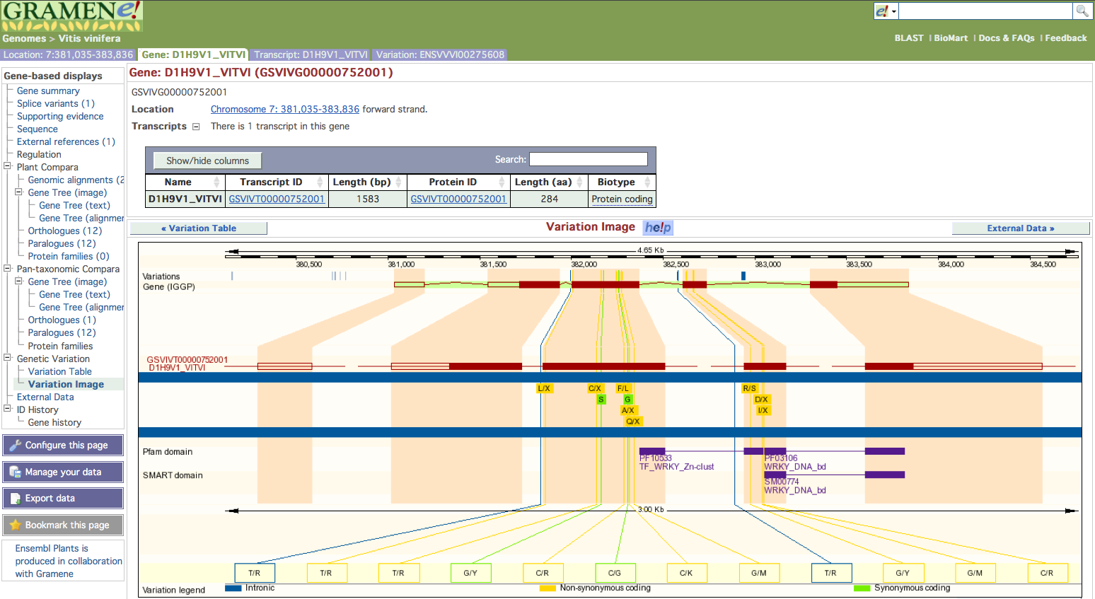

Figure 1: An Ensembl browser view of grape showing an example Vitis vinfera (grapevine) SNPs in their genomic context.

Whole Genome Alignments
Researchers are often looking for the whole genome alignments to explore conservation of chromosomal structure and gene structure. Gramene provides precomputed whole genome and gene-gene alignments using a BLASTZ-net pairwise, whole genome alignment method developed by Ensembl to analyze 14 plant genomes (http://www.gramene.org/info/docs/compara/analyses.html#blastz). Ensembl's release 56 reintroduced multi-species comparative genome views driven by pairwise alignments that had been absent from the Ensembl views for a year, and figure 2 uses this view to show homology from a 50 Kb region on O. sativa japonica chromosome 9 (central panel) showing to similar sized regions of S. bicolor chromosome 2 (top panel) and B. distachyon chromosome 4 (bottom panel). To create such a view from any location-based display, a user would select the “multi-species view” option from the navigation hierarchy. Reference species can be added to and removed from the display using the “select species” option.

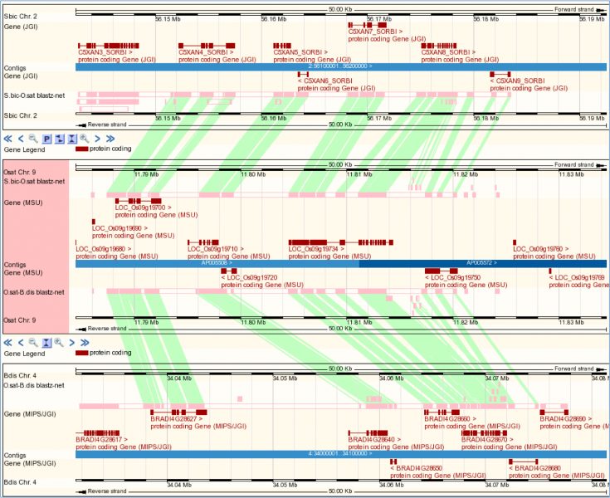
Figure 2. The new multi-species view shows alignments in the context of gene annotations across multiple species. In this case, a region of rice (centre) is displayed against homologous regions in sorghum (top) and Brachypodium (bottom).

Gene Trees
Comparative functional genomics allows researchers to trace evolutionary histories of genes and traits, and Gramene's Compara database adds a new level of tools to aid researchers make inferences of function and strategies for gene annotation. Gramene uses the standard Ensembl GeneTree method to generate gene trees and predict ortholog and paralog relationships between species. In the current release, the GeneTree database was rebuilt using five monocot genomes (O. sativa japonica, O. sativa indica, O. glaberrima, B. distachyon and S. bicolor), four dicot genomes (A. lyrata, A. thaliana, P. trichocarpa and V. vinifera) and five model metazoan genomes (C. elegans, C. intestinalis, D. melanogaster, H.sapiens, S. cerevisiae). Figure 3 shows an example of the results of our latest gene tree build.

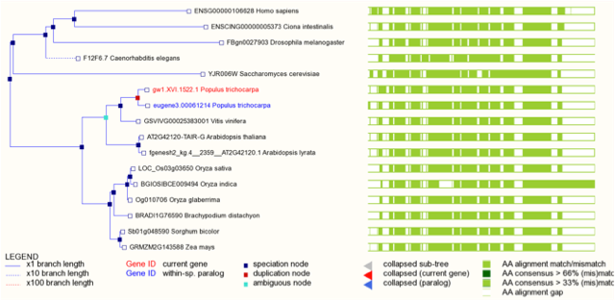

Figure 3. Phylogenetic tree for poplar gene gw1.XV1.1522.1, showing conservation throughout the eukaryotic lineage and a recent poplar-lineage-specific gene duplication.

Compara and Synteny Analysis
In order to ascertain true orthologs and paralogs as well as genetic colinearity, we conduct synteny analysis to infer co-localization of genes on chromosomes across its many hosted genomes. In previous builds, Gramene used DNA-level whole genome alignments (WGA), but, in the current release, Gramene implemented a new synteny analysis pipeline that makes use of gene ortholog assignments from our Compara GeneTree output as additional parameter to confirm homology. This avoids the complications associated with using WGA including spurious alignment and differential expansion and contraction within and between genomes. The new method was originally developed for the Maize Project and is now implemented as a “runnable” within our standardize genome annotation methods. To start the analysis, strictly collinear orthologs are mapped using DAGchainer to define syntenic/collinear gene-pairs. Next collinear mappings are used as anchor points to identify additional syntenic orthologs that may violate collinearity due to local rearrangements or assembly artifacts. This step is configured using a gene-index distance parameter, and its output defines collinear and “in-range” gene pairs. These relationships are stored as gene attributes, and ranges of syntenic blocks are displayed with the Ensembl SyntenyView module. The following list shows the five pairs of genomes compared in release 31:

Pathways
Gramene hosts metabolic pathway databases for eight species including rice, sorghum, Arabidopsis, tomato, potato, pepper, Medicago, coffee, as well as three reference databases namely the EcoCyc, PlantCyc and MetaCyc. These display gene functions in the context of biochemical reactions and networks. Users can download lists of genes associated with each pathway and extract inter-specific comparisons between pathways and associated genes. We have added an "Omics Validator" tool to map user-provided microarray probe identifiers from various microarray platforms to their respective gene identifiers starting with rice.

In the current release of the rice pathway database developed by Gramene, our curators added approximately 170 enzymatic and 80 transport reactions, revised approximately 65 tRNA and 600 transport reaction-associated genes, and updated several important rice pathways. Gramene’s RiceCyc has 342 known or predicted metabolic pathways for Oryza sativa Japonica cultivar "Nipponbare" and has undergone several rounds of data quality enhancement and manual curation. More than 100 literature citations were added or curated. The first release of the Sorghum metabolic pathways (SorghumCyc) developed by Gramene provides 328pathways. The pathways from rice and sorghum, both developed by Gramene, are provided in the web-based browsable form as well as for bulk download in several options including the BioPax and Systems Biology Markup Language (SBML) format for advanced users.

Genetic Diversity
Manipulating and storing vast amounts of sequence data from increasingly cheaper and faster sequencing methodologies is a significant challenge. Gramene's genetic diversity module is specifically designed to facilitate the integration and analysis of these data. It uses the Genomic Diversity and Phenotype Data Model (GDPDM, http://www.maizegenetics.net/gdpdm/) to store RFLP, SSR and SNP allele data, information about QTL, and passport data for wild and cultivated germplasm from rice, maize, wheat, Arabidopsis, and sorghum along with quantitative phenotypic data for some genotype accessions (Table 3).

In 2010, the GDPDM schema was updated to include a data packing system that can easily store and quickly retrieve millions of SNPs. We also released our SNP Query tool (Figure 4) to identify variations in our sequenced genomes via position. We now provide data sets for visualizing genotype patterns across cultivars of interest using the Scottish Crop Research Institute’s Flapjack program (http://bioinf.scri.ac.uk/flapjack/). A Java Web Start-enabled version of the TASSEL program is provided for evaluating trait associations, patterns of linkage disequilibrium, and genetic diversity. In the last year, we have added many features to TASSEL including a new alignment viewer, progress monitoring, pipelines, and wizards for automatic data loading and analysis. For users who prefer to interact with data using their own tools, all diversity data is provided in various formats including HapMap and PLINK.
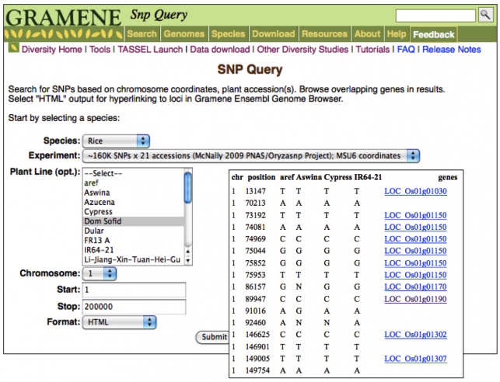
Figure 4: The new SNP Query tool returns variation from one or more accessions based on genomic coordinates.

Germplasm
A new entry point for the plant breeders and geneticists was added by way of the “germplasm” unit (http://www.gramene.org/db/germplasm/) to summarize all the curated data we hold for the most popular rice cultivars. Access to this database is by species or genotype/germplasm accession instead of genomic coordinates or markers. From the germplasm home page, users can search for a marker or genetic diversity information related to a particular accession.

Markers, Sequences and Maps
In addition to the many custom data sets we curate in collaboration with researchers in the plant community, Gramene mirrors GenBank's Viridiplantae sequences for our genome alignment pipeline. Gramene's markers and sequences database now holds around 49 million records we judge to be the most valuable to our users. This database also stores the results of the alignments from our annotation results for our completed genomes as well as manually curated maps provided by the researchers/projects and those extracted from peer-reviewed publications. We then build our comparative maps and DAS from this resource.

Gramene's comparative maps database now holds almost 8M features on 214 map sets from genetic, physical, bin, sequence, cytogenetic and QTL studies. Gramene uses the CMap application to allow users to create cross-species comparisons of any map type. Since last publication, we have curated from literature an additional 17 maps from rice, sorghum, barley, Aegilops tauschii, maize, and wheat. Figure 5 shows an example CMap view for Ae. tauschii.

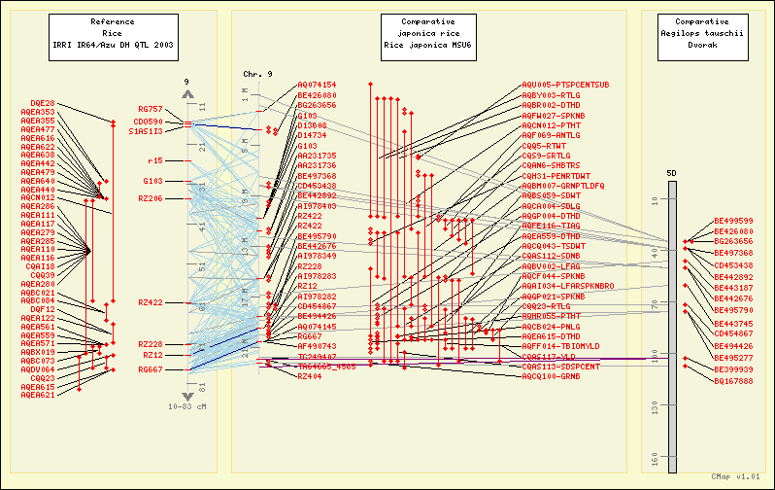

Figure 5. A comparative map view showing the new Aegilops tauschii from a wheat collaboration beside the latest O. sativa Japonica sequence map and a rice QTL map.

QTL
Gramene’s QTL database has seen no change to the data since our last update. It holds 11,624 curated QTL from ten species. The QTL are associated to terms from trait ontology (TO), plant ontology (PO), growth ontology (GRO), environment ontology (EO), as well as to co-localized or neighboring markers, and Gramene gene identifiers. A recent improvement is that users may now search for QTL by any of these associations.

Infrastructure, Quick Search and Gramene Mart
Since our last update, we have continued to work on making our user interfaces cleaner and more informative. Our footer bar was redesigned to be smaller and less obtrusive, and the front page was redesigned to highlight Gramene’s major data sets (e.g., genes, proteins, QTL) as entry points for users (Figure 6). Also prominently featured on the front page as well as in the upper-right corner of every page is the "quick search" which has itself been improved with the ability to filter results by species where applicable. For bioinformatics and software developers interested in installing a local copy of the Gramene database, upgraded the internal web server to the most recent Apache version 2. Gramene also hosts several BioMart databases to allow users to easily retrieve the results of complex queries of various data sets we hold, the results of which can be viewed in the web browser, downloaded, or integrated into the Galaxy system.

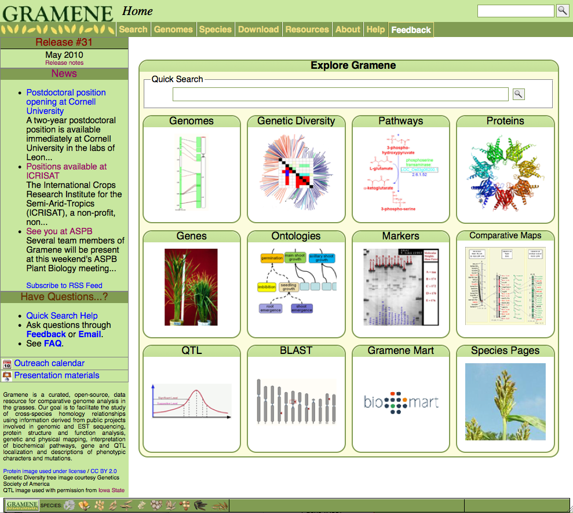
Figure 6. Gramene’s redesigned home page allows quick access to all our major datasets and quick search.

Web Services
Sometimes the advanced user needs access to Gramene's data through means other than our web pages, so we provide several ways to directly connect such as our public, read-only MySQL server. The host "gramenedb.gramene.org" mirrors the current build of our databases and can be accessed using the password "gramene.” With over 300 tracks to choose from, Gramene’s DAS can be used with our Ensembl browsers or any other DAS client to access our annotations. Recently we improved the query engine by moving from MySQL to FastBit, a bitmap indexing system that executes queries in a fraction of the time from MySQL. The aforementioned GDPC API also allows direct interaction with our diversity databases. Finally, Gramene continues to maintain a mirror of Ensembl’s BLAST databases for our users.

Third-party Submission of Data
In an effort to encourage community curation, Gramene created the PlantGeneWiki (http://plantgenewiki.gramene.org/) to allow users to search genes as well as to register and contribute new and edit existing genes from plant species. Designed as an online community portal on plant genes and their annotations, the site is managed by the research community and Gramene staff.

Data and Software Availability
Gramene makes all databases and software freely available under the GNU General Public License. Downloads are available from the Gramene FTP site (ftp://ftp.gramene.org). In addition, Gramene allows anonymous, read-only access to the Subversion source code repository at http://svn.warelab.org/gramene/trunk. In this way, users can have access to any previous release made as well as the most current changes in our development code.

Outreach
The Gramene staff uses many methods to inform, educate and interact with our users. A public news blog (http://news.gramene.org) with RSS feed capabilities is maintained to keep our users informed of changes to the website as well as important publications, job opportunities, and meetings of interest to our researchers. In addition to our on-going relationship with OpenHelix (http://www.openhelix.com) to provide tutorials, in the last year members of the Gramene team have been creating very short video tutorials that introduce very specific topics on Gramene or new tools and data sets (http://www.gramene.org/tutorials). Our staff also presents posters, talks, and hands-on workshops at meetings such as the annual Plant and Animal Genome (PAG) conference, the Rice Technical Working Group, the Maize Genetics Meeting, ISMB, Plant Biology, and Genome Informatics.

Acknowledgements
The project is currently supported by NSF Plant Genome Research Resource grant award #0703908 (Gramene: A Platform for Comparative Plant Genomics) and NSF award #0851652 (REU Bioinformatics and Computational Biology Summer Undergraduate Program). We would like to thank our users for their feedback and support as well as our collaborators and contributors who have supplied Gramene with data, especially NSF projects #0638566 (High Density Scoreable Markers for Maize Trait Dissection), #0321538 (An Annotation Resource for the Rice Genome), #0723510 (Collaborative Research: An Arabidopsis Polymorphism Database), #0723510 (Collaborative Research: An Arabidopsis Polymorphism Database), #0638820 (OMAP), #0701916 (Physical Mapping of the Wheat D Genome), #0743804 (POPcorn), #0543441 (NextGen PLEXdb), #0638820 (The evolutionary genomics of invasive weedy rice), and the USDA-ARS CRIS 9235-21000-013-00D (Complete Switchgrass Genetic Maps Reveal Subgenome Collinearity, Preferential Pairing and Multilocus). Gramene is deeply indebted to our Science Advisory Board members Paul Flicek, Michael Ashburner, Anna McClung, Georgia Davis, David Marshall, Patricia Klein, William Beavis, Tim Nelson for their critical comments, suggestions and improvements. We also thank Peter Van Buren for his excellent system administration work. Funding to pay the Open Access publication charges for this article was provided by the National Science Foundation (#0321685).

Table 1: A listing of the whole genomes available in Gramene.

Oryza sativa japonica | Updated to MSU version 6 released in January 2009 with 160,000 SNPs from 20 O. sativa lines determined as part of the OryzaSNP project using SNP array technology
Oryza sativa indica | The Beijing Genome Institute (BGI) assembly of cultivar 93-11 published in 2005
Arabidopsis thaliana | Updated to The Arabidopsis Information Resource (TAIR) version 9 released in June 2009 with the Ensembl database created by the Nottingham Arabidopsis Stock Centre (NASC)
Arabidopsis thaliana | 637,522 SNPs from 20 A. thaliana lines determined as part of the Arabidopsis 2010 project using genome tiling array technology
Arabidopsis thaliana | 220,000 SNPs from 363 A. thaliana lines determined as part of the Arabidopsis 2010 project using SNP array technology
Arabidopsis thaliana | 2,698,797 SNPs from 17 A. thaliana lines determined as part of the Arabidopsis 1001 genomes project using re-sequencing technology
Arabidopsis lyrata | Added the Araly1 assembly from the Joint Genomes Institute (JGI)
Brachypodium distachyon | Added the Brachy 1.2 version from JGI (2010)
Populus trichocarpa | Added JGI version 2.0 assembly (January 2010) and JGI version 2.0 gene predictions (March 2010)
Sorghum bicolor | Added the Sbi1 assembly and Sbi1.4 gene set (March 2007)
Vitis vinifera | Added the International Grape Genome Program (IGGP) and version “IGGP 12X” with 469,470 SNPs from 17 V. vinifera lines determined as part of the USDA project using re-sequencing technology

Table 2: Pair-wise BLASTZ-net whole genome alignments available in Gramene.
Oryza sativa Japonica | O. jap
Sorghum bicolor | Yes | S. bic
Zea mays | Yes | Yes | Z. may
Brachypodium distachyon | Yes | Yes | - | B. dis

Table 3: Large-scale variation-based genotype datasets available in Gramene’s genetic diversity database.
Rice | OryzaSNP large scale SNP variation study (~160K SNPs x 20 diversity rice accessions), mapped from IRGSP4 to MSU6
Maize | Panzea SNP data (1.6MSNPs x 27 NAM founder lines)
Arabidopsis | 2010 Project SNP discovery (637,522 SNPs, 20 accessions), mapped from TAIR8 to TAIR9
Arabidopsis | 2010 Project genotype data v3.04 (~214K SNPs x 1179 Arabidopsis accessions), mapped from TAIR8 to TAIR9. Construction of 250K chip used in this study is discussed in Clark and Kim.
Arabidopsis | 1001 Genomes WTCHG/Mott data from dbSNP (2,698,797 SNPs, 17 accessions)

References

Ware, D.; Jaiswal, P.; Ni, J.; Pan, X.; Chang, K.; Clark, K.; Teytelman, L.; Schmidt, S.; Zhao, W.; Cartinhour, S.; McCouch, S.; Stein, L., Gramene: a resource for comparative grass genomics. Nucleic Acids Res 2002, 30 (1), 103-5.
Liang, C.; Jaiswal, P.; Hebbard, C.; Avraham, S.; Buckler, E. S.; Casstevens, T.; Hurwitz, B.; McCouch, S.; Ni, J.; Pujar, A.; Ravenscroft, D.; Ren, L.; Spooner, W.; Tecle, I.; Thomason, J.; Tung, C. W.; Wei, X.; Yap, I.; Youens-Clark, K.; Ware, D.; Stein, L., Gramene: a growing plant comparative genomics resource. Nucleic Acids Res 2008, 36 (Database issue), D947-53.
Jaiswal, P.; Avraham, S.; Ilic, K.; Kellogg, E. A.; McCouch, S.; Pujar, A.; Reiser, L.; Rhee, S. Y.; Sachs, M. M.; Schaeffer, M.; et al., Plant Ontology (PO): a Controlled Vocabulary of Plant Structures and Growth Stages. Comp Funct Genomics 2005, 6 (7-8), 388-97.
Yamazaki, Y.; Jaiswal, P., Biological ontologies in rice databases. An introduction to the activities in Gramene and Oryzabase. Plant Cell Physiol 2005, 46 (1), 63-8.
Ashburner, M.; Ball, C. A.; Blake, J. A.; Botstein, D.; Butler, H.; Cherry, J. M.; Davis, A. P.; Dolinski, K.; Dwight, S. S.; Eppig, J. T.; et al., Gene ontology: tool for the unification of biology. The Gene Ontology Consortium. Nat Genet 2000, 25 (1), 25-9.
Flicek, P.; Aken, B. L.; Ballester, B.; Beal, K.; Bragin, E.; Brent, S.; Chen, Y.; Clapham, P.; Coates, G.; Fairley, S.; Fitzgerald, S.; Fernandez-Banet, J.; Gordon, L.; Graf, S.; Haider, S.; Hammond, M.; Howe, K.; Jenkinson, A.; Johnson, N.; Kahari, A.; Keefe, D.; Keenan, S.; Kinsella, R.; Kokocinski, F.; Koscielny, G.; Kulesha, E.; Lawson, D.; Longden, I.; Massingham, T.; McLaren, W.; Megy, K.; Overduin, B.; Pritchard, B.; Rios, D.; Ruffier, M.; Schuster, M.; Slater, G.; Smedley, D.; Spudich, G.; Tang, Y. A.; Trevanion, S.; Vilella, A.; Vogel, J.; White, S.; Wilder, S. P.; Zadissa, A.; Birney, E.; Cunningham, F.; Dunham, I.; Durbin, R.; Fernandez-Suarez, X. M.; Herrero, J.; Hubbard, T. J.; Parker, A.; Proctor, G.; Smith, J.; Searle, S. M., Ensembl's 10th year. Nucleic Acids Res 38 (Database issue), D557-62.
Liang, C.; Jaiswal, P.; Hebbard, C.; Avraham, S.; Buckler, E. S.; Casstevens, T.; Hurwitz, B.; McCouch, S.; Ni, J.; Pujar, A.; Ravenscroft, D.; Ren, L.; Spooner, W.; Tecle, I.; Thomason, J.; Tung, C. W.; Wei, X.; Yap, I.; Youens-Clark, K.; Ware, D.; Stein, L., Gramene: a growing plant comparative genomics resource. Nucleic Acids Res 2008, 36 (Database issue), D947-53.
Wing, R. A.; Ammiraju, J. S.; Luo, M.; Kim, H.; Yu, Y.; Kudrna, D.; Goicoechea, J. L.; Wang, W.; Nelson, W.; Rao, K.; Brar, D.; Mackill, D. J.; Han, B.; Soderlund, C.; Stein, L.; SanMiguel, P.; Jackson, S., The oryza map alignment project: the golden path to unlocking the genetic potential of wild rice species. Plant Mol Biol 2005, 59 (1), 53-62.
Myles, S.; Chia, J. M.; Hurwitz, B.; Simon, C.; Zhong, G. Y.; Buckler, E.; Ware, D., Rapid genomic characterization of the genus vitis. PLoS One 5 (1), e8219.
Clark, R. M.; Schweikert, G.; Toomajian, C.; Ossowski, S.; Zeller, G.; Shinn, P.; Warthmann, N.; Hu, T. T.; Fu, G.; Hinds, D. A.; et al., Common sequence polymorphisms shaping genetic diversity in Arabidopsis thaliana. Science 2007, 317 (5836), 338-42.
Kersey, P. J.; Lawson, D.; Birney, E.; Derwent, P. S.; Haimel, M.; Herrero, J.; Keenan, S.; Kerhornou, A.; Koscielny, G.; Kahari, A.; Kinsella, R. J.; Kulesha, E.; Maheswari, U.; Megy, K.; Nuhn, M.; Proctor, G.; Staines, D.; Valentin, F.; Vilella, A. J.; Yates, A., Ensembl Genomes: extending Ensembl across the taxonomic space. Nucleic Acids Res 2010, 38 (Database issue), D563-9.
Schwartz, S.; Kent, W. J.; Smit, A.; Zhang, Z.; Baertsch, R.; Hardison, R. C.; Haussler, D.; Miller, W., Human-mouse alignments with BLASTZ. Genome Res 2003, 13 (1), 103-7.
Kent, W. J.; Baertsch, R.; Hinrichs, A.; Miller, W.; Haussler, D., Evolution's cauldron: duplication, deletion, and rearrangement in the mouse and human genomes. Proc Natl Acad Sci U S A 2003, 100 (20), 11484-9.
Vilella, A. J.; Severin, J.; Ureta-Vidal, A.; Heng, L.; Durbin, R.; Birney, E., EnsemblCompara GeneTrees: Complete, duplication-aware phylogenetic trees in vertebrates. Genome Res 2009, 19 (2), 327-35.
1. Schnable, P. S.; Ware, D.; Fulton, R. S.; Stein, J. C.; Wei, F.; Pasternak, S.; Liang, C.; Zhang, J.; Fulton, L.; Graves, T. A.; et al., The B73 maize genome: complexity, diversity, and dynamics. Science 2009, 326 (5956), 1112-5.
Potter, S. C.; Clarke, L.; Curwen, V.; Keenan, S.; Mongin, E.; Searle, S. M.; Stabenau, A.; Storey, R.; Clamp, M., The Ensembl analysis pipeline. Genome Res 2004, 14 (5), 934-41.
Haas, B. J.; Delcher, A. L.; Wortman, J. R.; Salzberg, S. L., DAGchainer: a tool for mining segmental genome duplications and synteny. Bioinformatics 2004, 20 (18), 3643-6.
Zhang, P.; Dreher, K.; Karthikeyan, A.; Chi, A.; Pujar, A.; Caspi, R.; Karp, P.; Kirkup, V.; Latendresse, M.; Lee, C.; et al., Creation of a genome-wide metabolic pathway database for Populus trichocarpa using a new approach for reconstruction and curation of metabolic pathways for plants. Plant Physiol 153 (4), 1479-91.
Urbanczyk-Wochniak, E.; Sumner, L. W., MedicCyc: a biochemical pathway database for Medicago truncatula. Bioinformatics 2007, 23 (11), 1418-23.
Keseler, I. M.; Bonavides-Martinez, C.; Collado-Vides, J.; Gama-Castro, S.; Gunsalus, R. P.; Johnson, D. A.; Krummenacker, M.; Nolan, L. M.; Paley, S.; Paulsen, I. T.; Peralta-Gil, M.; Santos-Zavaleta, A.; Shearer, A. G.; Karp, P. D., EcoCyc: a comprehensive view of Escherichia coli biology. Nucleic Acids Res 2009, 37 (Database issue), D464-70.
Zhang, P.; Dreher, K.; Karthikeyan, A.; Chi, A.; Pujar, A.; Caspi, R.; Karp, P.; Kirkup, V.; Latendresse, M.; Lee, C.; et al., Creation of a genome-wide metabolic pathway database for Populus trichocarpa using a new approach for reconstruction and curation of metabolic pathways for plants. Plant Physiol 153 (4), 1479-91.
Caspi, R.; Altman, T.; Dale, J. M.; Dreher, K.; Fulcher, C. A.; Gilham, F.; Kaipa, P.; Karthikeyan, A. S.; Kothari, A.; Krummenacker, M.; et al., The MetaCyc database of metabolic pathways and enzymes and the BioCyc collection of pathway/genome databases. Nucleic Acids Res 38 (Database issue), D473-9.
Demir, E.; Cary, M. P.; Paley, S.; Fukuda, K.; Lemer, C.; Vastrik, I.; Wu, G.; D'Eustachio, P.; Schaefer, C.; Luciano, J.; et al., The BioPAX community standard for pathway data sharing. Nat Biotechnol 28 (9), 935-42.
Gauges, R.; Rost, U.; Sahle, S.; Wegner, K., A model diagram layout extension for SBML. Bioinformatics 2006, 22 (15), 1879-85.
Bradbury, P. J.; Zhang, Z.; Kroon, D. E.; Casstevens, T. M.; Ramdoss, Y.; Buckler, E. S., TASSEL: software for association mapping of complex traits in diverse samples. Bioinformatics 2007, 23 (19), 2633-5.
Youens-Clark, K.; Faga, B.; Yap, I. V.; Stein, L.; Ware, D., CMap 1.01: a comparative mapping application for the Internet. Bioinformatics 2009, 25 (22), 3040-2.
Ni, J.; Pujar, A.; Youens-Clark, K.; Yap, I.; Jaiswal, P.; Tecle, I.; Tung, C. W.; Ren, L.; Spooner, W.; Wei, X.; Avraham, S.; Ware, D.; Stein, L.; McCouch, S., Gramene QTL database: development, content and applications. Database (Oxford) 2009, 2009, bap005.
Blankenberg, D.; Taylor, J.; Schenck, I.; He, J.; Zhang, Y.; Ghent, M.; Veeraraghavan, N.; Albert, I.; Miller, W.; Makova, K. D.; Hardison, R. C.; Nekrutenko, A., A framework for collaborative analysis of ENCODE data: making large-scale analyses biologist-friendly. Genome Res 2007, 17 (6), 960-4.
Wu, K., FastBit: interactively searching massive data. Journal of Physics: Conference Series 2009, 180 (1).
Williams, J. M.; Mangan, M. E.; Perreault-Micale, C.; Lathe, S.; Sirohi, N.; Lathe, W. C., OpenHelix: bioinformatics education outside of a different box. Brief Bioinform.
Ouyang, S.; Zhu, W.; Hamilton, J.; Lin, H.; Campbell, M.; Childs, K.; Thibaud-Nissen, F.; Malek, R. L.; Lee, Y.; Zheng, L.; Orvis, J.; Haas, B.; Wortman, J.; Buell, C. R., The TIGR Rice Genome Annotation Resource: improvements and new features. Nucleic Acids Res 2007, 35 (Database issue), D883-7.
McNally, K. L.; Childs, K. L.; Bohnert, R.; Davidson, R. M.; Zhao, K.; Ulat, V. J.; Zeller, G.; Clark, R. M.; Hoen, D. R.; Bureau, T. E.; et al., Genomewide SNP variation reveals relationships among landraces and modern varieties of rice. Proc Natl Acad Sci U S A 2009, 106 (30), 12273-8.
Zhao, W.; Wang, J.; He, X.; Huang, X.; Jiao, Y.; Dai, M.; Wei, S.; Fu, J.; Chen, Y.; Ren, X.; Zhang, Y.; Ni, P.; Zhang, J.; Li, S.; Wong, G. K.; Zhao, H.; Yu, J.; Yang, H., BGI-RIS: an integrated information resource and comparative analysis workbench for rice genomics. Nucleic Acids Res 2004, 32 (Database issue), D377-82.
Swarbreck, D.; Wilks, C.; Lamesch, P.; Berardini, T. Z.; Garcia-Hernandez, M.; Foerster, H.; Li, D.; Meyer, T.; Muller, R.; Ploetz, L.; Radenbaugh, A.; Singh, S.; Swing, V.; Tissier, C.; Zhang, P.; Huala, E., The Arabidopsis Information Resource (TAIR): gene structure and function annotation. Nucleic Acids Res 2008, 36 (Database issue), D1009-14.
Tuskan, G. A.; Difazio, S.; Jansson, S.; Bohlmann, J.; Grigoriev, I.; Hellsten, U.; Putnam, N.; Ralph, S.; Rombauts, S.; Salamov, A.; et al., The genome of black cottonwood, Populus trichocarpa (Torr. & Gray). Science 2006, 313 (5793), 1596-604.
Paterson, A. H.; Bowers, J. E.; Bruggmann, R.; Dubchak, I.; Grimwood, J.; Gundlach, H.; Haberer, G.; Hellsten, U.; Mitros, T.; Poliakov, A.; et al., The Sorghum bicolor genome and the diversification of grasses. Nature 2009, 457 (7229), 551-6.
Jaillon, O.; Aury, J. M.; Noel, B.; Policriti, A.; Clepet, C.; Casagrande, A.; Choisne, N.; Aubourg, S.; Vitulo, N.; Jubin, C.; et al., The grapevine genome sequence suggests ancestral hexaploidization in major angiosperm phyla. Nature 2007, 449 (7161), 463-7.
Myles, S.; Chia, J. M.; Hurwitz, B.; Simon, C.; Zhong, G. Y.; Buckler, E.; Ware, D., Rapid genomic characterization of the genus vitis. PLoS One 5 (1), e8219.
McNally, K. L.; Childs, K. L.; Bohnert, R.; Davidson, R. M.; Zhao, K.; Ulat, V. J.; Zeller, G.; Clark, R. M.; Hoen, D. R.; Bureau, T. E.; et al., Genomewide SNP variation reveals relationships among landraces and modern varieties of rice. Proc Natl Acad Sci U S A 2009, 106 (30), 12273-8.
Clark, R. M.; Schweikert, G.; Toomajian, C.; Ossowski, S.; Zeller, G.; Shinn, P.; Warthmann, N.; Hu, T. T.; Fu, G.; Hinds, D. A.; et al., Common sequence polymorphisms shaping genetic diversity in Arabidopsis thaliana. Science 2007, 317 (5836), 338-42.
Ibid.
Kim, S.; Plagnol, V.; Hu, T. T.; Toomajian, C.; Clark, R. M.; Ossowski, S.; Ecker, J. R.; Weigel, D.; Nordborg, M., Recombination and linkage disequilibrium in Arabidopsis thaliana. Nat Genet 2007, 39 (9), 1151-5.

