August 24, 2009
Prof. Pamela Ronald
228 Robbins Hall
UC Davis
Davis, CA 95616
Email: pcronald@ucdavis.edu

Dear Pam,

I am writing this letter on behalf of the Gramene database project (www.gramene.org) in support of your proposal entitled “Improvement of submergence tolerance in rice“ that you are submitting to the NSF-BREAD program in September, 2009.

As part of your proposal, you aim to identify genes conferring submergence tolerance in rice and generate markers associated with these genes/QTLs that will be broadly useful to plant breeders seeking to improve submergence tolerance of regionally adopted varieties.

Gramene will be happy to work with you to integrate functional information about the genes/alleles that you identify, the germplasm resources in which they were discovered, markers that can be used to select for them, the phenotypes they confer and the environments in which they are expressed. This information will enhance our curated Genes database, our Diversity database and our Markers database.

To ensure that we are able to curate this information in a timely way, we will work with a designated bioinformatics person in your group to obtain raw data and information about genes, sequences, alleles, germplasm, phenotype and environment in a structured format provided by our curators and we will designate a window of time when we can expect to receive your data. We will ask that you take responsibility for checking the curated version of the data before it is released to the public and that you help identify possible errors or inconsistencies and communicate with Gramene’s curators and programmers to make corrections prior to our 6-month release schedule.

Gramene is well equipped to handle this kind of information and it will be a pleasure to collaborate with you to ensure that users can easily query the database using GrameneMart to retrieve information related to submergence tolerance in rice.

We look forward to working with you if you are funded and wish you all the best with your proposal.

Sincerely yours,
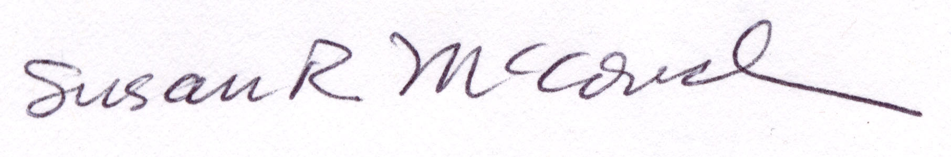
Susan McCouch

