Gramene Project Summary 2008-9

Activities and Findings
The Gramene website is a portal for comparative genomics in plants. The Gramene team members have created and integrated novel and existing software, processes, and ontologies with genomic, genetic, and comparative data sets to add value to the original data and create an environment for discovery. In this report, we review Gramene’s accomplishments during the period from June of 2008 through May of 2009.

Results for Specific Aim #1: Provide an infrastructure of comparative genomic data to allow for the mining and analysis of functional data on the genomes of rice and other monocots.

The main resources covered under specific Aim 1 include the Ensembl genome browser and pipeline infrastructure, Gramene’s comparative map viewer, and our markers and sequences database. In the past year, Gramene has brought to eight the number of genomes available in our Ensembl genome browser, which itself was upgraded to the latest release version 52. New in the last six months is the addition of the Joint Genomes Institute (JGI) pre-release annotation for the draft assembly of Arabidopsis lyrata (Araly1). We have also updated our Arabidopsis thaliana sequence from The Arabidopsis Information Resource’s (TAIR) release 7 to 8 and are working to update our O. sativa japonica assemble to the latest MSU/TIGR version 6 in our fall 2009 release.

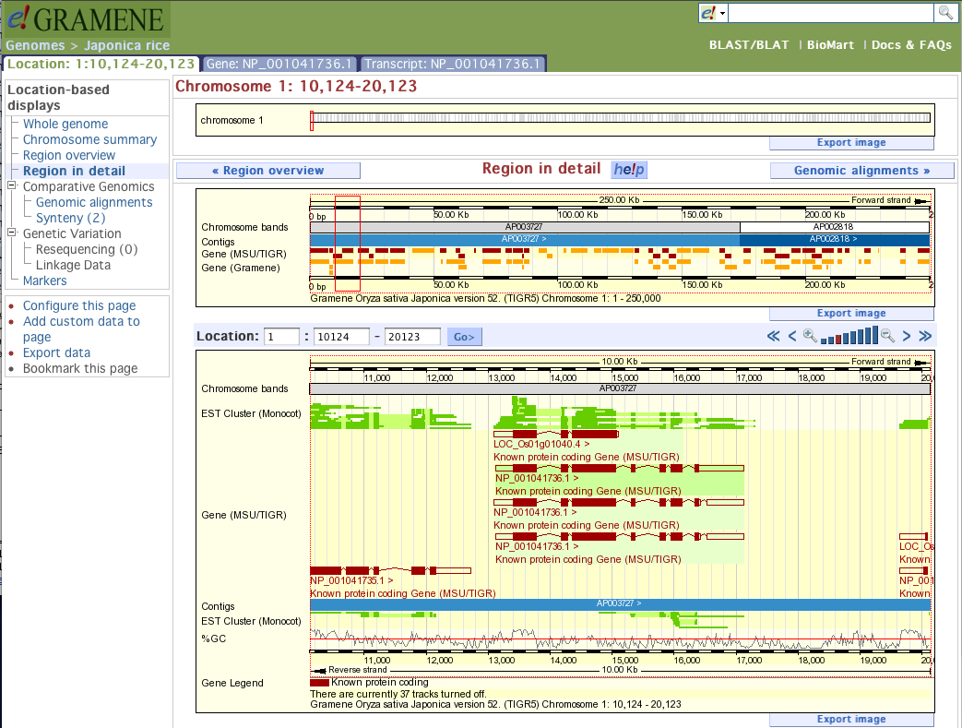
Figure 1 showing Gramene’s new Ensembl 52 installation.

To provide evidence for genes and a point of entry for non-sequenced genomes Gramene aligns all available plant ESTs to each of our sequenced genomes as part of our standard procedures. We currently have 18M plant EST/mRNA/oligos in our markers and sequences database that we align to each of our 8 sequenced genomes, generating 253M alignments. These were loaded into both our markers and Ensembl databases using the Compact Idiosyncratic Gapped Alignment Report (CIGAR) format rather than High Scoring Pair (HSP) format we used previously, a change that reduced the number of records significantly without losing the richness of the alignments. Fewer records in turn have decreased the size of our databases and increased performance and disk usage.

Last year we decided to load only a subset of the alignments into our Ensembl genome browser in order to improve performance and usability. This year the alignments previously excluded are now available through a Distribute Annotation Server (DAS) running on our markers and sequences database. DAS sources are limited to sequence types (e.g., ESTs, EST clusters) and species that have 100K or more alignments to a genome.

Gramene has increased number of external database identifiers cross-referenced by the Ensembl genes to include UniProt, RefSeq, GenBank mRNA, GenBank dbEST, Entrez Gene, UniGene, Gene Index and PlantGDB Transcripts allowing the user to assess genomic features in their original context. In addition, we have annotated genes with their protein domains using Interpro and with gene ontology (GO) terms using a combination of direct mappings (where available) from the GO consortium, projections from UniProt cross-references, and inferences from protein domains (interpro2go).

New this year we mapped oligo sequences from the Affymetrix GeneChip arrays to the A. thaliana, O. sativa japonica, O. sativa indica, Populus trichocarps, and Vitis vinifera. The locations of the oligo sequences were used to infer gene mappings from the probe sets following the standard Ensembl procedure. Such information aids users of high-throughput gene expression studies to infer which genes are actually being expressed.

Accurate genome-wide identification of gene homology is a central problem in comparative genomics. Using the Ensembl “Compara” protein pipeline, phylogentic trees of genes and multiple protein alignments were built with gene annotations for A. lyrata, A. thaliana, O. sativa japonica, O. sativa indica, O. glaberrima chromosome 3 short arm, Populus trichocarpa, Sorghum bicolor and Vitis vinifera. In addition to the plant genomes, used the C. elegans, yeast, drosophila and human genomes from Ensembl. These trees are one of the best ways to infer orthologous and paralogous relationships between genes. They help us understand the evolution from individual genes to complete genomes and can be used by evolutionary biologists with an interest in plant species or by plant biologists wanting to infer function based on annotations of related genes.

Our comparative maps module provides a unique resource for the plant research community to visualize and compare over 200 bin, cytogenetic, deletion, genetic, physical, QTL, and sequence map sets from 30 species. Map comparison is valuable to our community because it allows researchers to fill in gaps. For example, they can use feature order information in other maps of the same species to pick additional markers for mapping in their population of interest. We have added or updated nine maps from rice, maize, wheat and barley and upgraded our “CMap” comparative map viewer software to the latest 1.01 version.

It is possible to make comparisons of maps between species because of synteny -- the order of features on a map of one species is similar to the order of features in another species. Researchers can use a known order in one map, such as the sequenced rice genome, to make inferences about the order in another map, such as in assembling the maize genome.

As with comparative maps, Whole Genome Alignments (WGA) allow cross-species comparisons but at the genomic sequenc level. In the last year’s report, we were evaluating methods for WGAs. This year we can report that we have created new WGAs using Ensembl's blastz-chain-net pipeline on the following genomes:

- Sorghum bicolor vs. Oryza sativa japonica
- Vitis vinifera vs. Arabidopsis thaliana
- Populus trichocarpa vs. Arabidopsis thalianaa
- Populus trichocarpa vs. Vitis vinifera
- Arabidopsis lyrata v.s. Arabidopsis thaliana

We have made efforts to find syntenic regions that indicate common ancestry of large blocks of genes between two species. To find common regions, we have investigated both alignment-based and phylogenetic-based approaches. Orthologous genes, determined phylogenetically using the Ensembl Compara method, gave cleaner mappings when compared to DNA whole genome alignments base on internal evaluation. We are currently investigating two methods to define boundaries between blocks. Orthocluster finds conserved clusters of genes, whereas DAGchainer is based on colinear gene arrangements. Ultimately results will be incorporated into the Gramene database and displayed using SyntenyView and CMap.
During the past year, we have made progress towards serving multiple whole genome alignments (MWGA) for the community. We have installed Pecan pipeline – an Ensembl MWGA tool on the “Bluehelix” computing cluster at CSHL. This allows us to generate large-scale whole-genome-level alignments across multiple grass genomes in addition to the pair-wise whole-genome alignments that we are already serving. Moreover, this pipeline can also calculate conservation scores called “constrained elements” across multiple genomes using the GERP tool. GERP employs sophisticated statistical models and calculates conservation scores by comparing the observed substitution rate with the expected substitution rate at each nucleotide alignment site. We successfully tested this pipeline with four of Gramene’s species including grape, Japonica rice, Indica rice and sorghum. As expected, multiple alignments, GERP scores and constrained elements were generated and stored in the resulting Compara database and had been displayed on a testing genome browser as “contigview” tracks. At this point, we are working on quality check on the data before putting it into production.
In addition, we have also made preparation to incorporate another Ensembl-originated MWGA pipeline called “EPO”. Besides having functions similar to Pecan, this tool has the additional benefit of detecting intra-species segmental duplications and inferring ancestral genome.
Both of these MWGA pipelines need a comprehensive species tree with branch length to represent the general evolutionary substitution rate. In order to generate such a tree, we took advantage of the gene trees from Gramene’s build #28. We concatenated multiple protein alignments stored in Gramene Compara database for all the 2,845 qualified gene trees, converted them into a PHYLIP format file, which was then fed to the PAML-baseml package. The resulting species branch-lengths were generated based on over 6 million nucleotide sites across the alignments. See figure below for an example of the gene trees Gramene generated.
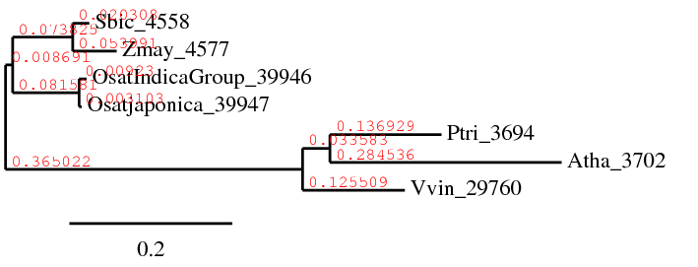
Figure 2 showing the species tree with branch lengths for the seven Gramene grass species. The branch lengths represent the overall neutral substitution rates of the species, and are used in calculating expected substitution rate at each alignment site. These seven species are: Vitis vinifera (Vvin_29760), Arabidopsis thaliana (Atha_3702), Populus trichocarpa (Ptri_3694), Oryza sativa Japonica (Osatjaponica_39947), Oryza sativa Indica (OsatIndicaGroup_39946), Zea mays (Zmay_4577), Sorghum bicolor (Sbic_4558). The newick representation of the tree is: ((Vvin_29760: 0.125509, (Atha_3702: 0.284536, Ptri_3694: 0.136929): 0.033583): 0.365022, ((Osatjaponica_39947: 0.003103, OsatIndicaGroup_39946: 0.009230): 0.081581, (Zmay_4577: 0.053991, Sbic_4558: 0.020308): 0.073825): 0.008691).

Keeping with our biannual release schedule, Gramene made two releases in the last year with our 28th build coming out in September of 2008 and our 29th build in February of 2009. With each release, we create multiple ways for users to access our data not only through website views, genome browsers, and comparative map viewers, but also through bulk downloads through our GrameneMart, which is based on the BioMart tool and has been expanded to now include mappings, markers, ontologies and QTLs. Additionally we offer Simple Semantic Web Architecture and Protocol (SSWAP) queries based on our QTL database, the Genomic Diversity and Phenotype Connection (GDPC) and Tassel tools, a public MySQL database server, DAS, and FTP downloads of all our software, database exports, and comparative maps. For a complete description of our various web services, please refer to the documentation on our website.
The CMap comparative map viewer has remained stable since it’s 1.01 release in July of 2008. New development work has begun to create a 2.0 version that would include major upgrades to the ability of CMap to handle larger datasets as well as greatly improved user interfaces. Requirements are still being written and prototypes created, but we anticipate a release in the next year. Additionally, a collaboration has begun with the author of Circos, a Perl program for creating circual representations of genomes, with an aim to integrating this code with CMap and Ensembl. See the figure below for an example CMap view from Gramene.
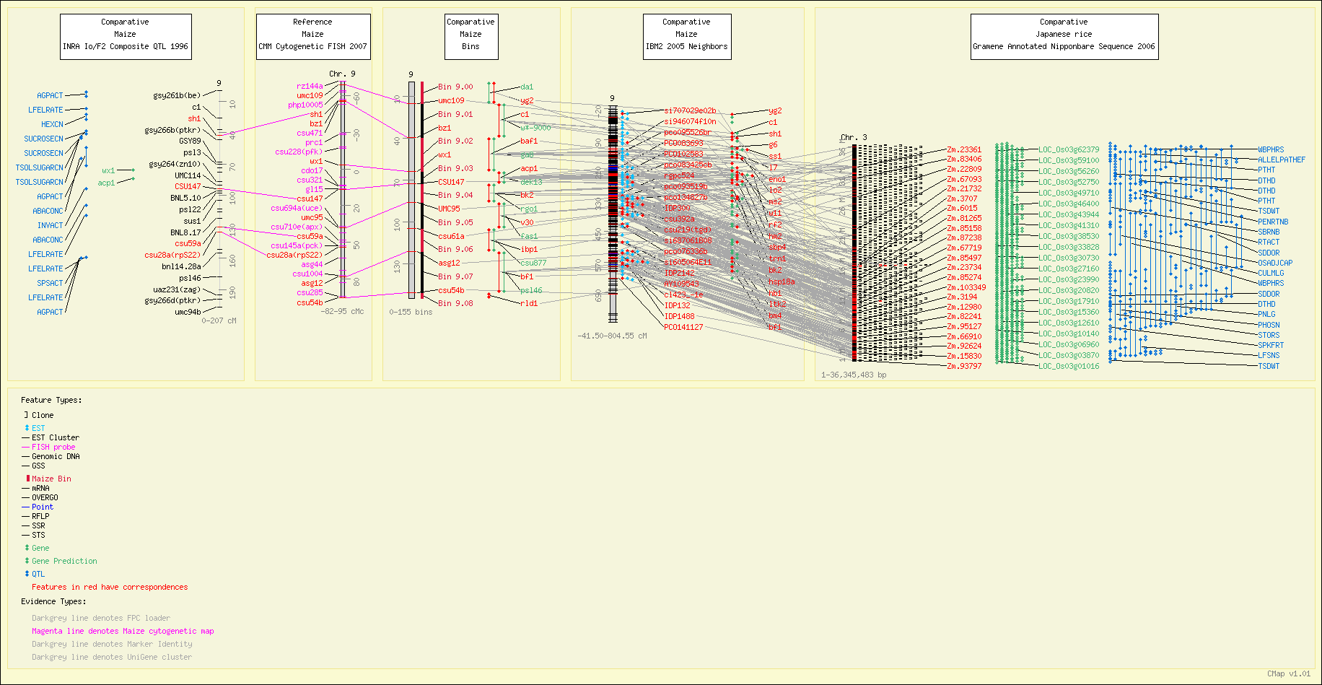
Figure 3 showing a sample view of comparative maps from Gramene.
We have made good strides in improving our hardware. All of our computationally intensive operations such as alignment pipelines have been moved to the 2000-node “BlueHelix” cluster at Cold Spring Harbor Laboratory. Last year we reported the purchase of a 1.1TB external disk array to accommodate our ever-expanding databases, splitting this resource between our development and live servers. In May of 2009, we will inherit an additional array of the same size from the HapMap project, allowing us to dedicate one array each for live and development purposes. In addition, we purchased a new dedicated machine for our public BLAST server and a new backup server.
Results of Specific Aim #2: Enhance the value of the comparative maps with pathway, phenotypic and other functional information from rice, maize, and Arabidopsis.

Pathway database: Gramene hosts 10 organisms in our pathways module. We added new pathways, made improvements in usability, and updated RiceCyc, MetaCyc and our mirrors of AraCyc and Ecocyc. Last year we added a beta release of SorghumCyc, and in our next release this will be christened our first official release based on the release of the sorghum genome and annotations from JGI. Our mirror databases allow users the ability to compare between the known and predicted pathways listed in the organism specific pathway database. This approach allows the researchers to draw comparisons of rice (RiceCyc) and sorghum (SorghumCyc) databases developed and maintained by us to compare against each other as well as the dicots (Arabidopsis, tomato, potato, coffee, pepper and Medicago).
Last year we were examining ways to collaborate with other pathway sites like WikiPathways and Reactome with the hope to make use of the Reactome model and corresponding curation tools. This will be possible now that the Pathway Tools package we use from SRI International provides the capability to export the databases like RiceCyc and SorghumCyc in the Biological Pathway Exchange (BioPAX) level-3 format. BioPAX is the community established pathway exchange format besides SBML and it is required to exchange our data with the WikiPathways.org and the Reactome.org databses.
Pathway Curation: The curators at the newly established sub-contract to Oregon State Univ. (via the co-PI Dr. Pankaj Jaiswal) restarted work on the curation of rice pathways begun in February of 2009 after the co-PI Jaiswal relocated from Cornell University. In a few months, we have been able to add or update the following pathways (multiple reactions and sub-pathways) that will be available in our fall release:
- Phenylpropanoid biosynthesis
- Flavonoid and flavonol biosynthesis
- Iron uptake pathways
- Phytoalexin and diterpenoid biosynthesis
    - Momilactone
    - Oryzalexin S
    - Phytocassane
    - Oryzalexin A-F
  - Geranylgeranyldiphosphate biosynthesis
  - ent-kaurene biosynthesis

Besides the above rice pathways, we trained our curators on the tools developed by WikiPathways by curating the Long-Day Flowering Time Pathway from Arabidopsis thaliana. This will form the basis of our exchange of data formats and curation protocols. In addition, the Gramene database also became the sole provider of the rice and Arabidopsis genomes and gene-based coordinates to the WikiPathways database.

OMICs Viewer validator: The OMICs Viewer tool in RiceCyc project allows users to upload the expression datasets from transcriptome (microarray) and proteomics experiments to visualize the real-time cellular view of up- and down-regulated pathways. This tool requires that users identify each data point by the rice gene IDs, and, since there are multiple providers of array manufacturers, not everyone follows the same version of the genes builds and ID system. Thus it is essential to cross-reference multiple datasets. To overcome this problem, we have curated the microarray probe IDs from multiple manufacturers for rice arrays such as Affymetrix, Agilent and the NSF rice array project, and mapped them to the gene IDs we store in our own databases. Further, we have developed an OMICs viewer validator that correctly maps probe IDs to gene IDs. This tool allows users to upload the expression data files and generates a new file that correctly identifies the gene ID based on the probe-gene ID mapping stored in Gramene’s markers and sequences database as noted in Specific Aim #1. The newly generated file is then made available to the user along with an error report. The new file (devoid of errors) is then ready for use in OmiCs viewer based data analysis.

Plant Gene Wiki: As originally proposed in our initiative on the community outreach for the Specific Aim #2, we were successful in releasing the beta version of the PlantGeneWiki (PGW). It is available at “http://plantgenewiki.gramene.org/” as well as “http://www.plantgenewiki.org/” where the latter redirects to the first. Its design is based on the EcoliWiki model using the MediaWiki package customized for plant needs and ease of community-based curation. It is designed as an online community portal on plant genes and their annotations that is managed by the research community. Our goal for PlantGeneWiki is to generate community curated and annotated pages where the researchers can browse, search, read and manage the content by editing. The biggest advantage is that researchers now have the ability to update and edit the information known about the genes identified in plants on their own without any delays. More information is provided in our news release.
Gene and protein database: Since majority of the gene curation required for subsequent pathway annotation is driven by gene annotation, we managed to add about 1,800 maize genes in collaboration with MaizeGDB.org as well as adding about 33,000 protein entries from Uniprot. Uniprot and gene entries are computationally and manually annotated by Gramene’s staff.
Results of Specific Aim #3: We will acquire genotypic and phenotypic diversity data for each of the sequenced monocot genomes. We will recalculate this data using a standardized methodology that allows us to integrate the QTL values across species and to relate phenotypic diversity to candidate genes via pathway information.

The genetic diversity module in Gramene expanded to five species last year with the inclusion of two important datasets from the Arabidopsis thaliana "HapMap" project:

- The "SNP discovery" set comprised of 1.1M SNP markers used for genotype microarray construction
- Assay data from 362 Arabidopsis lines assayed against the 250K microarray

The addition of Arabidopsis to the diversity module represents an important step toward development of a core dataset whereby association information from rice, maize and Arabidopsis will be integrated, allowing users to build on the advantages and compensate for the disadvantages of each species system.

Raw genotype and phenotype data from several important rice QTL experiments are also in the process of being loaded into the diversity module. Additionally, entry of rice SNP marker data coming out of the NSF Rice Diversity Project is pending. Gramene’s release of these data is based on an upcoming publication. A large volume of genotype data for hundreds of rice varieties is expected within the next several months from assays with the 44K rice microarray constructed by this project, as well as extensive associated phenotype data being collected by USDA-ARS and RiceCAP researchers in Stuttgart, AK.

The quantitative trait loci (QTL) database held steady at 11,624 QTLs curated from 10 species. New this year is the ability to search QTLs by any associated trait, plant, growth, environment, development, or species ontology as well as any co-localized, neighboring, or flanking marker.

In this last year, considerable work was done on the “Trait Analysis by aSSociation, Evolution and Linkage” (TASSEL) code to make it more robust and maintainable as well as to create a plugin architecture that allows users to create command-line interface pipelines. One such pipeline we created helps researchers identify genes associated with particular traits. We used both General Linear Model (GLM) and Mixed Linear Model (MLM) association analyses against random single nucleotide polymorphisms (SNPs) and all traits stored in the Panzea (maize) database. This trait association data was made available on our FTP site in build 30. We have plans to extend this analysis to Arabidopsis -- pending curation of flowering time -- and rice.

Results of Specific Aim #4 Support the Plant Ontology (PO) Two Years Only

This specific aim was added to the original Gramene project after consultations with the NSF program directors to continue funding for the maintenance and development of the the Plant Ontology Consortium project. The Award included funding for the first two years of the project (2007-2009). It was suggested at the time of the award that an independent proposal be submitted to the NSF in year 2008/2009 for any subsequent funding of the PO project based on its merits. The deliverable of the bridge funding included development and maintenance of the resource database, ontology development, integration in plant databases, and annotations of new datasets in addition to continued efforts to annotate rice, maize and Arabidopsis gene and germplasms datasets by Gramene, MaizeGDB and TAIR.
As part of the bridge funding in 2008-2009 (year 2 of Gramene award), we delivered the following:
- POC database releases (2008-2009) in April 2008, November 2008, April 2009
- Number of ontology terms: 1,149 (50 new terms added in 2008-2009)
- Number of associations/annotations: 557,692 (518,147 new additions in last one year, including maize stocks from MGCSC-USDA, SGN germplasm, ArrayExpress from TAIR)
- Meetings attended: 2 international conferences/workshops; 3 domestic meetings
- POC wiki: Organize and update SOP, documents, outreach activities on wiki
- Collaboration: Cornell, NYBG, UniProt Tissue specific Keywords, FAO AGROVOC vocabularies, generation Challenge programme (GCP) ontology, Genomics Database for Rosaceae (GDR).
- Grant: Awarded new PO grant (start date 15 Feb 2009) NSF DBI # 0822201.

In April of 2009, build #409 of PO was released. For detailed release notes, please visit the Plant Ontology website. The project currently hosts 1,046 terms (excluding obsoletes) and 557,692 annotations. The database now holds 26,625 gene annotations from TAIR, Gramene, SGN and MaizeGDB; 8,558 QTL annotations from Gramene; and 9,832 germplasm associations from SGN, MaizeGDB and NASC. Many new annotations were added including 16,016 Arabidopsis gene annotations from TAIR, 3,928 germplasm annotations from MaizeGDB and several annotations on Rice provided by Gramene and Solanaceae provided by SGN. Several improvements were made to the website and work has begun on a new PO project Wiki.
Since many of the objectives for the second year of this specific aim overlap the first year aims of the newly funded PO project (NSF DBI # 0822201), we have started to move the responsibility of project coordination, ontology development, database and website hosting, and maintenance to the new project site at Oregon State University (OSU). We expect that by the fall of 2009, this transition will be complete.
With this report, we would very much like to acknowledge the support of NSF’s DBI and PRGP program for the Plant Ontology project and all the help and support we received from CSHL and the Gramene PIs and personnel in successful management of the PO project in its current capacity. We will be happy to provide occasional support as and when required by the new project site for the project’s success.
Specific Aim #5: Education, Outreach and Diversity
The experimental plan consists of the following three specific components:
- Community-supported Wikis for cereal gene function and pathways: Gramene launched the “Plant Gene Wiki” in April of 2009 “generate community-based pages about everything related to genes identified in plants.” Additionally, we have been contributing to the WikiSpecies project our species pages we created previously as outreach to the lay public.

- Traditional “push” presentations at meetings: Members of the Gramene team were very busy throughout the year attending meetings, presenting posters and talks, furthering professional and technical skills, and engaging with the plant research community. A detail list of these outreach activities are given in the “Outreach” section.
- Virtual and physical tutorials sponsored by a commercial partner, OpenHelix, targeted at students in under-served institutions and underrepresented minorities.
Gramene’s Scientific Advisory Board (SAB)
Gramene was honored to have all our 2008 SAB members return:

Michael Ashburner GO Consortium
Bill Beavis Iowa State University
Georgia Davis University of Missouri, Columbia
Paul Flicek EBI/Ensembl
Patricia Klein Texas A&M University
Ann McClung USDA
David Marshall Scottish Crop Research Institute
Tim Nelson Yale University

The SAB met with the members of Gramene via a WebEx teleconference where we were able to share slide presentations. Our agenda included a time for Gramene to present updates on specific objectives and to discuss specific requests for suggestions on existing challenges. SAB projects member were then allowed time for internal discussion, without Gramene members being present, and then the remaining time was devoted to further discussions between the SAB and Gramene. At this time we are still awaiting a final report from the Chair Georgia Davis. At the time the report is submitted we will make this available to NSF.

Management

Activities within the group are coordinated through weekly staff meetings, monthly PI meetings, an internal Wiki, and the Mantis bug-tracking system for project management of specific deliverables. In addition to these regularly scheduled activities, the project also participated in the yearly Scientific Advisory Board meeting in September of 2008 and the annual project retreat in May of 2009.

In the last year, co-PI Pankaj Jaiswal moved to Oregon State University. All appropriate movements of subcontracts have been completed.

Publications

Gramene team members participated in the publication of the following three papers this past year:

T. J. P. Hubbard, B. L. Aken, S. Ayling, B. Ballester, K. Beal, E. Bragin, S. Brent, Y. Chen, P. Clapham, L. Clarke, G. Coates, S. Fairley, S. Fitzgerald, J. Fernandez-Banet, L. Gordon, S. Graf, S. Haider, M. Hammond, R. Holland, K. Howe, A. Jenkinson, N. Johnson, A. Kahari, D. Keefe, S. Keenan, R. Kinsella, F. Kokocinski, E. Kulesha, D. Lawson, I. Longden, K. Megy, P. Meidl, B. Overduin, A. Parker, B. Pritchard, D. Rios, M. Schuster, G. Slater, D. Smedley, W. Spooner, G. Spudich, S. Trevanion, A. Vilella, J. Vogel, S. White, S. Wilder, A. Zadissa, E. Birney, F. Cunningham, V. Curwen, R. Durbin, X. M. Fernandez-Suarez, J. Herrero, A. Kasprzyk, G. Proctor, J. Smith, S. Searle and P. Flicek (2009). Ensembl 2009. Nucleic Acids Research (Database issue D690-D697).

Chengzhi Liang, Doreen Ware, Lincoln Stein (2009).
Evidence-based gene predictions in plant genomes (Submitted with revisions)

Junjian Ni, Anuradha Pujar, Ken Youens-Clark, Immanuel Yap, Pankaj Jaiswal, Isaak Tecle, Chih-Wei Tung, Liya Ren, William Spooner, Xuehong Wei, Shuly Avraham, Doreen Ware, Lincoln Stein, Susan McCouch (2009). Gramene QTL database: Development, content and applications. Database: The Journal of Biological Databases and Curation. In press.

Websites

Gramene maintains the following websites:

http://www.gramene.org/ (public website)
http://dev.gramene.org/ (development website open to the public)
http://news.gramene.org/ (news blog)
http://docs.gramene.org/ (documentation Wiki)
http://www.plantontology.org/
http://www.gramene.org/gramenedas/
http://www.maizegenetics.net/ (TASSEL software)
http://gmod.org/wiki/CMap
http://search.cpan.org/dist/Text-RecordParser/
http://search.cpan.org/dist/SQL-Translator/
http://search.cpan.org/dist/Bio-GenBankParser/

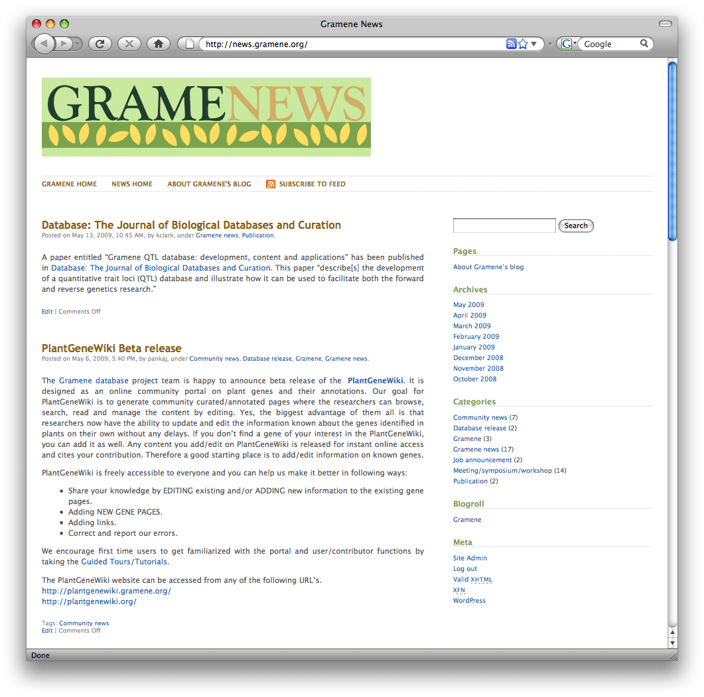
Figure 4 showing the Gramene news blog.
Collaborations
The following lists our collaborations and letters of support:

Outreach
Following is a timeline of our outreach activities this year:
- Junjian Ni attended the Mérida, Mexico meeting of the American Society of Plant Biologists in June of 2008 where he presented a tutorial on Gramene. Chengzhi Liang also attended and presented a talk on Gramene’s Pathways Tools.
- Jim Thomason attended the “Yet Another Perl Conference” in Chicago, Illinois, in June of 2008.
- In September of 2008, Shuly Avraham, Chengzhi Liang, William Spooner, and Sharon Wei attended the “Genome Informatics” conference in Hinxton, UK, and sister meeting of the Ensembl developers. Shuly presented a poster on Plant Ontology, Chenghzi a poster on Gramene’s evidence-based gene builds, and Will a poster on the Oryza Mapping Alignment Project. Will also spoke about the Ensembl web code.
- Chih-Wei participated in a workshop on Plant Ontology and MetaCyc at Cornell University, New York, in October 2008.
- In October of 2009, Pankaj Jaiswal presented a talk on Gramene tools at the iPlant Collaborative’s “Climate Change and Plant Adaptation” workshop in Tucson, Arizona. Ed Buckler also attended this meeting remotely.
- In October of 2008, Gramene created a Wordpress-powered news web log (blog) with concomitant RSS feed in order to easily publish items of interest to the plant research community such as meetings and conferences, new data sets, publications of importance, and Gramene releases and workshops. To date we have made thirty-three posts.
- Pankaj Jaiswal attended the “RAP5” meeting of the Rice Annotation Project in Tokyo, Japan, in November of 2008 where he presented a talk on Gramene.
- Doreen Ware attended the “National Wheat Genomics Conference” in Indianapolis, Indiana, in December of 2008 where she discussed research developments in maize and how Gramene’s Ensembl Compara resources could contribute to that community’s projects.
- At the Plant and Animal Genome meeting in January of 2009, Gramene teamed with several other plant databases to obtain a booth and provide one-on-one demonstrations with conference participants. In addition, Noel Yap presented a computer demo on Gramene, Terry Casstevens presented a poster on the aforementioned TASSEL pipeline, and Chih-Wei Tung presented a poster on Plant Ontology. Also attending where Genevieve DeClerck, Susan McCouch, and Doreen Ware. It should be noted that several of the posters at the meeting cited Gramene or our comparative map software, CMap.
- With the 29th release, Gramene created a public Wiki for sharing a subset of our documentation (such as standard operating procedures or project specifications) found on the private project Wiki our project.
- In March of 2009, William Spooner, Sharon Wei, Doreen Ware, and Ken Youens-Clark attended the Plant Genomes meeting at Cold Spring Harbor, New York. Ken presented a poster on Gramene’s 29th build and Will a poster on comparative plant genomics using Compara.
- In March of 2009, Ed Buckler, Genevieve DeClerck, and Doreen Ware attended the Maize Genetics meeting in St. Charles, Illinois. Genevieve presented posters on Gramene’s genetic diversity modules and the maize resources in Gramene. Doreen gave a talk <about what?> and participated in a community forum
- Doreen Ware spoke at a “Great Moments in Science” lecture series to local teachers at the DNA Learning Center at Cold Spring Harbor Laboratory, New York.
- Noel Yap participated in a workshop on genome databases at Cornell University, New York.
- Shuly Avraham attended weekly conference calls for the semantic web services project.
- Doreen presented a talk about Gramene at “The Genome Access” course at Cold Spring Harbor Laboratory, New York, in April of 2009.
- Susan McCouch attended the “Rice Production Workshop” at the International Rice Research Institute in the Phillipines in May of 2009.
- Genevieve attended NSF’s “Trangressive Variation in Rice” meeting at Cornell University, New York, in April of 2009.
- Pankaj participated in the monthly conference calls for the C3-C4 Photosynthesis project.
- Shuly Avraham participated in weekly teleconference calls for the SSWAP project.
- Doreen Ware participated as advisory board member for USDA MaizeGDB and the NSF Grassius projects, both of which have active collaborations with Gramene.

http://www.gramene.org/gramenedas
http://www.ensembl.org/info/docs/microarray_probe_set_mapping.html
http://genome.cshlp.org/content/19/2/327
http://www.cs.sfu.ca/~jpei/publications/orthocluster-edbt08.pdf
http://www.ncbi.nlm.nih.gov/pubmed/15247098
http://genome.cshlp.org/content/18/11/1814.full.pdf+html
http://mendel.stanford.edu/SidowLab/pdfs/2005CooperEtAlGERP.pdf
http://genome.cshlp.org/content/18/11/1814.full.pdf+html
http://evolution.genetics.washington.edu/phylip.html
http://www.biomart.org/
http://www.gramene.org/documentation/web_services.html
http://code.google.com/p/circos/
http://www.biopax.org/
http://www.wikipathways.org/index.php/Pathway:WP622
http://news.gramene.org/?p=220
http://walnut.usc.edu/2010
http://www.ricediversity.org/
ftp://ftp.gramene.org/pub/gramene/release29/data/associations/maize/
http://www.plantontology.org/docs/release_notes/index.html
http://plantgenewiki.gramene.org/
http://news.gramene.org/
http://docs.gramene.org/

