1. Created the 2 Security Groups for EC2 (Webserver) & RDS(DB)

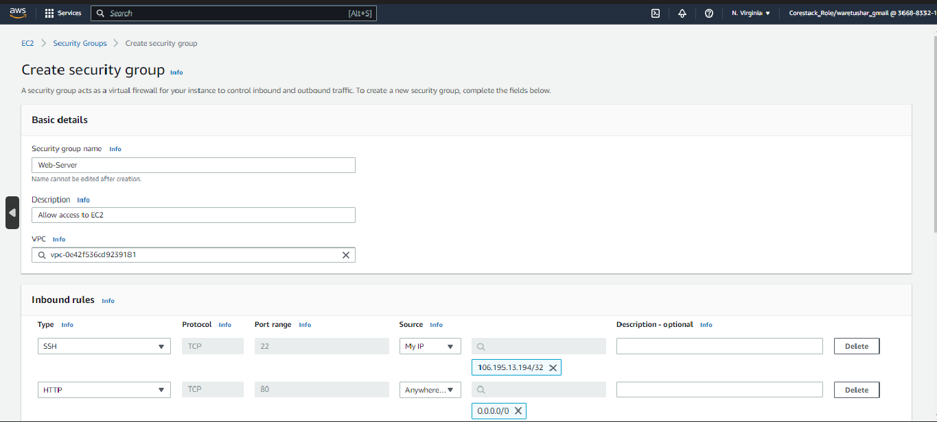

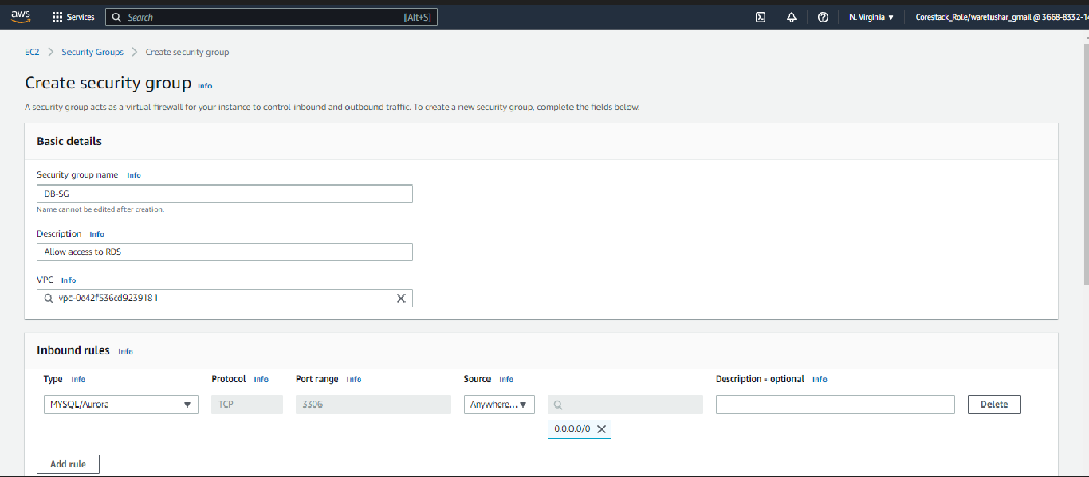

1. Created EC2 Instance

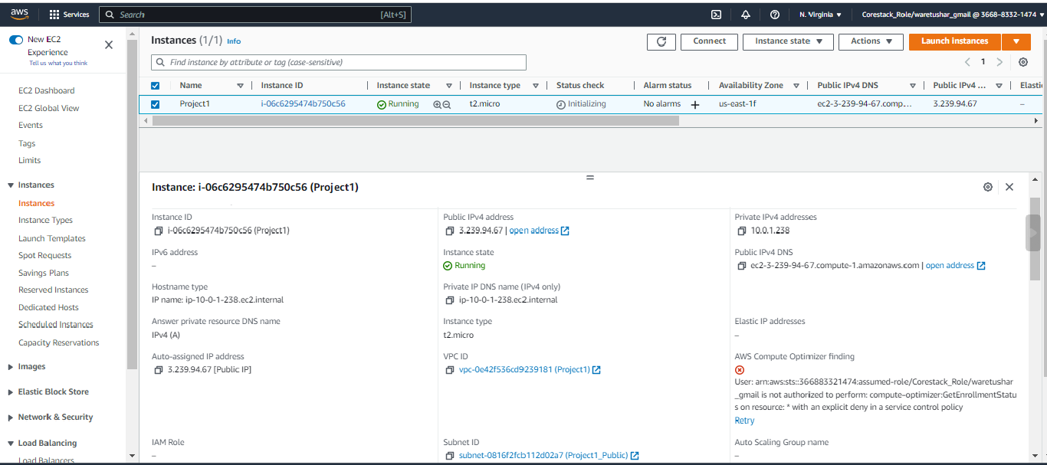

C & D. Installed by source code using putty & tested the Apache Server is working successfully